Name: Syed Affaq

Section: D8

Lab 7 Practice queries

-- task 1

select \* from employee;

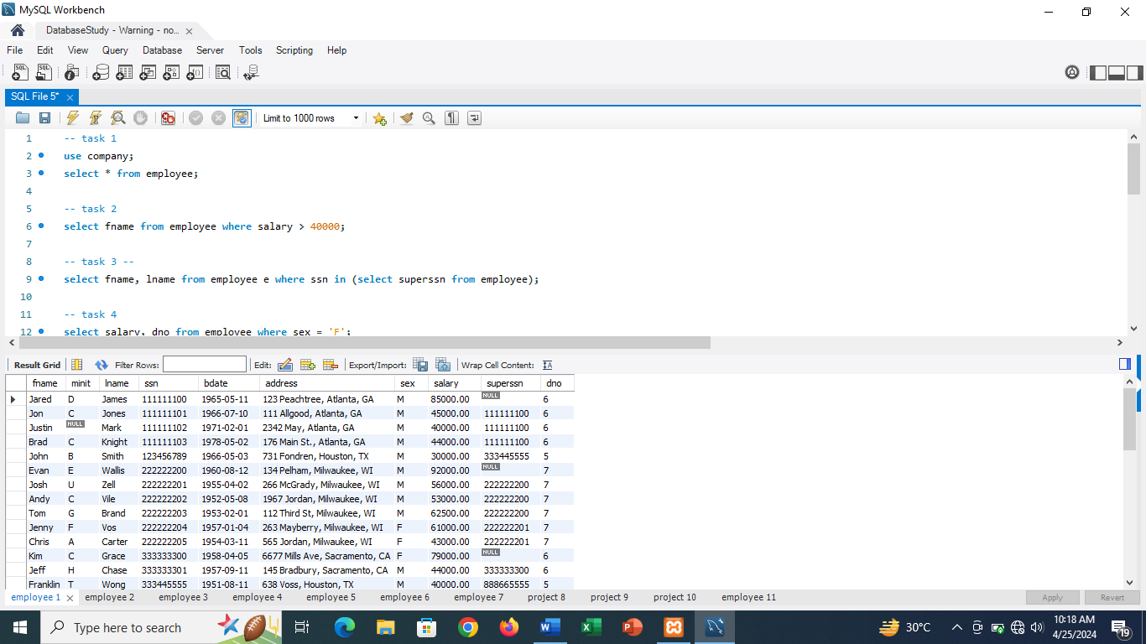

-- task 2

select fname from employee where salary > 40000;

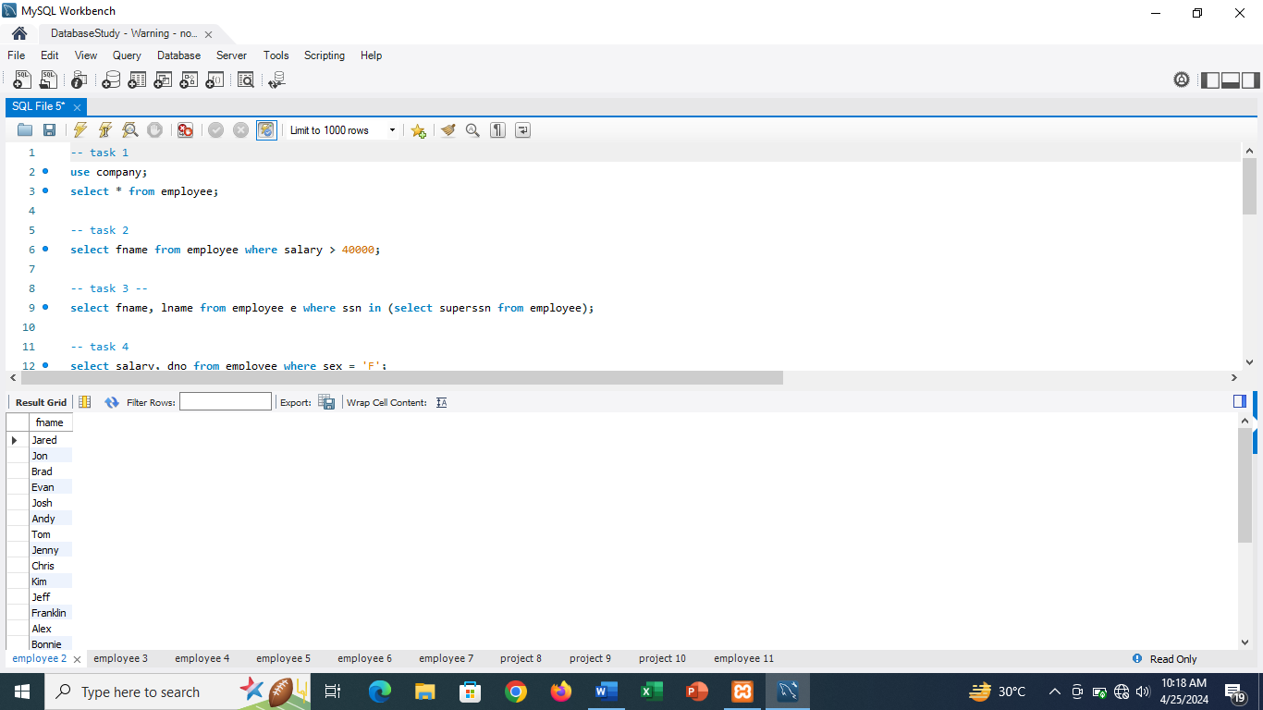

-- task 3 --

select fname, lname from employee e where ssn in (select superssn from employee);

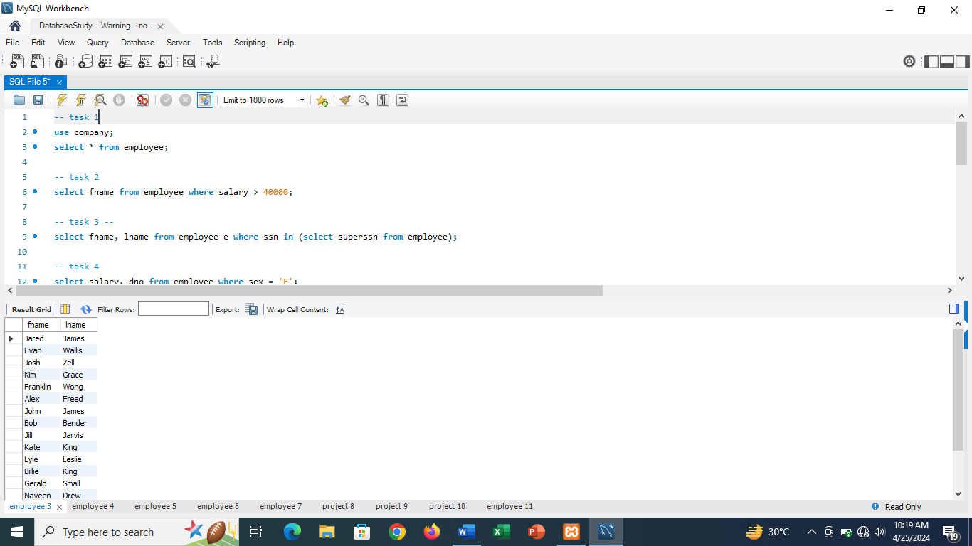

-- task 4

select salary, dno from employee where sex = 'F';

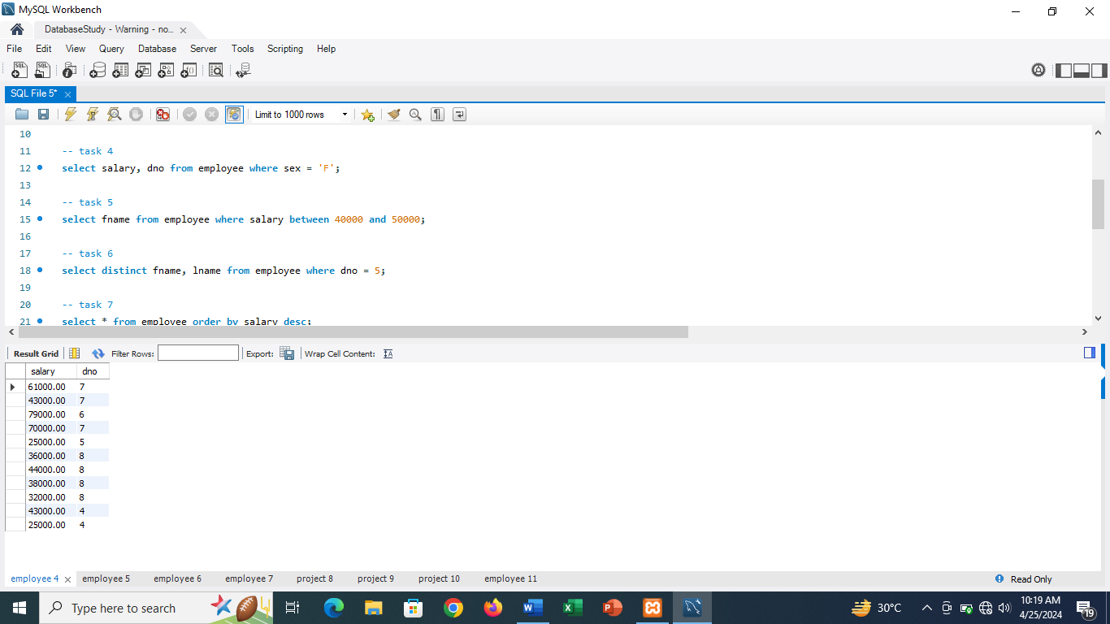

-- task 5

select fname from employee where salary between 40000 and 50000;

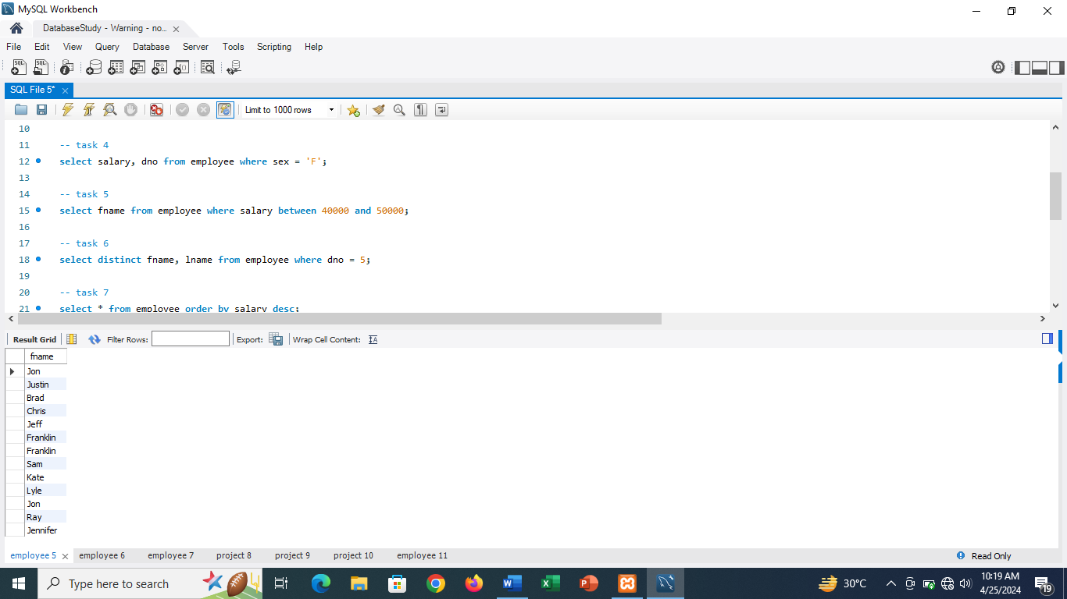

-- task 6

select distinct fname, lname from employee where dno = 5;

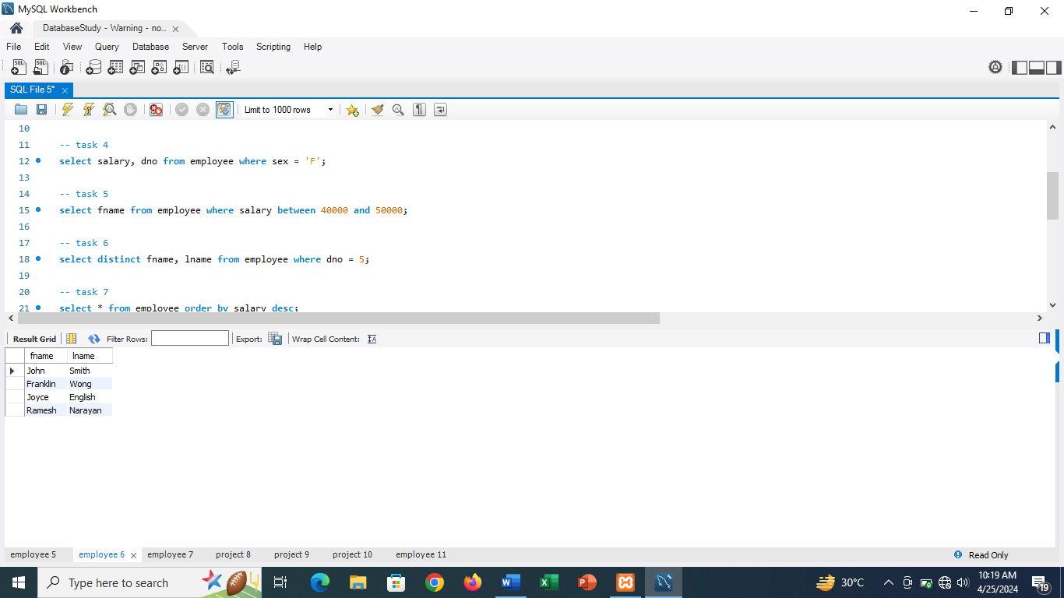

-- task 7

select \* from employee order by salary desc;

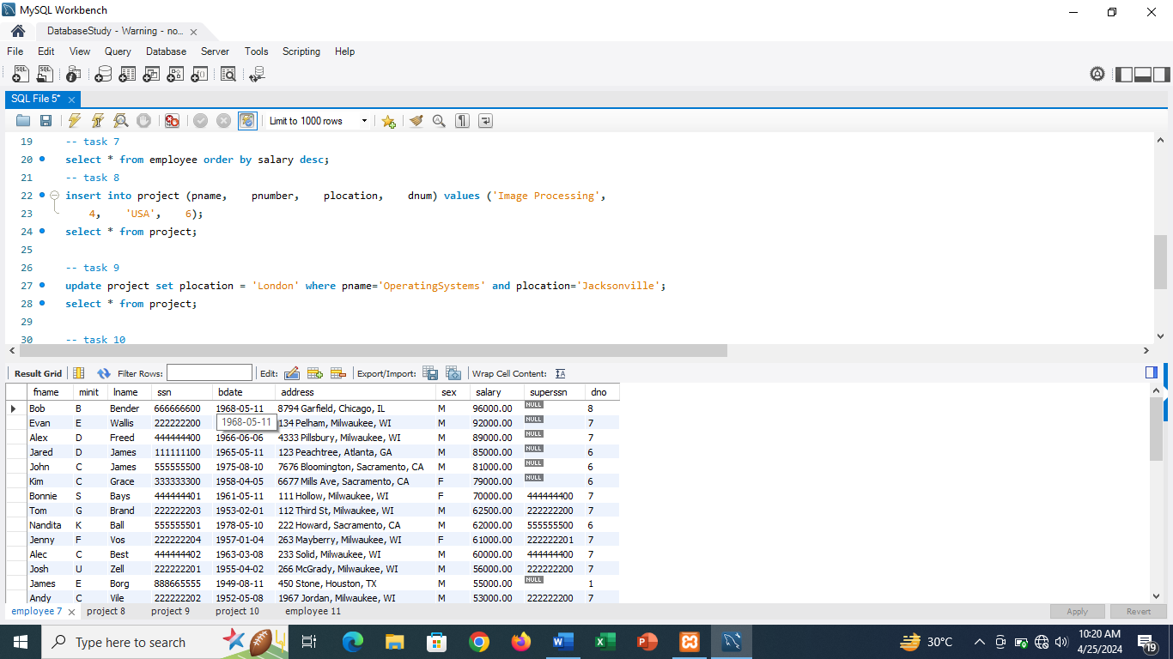

-- task 8

insert into project (pname, pnumber, plocation, dnum) values ('Image Processing',

4, 'USA', 6);

select \* from project;

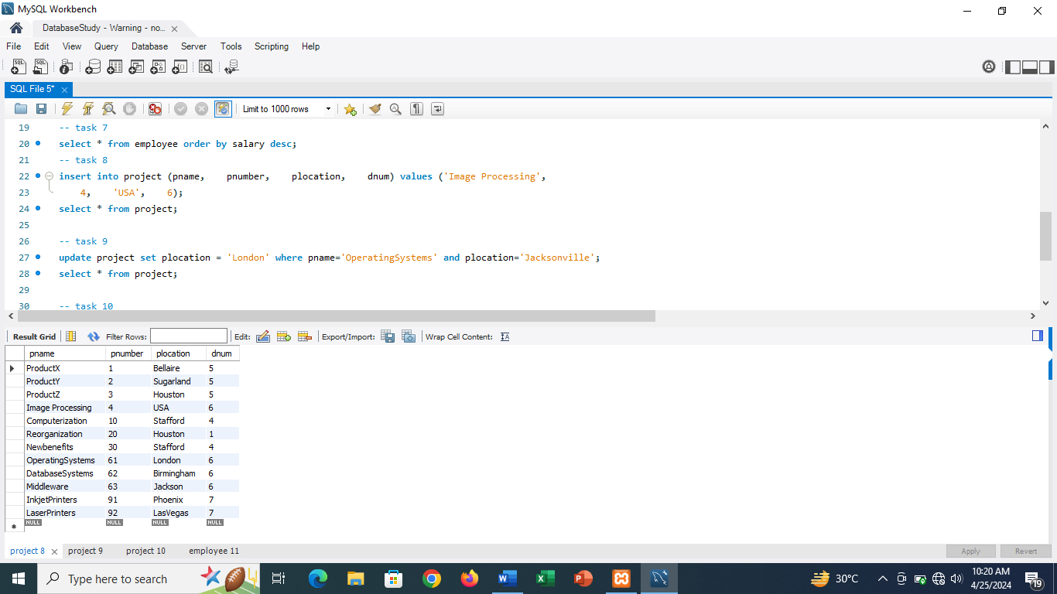

-- task 9

update project set plocation = 'London' where pname='OperatingSystems' and plocation='Jacksonville';

select \* from project;

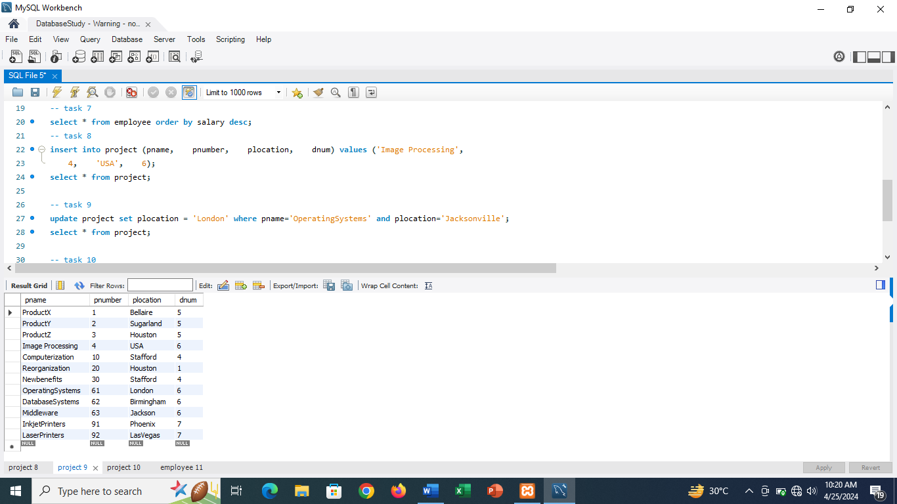

-- task 10

delete from project where pnumber = 4;

select \* from project;

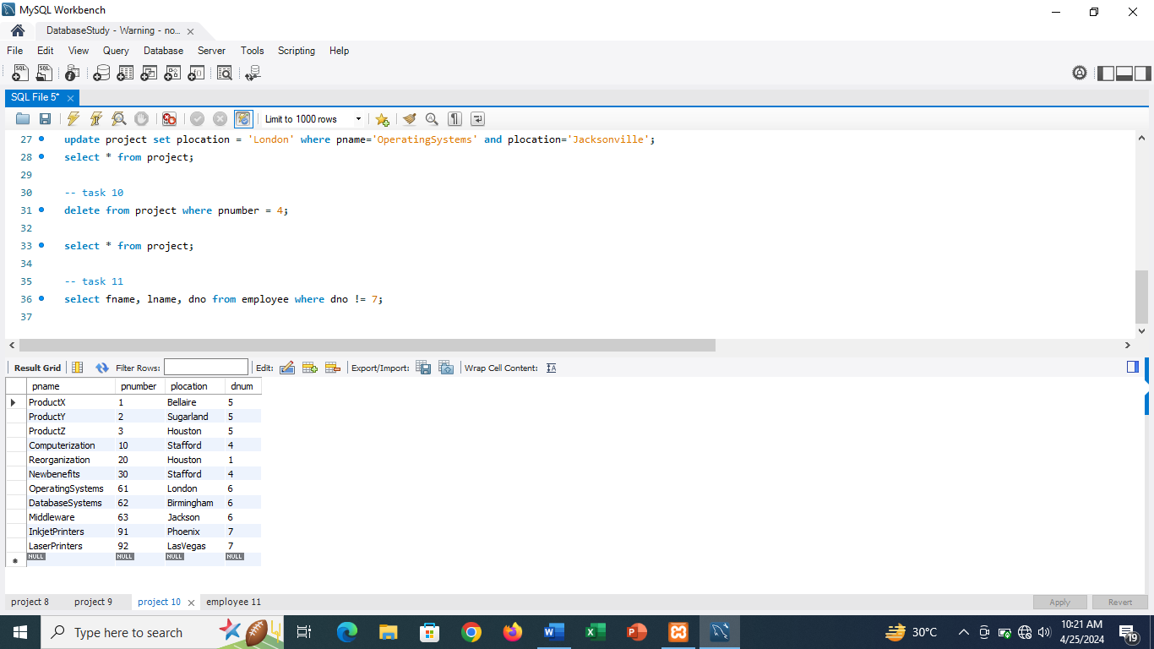

-- task 11

select fname, lname, dno from employee where dno != 7;

