Introduction to Database Systems – Lab

JOINS (LEFT, RIGHT, OUTER) + UNION

Note: Use ‘**Classic Model’** database for following questions.

1. List all customers along with their sales representatives (employees who handle their accounts), including customers without a sales representative.

select * from customers c left join employees e on c.salesRepEmployeeNumber = e.employeeNumber;

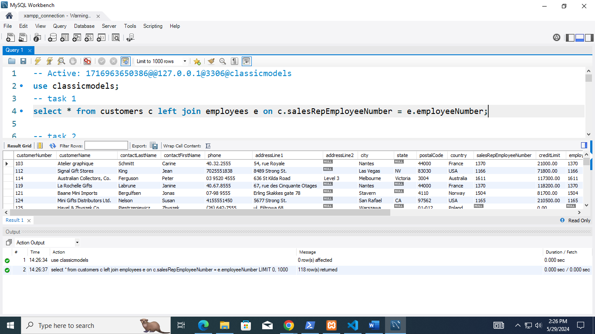

1. List all employees and the customers they handle, including employees who do not have any customers.

select * from employees e left join customers c on e.`employeeNumber` = c.`salesRepEmployeeNumber`;

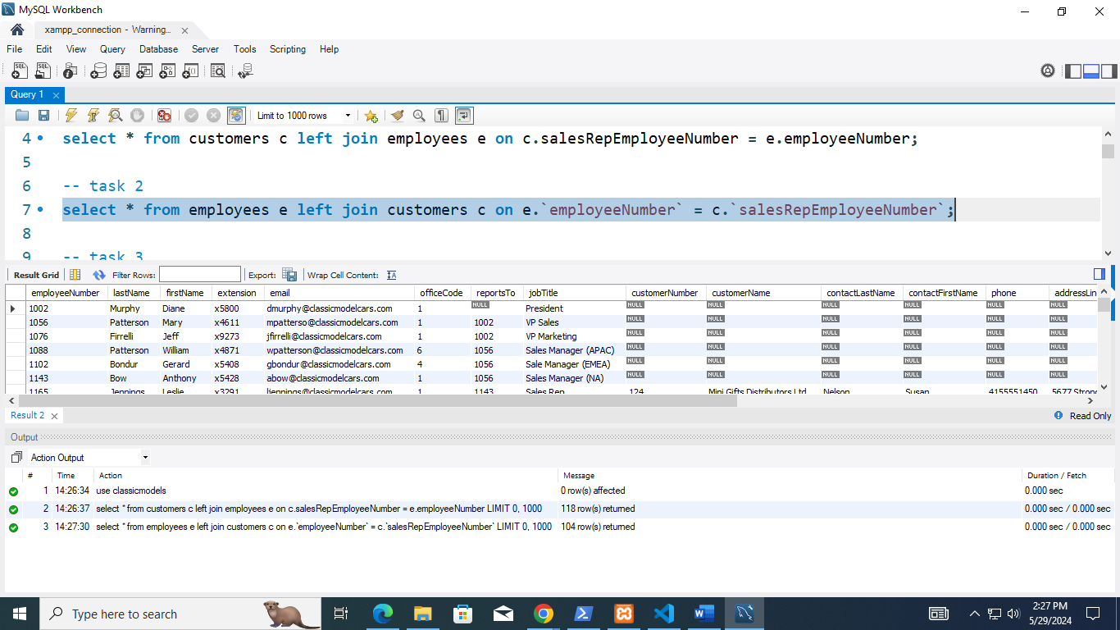

1. Display all orders along with the customer details, including orders that have no associated customer information.

select * from customers c right join orders o on c.`customerNumber` = o.`customerNumber`;

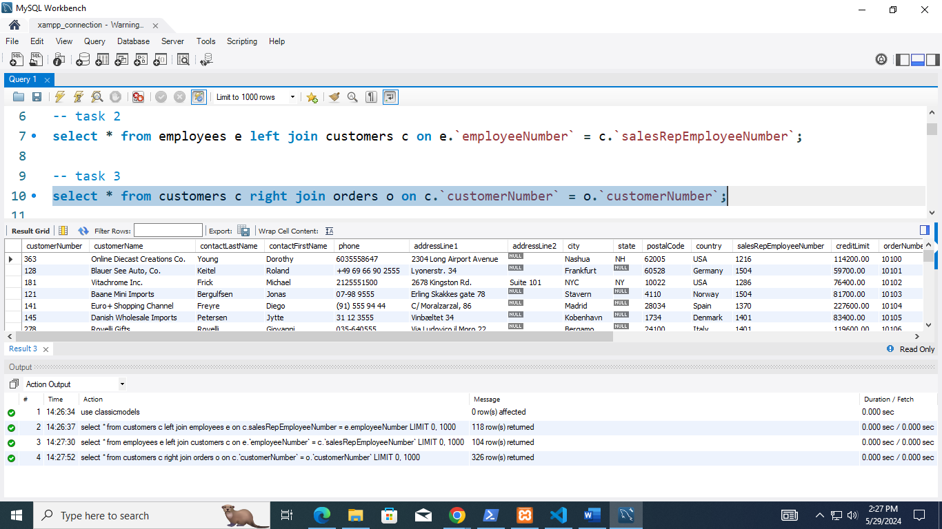

1. List all products along with the order details, including products that have never been ordered.

select * from orderdetails od right join products pr on od.`productCode` = pr.`productCode`;

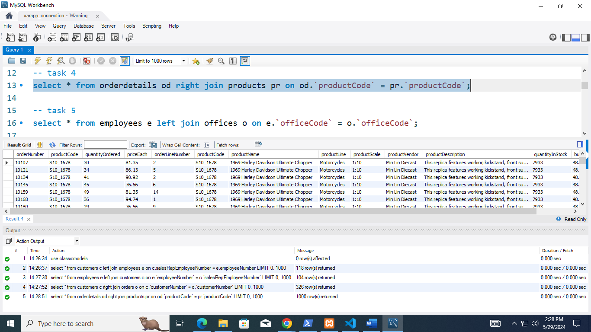

1. Display all employees along with the office location details, including employees who are not assigned to any office.

select * from employees e left join offices o on e.`officeCode` = o.`officeCode`;

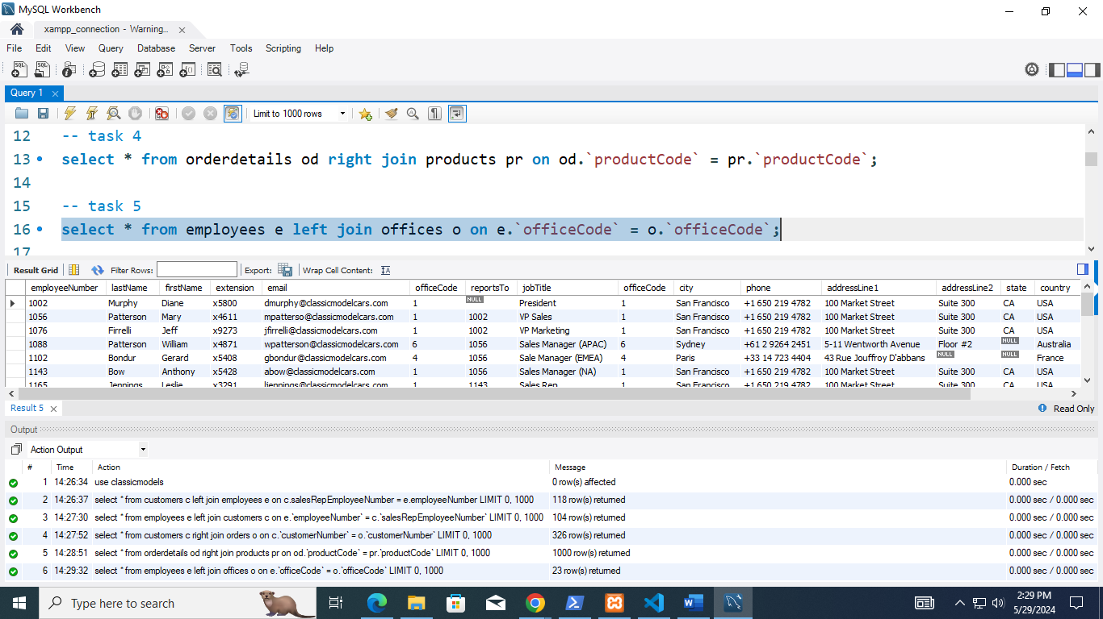

1. Retrieve all orders along with the products ordered, including orders that do not have any products.

select * from orderdetails od right join products pr on od.`productCode` = pr.`productCode`;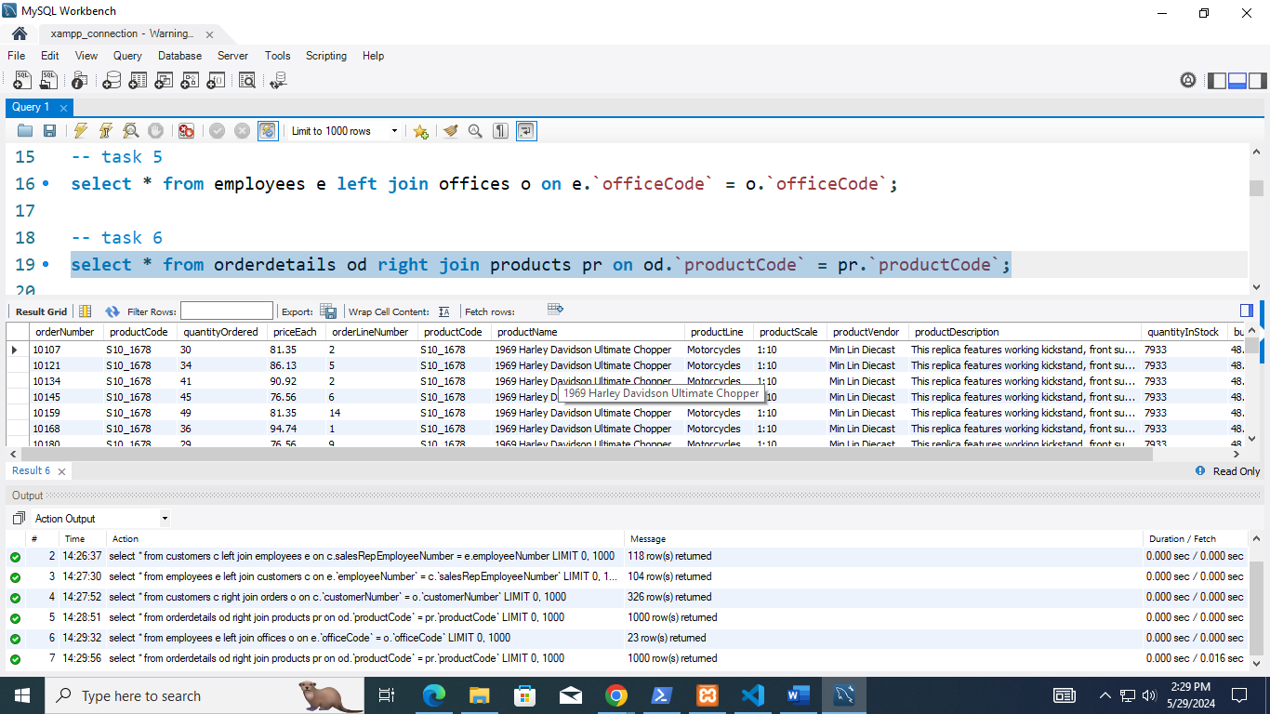

1. List all customers and their payments, including customers who have not made any payments for payment amount greater than 10000.

select * from customers c left join payments p on c.`customerNumber` = p.`customerNumber` where p.amount > 10000; 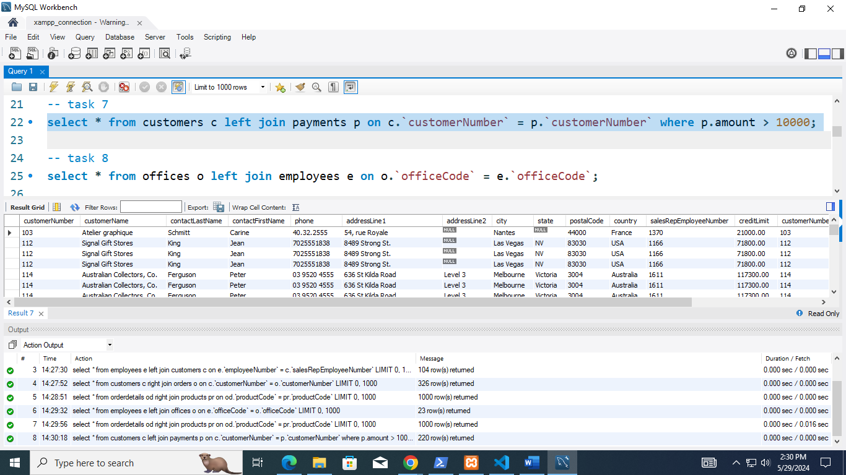

1. Display the list all offices and their employees, including offices with no employees.

select * from offices o left join employees e on o.`officeCode` = e.`officeCode`;

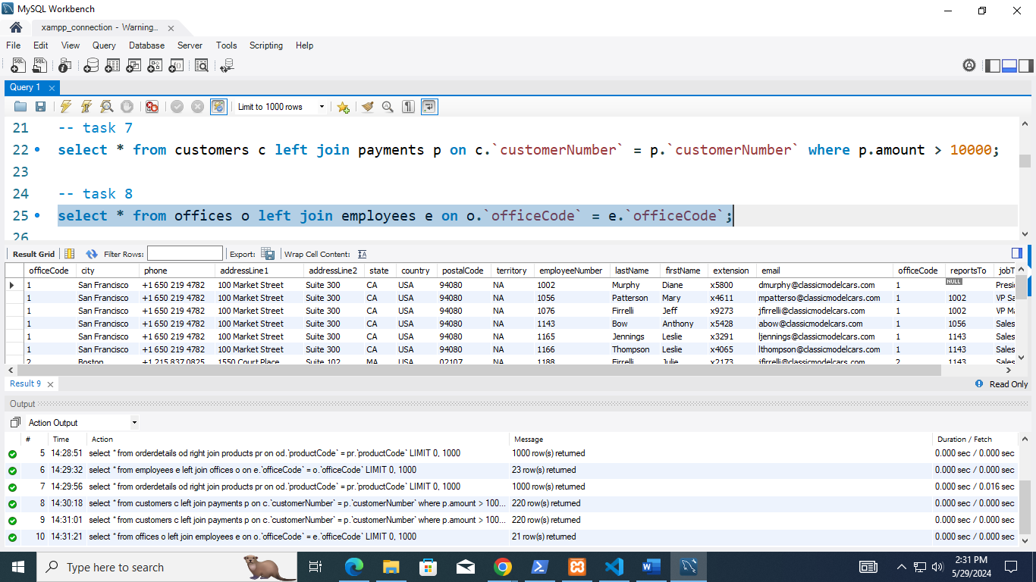

1. List all orders and the status of their shipments, including orders that have not been shipped.

select * from orders where status != 'Cancelled';

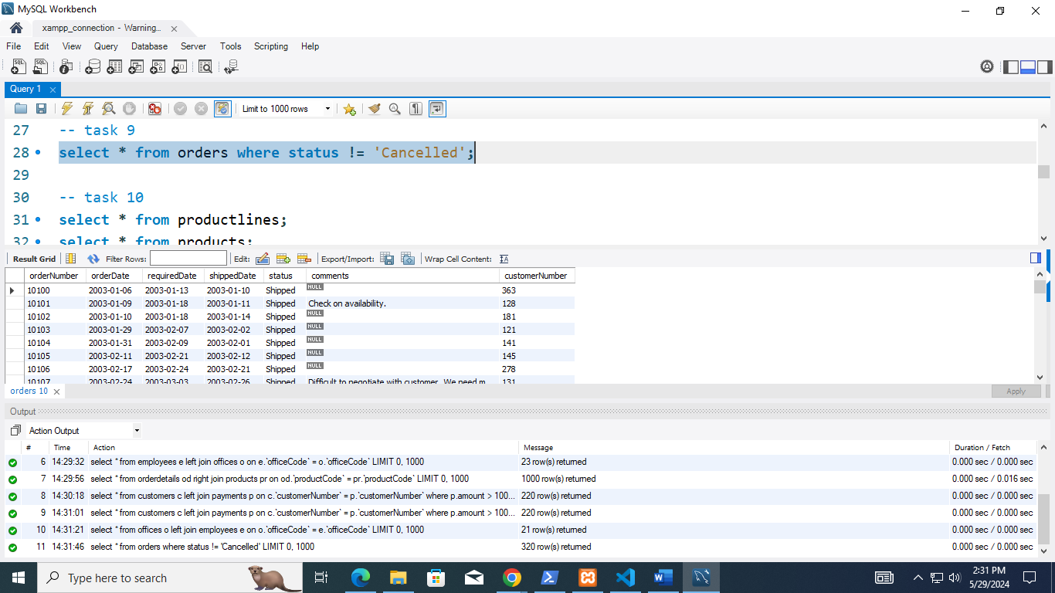

1. List all product lines and the products in each line, including product lines with no products

select * from productlines pl left join products p on pl.`productLine` = p.`productLine`;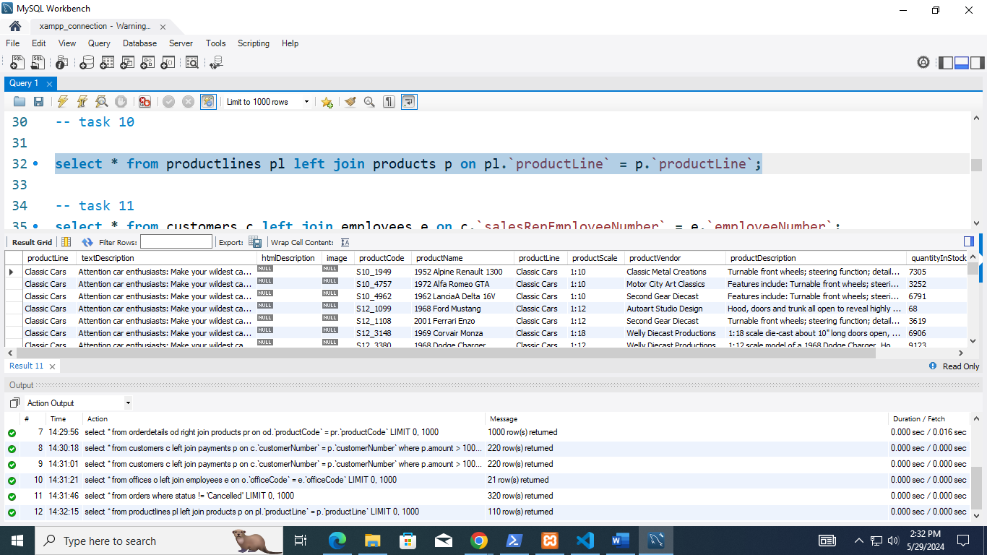

1. Write a query to display all employees along with the customer they handle, make sure to display all of the customer regardless of their sales representative.

select * from customers c left join employees e on c.`salesRepEmployeeNumber` = e.`employeeNumber`;

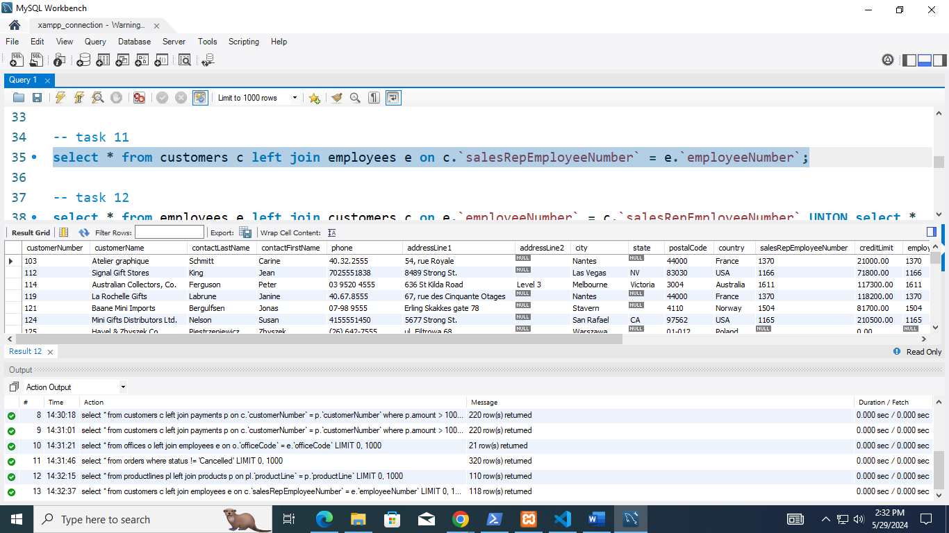

1. Display the list of all employees and all customers in order of their association.

select * from employees e left join customers c on e.`employeeNumber` = c.`salesRepEmployeeNumber` UNION select * from employees e right join customers c on e.`employeeNumber` = c.`salesRepEmployeeNumber`;

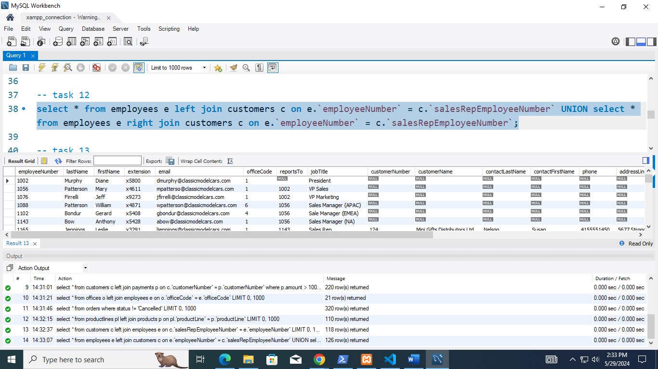

1. List all customers and their orders, including customers with no orders and orders with no corresponding customers.

select * from customers c left join orders o on c.`customerNumber` = o.`customerNumber` union select * from customers c right join orders o on c.`customerNumber` = o.`customerNumber`;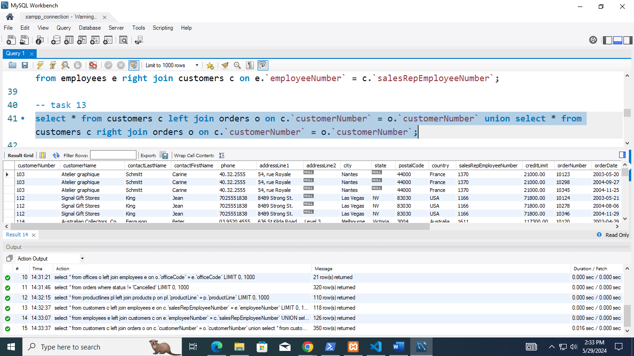

1. List all product lines and their products, including product lines with no products and products not assigned to any product line.

select * from productlines pl left join products pr on pl.`productLine` = pr.`productLine` UNION select * from productlines pl right join products pr on pl.`productLine` = pr.`productLine`;

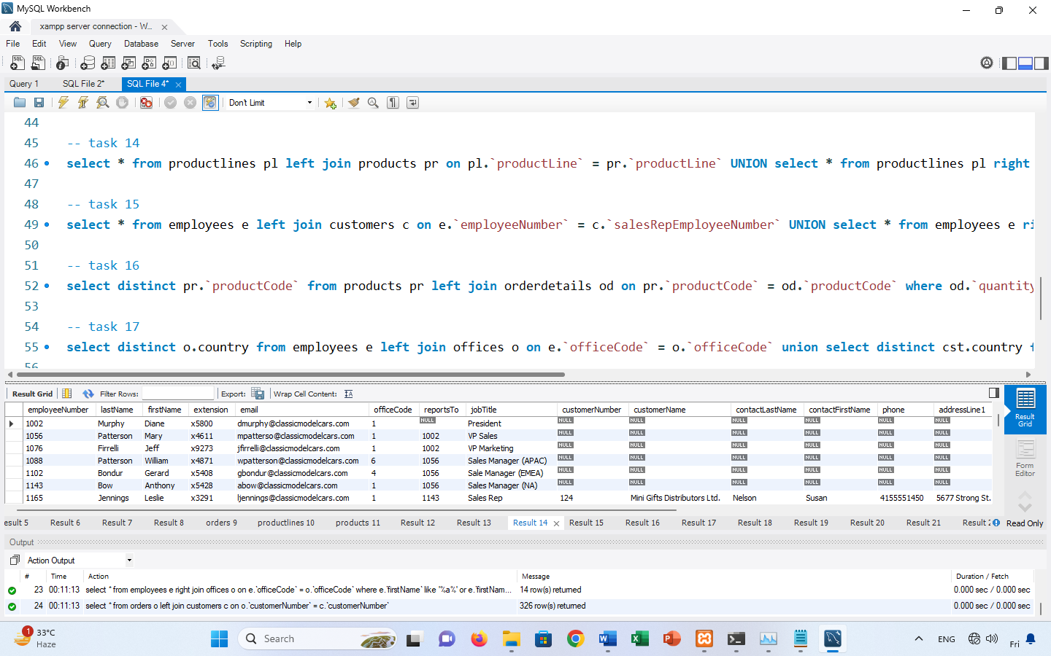

1. List the name of all employees and all customers that has ‘a’ in their name.

select * from employees e left join customers c on e.`employeeNumber` = c.`salesRepEmployeeNumber` UNION select * from employees e right join customers c on e.`employeeNumber` = c.`salesRepEmployeeNumber` where c.`contactFirstName` like '%a%';

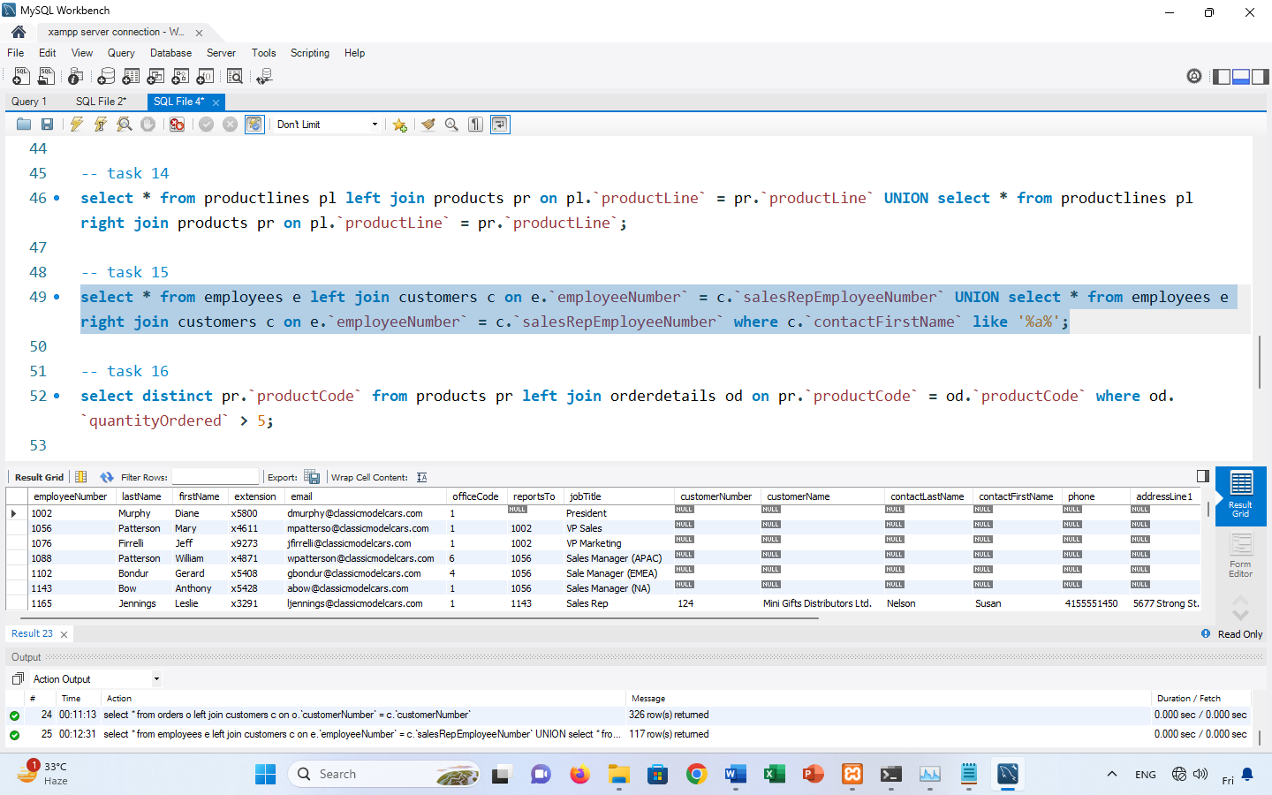

1. Retrieve the distinct list of all product codes whose either quantity ordered is greater than 5 or quantity in stock in greater than 5.

select distinct pr.`productCode` from products pr left join orderdetails od on pr.`productCode` = od.`productCode` where od.`quantityOrdered` > 5;

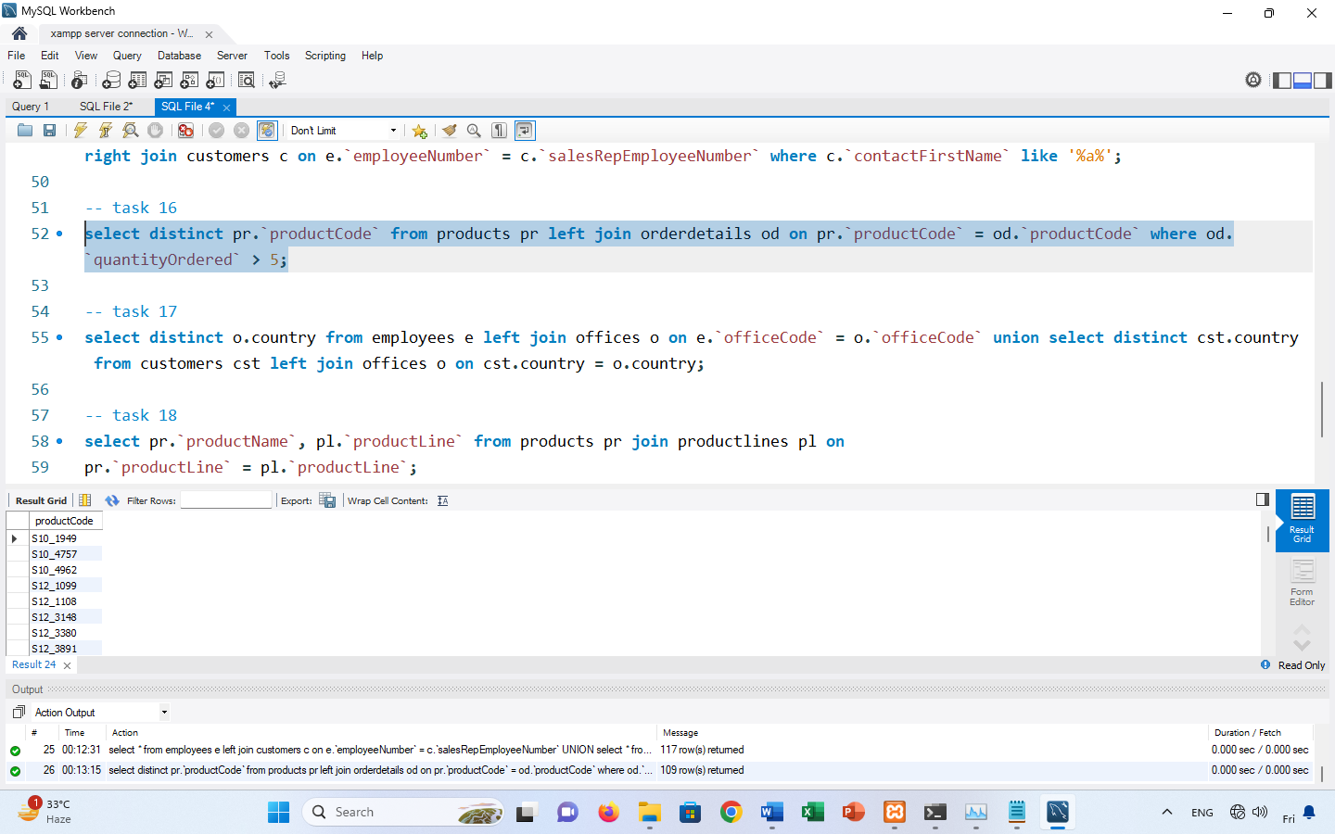

1. List all unique country name where either employee office is located or where customer resides.

select distinct o.country from employees e left join offices o on e.`officeCode` = o.`officeCode` union select distinct cst.country from customers cst left join offices o on cst.country = o.country;

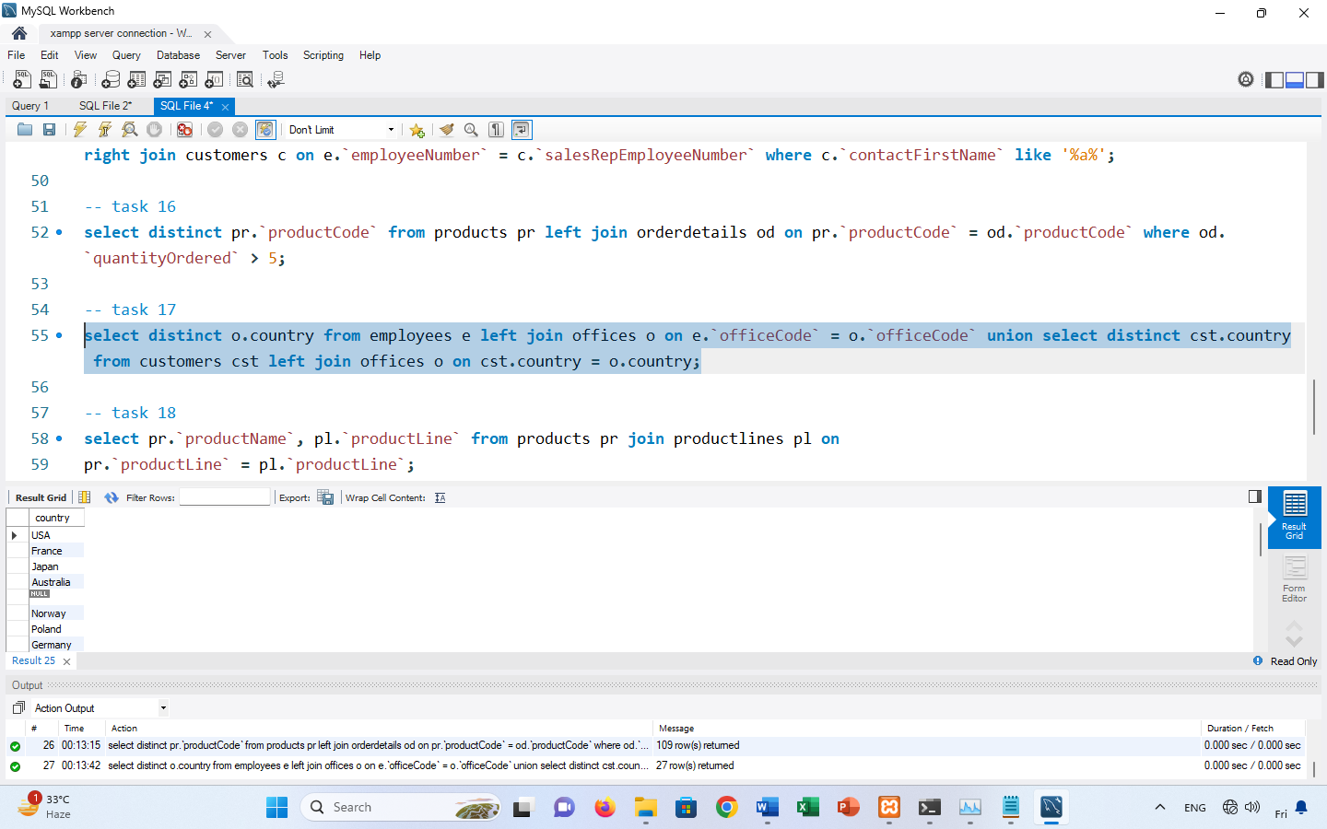

1. Retrieve the product names along with their respective product line names.

select pr.`productName`, pl.`productLine` from products pr join productlines pl on

pr.`productLine` = pl.`productLine`;

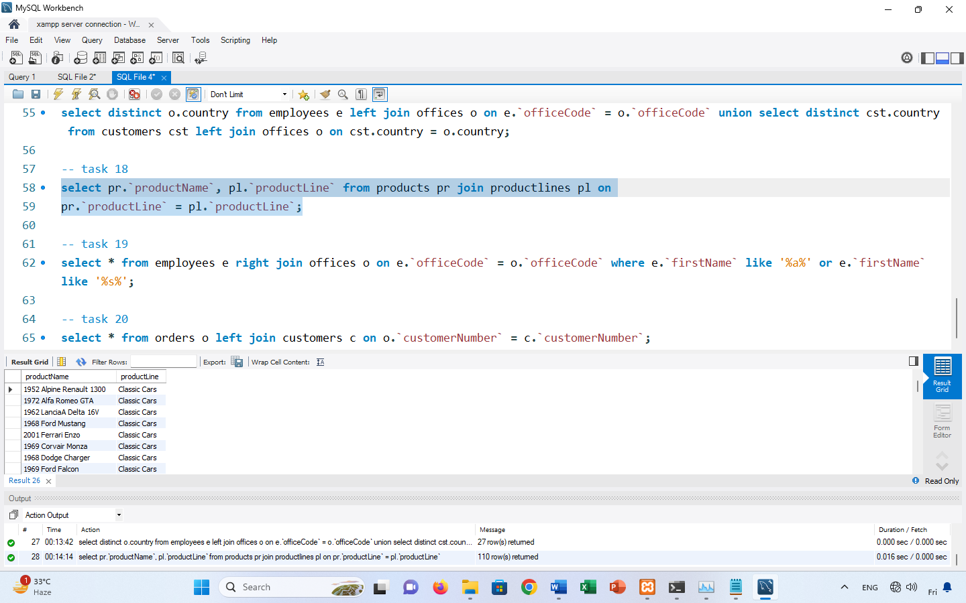

1. List all employees and the offices they work in, including office city and country where there is ‘a’ or ‘s’ in their name.

select * from employees e right join offices o on e.`officeCode` = o.`officeCode` where e.`firstName` like '%a%' or e.`firstName` like '%s%';

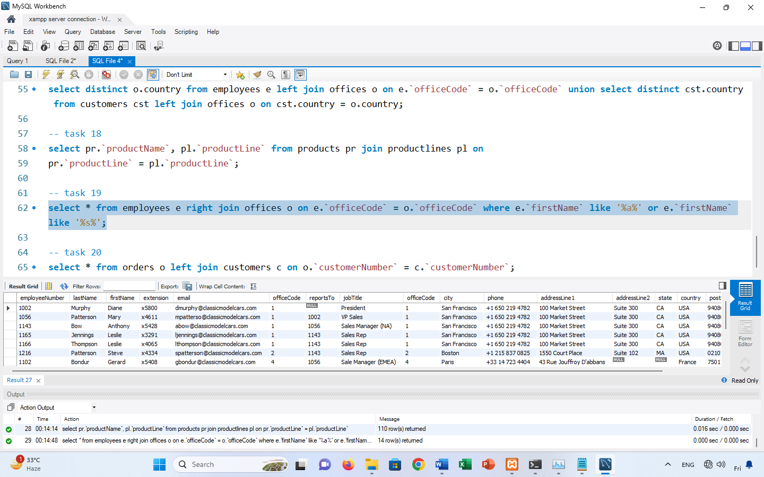

1. List all orders along with the customer names who placed those orders.

select * from orders o left join customers c on o.`customerNumber` = c.`customerNumber`;

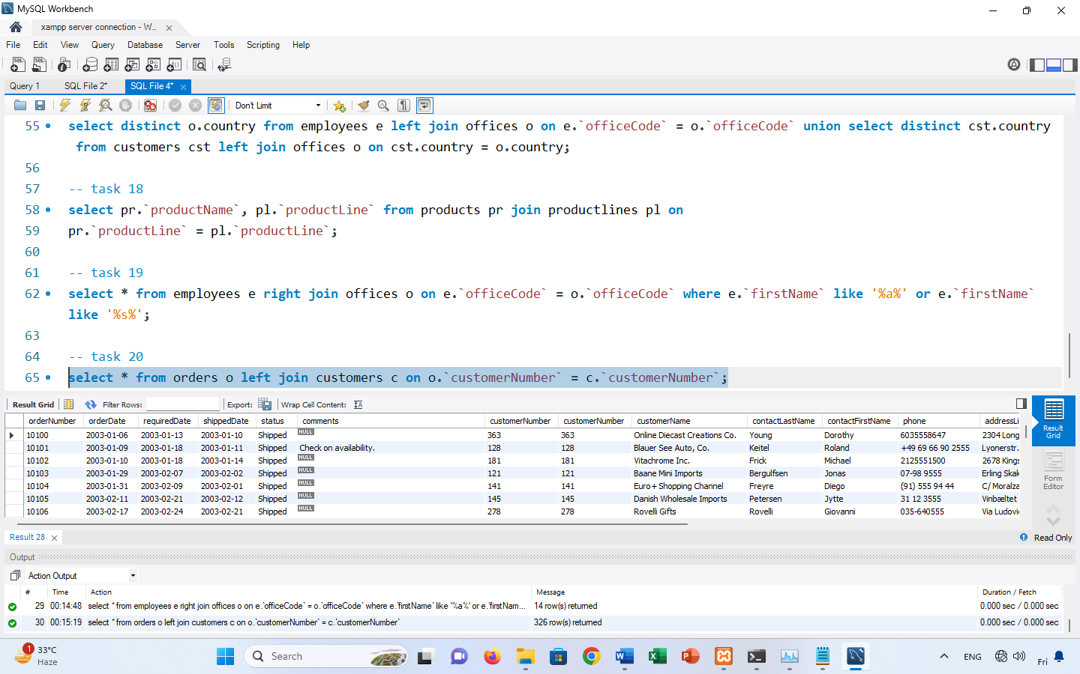

P.S: In order to achieve outer join you can take left join union with right join.