**

**Use Case**: Manage Admin Privileges

**Actor**: System Admin

**Preconditions**:

* Admin is logged in
* Admin has necessary privileges

**Basic Flow**:

1. Admin selects action (manage roles/view logs/reset account)
2. System verifies permissions
3. Admin performs action
4. System:
   * Executes request
   * Logs activity
   * Notifies affected users (if needed)
5. Confirms completion

**Alternate Flows**:

* *Unauthorized action* → Log violation, notify security
* *Invalid request* → Show error, cancel action

**Postconditions**:

* Action completed
* Audit log updated

**Special Notes**:

* All actions are logged
* Temporary passwords expire after 24hrs

**System use case:**

**PACKAGE DIAGRAM:**

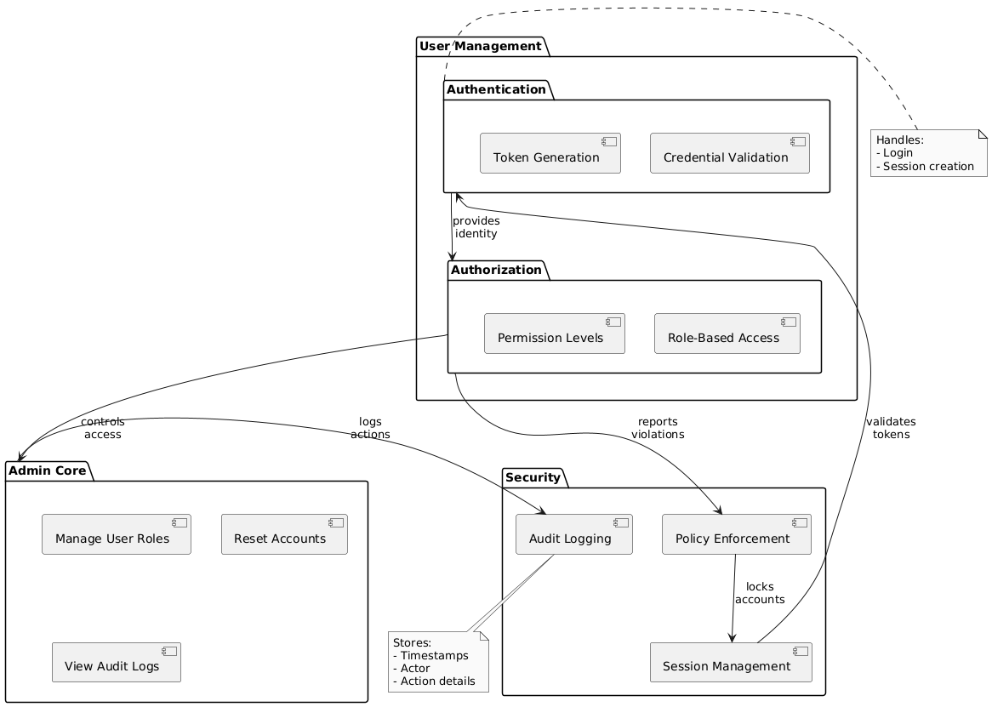

**Class diagram:**

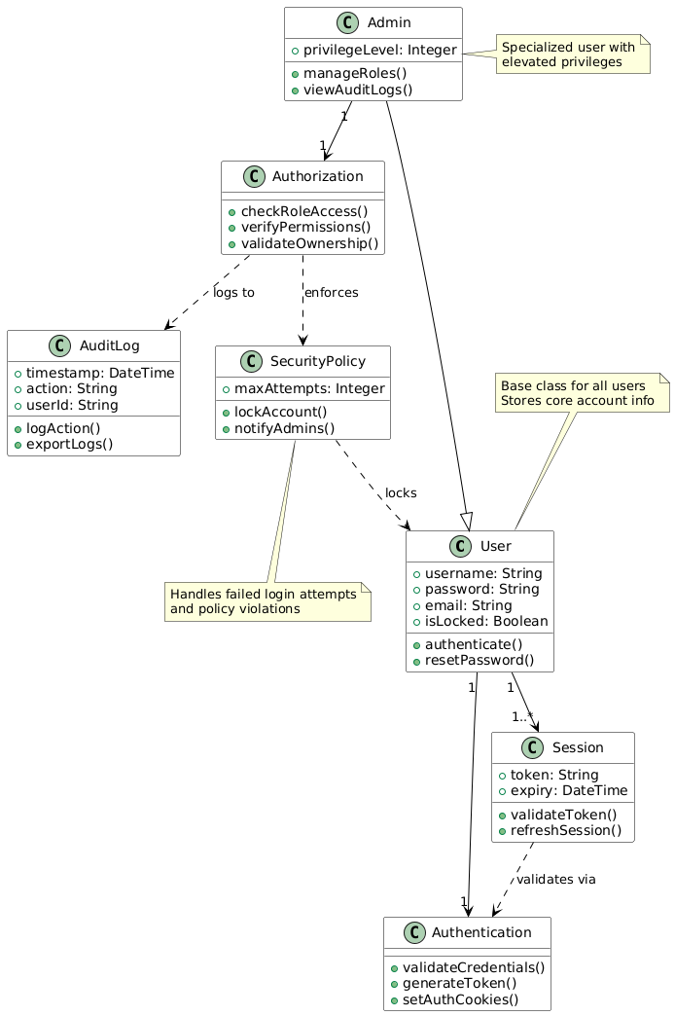

**SYSTEM SEQUENCE DIAGRAM:**

