RESUME
Mahafuz Alam 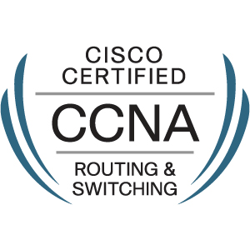 Email – mahafuzalam90@gmail.com
Contact no – 0508754560

Summary

An IT professional more than 4 years of experience in Hardware and Networking, Client-Server, Experience on Windows and networking.

Experience Summary

- Worked as Desktop Support Engineer with CMS IT Services, Gurgaon(India) since April 2018 to August 2019.
- Worked as Desktop Support Engineer with Anees and Associates, New Delhi-13 (India) since February 2017 to April 2018.
- Worked as Desktop Support Engineer with Apollo Asia Travel Group New Delhi-65 (India) since February 2015 to February 2017.
- CCNA Training from CMS IT Services Pvt. Ltd. South ex. New Delhi.

Role & Responsibilities

- Installing the basic OS and supporting software as per the guidelines of the organization.
- MS outlook configuration, Outlook backup & restore and troubleshooting.
- Installing and configuring the peripherals, components and drivers.
- Troubleshooting of LAN and Desktop related issues.
- Installing new computer systems and connecting them in to LAN.
- Ability to solve the technical problems remotely.
- Work experience on ticketing tool (Service now).
- TCP/IP Configuration.
- Software troubleshooting update and patch installation.

Qualification And Certifications

- Completed CCNA from Cisco. {Cisco ID – CSCO13108360 }
- “O” Level (Hardware and Networking ) from DOEACC
- BCA from Lovely professional University.
- 10+2 from U.P Board .

Technical Skills

- Strong working knowledge of TCP/IP protocol stack and applications working on it like WWW, HTTP, DNS, SMTP, FTP, etc.
- Understanding of Antimalware, Antivirus and Endpoint security.
- IPv4 Addressing
- IPv4 saving techniques including Subnetting, VLSM.
- Strong working knowledge of RIP (V1 & V2), OSPF & EIGRP ACLs (Packet Filtering), VLANs, Trunking Protocols, VTP& Inter VLAN Routing

Personal Details

Name | Mahafuz Alam
S/O | Mohd Matin
Email ID | mahafuzalam90@gmail.com
Phone Numbers | 0508754560 (India-91-9717270930)
Date of Birth | 20 Aug 1990
Address | Street-44, Abu Hail-Dubai

Declaration

I hereby declare that the above all information is true to the best of my knowledge.
Signature
Mahafuz Alam

