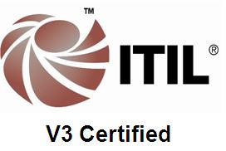

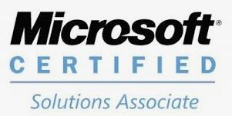
DANIYAL MOHTISHIM
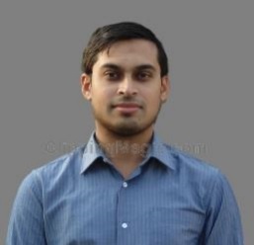
Accomplished MS Certified IT Professional with over 7 Years of experience delivering excellent, accountable, high class IT services to over 320+ users in different countries.

MCSA Server, MCP and ITIL V3 Certified.

________ACADEMIC QUALIFICATIONS_________________________________________________

- Qualification: Bachelor’s Degree in Information Technology (IT)
Institute: Lancaster University, England, UK

- Qualification: Associate Degree in Computer Science (Software Development)
Institute: Champlain College, Vermont, USA

______ WORK EXPERIENCE ____________________________________________________
IT Technical and Infrastructure Support Engineer
Abbott, Dubai
Apr2018 – Nov2019

Responsibilities:
- Delivered IT support (1st, 2nd and 3rd level) to over 200 users in different countries (UAE, Oman, Lebanon, Kuwait, Jordan, Saudi Arabia, Bahrain, Qatar)
- On-boarding of New users - Set up and delivered new IT Hardware & Accessories.
- Solved IT tickets In-Person, Remotely & via Phone/Email.
- Resolving High Priority tickets by involving Rapid Response Team (RTT)
- Documented IT Solutions & Analyzed monthly SLA reports for continuous improvement.
- IT Infrastructure support and maintenance.
- Troubleshooting and Configuring of Office 365, 2016 and IBM Lotus Notes.
- Corporate Image Installations on Laptops and Desktop PCs
- Repaired laptops and desktops and filed claims for warranty (RMA).
- Replaced End of Life laptop and mobile devices according to company policy.
- Encryption of all laptops with McAfee Endpoint Encryption & Bit locker.
- Identifying and resolving Network Related Issues both user and system related.
- Coordinating with ISP & Regional support teams for connectivity related issues.
- General maintenance of Data Center equipment & escalate any issues to IT Manager.
- Completed Network Refresh upgrade project in different countries.
- Configuration & setup of iPads/other supported PDA's & Mobile devices (Android & IOS)
- Preparing LPO’s & Coordinating with IT vendors for Hardware procurement & warranty services.
- Configuration & setup of Avaya IP Desk Phones.
- Support & Maintenance of all Meeting Room Audio Video conference equipment.
- Support of Cisco Switches and Wireless access points
- Support of Extreme Switches and Wireless Access points
- Configuring Mobile devices with Airwatch environment.
- IT Asset tagging and Inventory Management.
- Cisco Telepresence and Audio video conference support.
- HP Multifunction Printers and Scanners Support.
- Cisco VPN and Zscaler VPN support.
- Configuring Cisco switches with help from Regional teams.
- Tested and Deployed Windows Images on Laptops & Desktops.
- Cisco WebEx and Audio Conference Support.
- Regional Video Conferences support.
- Delivered administration support within the IT Department.
- Experience with contract and vendor negotiations, and expertise in negotiating contracts and managing vendors, including tracking of Service Level Agreements (SLAs)
Temporary IT Support Project at Real Estate Company + Microsoft Certification Courses
Sep2017 – March2018

IT Support Engineer / IT System Engineer
Henkel, Dubai
Jan2013 – Aug2017

Responsibilities:
- Delivered IT support (1st, 2nd and 3rd level) to over 320 users in different countries (UAE, Morocco, Kuwait, Saudi Arabia, Oman, Jordan, etc.)
- Achieved & exceeded defined SLA targets for IT Tickets.

Service Desk Management Role:
- Assign and schedule Tickets to all technicians (including myself), Monitor Helpdesk
calls & escalation of tickets. Monitor SLA’s & IT tickets status.

Technical Support & Analyst Role:
- Provide solutions for day-to-day problems arising from end user queries (desktop/notebook support, MFP, Network printers/scanners, Video Conferencing system, Hardware/software installation, internet issues, etc.)
- Delivered administration support within the IT Department.
- Responsible for IT Asset Inventory & Asset Management.
- On-boarded New users - Set up and delivered new Hardware & Accessories.
- Managed Software licensing & created Purchase Requests for ordering of all IT Hardware & Software Equipment.
- Documented IT Solutions & Analysed monthly SLA reports for continuous improvement.
- Created content & educated users through IT Tutorials & User guides.
- Organized & Delivered Office 365 Training to End users.
- Setup and Troubleshoot issues related to Android, Windows & Apple IOS devices.
- Managed user accounts through HAD (Active directory Integrated tool).
- Proactively identified process improvement opportunities & supported continuous improvement initiatives.
- Reduced costs by 30% by negotiating prices with IT vendors & ensuring delivery of satisfactory vendor services to business.
- Repaired laptops and desktops and filed claims for warranty (RMA).
- Replaced End of Life laptop and mobile devices according to company policy.
- Configured and Installed Alcatel Lucent IP based (PABX) phones.
- Reduced monthly telecom bill by 25% by providing training to end users and optimizing mobile data packages for all employees on own initiative.
- Delivered on the spot solutions for complex problems to ensure continuation of business.
- Devised and implemented migration plan for Windows OS upgrade for all users.
- Supported Single Site and Multi-Site Audio/Video Conferences using Polycom.
- Ensure Daily backup (Symantec Backup Application) is checked, maintained and kept off-site.

___ IT CERTIFICATIONS____________________________________________________________

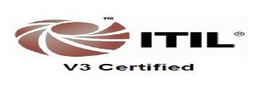

  - Microsoft Certified Professional (MCP)
  - Microsoft Certified Solutions Associate (MCSA) Server 2012
- ITIL V3 Certification.

PERSONAL DETAILS
Name: Daniyal Mohtishim
Gender: Male
Marital Status: Single
UAE Driving License: Yes
E-mail: daniyal.mohtishim@hotmail.com
Mobile Number: +97155 6003725
Date of Birth: 24-11-1984

