Meer Azher Hussain
Mobile +971509614025
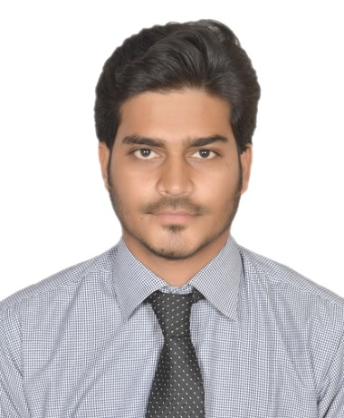
meerazherhussain@gmail.com


Dubai - UAE.
Visit Visa
Valid Till 12th March 2020

Objective

To strive for Excellence in the field of IT with dedication, focus, proactive approach, positive attitude and passion, And to utilize my knowledge and skills in the best possible way for the fulfillment of organizational goals.

Work Experience May-2016 To June-2019

Organization : Ramee Group of Hotels & Resorts. Dubai, UAE.
Role : IT Executive
Responsibilities :

- Hotel ERP, IDS Hotel Management Software for Managing and Administering Users and Database including client Installation
- Responsible for installation and maintenance POS machine and KOT printer
- Maintenance of Networking (Crimping, Punching, installation of Network Rack Switch)
- Troubleshooting network connectivity in a LAN/WAN environment.
- Configuring of Switches. Creating VLAN
- Monitoring and Maintenance of Firewalls (Fortinet100D), D-Link, Allied Telesis POE Switches, Wireless Routers
- Installation of operating systems such as Windows 10, Windows 7, Mac OS X and relevant application software’s Troubleshooting all Desktop, printer’s problems.
- Microsoft Outlook, Office365 configuration, backup, troubleshooting.
- provided the Remote support using following software Team Viewer, VNC Server, Ammy Admin, Remote Desktop.
- Hand on experience on Video and Audio Devices like audio Mixer, Video Switcher, video distributor.
- Board Room Solutions, Installations of Audio and Video Conferencing Equipments
- installing equipment such as video screens, projectors, video monitors, microphones, sound speakers, all type of switchers and Mixers.recording
- Doing Web Based Video Conferencing By using Software like Zoom.
- Installing, configuring and troubleshooting in HP LaserJet 1606dn, HP LaserJet Pro MFP M127- M128, HP LaserJet 1020, Canon Lide scanner.

Work Experience June-2012 To April 2016

Organization : MK Technolgies. Masab Tank. Hyderabad 500028.
Role : IT Support Engineer
Responsibilities :

- Install, configure and managing Active Directory/ Users / DHCP / DNS / Domain Users Profiles /. Groups as well as assign access rights and permission to use internet facility
- Troubleshooting issue with Mac operating system.
- Maintenance of Projector, Smart boards.
- Creating Site to Site VPN
- Installing of Operating System Windows XP, Windows Vista, Windows 7 Windows 8.
- Maintenance of Networking (Crimping, Punching, installation of Network Rack Switch)
- Experienced in installing, implementing & troubleshooting of LAN and WAN
- Microsoft Outlook, Outlook Express configuration, backup, troubleshooting.
- Resetting user passwords
- Lock/unlock user accounts
- Troubleshooting network connectivity in a LAN/WAN environment.

Certification
MICROSOFT: MCP ID: 10581806
Cisco CSCO13299259
Academic Qualifications

1) Bachelor Of Technology in Computer Science and Engineering from JNTU Hyderabad.

2) Intermediate from Board of Education AP.

3) SSC from Board of Secondary Education AP.
Personal Profile

Nationality Indian
Religion Islam
Gender Male
Marital Status Single

I declare that all the information furnished above is true and correct to the best of my knowledge and belief.

PLACE: UAE MEER AZHER HUSSAIN
DATE:

