PRAVAT KUMAR RANA
AT/P.O- GAYAL BANK, VIA- DOMPARA, DIST- CUTTACK (ODISHA)
MOB: 09778651671, 07008121429 | Email: pravat.rana355@gmail.com, pravat.rana@rediffmail.com

Dear Sir/Madam,
I am Pravat Kumar Rana from Cuttack (Odisha). I have completed one-year Advance Diploma in Hardware and Networking course from N-power, Aptech. I have 7 years 10 months experience in this particular area in Information Technology as Desktop Support Engineer, Network Engineer, Server Support Engineer, Rollout Engineer and Infrastructure Management Services. I want to apply for the post of Remote Desktop Engineer or System Engineer in a corporate company.
Within desktop support, Service desk Support as well as, as a remote desktop support engineer, I handled a number of technical, maintenance and support issues for corporate and educational institutions.
Specifically, I configured and installed hardware, software, and peripherals — and diagnosed and troubleshoot complications pertaining to the local area network (LAN). I worked with virus protection software and utility programs, ensuring that company policies and procedures were followed and that each new feature addressed technological advancements.
Specific relevant IT skills include:
- Managed LAN network lifecycles on a Windows platform, from software and hardware applications to equipment layout and technical support
- In-depth knowledge of LAN maintenance and troubleshooting, including desktop support, configuration, and workstation issues, from initial problem analysis to final end resolution
- Integrate amongst technical support, ensuring multiple tasks and parallel deadlines are met and in line with technological advancements and company growth

Among my strengths, I am disciplined and hardworking with a demonstrated ability to balance the competing demands of multiple projects. I would be pleased to have the opportunity to discuss future employment and look forward to speaking with you.

Thank you for your consideration.
Sincerely,
Pravat Kumar Rana

RESUME

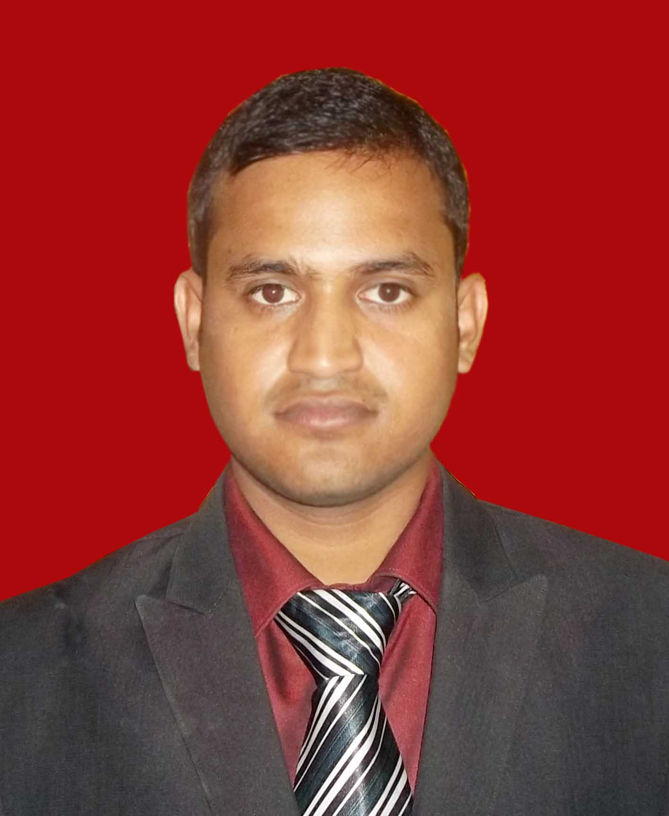
Pravat Kumar Rana
At/P.O- Gayal Bank, Via- Dompada
Dist- Cuttack
Pin- 754007 (Odisha)
Mob- +91919778651671, +917008121429
Email- pravat.rana355@gmail.com, pravat.rana@rediffmail.com,
Objective
Seeking a position of a Remote Desktop Support or Technical Support Engineer or Service Desk Support to serve as the first level of contact for all desktop or general windows issues and also as the escalation level for other issues into various levels.

Key Skills for & Strengths
- Hardware and software installations on servers, laptops and desktop.
- Basic knowledge in Active Directory, DHCP, DNS
- Basic knowledge in Server 2003 and Exchange Server 2003
- Basic understanding of Linux operating systems
- Network connectivity troubleshooting, TCP/ IP, Dial-up, Ethernet, LAN /WAN.
- Browser Support - Internet Explorer / Mozilla / Google Chrome
- Installation, Configuration, Troubleshooting of IBM Lotus Notes
- Installation, Configuration, Troubleshooting of Microsoft Outlook client and Outlook Express
- Quick resolving errors related to OS/hardware/Software.
- Configuring home and corporate level routers, switches and Access Point
- Recovering data through software.
- Monitoring of all networking devices i.e. Routers, Switches, Access Point
- Configuring software firewalls.
- Good Technical Skills that operate for the best outcome before the deadlines.
- Strong Team Player with excellent skills to handle a team
- Knowledge in Windows vista, XP, 7, 8, 10, Server 2003 Operating Systems.
- Knowledge in MS Office software, Hardware & networking etc.
- Good communication skills
- Ability to take initiative
- Multi-tasking
- Efficient problem solving
- Oriented towards customer service
- Willing to work shift wise process.
Professional Experience
Experience 1:
Position : Jr. System Administrator
Office : Hi-Tech Institute of Technology, Khurda, Odisha
Date : Jul, 2011 to April 2013

Roles & Responsibility
- Assisted company personnel with Desktop, laptop, workstation operation both hardware and software related issue
- Supervised and performed the installation of new IT network equipment, system software desktop computer.
- Planned routine repairs and system upgrades.
- Performed regular maintenance of company peripheral network devices – printers and scanners.
- Installation of OS & all applications. Resolution to OS issues
- Configuring mail clients (MS Outlook, Outlook Express).

Experience 2:
Position : System Administrator
Office : Binodini Retail Shoppe Pvt. Ltd, Bhubaneswar, Odisha
Date : April, 2013 to September, 2013

Roles & Responsibility

- Computer assembling and maintenance.
- Handling customer queries of company web portal and provide support by phone, mail (MLM Web Link).
- Troubleshooting hardware and software problems.
- Installing and configuring the peripherals, components and drivers
- Installing software and applications as per company require.
- Configuring and troubleshooting desktops, laptops.
- Virus Protection and Eradication.
- Configuring mail clients & mail archives issues (MS Outlook.)

Experience 3:
Position : Customer Support Engineer (Wipro Project & IBM Project)
Office : Kaizen IT Services Pvt Ltd
Date : September, 2013 to July 31, 2014

Roles & Responsibility

- Installation and troubleshooting issues related to (Desktop, Laptop, Printer, and Scanner).
- Formatting system and installation of all company required software and drivers.
- Basic software installation and Configuration of new desktop, laptop, assigning IP address and subnet mask, DNS servers and joining to domain.
- Managing Virus protection and eradication through Symantec End Point Protection and MacAfee Antivirus.
- Troubleshooting hardware and software problems.
- Installation of basic software for supporting banking applications & proactively resolving issues if issue exists.
- Serves as customer facing technical resource and works in collaboration with engineers and other senior staff as needed to provide effective end user support and issue resolution.
- Using system analysis techniques responds to the complex application issues for end users.
- Identifies problems and coordinates appropriate corrective action.
- Perform Branch Visits & checking all security policies, patch updates, antivirus updates, resolving issues faced by each users & share report to higher authorities.

Experience 4:
Position : Technical Support Engineer (Manappuram Finance Ltd)
Office : Info Services Pvt Ltd (Exclusive service provider of IBM)
Date : Aug 01, 2014 to 15th Mar 2015

Roles & Responsibility

- Hardware and software installations of desktop, laptop & server
- Quick resolving errors related to OS/hardware/Software.
- Network connectivity troubleshooting, TCP/ IP, LAN /WAN.
- Browser Support - Internet Explorer / Mozilla / Google.
- Installation, Configuration, Troubleshooting of IBM Lotus Notes Managing and maintaining networks
- Supervised and performed the installation of new IT network equipment, system software desktop computer.
- Planned routine repairs and system upgrades
- Tested the IT networking systems, monitored the performance of network servers and maintained computer systems of the organization.
- Updated management on a regular basis through reports, email, and presentations. Made use of Helpdesk systems to make work-load prioritization, to update calls.
- Performed regular maintenance of company peripheral network devices – printers and scanners

Experience 5:
Position : System Engineer
Office : 3i-infotech Ltd (Mannapuram Finance Ltd- IBM Project)
Date : March 26, 2015 to August 20, 2015

Roles & Responsibility

- Provide technical support for both hardware and software issues our users encounter
- Manage the configuration and operation of client-based computer operating systems
- Monitor the system daily and respond immediately to security or usability concerns
- Create and verify backups of data
- Respond and resolve help desk requests
- Upgrade systems and processes as required for enhanced functionality and security issue resolution
- Administrate infrastructure, including firewalls, databases, malware protection software and other processes
- Setup security policies for users (e.g. firewalls and intrusion detection systems)

Experience 6:
Position : Field Engineer (Contract Assignment)
Office : TCS Ltd (Reliance Retail Industries Limited Project)
Date : August 21, 2015 to July 01, 2016
Ticketing Tool : HP Service Manager

Roles & Responsibility

- Implementing LAN according to the customer’s requirement
- Installation, configuration and maintenance of HP Servers, Desktops and Laptops.
- HP system/backup administration while migration is on-going.
- Maintaining ghosting procedure with proper backups at the time of OS issue of POS and server.
- Installing and operating Windows and Server 2003, 2008 operating Systems.
- Applying patches as per company policies.
- Install, configure & upgrade E-Mail Software. (MS outlook, Mozilla thunderbird, Lotus Notes)
- Installation and troubleshooting, configuration of all type of printers like HP LaserJet Network printers, canon MFD Printers and Zebra barcode printers.
- Checking the configuration and connectivity of wireless devices like Motorola PDA with CISCO Access points.
- CISCO Routers (880, 2800 & 2900 series), Catalyst Switches (2960) and Wireless access point Configuration of various models as per SOP.
- Wireless access point Configuration of various models (AP-1042,1600,1702 series)
- Management & resolving network issues of Internet Lease line, V-SAT, ADSL link
- Responsible and undertaken End to end Reliance Retail Store Rollouts Successfully.
- Supporting users and Field Engineers over the telephone and Remote Desktop Connection to resolve their issues.
Experience 7:
Position : System Engineer
Office : Hexaware Technologies Limited (Tata Steel IT Service Desk)
Date : Jan 18, 2017 to till date
Ticketing Tool : Service-Now

Roles & Responsibility

- Provides consistent, first-line support for end users seeking assistance with IT and service issues via remote, phone, email and chat with Service-Now Tool.
- Provide timely resolution for incidents or escalation on behalf of customer to appropriate personnel, and provides incident status updates to management and end-users.
- Respond promptly and accurately to customer complaints, inquiries and requests for information and coordinate appropriate follow-up.
- Analyze complex technical issues and problems, diagnose problems, provide support to employees and support other engineers with issues.
- Create accurate ticket documentation for all user interactions.
- Coordinate with other staff for the purpose of completing incidents and requests efficiently. Work independently to resolve customer issues with little or no supervision.
- Managing calls within the service levels agreement (SLA).
- Carrying out Lotus Notes activities, installation and troubleshooting in client system.
- Documenting, logging and managing calls in the Service Management tool to high standards.
- Proactively manage Customer expectations through either resolution of or updating on progress of their outstanding problems/orders.
- Proactively engage in improvements initiatives through constant review of processes/procedures.
- Represent the IT Service Desk on any project activity which may impact support services.
- Send, collate and manage responses to customer satisfaction surveys.
- Handling critical calls & providing updates on progress & continuous follow up in earliest closure.
- Perform root cause analysis for each & every calls.
- Follow up with vendors to ensure problem resolution and call closure.
- Track inventory for any items sent for repairs and follow up for replacement.
- Ensure preventive maintenance schedules adhered to by vendors
- User AD ID password reset and Unlock through AD Tool
- Remotely resolve Outlook client, Onedrive, SharePoint configuration and troubleshooting
- Knowledge in SAP Logon configuration and troubleshooting
- Provide remote support for Network printer installation and troubleshooting

Academic Qualifications
- Graduation from Sikkim Manipal University in 2015 with 56.6%.
- 12th from CHSE Board, Orissa in 2006 with 48%.
- 10th from BHSE Board, Orissa in 2004 with 52 %.

Profession Qualifications
- Advance Diploma in Computer Hardware and Networking Professional (A+, N+, MCSE, CCNA & RHCE) from N-Power, APTECH Institute.
- PGDCA from Cyber Technology, Banki, Cuttack

Certification:
- N-Power Certified Enterprise System Engineer from N-Power, Aptech, Bhubaneswar
- Microsoft Certified Professional: (ID- 8147920)

Passport Details:
Issue Authority: Regional Passport Office, Bhubaneswar
Passport No: R3582729

Personal Details
Father’s Name : Arakshita Rana
Date of Birth : 20th May 1988
Sex : Male
Nationality : Indian
Status : Married
Language : Hindi, English & Oriya
Address : At/P.O- Gayal Bank
Via- Dompara
Dist- Cuttack
Pin- 754007 (Orissa

Declaration: -
I Pravat Kumar Rana hereby declare and confirm that the above information furnished by me is true to the best of my knowledge & belief.

Date:
Place: Cuttack, Odisha Pravat Kumar Rana

