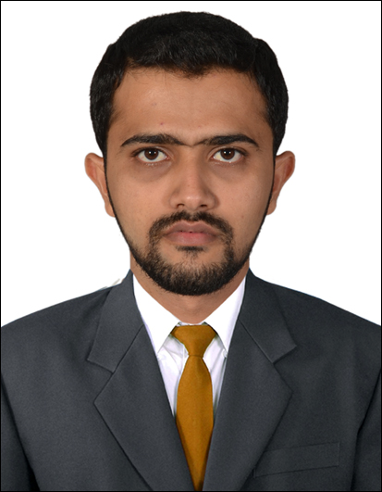
Mohammed Idrees
Deira, Dubai U.A.E.
U.A.E Car Driving License
Mob no: 055-5125022
Email: mids089@gmail.com

Objective
IT Professional with 6+ years of experience as a System Engineer. Looking for a suitable position and want to work with a progressive and forward thinking company where my skills and knowledge can be successfully utilized to enlarge the company and also help to expand my skills and experience further.
Educationional Qualification

Bachelor of Engineering in Electronic and Communication (E&C) from Visvesvaraya
Technological University, Belgaum, India in 2011.

Work Summary
1. Company : Business Continuity Solution L.L.C Dubai,UAE.
Designation : Project Engineer (July2018 to till date)

2. Company: Technoa-Middle East L.L.C Dubai, UAE.
Designation : Network & System Engineer (Oct 2016 to June 2018).

3. Company: Saeedaan Trading L.L.C Dubai, UAE.
Designation : IT Support Engineer (Sept 2013 to Sept 2016).

Technical Experience

- Managing Data Center of Multiple AMC Client across UAE.
- Preparing Action Plan for the new project and executing the project alone and with the team.
- Installing and Configuring of Windows Server 2016, 2012/2008 R2, Domain Controller, ADC, DHCP Server, DNS Server and File Server.
- Creating Users and Groups in Active Directory & Applying Permission and Security as per the requirements.
- Active Directory Migration from Server 2008R2 to 2012R2/2016, 2012R2 to 2016.
- Experience in Hyper V failover Clustering,Perform Live Migration for the VMs.
- Installation and configuration of Vcenter server,Esxi server,Esxi Upgradation,Vsphere HA,DRS,VM Migration through Vmotion.
- Experience in Hyper Converged infrastructure ( HCI) like Nutanix.
- Experience in HPE Synergy 12000, HPE3Par,MSA SAN,HPE OneView,Blade SAN switch, Virtual Connect,Proliant DL,ML Series Server.
- Experience in Dell Power Edge VRTX,UNITY SAN, R Series Server.
- Experience in IBM Storwize 3700 and IBM X Series Server.
- Configuring Brocade SAN switch,Creating alias,creating zone and zone config.
- Experience in NAS like QNAP, Netgear, Synology and WD.
- Configuring and Managing of Microsoft Exchange Server 2013, 2016, DAG and Cloud Based Microsoft Office 365.
- Experience in Barracuda Spam Firewall, Barracuda Essential, Sonicwall Hosted Email Security,Sophos Email Security for Spam Filtering.
- Configuring and Monitoring of Virtual Machine Backup through Veeam Backup and Replication, Arcserve UDP and RHA, Altaro and Veritas.
- Hands on Experience Firewall like Cisco ASA, Fortinet, SonicWALL, Sophos XG, and Cloud based Cisco Meraki Firewall.
- Configuring and Maintaining of IPsec Site to Site VPN between Head Office and Branches and SSL VPN for Remote Users
- Configuring Access Point with Wireless Controller like Cisco WLC, Aruba IAP, Ruckus,Unifi Controller and Cisco Meraki Access Point.
- Hands on Experience on Cisco Switches like 2960,9300, 3850 and 4506 and Aruba Switches.
- Configuring Switch Stacking,Vlan,Trunking,Intervlan Routing,LACP and Static routing.

Personal Profile

Name : Mohammed Idrees Siddique.
Date of birth : 05-03-1989.
Sex : Male.
Marital Status : Married.
Nationality : Indian.
Hobby : Passion to learn New Technologies.
Language known : English, Hindi, Urdu, Kannada (Read, Write & Speak).

Declaration

I do here by declare that the details furnished above are true, correct and complete to the best of my knowledge and belief.

