Hamid Khan

Dear Sir/Madam,

The purpose of this communication is to introduce myself briefly and I would be highly appreciated if this letter brings me an opportunity to discuss my qualifications further.
I having spent nearly 10+ years in operations and IT management sector and attaining qualifications from well reputed institutes, I have acquired extensive knowledge of servers, their operation system. I possess a strong understanding of problem solving techniques, real time solutions and depth knowledge of IT Requirement and Procurement. My work experience in various organizations has infused in me as solution provider to Create, operate and manage and optimize the network and manage different projects simultaneously
My educational, interpersonal and office management talents have been complemented by my technical and analytical background in the arena of Internet and information technologies. As my resume indicates I’ve done MSC (Masters in Computer Science) from University of the Punjab, Pakistan also I have following Certifications
MCP (Microsoft Certified Professional)
MCSA (Microsoft Certified System Administrator)
MCSA-Messaging (Microsoft Certified System Administrator-Messaging)
MCSE (Microsoft Certified System Engineer)
MCITP (Microsoft Certified IT Professional)
CCNA (CISCO certified Network Associate)
CCNP (CISCO certified Network Professional)

I would appreciate an opportunity to discuss my abilities in more depth and share with you my enthusiasm to grow with you and add value to your organization. I am available for an interview at your earliest convenience. I would like to thank you in advance for your time and any consideration you may give me.

Yours sincerely,
Hamid Khan

CURRICULUM VITAE
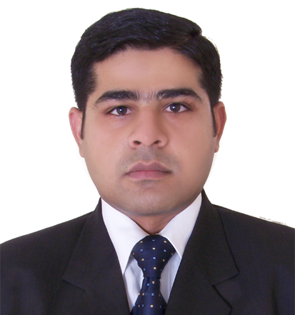

Hamid Khan (UAE LMV Driving License)

CELL#: 971-0529128393

Email Id: hamid.khan84@hotmail.com

Address: Building 1-3B, Flat # 711, Al Khail Gate, Dubai, U.A.E

PERSONAL DETAILS
Date of Birth | December24, 1984
Passport No | BG4117792
Nationality | Pakistan
Emirates ID | 784-1984-7131752-2

PROFILE

- Excellent expertise on the deployment of latest technologies.
- Great aptitude of Research & Development for network solutions.
- Hands on experience on windows base Network environment.

CARRIER OBJECTIVE
Seeking a challenging career in a growing organization that offers me professional growth where I can learn, utilize my professional skills and deploy latest technologies.

QUALIFICATIONS

Degree | Institute | Year | Attested From
MSC Computer Science | University of the Punjab Lahore | 2007 | UAE Embassy
BCS Computer Science | University of the Punjab Lahore | 2004 | UAE Embassy

CERTIFICATIONS

CISCO CERTIFICATION (ID-CSCO11629113) | Date
(CCNP) Cisco Certified Network Professional | DEC 07,2014
(CCNA) Cisco Certified Network Associated | MAR 21, 2012
MICROSOFT CERTIFICATION (MCP ID: 3349628) | Date
(MCITP) Microsoft Certified IT Professional Enterprise Administrator | APR 16, 2012
(MCSA) Microsoft Certified Solution Associate | APR 16, 2012
(MCTS) Microsoft Certified Technology Specialist | MAR 27, 2012
(MCSE) Microsoft Certified System Engineer | APR 25, 2006
(MCSA-M) Microsoft Certified System Administrator Messaging | JAN 09, 2006
(MCSA) Microsoft Certified System Administrator | JAN 09, 2006
(MCP) Microsoft Certified Professional  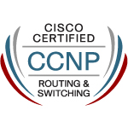 | FEB 28, 2005
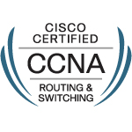




MCP Microsoft Site Transcript ID (709055) & Access Code (mcse2030)

CISCO Credential Verification CISCO SITE Authorization Code (MGHSryuo)

EXPERIENCE

Company: United Supplies Establishment (Dubai, UAE)
Designation: System Administrator
Duration: 16 DEC 2014 To Date(5+ Year )
Responsibilities:

- Providing All IT Related support.
- Managing IFS ERP and Oracle DB..
- Responsible for ERP Training.
- Managing Hyper-V virtualized Servers & NAS.
- Install & Manage CCTV & Attendance Devices.
- Install & Manage Sonic Wall, Dray Tech Firewalls on remote locations.
- Configured Fortigate 100E, 30E, 100E forsite to site VPN and web filter In Head Office.
- Responsible for purchasing all IT related Hardware, software and SLAs.


Company: Industrial Material Supply (Dubai, UAE)
Designation: IT & Network Supervisor
Duration: 16 JUN 2012 To 16th DEC 2014 (2.5 Years)
Responsibilities:

- Managing FOCUS ERP ,Database SQL server.
- Install VPN clients & FOCUS for remote users.
- Create hardware inventory and documentation.
- Design server rack, ports & cable tagging.
- Install & Manage exchange server 2010 & configure POP3 for PAN Emirates.
- Install & configure Dell SONICWALL for PAN Emirates building material.
- Create Backup policy for Exchange, FOCUS ERP, & File server.
- Install & manage Symantec endpoint protection manager & clients.

Company: Jaag Broadcasting Systems Limited (Lahore, Pakistan)
Designation: IT Engineer
Duration: 17th DEC 2007 to 21st JAN 2012 (4 Years)
Responsibilities:

Management of Active Directory, DNS, DHCP, & ISA server.

Site restriction & content filtering using ISA 2006 & SONICWALL Firewall.

User management & Outlook configuration.

Create VPN with head office using SONICWALL.

Install & manage Autoscript prompter.

Training of ENPS (Electronic News Processing System).

Install & manage Title box server for tikers also configure RAID.

Install and manage MAC systems for Non-linear editing.

Honeywell CCTV cameras, DVR installation & Network Access.
- Managing Network Printer & FAX machine.
- Installation of Nortel IP phone & IP soft phone.
- Worked with SIEMENS & Nortel PABX.
- Act as a point of contact for all IT related issues.
- Manage the Team of Technician for IT support.

Responsible for new equipment installation, troubleshooting, up gradation and maintenance.

EXPERTISE IN CISCO

Configure and Manage Cisco Lab through 2600, 3600 & 7200 series Routers and Switches like 1900, 2900, 3550 & 3600 series. Configuration of static routes & dynamic routing Protocols such as RIP, EIGRP, OSPF and BGP. Troubleshoot multi-protocol environment. Create VLAN and perform inter-vlan routing. Configure port security,

