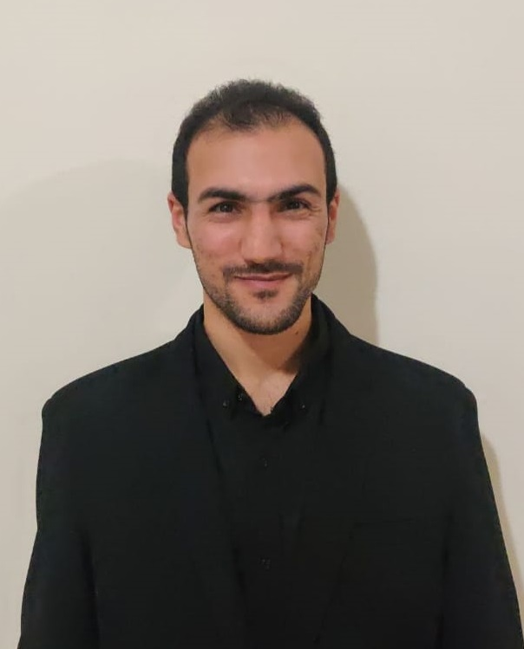

**Azure Cloud Technical Engineer**

**Ihab ALKasrawi**

Ehabalkasrawi@hotmail.com

00-(971)-551244121



Ihab-alkasrawi☁

Dubai-United Arab Emirates

**Citizenship:** Jordanian

**DOB:** 23 October 1990

**Personal Information**

**Notice Period:** Immediately

**Legal Status:** Resident Visa

**Marital Status:** Single

Picture9

To work towards achieving the greater success in my career through hard work, consistency and the ability to work with others to achieve organizational goals, aims and objectives.

**CAREER GOAL**

**Bachelors in Computer Engineering | 2013**

AL-HUSSAIN BIN TALA UNIVERSITY – MAAN, Jordan

The graduation project consisted of building a robot car that is controlled by Wi-Fi from any location with an IP camera, IR sensor, temperature sensor and a PIC Micro Controller.

**EDUCATION**

Picture12

* Strong understanding of different deployment resource types and when to deploy each type (IaaS, PaaS, SaaS).
* Knowledge of background in IT infrastructure fundamentals, including networking, storage, and security.
* Knowledge of Azure WAF and Load Balancer.
* Basic Knowledge in PowerShell and/or Azure CLI.
* Knowledge in automating deployment workloads in Azure.
* Ability to design, deploy, and maintain multi-tier server applications.
* Knowledge of migrating Data Centre workloads to Azure.
* Knowledge of working on hybrid cloud solutions.
* Experience with claims-based authentication (SAML/OAuth/OIDC), MFA, JIT, and/or RBAC.
* Knowledge of Cloud Compute, Storage, Database Cloud Security, Cloud Governance, Cloud Optimization, Cloud Support and Management, Cloud Native Applications, Serverless, Azure AD, MDM, Office 365, Microsoft Exchange 365.
* Knowledge of Cisco Routers/Switches/NGFW/IPS/IDS).
* Knowledge of web technologies, protocols and tools.
* Virtualization (Microsoft Hyper-V, VMware Workstation).
* Knowledge of Simulators and Emulators (GNS, Packet tracer).

**CORE SKILLS**

* AZ-900 - Microsoft Azure Fundamentals.
* AZ-103 - Microsoft Azure Administrator.
* AZ-300: Microsoft Azure Architect Technologies.
* AZ-301: Microsoft Azure Architect Design.
* AZ-500: Microsoft Azure Security Technologies.
* MS-100: Microsoft 365 Identity and Services.
* MS-101: Microsoft 365 Mobility and Security.
* ITIL Foundation V3.
* CCNP Routing & Switching.
* MCSE Infrastructure 2012.
* CCNA Routing & Switching.
* CCNA Security.
* Fortinet - NSE1, NSE2, NSE3.

**ACHIEVEMENTS**

**WORK**

**EXPERIENCE**



**ITSD Administrator | April 2017 – Dec 2019**

**CNS Middle East - UAE **

* Proven success working in high-volume. Demonstrated strengths in rapidly diagnosing, troubleshooting and resolving client issues.
* Performed quality assurance check of tickets processed by team.
* Provided technical support for client services.
* Used AXIOS, BMC, Service Desk Plus ticketing systems to log, track and manage Incidents and Service Requests.
* Managed services contracts verification with customers and Account managers.
* Supporting internal Network environment - LAN, Wi-Fi VPN, Cisco Jabber, and VOIP, FortiGate, FortiClient.
* Install and support Endpoint Security Protection – Symantec for end users.
* Support Outsourcing projects in regards of L1 & L2.
* Support Microsoft Applications – Windows 10,7 - CRM -Office 365, Office 2016.
* Monitoring the network performance and security peripherals, Servers.
* Use remote tools to efficiently assist the users to resolve problems remotely – SCCM.

**IT Specialist | Aug 2016 – March 2017**

**ITQAN – MOE**

**(SMART LEARNING SCHOOLS) – UAE**

* Support and communicate with vendors to resolve smart devices issues and liaise to assign the tickets to regarded side (SAMSUNG, LG, DELL, MS, HP, LENOVO, APPLE, ACER).
* Support Network equipment and School’s Tools - WIFI and LAN, WAN, MDF & IDF. (CISCO, HP, Fortinet)
* Support Smart Board and meet vendors to resolve the critical problems (LG, SAMSUNG)
* Support End-user devices – Fingerprint, Printers, Scanners, Data Show.
* Install and Support Software’s, Windows 7, 8, 10, Microsoft office 365, 2016, and 2013 & Support Security Antivirus.

**Technical Support Engineer | Jun 2014 – July 2016**

**Diyar United Company – Kuwait**

**PAAET PROJECT**

* Support End-User Devices and laptops, Smartphones.
* Support End-User developed software’s to achieve maximum usability and availability - mainframe, Banner.
* Customer training for Office 365 and computer tools.
* Microsoft Windows upgrade for end-users and support for Office 365, Office 2013, 2016.
* Support end-user networking issues for LAN and VOIP.
* Use BMC as a ticketing system for tracking and logging. managing user’s tickets.
* Install and support Endpoint Security Protection, Symantec, BitDefender.

**LANGUAGES**

* Fluent Arabic (Native) and English language (writing, reading and speaking).
* Excellent communication skills, dynamic and energetic.

**Jun 2012 – Jun 2016**

* LOYAC Kuwait: Team Leader volunteers and events coordinator.
* INJAZT: Works in tourism & Volunteers with Jordan vibes
* Partners-Jordan: Mediation in resolving conflicts peacefully
* LOYAC Jordan & Children's Museum in Jordan & Akhtaboot 4th Job Fair 2013
* All Jordan Youth Commission: 17/8 – 23/8 Amman Summer Festival 2013.

**Community Participation**

Available upon request

**REFERENCES**