CURRICULUM VITAE

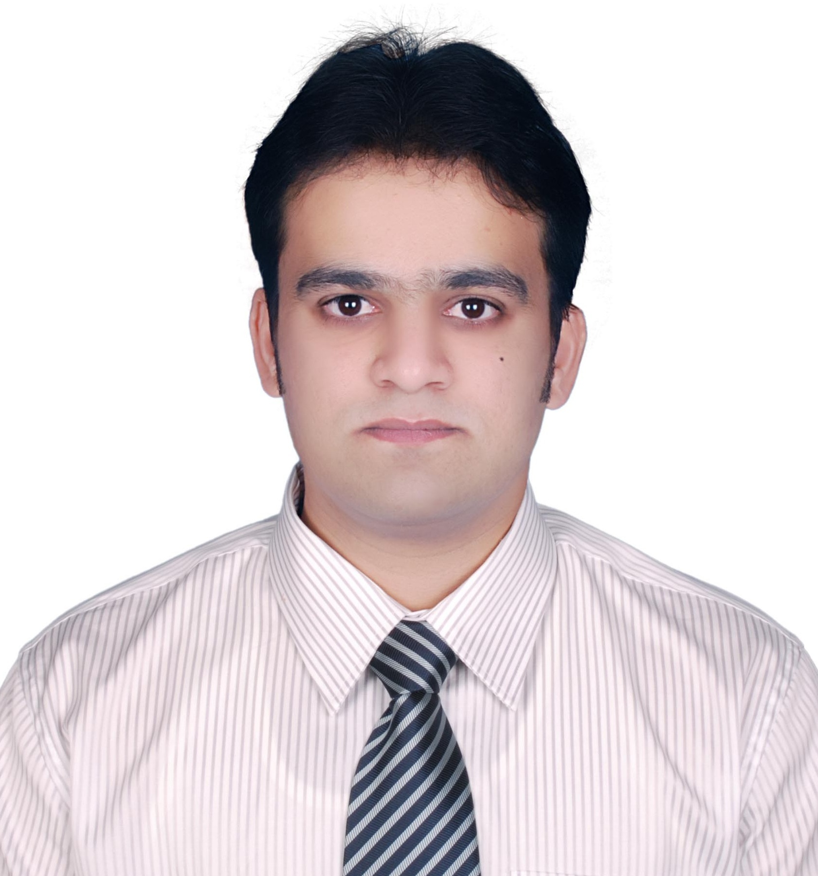

Abdul Rehman Tariq

Mob: +966-536931065

ch_rehman83@hotmail.com

OBJECTIVE

Looking forward to work with a progressive organization to support its operations effectively. Being Sharp Mind and having exposure of working dynamically. Desiring to work in fast paced, environment requiring high analytic and decision-making skills at a challenging position in the field of Information Technology.

PROFESSIONAL QUALIFICATION

* MCSE, MCP –Transcript ID :5734017
* ITIL V3 Foundation
* CCNA CISCO

TRAINING CERTIFICATES BY MUBADALA

* Effective Time Management (Dyncorp International LLC).
* OHSAS 18001 Hazard Identification and Risk Assessment.
* Basic Lean (Learning Program Code: ILP-QM-032).
* Root Cause Analysis & Corrective Action 5 Why’s.
* Failure Mode and Effects Analysis (Learning Program Code: ILP-QM-044).
* Quality Management System (ISO 9001:2008)
* Environmental Health & safety.

ACADEMIC QUALIFICATION

Program: BSCS Hons

Duration: 2003-2007

University: University of Central Punjab (UCP), Lahore, Pakistan

Campus: Punjab College of Information Technology, Gujranwala, Pakistan

Program: Intermediate in computer science (I.C.S)

Duration: 2003

College: National Science College, Gujranwala

Program: Matriculation

Duration: 2000

University: Saint Joseph’s English High School, Gujranwala

Program: MCSE (training)

Duration: 2007

University: Corvit Systems, Lahore

Program: MSCS (Equivalence of BSCS Hons from HEC)

PROFESSIONAL EXPEREINCE

Company: Al FANAR Company, Riyadh, KSA

Duration: December 2012 to December 2019

Designation: IT SUPERVISOR, TECHNICAL SUPPORT

* Responsible to make sure all IT Services are 24x7 operational, ensuring data centre equipment’s are functional. Servers, storage, backup, Network devices are up and running all-time.
* Dealing with vendors/ suppliers / Contractors for hardware / software procurement, ISPs, AMCs.
* Installation of Servers, PCs, laptops, printers and other networking devices. Setup and configuration of RAID 0, 1 and 5 Partitions.
* Control and manage IT Communication with Business and Assist IT Strategy Formulation and

Budget Planning for software and hardware.

* To act as the on-site contact for all IT related incidents logged in SAP ITSM, delivering high quality support across all key applications, networks and desktops / laptops.
* Performed daily, weekly, and monthly backups and restores through Symantec Veritas Backup exec. Monitored application performance and assisted with technical support.
* Commended for quickly resolving complex issues including system crashes, network slowdowns, connectivity problems, security breaches, virus infections and more.
* Expertly manage technical support operations, diligently troubleshooting issues to identify root causes and prevent recurrenceand Provide off-hours operational support as needed.
* Administration of Microsoft Windows Servers 2008, 2012 and 2016, (Active Directory), Microsoft office 365 administration, Workstations, and network security devices for users.
* Responsible to Administer Managed printing solution Y-Soft.
* Managing the Users in the Remote areas and Offshore Offices via Remote Software (Dameware Mini remote console, SCCM, TeamViewer).
* Managing the Cisco IP phones, Cisco Video Conference Solution, soft phones and responsible to assign the IP extensions.
* Ability to provide support for business tools and manage license servers such as (Autodesk Products, Bentley Products, CDEGS and Row Pro, EMTP, PSCAD, DS Anchor, Mat3D, SP Column, CSI Products, PTC Products CESAR II and etc).
* Responsible to participate in tenders and prepare BOQ for IT scope.
* Responsible to Provide access to users and clients on Aconex and define security permissions.

Company: Al TAIF Technical Services (A Mubadala Company), Zayed Military City, Abu Dhabi, UAE

Duration: April 2008 to June 2012

Designation: IT HELP DESK SUPERVISOR

* Responsible for checking the day-to-day issues in Track-IT and assigning the duties to Help Desk Administrators.
* Installing and configuring computer hardware operating systems and applications.
* Responsible for Installation and deployment of the Network Printers, Configuration and maintenance of multifunction Printer HP, Xerox, etc.
* Delivers, tags, sets up, and assists in the configuration of end-user PC desktop hardware, software and peripherals.
* Supports server, network and desktop hardware, software and applications.
* Rolls out hardware and software to ensure optimal deployment of resources.
* Plans, implements, and supports the network and computing infrastructure plan.
* Assists with technology planning through ongoing research.
* Install new / rebuild existing servers and configure hardware, peripherals, services, settings, directories, storage, etc. in accordance with standards and project/operational requirements.
* Perform daily system monitoring, verifying the integrity and availability of all hardware, server resources, systems and key processes, reviewing system and application logs, and verifying completion of scheduled jobs such as backups.
* Receives and logs requests for support from help desk, other service delivery staff or users.
* Prioritizes requests in accordance with agreed criteria and the needs of the organization.

Company: ASIA TECH (Software House), Gujranwala, Pakistan

Duration: August 2007 to January 2008

Designation: System Administrator

* Troubleshooting and resolving hardware, software, peripheral equipment, and network problems.
* Responsible for security, documenting the configuration of the systems, troubleshooting any

reporting problems, system performance tuning and keeping the networks up and running.

* Applying the restrictions on the users and giving the rights through group policy and responsible for

planning, implementing, designing the Microsoft Active directory 2003, network infrastructure and

managing the Microsoft server 2003, Microsoft server 2008.

* Responsible to create user profiles and implement management policy on security across the system.

**Areas of Expertise**

Testing & Troubleshooting | Project Management | System Administration

Vendor Relations | Strategic Planning | Resource Allocation | Effective Communication

Team Leadership | Business Continuity | Data Backup & Recovery | Server Management

**Microsoft**

* Designing, implementing and managing Active Directory.
* Installation and configuration of Microsoft Server 2008, 2012, 2016.
* Installation, Configuration and Administration of DNS Server and DHCP Server.
* Responsible to update portal news, updates and circulars in SharePoint.

Numara Track-IT

* Expert in Numara Track-It reports; configuration; and process design.
* Creates assignment related to the work order. Responsible to update the IT assets in the system and deletes the retired assets.
* Responsible to update the policies through the change management in Track IT.

Maximo IBM

* Responsible to Add, Modify, update IT assets in Maximo and creating the Purchase requests in maximo.
* Responsible to create the users in Maximo.

Bentley ProjectWise

* Administration of Bentley ProjectWise for configuration and application support of projects. Using ProjectWise Administrator/ProjectWise Explorer to configure data source security, workflows, folder structure, projects, and to manage users and groups.
* Provide support for existing project environments.
* Working with Engineering Teams to implement Project Specific requirements.

SAP

* Responsible to manage all the IT assets hardware, Software’s and transferring of the Assets in SAP.
* Creating the IT purchase requests in SAP and approves the software request for procuring in SAP.

**ACHIEVEMENTS**

I have achieved best attendance prize 5 times in 4 years of BSCS.

I got promoted 2 times in my 4.2 years career in AlTaif Technical Services.

I got Promoted 1 time in my 7 Years career in AlFANAR Company.

LANGUAGES

* English (Fluent)
* Urdu (Fluent)
* Punjabi(fluent)
* Arabic (Basic-Familiar)

PERSONAL INFORMATION

* Father Name: Abdus Salam Tariq
* Date of Birth: 2 July,1983
* Passport No: AQ7961663
* Marital Status: Married
* Nationality: Pakistani
* Driving Licence: Valid (UAE, KSA, PAKISTAN)
* Job Joining: Immediately
* Iqama Status: Transferable
* SCE Membership Number: 564596

REFERENCES

Will be furnished on demand.