**CURRICULUM VITAE**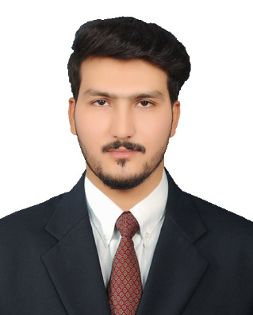

**Hassan Ali**

Position:  **IT Engineer**

Experience: **Four Years**

Qualifications: **Master in IT (Information Technology)**

Certification: **MCSA, MCSE and CCNA,**

Mobile**: +92-333-9994415**

Current Location: **Gujranwala, Pakistan**

Email**: Hassanriaz216@gmail.com**

##### Summary of Career

**An accomplished professional with almost Four years** of work experience in IT Administration, system administration, Networking and troubleshooting in reputed organization. Possessing effective organizational skills and excellent working knowledge of IT technologies and having a commitment to keep up to date with the latest developments.

##### Employment Records

##### **Name of Institution: Punjab Group of colleges**

##### **Job position : IT Assistant (Network/System)**

* Implementation and configuration of server.
* Implement DNS, DHCP and Active Directory in window server 2012,16
* Install Domain Controller (DC) and Configure GPO and OUs.
* Backup of server, users and make share drives.
* Malware, Spyware, adware removal.
* Networking concepts including router, Switches copper link.
* Network infrastructure implementation.
* Handling desktop users and problem management in desktop area.
* Installing and configuring of computer hardware, software, systems, networks, printers and scanners
* Monitoring and maintaining computer systems and networks
* Troubleshooting system and network problems and diagnosing and solving hardware or software faults
* Maintain all systems, applications, security, network configurations and troubleshoots
* Network performance issues.
* Monitor and perform daily troubleshooting task
* Providing support, including procedural documentation and relevant reports.
* Install different operating system on laptop and desktop and install their required software.
* Installation and configuration of Firewall.

##### **Name of Institution: Pakistan Telecommunication Company Limited**

##### **Job position : IT Support Engineer (Internee)**

* Configuration of Cisco Routers and Switches and configuration of all types of CAT cable.
* Works on Optical Fiber commonly used fiber connector and types of fiber.
* Works on Different types of Media Converter like Ethernet and Gigabit media converter.
* Installing network cable through patch panel termination
* Maintain proper internet either wired or wireless.
* Installing new hardware (servers, printers, computer work stations)

##### IT Skills

* + **C, C++,HTML/cctv Load Balancing**
  + **Network Security Microsoft Office**
  + **System Admin Microsoft Outlook**
  + **Active Directory DHCP**
  + **DNS Good Communication Skill**
  + **VMware virtual box**
  + **Virtualization TCP/IP**
  + **Window OS printer configuration**
  + **Office 365 Network & System Troubleshooting**
  + **Network protocols Routing & Switching**
  + **Window Servers LAN/WAN**

##### Professional Certification

* Microsoft Certified Solution Associate (MCSA)
* Microsoft Certified Solution Expert (MCSE)
* Cisco Certified Network Associate (CCNA)

##### Academic Qualification

* **Master in IT (Information Technology)**
* From University of Sargodha
* 2015-2017
* CGPA 2.93

##### Personal Information

* **Father Name**: Muhammad Riaz
* **Address**: Gujranwala, Lahore Pakistan
* **Language:**  English