**CURRICULUM VITAE**

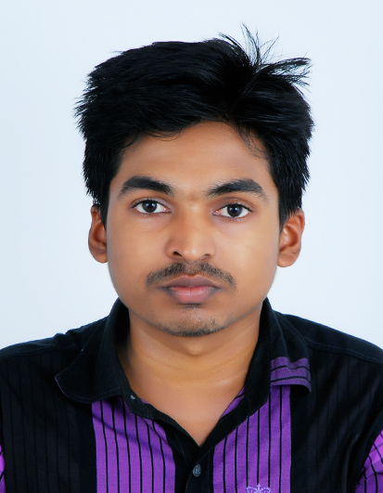

**RIYAS S**

**Puthen Veedu Padayatty**

**Erimayur post**

**Palakkad - 678546**

**Kerala, India 🖁+919895060633, +918086110143**

**Email ID:** [**riyasemr@gmail.com**](mailto:riyasemr@gmail.com)

Career Objective

**A** Diploma with comprehensive knowledge of administration procedures, Capable of providing administrative and Technical support. Presently working as system administrator handling important commercial and technical Software’s. Easy going by nature and able to get along with both work colleagues and senior managers, currently looking for technical, administrator, or any suitable position.

Academic Qualification

|  |  |  |  |
| --- | --- | --- | --- |
| **EDUCATION** | **INSTITUTION** | **BOARD/**  **UNIVERSITY & YEAR OF PASS** | **PERCENTAGE** |
| Diploma in computer science | Ace college Palakkad | IETE | 65% |
| Diploma in hardware and networking | Ace college Palakkad | Electronics corporation India ltd(ECIL) | A Grade |
| Higher Secondary | Government Higher Secondary School, Erimayur,Palakkad | Board of Examination  2010 MARCH | 62% |
| CBSE 10th level | Moulana English Medium School,Kombam, Palakkad | Board of Examination  2008 MARCH | 50% |

Technical Skills

### Software’s : ASP.net, My SQL, Adobe Photoshop, XML, Java,

**C, C++, MS Office package, HTML, Open Office.**

* Hardware : **System Assembling, Servicing,**

**Networking, Software & Hardware installation.**

### Operating System : Windows 2000, XP, Vista, 7, 8, 8.1, X

**GNU Linux, Linux, Ubuntu, K Ubuntu, UNIX**

Areas of Experience

* (**2013 June to 2016 February**) 2 Years 9 months in Akshaya E Center Entrepreneurship. (E-Commerce service and implementation centre under Government of Kerala, India - CSC Scheme)
* Reference: ( [www.**akshaya**.**kerala**.gov.in](http://www.akshaya.kerala.gov.in) )
* **Akshaya**, an innovative project implemented in the State of Kerala aimed at bridging the digital divide, addresses the issues of ICT access, basic skill sets and availability of relevant content. Quality ICT dissemination and service delivery facilities (‘Akshaya Centres’) are set up within a maximum of 2 kilometers for any household and networked leveraging entrepreneurship. Today, Akshaya is acting as an instrument in rural empowerment and economic development. The project is a catalyst in creating massive economic growth and creation of direct and indirect employment in the State by focusing on the various facts of e-learning, e-transaction, e- governance etc.
* Program Supervisor (UIDAI AADHAAR BIOMETRIC Authentication Identity card system Operator and Supervisor Ref: <https://uidai.gov.in/> )

Computer & Biometric System operator (software installation, Assembling, Troubleshooting etc…)

Present Job Position

* **(2016** **February to 30th May 2019 )**

**System support Staff in premier agencies PepsiCo**

**Roles and Responsibilities**

* Install and configure computer hardware operating systems and applications
* Monitor and maintain computer systems and networks
* Troubleshoot system and network problems, diagnosing and solving hardware or software faults
* Replace parts are required
* Provide support, including procedural documentation and relevant reports
* Follow diagrams and written instructions to repair a fault or set up a system
* Support the roll-out of new applications
* Set up new users accounts and profiles and deal with password issues

* Respond within agreed time limits to call-outs
* Work continuously on a task until completion
* Test and evaluate new technology
* Conduct electrical safety checks on computer equipments

Skill Set

* Willing to work hard.
* Willingness to work as a team.
* Dedicated, Trust worthy, Punctual.
* Eagerness to learn, positive outlook, honesty.

Academic Project

* An interactive asp Website

Area of Interest

* Projects Supervisions, Coordination, Development and Administration.
* Implementation and technical support
* Engineering Implementation

Passport Details

### Passport Number : M9944240

* Date of issue : 05/06/2015
* Date of Expiry : 04/06/2025
* Place of Issue : Cochin

Personal Details

**Father’s Name** **:** P S Sulaiman

**Mother’s Name** **:** Hajara beevi

**Date of Birth** **:** 03.02.1992

**Age :** 27

**Sex** **:** Male

**Nationality** **:** Indian

**Religion** **:** Muslim

**Marital Status** **:** Unmarried

**Languages Known** **:** Malayalam, Tamil, English, Hindi and Arabic

Declaration

I hereby declare that the information given above is true to the best of my knowledge and I bear the responsibility for the correctness of the above-mentioned particulars.

**Place : Palakkad**

**Date : 25/01/2020 RIYAS S**