**TAUSIF AHMED**

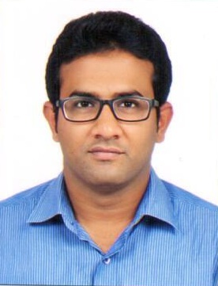

Mobile: +971551195096

E-Mail: tausifahmed.ece@gmail.com

Skype ID: tausifahmed.pd

**Background ad Objective:**

A Computer Engineer with around 8 years of extensive experience in the UAE, across a spectrum of compute technologies.

Intend to structure growth in pace with the ever-changing IT environment. Make the learning curve to move in a linear fashion along with the growth of functional skills coupled with overall personality development in order to face the challenging times ahead.

**Educational Qualifications:**

* Bachelor of Engineering (Electronics and telecommunications Engineering) from Anna university, India, in 2009 with 65.00%

**Professional Certifications and Training:**

* Undergone professional training course covering **CCNA & MCITP** administration
* CCNA certified
* MCSA certified, Windows server 2012
* Undergone Project Management Professional (PMP) training

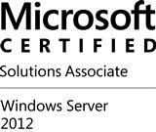 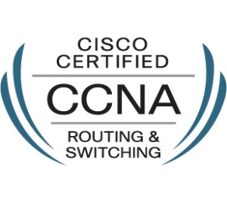

**Work Experience:**

* Working as Computer Engineer in Seven Seas Computers LLC, Dubai (Currently outsourced in BNP Paribas Bank as IT Officer)

(From June 2017)

Job responsibilities include:

* Assist all our users with any logged IT related incident when called upon.
* Diagnose and resolve software and hardware incidents, including operating systems across a range of software applications.
* Take ownership of issues by carrying out problem analysis to implement temporary or permanent fixes with the aim of restoring service to the users as soon as possible
* Escalating incidents to other support teams where necessary.
* Accurately record, update and document requests using the IT service desk system.
* Maintain and Record all the assets
* ITSM related activities and asset management
* Install and configure new IT equipment, resolve incidents and upgrade different types of software and hardware
* Resolve incidents of MEA region with ITSM Tickets and calls.
* Maintain a first class level of customer service ensuring that all end users are treated efficiently and in an appropriate manner.
* Maintain excellent verbal communication skills with the ability to communicate effectively with technical and non-technical colleagues at all levels in the organisation.
* Resolving incidents and issues related to Network devices and Servers.
* Worked as an IT Systems/Network Engineer in **Optica,** Dubai (From Jan 2014. to March 2017).

**Job responsibilities include:**

* + Install all new hardware, systems, and software for networks
  + Installing, configuring and maintenance of end user computing devices, including all mobile computing devices.
  + End user data backup assistance
  + Managing all system back-up and restore protocol
  + Documenting and maintaining all the IT related assets
  + Planning and supporting network and computing infrastructure
  + Perform troubleshooting analysis of servers, workstations and associated systems
  + Documenting IT problems and resolution for future reference
  + Monitoring system performance and implements performance tuning
  + Manage user accounts, permissions, email, anti-virus and anti-spam
  + Oversee software and network security in the end computing devices
* Worked as Technical Engineer in **Americana Computer Systems**, Abu Dhabi, for two years+ (From Sept. 2011 to Nov. 2013)

ACS is a leading technology solutions provider of leading network vendors like Cisco, Microsoft, HP, Fujitsu, Fortinet, etc...

Job responsibilities include working on various systems and networking solutions with large enterprises, corporate, government, banking & other sectors. Also involved in the operations of various managed service clients of ACS...

**Additional Technical Skills:**

* Additional skills include Installing and Configuring Wifi routers, entry level Routers ,Switches and DNS, DHCP, Sub-netting, VLANs, Switching, IP Routing, VPN, VLAN Configuration and OSI Network model
* Basic knowledge of ITIL
* Good knowledge with CCNA, MCITP and Backup Certifications.
* Expertise in Networking and Implementation with more than 5 years of hands on experience.
* Confidently and effectively perform under pressure.
* Systems: Windows Server 2008 &2012, Implementation of Fujitsu and HP Servers, Exchange server.
* Hardware: Cisco, Sonic wall, IP Telephony, IP Phones, WebEx, Fortinet, HP, Dell, Ergotoron, All Mobile device support ,Configure and install firewalls and more.
* Software: Microsoft (Exchange 2010 and 2013, Lync, Office 365), ERP, Microsoft SQL Server 2012, Knowledge about Virtualization.
* Worked on Cisco 1900 and Cisco 2900 Routers, Fortigate 110C and 600C, Cisco 2960 switches, Cisco wireless and Aruba wireless access points.

**Co-curricular Activities:**

* Attended one week In-plant training in AMARA RAJA ELECTRONICS PVT.LTD, India
* Attended five days In-plant training in MEDIA AUTHORITY, Chennai, India

**Strengths:**

* Fast learning, Committed and ability to work under pressure
* Good Communication Skills
* Creative, Positive Attitude

**Personal Details:**

Date of Birth : 04 May 1988

Nationality : Indian

Gender : Male

Marital Status : Married

Languages Known : English, Urdu, and Hindi

VISA Status : Residing in Abu Dhabi on Job Visa

U.A.E Driving License : Having Valid U.A.E Driving license

References : Will be provided as required

I hereby declare that, the information furnished above is true to the best of my knowledge.

Date:

Place: Abu Dhabi

TAUSIF AHMED P.D.