**CURRICULAM VITAE**

**UMMAR ALI** 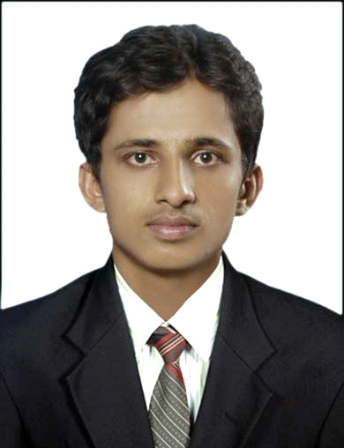

*Dubai, UAE*

**Email :** [**ummar7864@gmail.com**](mailto:ummar7864@gmail.com)

**Mobile : +971505147684**

**+971549952220**

|  |
| --- |
| **Career Objective** |

To obtain highly challenging position in IT & to work with team in the Organization that provides excellent IT experience, this enables me to apply my skills & increases my knowledge to achieve Organization objectives.

|  |
| --- |
| **Core Competencies** |

Customer intreraction /Analytical Thinking / Continuous Learning / Focused / Initiative Taking / Planning & Organizing /Good Team Player

|  |
| --- |
| Technical/ IT Skills |

* **OS & Server** : Window 7, Windows 10 , Windows 2008,2012 Server, MS Exchange server, Active Directory,
* MS Office applications, MS Outlook etc
* **Networking** : LAN and WAN , TCP/IP, Router and switch Configuration
* **Desktop & Laptop Support** : On-site & Remote Support ,Hardware Support ,Patches Updating, Desktops on VDI Environment
* **Printer Support:** Managing and repair Dot Matrix, Laser and Inkjet Printers
* **Antivirus** : Symantec Endpoint Protection ,MacAfee ,Kaspersky
* **Maintainance of CCTV,IP Phone,Bio metric Attendence System**

|  |
| --- |
| **Work Experience** |

* Worked as an **Desktop Support Engineer** at **WIPRO Technologies (**On the pay-roll of **KBC Technologies )** Dubai, UAEfor **Abudhabi Commercial Bank-ADCB** from **September 2019 (On 2 months Contract)**

**Responsibilities:**

* *Provide onsite and remote support to employees to resolve IT related issues, logging all issues and requests in line with the required standards*
* *Maintain the end user environment by ensuring the anti-virus is updated and VDI images are updated and maintained as per the agreed standards*
* *Demonstrate Our Promise and apply the ADCB Service Standards to deliver the bank’s required levels of service in all internal and external customer interactions*
* *Escalate issues to vendors, where applicable, and follow up to ensure resolved as required within the agreed timeframes*
* *Act as the second line of support to the IT Service Desk and escalate where required in line with the agreed process*
* Worked as an **Customer Support Engineer (Desktop Support )** at **Sysnet Global Technologies Pvt. Ltd,** Bangalorefor[**Department of Treasuries, Government of Karnataka**](http://karnatakatreasury.gov.in/)from **JAN 2016 to JUNE 2019**

**Responsibilities:**

* *Install, upgrade, troubleshoot and maintain Windows Systems and various Microsoft Applications and any other authorised desktop applications*
* *Performing Various activities windows server 2008 client Desktops.*
* *Performs general preventative maintenance tasks on computers, laptops, printers and any other authorised IT peripheral equipment.*
* *Performs general preventative maintenance tasks on CCTV Systems, Bio Metrics and other Security Systems.*
* *Returns defective equipment/parts to maintenance inventory, documents customer repairs, maintains and restocks assigned parts inventory to insure proper spare parts levels*
* Worked as an **Technical Customer support Assosiate** at **MPHASIS PVT LTD,** Bangalore for **Bharti Airtel Pvt LTD** from **Feb 2014** to **AUG 2015**

**Responsibilities:**

* *Interact with customers to provide and process information in response to inquiries, concerns, and requests about products and services*
* *Configuring various modems, troubleshooting various internet related issues like no browsing, slow browsing etc*
* *Gather customer’s information and determine the issue by evaluating and analyzing the symptoms*
* *Identify and escalate priority issues per Client specifications*
* *Follow up and make scheduled call backs to customers where necessary*

|  |
| --- |
| **Educational Qualification** |

* **B.E ( Electronics and Communication Engineering)** from**Sahyadri College of Engineering & Management, Mangalore** Under **VTU, Belgaum**in the year ***2013***
* **Diploma ( Electronics and Communication Engineering)** from **K.V.G Polytechnic, Sullia**under**Dept of Technical Education, Bangalore** in the year**2010**

|  |
| --- |
| **Professional Certification** |

* **CCNA(**Cisco certified Network associate)-WAN Administration course from GOAL Technologies , Mangalore
* **MCITP (**Microsoft certified IT professional) – Server Administration course from GOAL. Technologies, Mangalore

|  |
| --- |
| **Achievements and Extra-curricular activities:** |

* Won the **First place** in the Project competition held in our college.
* Attended two day workshop on **MACHINE VISION** based on vision robotics in our college conducted by ***Robotics Core School***.
* Have undergone training from **Infosys Campus Connect**

|  |
| --- |
| **Personal Details** |

**Date of Birth :** 31st July 1988

**Nationality** : Indian

**Religion**  : Islam

**Marital Status** : Married

**Passport Details :** Passport No: K9837852

*Date of Issue:* 08/03/2013 *Date of Expiry:*07/03/2023

**Visa Status** *:* Employment Visa

**Driving License :** India

**Languages Known** : English, Hindi, Malayalam, Kannada

**Declaration:**

I hereby declare that above provided information are true and correct to the best of my Knowledge.

Place:Dubai

Date: 07\01\2020

**( UMMAR ALI )**