RESUME

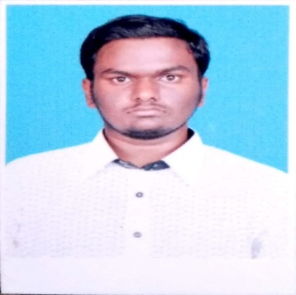Name: MOHAMED AJMAL ABDUL HAMEED K.A

Email id: [ajmalabdul1998@gmail.com](mailto:ajmalabdul1998@gmail.com).

Phone no: 7358992480.

|  |
| --- |
| Objective |

To grab an opportunity and set myself a goal where I can be innovative and attain challenging position by exercising my interpersonal and personal skills to fullest for the growth of the organization and mine as well.

|  |
| --- |
| Academic Qualification |

* **B.Sc** Computer Science (2016-2019) from **Manonmaniam Sundarnath University** with **SGPA-8.55**(out of 10 at Fifth Semester) in **Sadakathullah Appa College** , Tirunelveli.
* **Higer Secondary Exam (2016)** with **63%** from State board Education, Tamil Nadu in **TIME Matric Hr Sec School Araikulam Tirunelveli**.
* **SSLC** (2014) with **74%** from State board of education, Tamil Nadu in  **The Golden Jublie Matric Hr Sec School**, **Melapalyam, Tirunelveli**.

|  |
| --- |
| Software Skills |

Operating System : Windows 7, 8, Linux.

Database System : Oracle.

Web Technologies : HTML, PHP.

|  |
| --- |
| Certificate |

* Certificate on “ANDROID APP DEVELOPMENT” in Sadakathullah Appa college Tirunelveli .
* Certificate of Language Proficiency course “The Current Communication Skill” in Al Amanath English Academy Tirunelveli.

|  |
| --- |
| Personal Particular |

**Gender**  **:** **Male**

**Date of Birth** **:** **04.09.1998**

**Father’s Name**  **:**  **ABDUL RAZAK .A**

**Languages known : English, Tamil.**

**Native Place**  **:** **Tirunelveli-India**

**Address** **:** **8 Sappani Alim west Street, Melapalayam Tvl.**

|  |
| --- |
| Assurance |

I assure you that the above given information are true to the best of my knowledge and skills.

Tirunelveli. Your’s faithfully

Mohamed Ajmal.