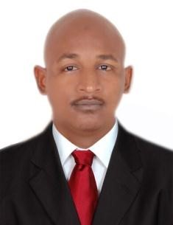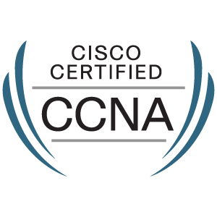



#### **Sameh Osman Hashim**

#### [**samehosman1070@gmail.com**](mailto:samehosman1070@gmail.com)

***+971 505027268-00971507045042***

**PERSONAL INFORMATION**

Address : Dubai, UAE

Date of Birth : 07/11/1991

Nationality : Sudanese

Marital Status : Single

Languages : English, Arabic (Mother Tongue)

Driver’s License : UAE -SUDAN

**EXPERIENCE**

**Service Desk(LINKSYS-UAE) 11-2018-untill now**

Troubleshooting, diagnosing and resolving hardware, software, and other network and system problems.

* Answer helpdesk phone line/email/Self-Service requests and use Helpdesk Tracking system to track all calls and emails received in accordance with the established or documented procedures.
* Support, diagnose, and troubleshoot networks Issues.
* Ability to prioritize outstanding issues and manage user expectation.
* Escalate high priority issues using established processes.
* Troubleshooting issues using provided scripted and published materials and resolving them with maximum customer satisfaction.
* Prioritize numerous issues of varying severity, and effectively manage the resolution of all issues within acceptable service levels and timelines.
* Ensure customer needs are met with follow-up calls and communications.
  + Consistently achieve key performance indicators (KPI) and meet all quality assurance requirements.

|  |
| --- |
|  |
|  |

**Contact center (ETISALAT-UAE) from May 2017 until nov 2018**

**Job Responsibilities**

Troubleshooting, diagnosing and resolving hardware, software, and other network and system problems.

 Answer helpdesk phone line/email/Self-Service requests and use Helpdesk Tracking system to track all calls and emails received in accordance with the established or documented procedures.

 Support, diagnose, and troubleshoot networks Issues.

 Troubleshooting issues using provided scripted and published materials and resolving them with maximum customer satisfaction.

 prioritize numerous issues of varying severity, and effectively manage the resolution of all issues within acceptable service levels and timelines.

 Ensure customer needs are met with follow-up calls and communications.

**IT Technical Support**

**Farmers Commercial Bank (FCB) – Khartoum, Sudan**  **from Jan 2016 till Jan 2017**

**Job Responsibilities**

* Managing and solving most of the Hardware/Software issues as second support line.
* Update work log and resolution with in time according to SLA.
* Assign tasks /tickets to appropriate team and ensure that tickets updated and not exceed
* HPSM Service Desk Desktop Central.
* Migrate from Windows XP to Windows 7&8.1 & troubleshooting Win7, I pad, I phones.
* Create, Secure and Share Files over an Ad-Hoc Wireless Network.
* Experience in workstation configuration &Troubleshooting Windows.
* Site Survey, Design, Installation, Maintenance &Configuration Both LAN & WAN Networking Even Wireless WIFI & WIMAX.
* **IT Support Engineer**

**JARASH Int’l Specialized Hospital – Khartoum, Sudan** **from Jan 2015 till Dec 2015**

**Job Responsibilities**

* 1st and 2nd line support - troubleshooting of IT related problems from in-house software to hardware, such as Laptops, PCs and Printers.
* Troubleshoot basic network issues such as ADSL broadband issues.
* Escalate unresolved calls to the infrastructure support team and Third-Party Vendors.
* To maintain a high degree of customer service for all support queries and adheres to all service management principles.
* To arrange for external technical support where problems cannot be resolved in house (Vendors Support Dell, HP, LENOVO, etc.…).
* Resolution and closure of trouble tickets.
* Performed Installations, technical support, troubleshooting and maintenance of Computer equipment, install and upgrade software and hardware equipment, Installed, configured and maintained OUTLOOK and Emails.
* HPSM Service Desk Desktop Central.

**SKILLS**

* Good Communication and interpersonal skills.
* Logical and balanced approach even in the most adverse circumstances.
* Ability to understand and analyses customer preferences.
* Excellent team player, open and adaptable to new ideas.
* Able to work under pressure.
* Able to travel anywhere if needs*.*

**TECHNICAL SKILLS**

* Internetworking, TCP/IP.
* Handle Change requests.
* Doing all the Daily, weekly & monthly checks carefully in time and raise the incident in case of any inconsistencies found.
* Escalates issues in a timely manner in order to avoid project delays
* Responsible for task completion on a timely and accurate basis.
* Manage Service Desk Plus.

**QUALIFICATION**

* BSC in Information Technology, Faculty of Computer Studies, 2016, National Ribat University, Sudan