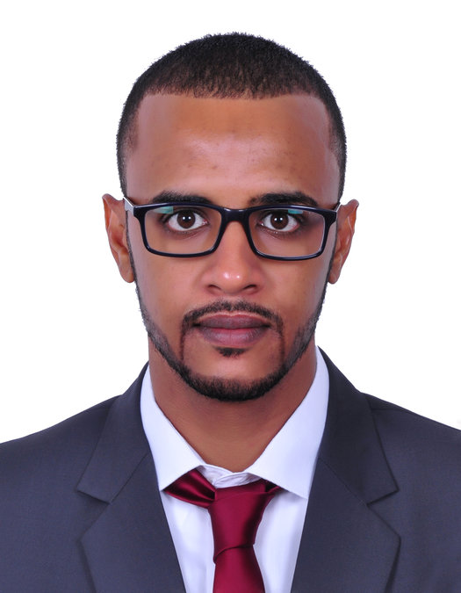 **Mazin Elmubarak**

**ICT Support Engineer**

**Location: Abu Dhabi, UAE • Tel: +971 5084 46127 ● Email: mazin05157@gmail.com**

**Professional Profile**

*Diligent. Detail Focused. Reliable.* A solution oriented IT professional who benefits from an extensive knowledge of various computer operating systems, applications and hardware, honed through the performance of numerous diverse support roles. Excels in the provision of 1st and 2nd line support on a 24/7 basis; liaising directly with external customers and internal colleagues of all disciplines in a positive and collaborative manner. Demonstrates the natural problem solving skills required to investigate and resolve queries swiftly; prioritising a complex workload effectively and ensuring strict deadlines are adhered to at all times. A flexible and adaptable individual who works efficiently with minimum supervision and guidance.

Key Skills:

Diagnostic skills **●** Installations **●** Upgrades **●** Communication **●** Analytical thinking **●** Incident analysis **●** Escalations **●** Troubleshooting **●** Test environments **●** Documentation & reporting **●** Regulatory compliance **●** Team working **●** Customer service **●** On site assistance ● Forensics the logs and check the suspicious network traffic.

Languages: Native Arabic & Fluent English

**Professional Development**

* **B.Sc. (Honors) Computer Engineering (computer and electronic system) - University of science and technology - Sudan – Khartoum (2005 to 2010).**
* Huawei : Training at the networks and IT office support : Muscat - Oman: (2012)
* Training at CTS Cupola Teleservices: Customer service & Quality assurance: Dubai - UAE: (JAN - 2013)
* Information Technology Infrastructure Library: ITIL V3 foundation: (NOV - 2015)
* Microsoft Certified Professional: MCP: (JAN - 2016)
* Microsoft Certified Solutions Associate: MCSA: (MAR - 2016)
* Cisco Certified Network Associate: CCNA: (Apr - 2016)
* CompTIA Network+ : (2017)
* Cisco Certified Network professional: CCNP: (JUL - 2018)
* Tech-Mahindra: ENEC Project – UAE AUH: PCNSE 8 (DEC - 2019)
* Certificates: ITIL v3 f / CCNA R&S /MCP / MCSA / CCNP /PCNSE

**Career History**

**May 2019 – Present Tech-Mahindra (Abu Dhabi ENEC Project), Abu Dhabi**

**ICT Support Engineer**

* Accountable for the provision of support to Windows 7, Windows 10.
* Monitor Network applicable using various network management tools and respond to system alerts.
* Responsible for swiftly and professionally troubleshooting tire 1 incidents related to Software ,Hardware , Network connectivity, printer, DNS and outlook or other issues as reported by end users.
* Ensuring all required security and software / hardware upgrades, on both desktops and laptops, are performed and kept up to date.
* Scheduling HSE audit inspections, and analyzing and review the assessment.
* Setting up new users’ accounts and profiles and dealing with password issues.

**Oct 2016 – Apr 2019 Smart world (Abu Dhabi Government Network Project), Abu Dhabi**

**IT Support Engineer**

* Contributing to the ADNET project, which is managed by Etisalat in partnership with Smart World
* Monitor, research, access and analyse on systems tools (Arcsight, palo Alto, riverbed Opnet, NNMi, OMi, etc).
* Maintain Access Authorization Lists for personnel granted access to classified information to maintain security measures and minimize any risks of security breaches.
* Monitor and update incident tracking tickets for purposes of demonstrating compliance with issue response and resolution.

**Jul 2015 – Sep 2016 Study and Development in India**

**Sep 2013 – Jun 2015 HP (IPG team), Dubai-UAE**

**IT Support Engineer**

* Diagnose And Order the parts for the commercial printers, with follow-up from the warehouse in (Middle East and Europe), to the site of the issue in (KSA / UAE).
* Maintaining and Support the customers regarding technical issues.
* Fully support, configure, maintain and upgrade corporate customer's networks.
* Contact with high level of engineering (L2 & L3) to take the best action plan and perfect support with latest update.
* Support SLP team regarding the agreement between HP and Samsung for the smart learn program in UAE.

**Jan 2013 – Jun 2013 RTA, Dubai-UAE**

**Customer Service Representative**

* Handling the customer queries & maintaining the customer data.
* Update the CRM system.

**Dec 2011 – Nov 2012 National Duty Service in Sudan**

**Oct 2010 – Oct 2011 AFISC, Khartoum-Sudan**

**IT Help Desk Support**

* Administer servers, desktop computers, printers, routers, switches.
* Microsoft Server Platform, Windows Server (2003-2008) and Client (WinXP-Win7).
* Undertaking analysis, and diagnosis problems via phone, Email.
* Working with the Network Team, which Involves management of local and remote network infrastructure.

**Technical Skills**

**Operating Systems**: Windows7; Windows 10; Windows Server (2008-2012).

**Tools:** wire shark; Reverbed; Event Viewer

**ITSM:** NNMi; OMi; HP Service Manager (HPSM); Splunk

**Backup service:** Windows Backup;

**Web and Application:** HTML; CSS; PHP

**Remote Tools**: Windows Remote Desktop; Team-Viewer

**Networking Services:** TCP/IP; Wireless; DNS; VPN; DHCP; DNS; SMTP; POP3; IMAP; LDAP; VLAN