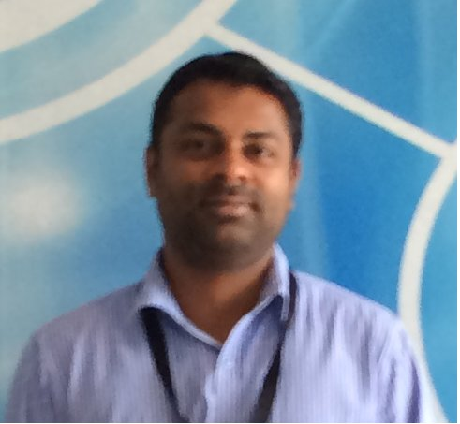

**Baiju Gopalakrishnan**

Abu Dhabi, UAE

Phone: + 971 554953707 | E-mail: baiju.g@hotmail.com

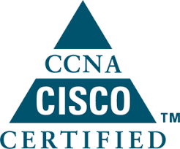****

**PROFILE**

* Articulates with ease
* Inquisitiveness to learn
* Positive Ability to prioritize tasks with high degree of flexibility with time bound action
* Ability to prioritize tasks
* Exhibits Trust and Integrity

**TECHNOLOGY SKILLS**

* Microsoft Windows Server 2012/2008/2003
* Virtualization Hyper-V, VM Ware ESXI 5.5 /6.0
* Mail Server Administrator – MS Exchange 2013/2010.
* Firewall (Cyberoam, SonicWALL, Fortinet) Network configuration and management
* LAN/WAN Configuration
* SQL Server configuration
* Backup solutions Acronis,
* Dell Enterprise 9th, 10th, 11th and 12th generation servers
* IBM X series. 205, 206, 226, 250, 345, 3650, 3250
* HP ProLiant ML series 110, 150, 350, 380. DL series 180,320, 360,380 385

**PROFESSIONAL PROFILE**

Technically accomplished professional with 13+ years of experience as Server Administrator and Data center Engineer, serving as catalyst for change with a commitment to improve data center efficiencies. Holds his diverse expertise in Installation, Administration, configuration, services, event viewer, tuning, user management, quota, share, Backups, in Windows 2012/2008 Server, Active Directory, Microsoft Exchange VMWare and Web Hosting. Accredited for Implementation and administration of Storage Area Network (SAN). Recognized for dealing with IIS, DNS, DHCP, TCP/IP. Proactively driving Configuration and implementation of Switches, Routers, Networks and Firewalls, LAN Administration.

**EMPLOYMENT HISTORY**

**Harmony Atelier |** Abu Dhabi, UAE| System Administrator

Feb, 2018 – till date

* Web/Application infrastructure for Stock Market/Financial Client.
* Web/Application infrastructure for Government project / private clients.
* Government Email infrastructure for Microsoft Exchange Server.
* Government IT infrastructure for VMWare.
* Windows Server – Installation, administration, configuration, services, performance tuning including user management.
* Active role in implementation team of Government Email infrastructure for Exchange 2010/2013 and Government IT infrastructure for VMWare.
* Experience in enterprise application architecture and service delivery models.
* Working in MS SQL cluster and managing daily and weekly server backup.
* Virtualization (Hyper V, VM-Ware) – Configuration & Management.

**TACME LLC |** Dubai, UAE| Data Centre Engineer

Feb, 2016 – Feb 2018

* Installation and configuration of Windows based Operating Systems.
* Installation and configuration of ADS, DNS and DHCP. Creation and management of User accounts in Active Directory Services.
* Firewall configuration and setting up SSL and IP Sec VPN. – Cyberoam, SonicWALL and Fortinet.
* Researching, Monitoring, administration and maintenance of multiple Intel based server systems.
* Diagnosing and resolving hardware related problems. Handling escalations- Assisted in resolving several Client issues.
* Updating & distributing virus update from centralized server.
* Provide assistance and infrastructure related advice to capacity planning, application owners, developers and business owners.

**HCL Infosystems Ltd |**Noida, INDIA | Team Leader /DELL Enterprise Server Engineer

May, 2012 – Nov, 2015

* Coordinating in Installation and Maintaining Windows Server 2008 and Upgrades.
* Implementing Group policy according to Process Requirement.
* Managing Windows DHCP Servers.
* Creating User IDs and Groups on AD Server and Configuration of Microsoft Outlook.
* Dell server hardware support for various clients.
* Performing remote installation through VNC and remote desktop.
* Configuration and Troubleshooting of Sap 7.0.

**SKC Management |** Delhi, INDIA | IT Engineer

Aug, 2009 – April, 2012

* Trouble shoot technical issues with Windows and Office applications
* Configure various Server operating systems
* Perform system backups.
* Installed and configured Norton Antivirus Corporate edition for Enterprise networks.
* Installed and configured various proxy servers like Wingate proxy, ICS etc.
* Configured users for accessing mail server-using Outlook as Client.

Configured network printers for group usage.

**CMC Ltd (TCS Ltd) |** Cochin, INDIA | Technical Support Engineer

May, 2003 – Jan, 2009

* Daily, weekly & monthly backup of user data and mails.
* Installing & Monitoring the updates of Symantec Endpoint Protection Antivirus.
* Responsible for daily anti-virus manual update.
* General maintenance of computers.
* Installation and Maintenance of Desktops, PCs. Network Printers, LAN.
* Installation of various Windows operating system environment using Windows 2000/2003, Win7/XP/NT.
* Internet Solution, Site Related Problem.
* Update and scan Servers using Trend Virus Scan using Trend Control Manager.
* Monitoring of hardware layer using IBM Director, Dell Open Manage and Compaq Insight Manager.
* Troubleshoot repeat alerts and fix root cause.
* Perform System recovery and system restores.

**Education**

* Engineering Diploma in Computer Technology from Govt. Polytechnic College, Kottayam, Kerala, India in 2002.
* Sr. Technician from Associate Member of the Institution of Engineers.

**Certifications**

* ITIL V3 Foundation Certified.
* Microsoft Certified Solution Expert (MCSE).
* Cisco Certified Network Associate (CCNA).
* Dell Certified Systems Expert.

**Baiju Gopalakrishnan.**

**PROFESSIONAL TRAITS**

* Server Management
* MS Windows Administration
* MS Exchange Administration
* Firewall Administration
* Storage Administration
* Operational excellence

**PERSONAL DETAILS**

Indian citizen

DOB: 20th, May, 1982

Passport Number: P7096708

**LANGUAGE SKILLS**

English, Hindi, Tamil and Malayalam