# Waleed Mostafa Abd Elazeem Mohamed

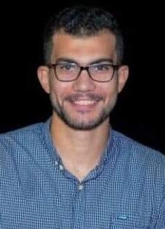

Mobile No : +201110043835 - 9710501628095

E-mail : [waleed.most0@gmail.com](mailto:waleed.most0@gmail.com)

# Career Objective

Enhance my technical and personal skills to build a strong and highly qualified career in software programming, development and research by working in a procedure and creative team.

# Personal Data

* **Date of Birth :** 05/11/1993
* **Place of Birth :** Mitt Ghamer, Al-Dakahlia
* **Nationality :** Egyptian
* **Marital status :** Single
* **Military Service :**Final Exempted

# Education

### Computer Science, Faculty Computers and information, Kfre El-Sheikh University, 2016

* Accumulative Grade : Very Good
* Graduation Project : E-Learning Web Site
* Project Grade : Excellent

# Working Experience

### Createivo,Mansoura,Egypt From 04/2018 – 08/2018 Back End Developer

* **Job Description**
  + Creating database schemas that represent and support business processes
  + Design and implementation of data solutions
  + Data migration and scripting

### Ipda3tech,Mansoura,Egypt From 01/2019 –06/2019 Back End Developer

* **Job Description**
  + Design and layout of a website according to a clients
  + Creating database schemas
  + Building Restful Web Services

### Smart,cairo,Egypt

**From 06/2019 – 07/2019**

**Technical Support**

* **Job Description**
  + solve network problems
  + Follow up on hardware failures

### Hit,cairo,Egypt

**From 07/2019 – 09/2019**

**Network Engineer**

* **Job Description**
  + Pull and Push cables **( UTP - Fiber)**
  + Fix and Determine the path of cables
  + Arrange Points
* **Future** **International** **School,AL Ain,UAE**

**From 09/2019 – 02/2020**

**IT Officer**

* **Job Description**
* solve network problems
* administrate school systems

# Technical Skills

## Programming Languages:

* **Web design:**
  + Html / Html 5
  + Css / Css 3
  + JavaScript
  + JQuery
  + Bootstrap
  + Ajax

## Database Programming:

* + My Sql

## Web Development:

* + Php programing
  + Laravel
  + Building Restful Web Services

# Personal Skills

* Ability to work in a team.
* Leadership capabilities.
* Interactive and fast learner.
* Ability to work under pressure.
* Highly communication and presentation skills.

# Language Skills

|  |  |
| --- | --- |
| • | **English :** Very good command of written, read and good spoke |
| • | **Arabic :** Native language. |