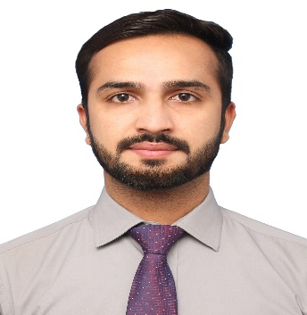



MUBASHIR NAZEER

Male, 28 Years, Lahore, Pakistan

**Email**: [mubasher95@gmail.com](mailto:mubasher95@gmail.com)

**Mobile**: +92.333.7733795

Professional Summary

5 Year of overall experience of Networks, UC&C and Security Surveillance. Installation, Configuration and Troubleshooting/Support. Extensive experience in Huawei & Cisco Video conferencing solutions and Design. Hand on experience of implementation of HIMS (Hospital Information Management System) Project of PITB across the THQ/DHQ Hospital of Punjab.

- 3 Year experience in Active/Passive Networking Solutions, installations and maintenance.

- 1 Year experience of HIMS operations and coordinate with respective departments and Vendor. Develop network plan and maintenance of network, Severs and database.

- 1 Year extensive experience in UC&C Video conferencing, Telepresence System of Solution providing, Designing and Troubleshooting.

- Excellent verbal, written and communication skills.

- Excellent Analytical problem-solving skills, Interpersonal skills, Self-learning and Team Player.

To obtain a challenging position that allows me to utilize my current skills to assist in advancing a business that offers a stable employment opportunity. I am also eager to learn new skills and business and technological advancements.

Personal Information

Father's Name: Nazir Ahmad

Date of Birth: December 3, 1991

Nationality: Pakistan

Marital Status: Single

Industry: Information Technology

Functional Area: IT & Computer Networking

Address: House# 352 R1 Johar town Lahore

Languages: English (Intermediate), Urdu (Expert), Punjabi (Expert), Saraiki (Expert)

Work Experience

**Resident Engineer**

Punjab Information Technology Board, Lahore, Pakistan

Dec 2017 - Present

* Supervise all the HIMS operations and coordinate with respective departments and ensure documentation and timely resolution of issues.
* Act as PITB's focal person for the project under the directions of program manager.
* Develop network plan and maintenance of network, Severs and database.

**Network Support Engineer**

CommTel Systems, Lahore, Pakistan

Nov 2015 – Dec 2017

Work as Network Support Engineer and provide network installations, troubleshooting and support in Networks, Servers, Data Center and Video Conferencing System.

**Network Administrator**

ICPA, Lahore, Pakistan

Sep 2014 - Oct 2015

Work as Network Administrator and provide network solutions and troubleshooting.

Education

Masters (Master of Information Technology)

Superior University Lahore. Lahore, Pakistan

2017

GPA: 3.4 Out of 4

Bachelors (Bachelors in Arts)

Bahauddin Zakariya University, Multan, Pakistan

2014

Grade: C

Intermediate (FSC (Pre-Engineering)

Punjab Group of Colleges Multan. Multan, Pakistan

2009

Grade: C

Matriculation (Matriculation)

Hawks Schools System Mailsi, Multan, Pakistan

2007

Grade: A

Certifications

* Cisco Certified Network Associate (CCNA)
* Cisco Certified Network Professional (CCNP)
* Huawei GSM (MSC, HLR, BSS, RNO)
* Microsoft Certified IT Professional (MCITP) *(Training only)*

Skills & Expertise

|  |  |
| --- | --- |
| Microsoft Windows | Adobe Photoshop |
| Microsoft Office Suite | Database Management Library |
| Adobe Dreamweaver | Microsoft Outlook |
| Microsoft SQL | MS Visual Studio |
| Software Engineering | VMware Fusion |