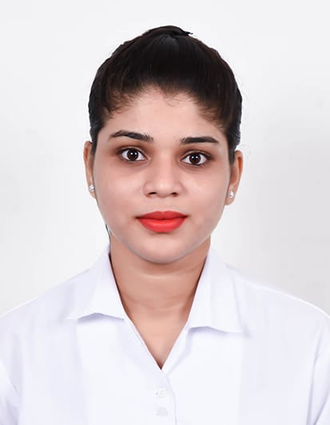

**ANISHA KAWLEKAR**

Mobile: +971 582399655

Email: [anishakawlekar@gmail.com](mailto:anishakawlekar@gmail.com)

Address: Deira Dubai, UAE.

Visa Status: Visit Visa valid until 9th March

**CAREER OBJECTIVE:**

Actively seeking a **customer service position** where I can optimize my problem-solving and organizational skills to contribute to increased **customer** satisfaction. Strong multitasking skills and fast learning ability ensure quick contribution to your **customer service** team.

**WORK EXPERIENCE:**

**Tommy Hilfiger,-Goa,India**

**Duration:**  December 2018 till December 2019

**Designation:** Customer Relation Officer

* Handles incoming calls or inquiries from prospective customers or clients
* Assists customers effectively by solving customer disputes
* Provides customer additional information or explains services
* Discusses products offered and ensures customer satisfaction
* Tactfully handles confrontational or stressful interactions with the public
* Completes supporting paperwork and data entry as required
* Accurately captures customer information
* Creates and maintains service reports
* Communicating with clients and customers about their experiences with a product or service
* Providing advice on purchasing products or services
* Answering client or customer questions about properly using or accessing a product or service
* Taking or processing orders for a product or service
* Listening to customer or client complaints or concerns and working to resolve their issues
* Maintains customer records by updating account information.
* Prepares product or service reports by collecting and analyzing customer information.
* Contributes to team effort by accomplishing related results as needed.

**KEY STRENGTH & SKILLS**

* Computer skills (MS Word, MS Excel, Power point & MS Outlook)
* Easily adaptable to new experience.
* Sense of responsibility.
* Quick learner
* Time management skills
* Leadership Skills/ Team Management
* Communication skills – written and verbal
* Problem solving skills

**ACHIVEMENTS**

* Won First place in Street play competition at , Panaji on 1st, 2nd & 3rd February 2016 organized by S.S Dempo
* Won First place in Inter – Class Play competition on the theme “Roaring voices of India’s Freedom Struggle”
* Won Third place in Street play competition organized by Urba in the year 2016-17.
* Won Second place in Street play competition organized by Goa Yuva Mohostav in the year 2015-16.
* Won First place in Dance competition organized by Goa Yuva Mohostav in the year 2016-17.

**ADDITIONAL QUALIFICATION**

* Diploma in Aviation, Hospitality and Travel Management (FDAHTM) at Frankfinn Institute of Air Hostess Training, Margoa – Goa.
* Certification in Galileo (CRS)

**ACADEMIC QULIFICATION**

|  |  |  |  |
| --- | --- | --- | --- |
| **Qualification** | **School/College** | **Board/University** | **Year of Passing** |
| Bachelor of Arts | Fr.Agnel Collage Of Arts &Commerce | Goa University | May 2018 |
| H.S.S.C | Don Bosco Higher Secondary School | Goa Board | May 2015 |
| S.S.C | Jesus & Mary High School | Goa Board | May 2013 |

**PERSONAL INFORMATION:**

* Passport No : P1988542
* Place of Issue : Goa
* Date of Issue :
* Date of Expiry:
* Birthday           : 25th September 1997
* Citizenship       : Indian
* Civil Status       : Single
* Gender             : Female
* Language spoken: English, Hindi, Konkani and Marathi

**DECLARATION:**

Hereby, I promise that, all the above information is true, and I am ready to work in your company according to your company’s rules and regulations, and I promise that, I will try my level best for the success of the company.

**Anisha Kawlekar**