**TALHA SIDDIQUI**

**Cell: +92-321-3444443**

**Email: talha.siddiqui@hotmail.co.uk**

**Address: Railway Wireless Colony GT.Road Lahore**

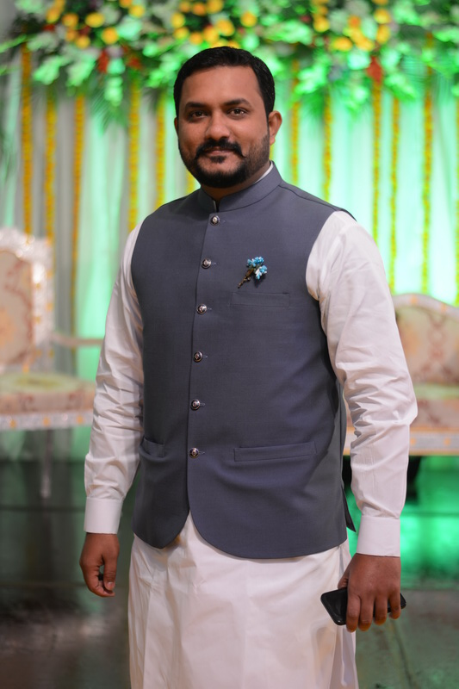

**PROFILE:**

Demonstrated ability to anticipate problems, design innovative, and balance multiple high-priority projects with competing deadlines. Effective in self-managed and team environment. Strong technical knowledge base and research/analytical skills gained from year career in business and information technology.

In-depth ability to think logically and critically in solving problems; explaining their conclusions; and evaluating, supporting, or critiquing the thinking of others.

**QUALIFICATION:**

* **CURRENT ACADEMIC CAREER:**

Master’s in Business and Administration from

**NATIONAL UNIVERSITY OF MODERN LANGUAGES**

**(Specialization in Finance / Marketing).**

* **PAST ACADEMIC CAREER:**

Punjab College of Commerce Lahore (PCC), **Bachelor (B.COM)**.

Scholars College Lahore, **Intermediate (I.Com)**.

**EXPERIENCES:**

* Currently working as a Executive Senior Manager Project Sales at Zameen.com (2018-Present).
* Previously Working as a National Sales Manager (B-2-B / B-2-C) in Dost Steels Limited. (2017)
* Previously worked as Group General Manager Corporate Sale/Supply Chain in Abbas Steel Group.(2015-16)
* Past Working as Deputy Manager Corporate Sale / Manager Supply Chain in Mughal Iron & Steel Industries Ltd.(2011-14)
* Past Working in Bata Pakistan Limited as a Retail Sales Manager. (2008-10).
* Past Working as Assistant Manager Project development in Zameen.Com (2004-07)

**Career Projects:**

|  |  |
| --- | --- |
| * Neelum Jhelum Hydro Power Project. * Karwot Power Project. * Patrind Power Project. * Sahiwal Coal Project. * Terbella 3rd & 4th Extension. * Metro Bus Project (Lahore/ISB/Multan). * Defence Raya. * Indigo Heights. | * Quaid-e-Azam Solar Power Project. * Fatima Sugar Factory Muzaffargarh. * Orangeline Project. * Muree Express Way. * Royal and Golf Country Club DHA-5. * Ring Road. |

**Skill Based Courses:**

* Business Communication.
* Foreign Risk Management.
* Strategic Management.
* Sales management.

**Future Ambition:**

* Adaptability & borrowing of a culture without self-reference criteria.
* Warm welcome to every kind of change occurring in the chaotic environment.
* Positive & confident person blended with strong working ethic.
* Highly energetic, enthustic & cooperative person who can accept challenge & work in competitive environment.

**Personal Information:**

Father Name: M. Yousaf Siddiqui

Date of Birth: 19/April/1988

C-N-I-C: 35202-8639195-5

Domicile: Lahore

**Interests:**

Book Reading, Financial Analysis, Risk Management,

Marketing new strategy review, Playing Cricket.

**Languages:**

Proficient in Urdu, English, Punjabi & French.

**Reference:**

It will be provided upon request.