­

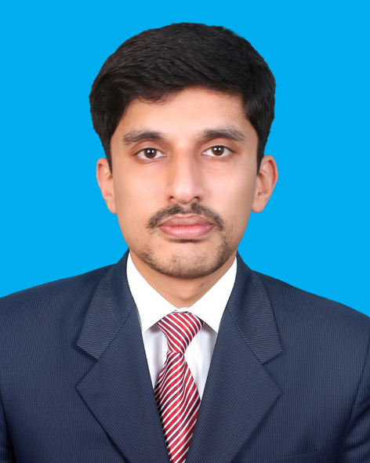

**Muhammad Nouman Khan**

**CONTACT**



+92-334-4704423



Noumankhan26



Nouman.khan1290@gmail.com

­

**Personal statement**

House#312 Block G

Khayban-e-amin New

Defense Road Lahore

A challenging and illustrious career in a competitive environment where I can practically apply and improve upon the analytical and technical skills acquired by my education to the company’s benefit and my own satisfaction

**Tools&Languages**

**WORK EXPERIENCE**

Notepad++ Ms-Office

|  |  |
| --- | --- |
| **Network Support Executive**  Naveena Exports Limited | *April-2017-Currently working* |

As Network Support Executive for Naveena Exports Limited, My responsibilities are:

* Installing and Configuring Computer System.
* Troubleshooting and solving Software and Windows fault
* Installing new software
* Installing new hardware (Servers, Printers, Computer Workstations, etc.)
* Fixing Network Faults
* Maintain Active Directory
* Technical support to those Users who use Network
* Setting up user accounts, permissions and password
* Anti-virus protection(Sophos)
* Network maintenance
* Basic It training to new Staff
* Server Maintenance
* Daily backup the windows Servers
* Maintain Daily Records about IT Equipment
* Install and configure Office 365 on 170+ clients

|  |  |
| --- | --- |
| **It Support(Internee)**  Microtech private limited | *March-2017-April-2017* |

As an It Support Internee for Microtech My responsibilities were:

* Installing Software’s
* Installing Printers, .scanners, etc.
* Troubleshooting
* Installing windows
* Resolve Network issues

**Network Support (Internee)**

Naveena Exports Limited

As a Network support Executive Internee in Naveena Exports Limited My Responsibilities were:

* Installing Software’s
* Installing Printers, scanners, etc.
* Troubleshooting
* Installing windows

Turbo C++ Visual Studio

Xampp Packet Tracer

SublineText Microsoft Visio

OOP Web Development

Networking Putty

MikroTIk Paper Cut

Office 365 WordPress

­

**EDUCATION**

**SKILLS**

* Using Microsoft Windows Server to configure DHCP Server, DNS Server.
* Using Microsoft windows server to Configure WDS and WSUS Service
* Using Microsoft Windows Server To Configure Other Features
* Quality of maintaining the appreciative attitude towards others
* Active and dynamic approach to work and getting things done
* High integrity and honesty; ethical and socially aware
* MikroTik router Basic Configration
* Cisco Switches Configration
* Bulk Entries in Domain
* Group policy Management
* Office 365 Deployment
* Static websites On Wordpress

|  |  |
| --- | --- |
| **Bachelor Of Sciences In Computer Sciences**  University Of Lahore | *2011-2016* |
|  |  |
| **F.S.C(ICS)**  Kips Boys Collage Lahore | *2009-2011* |
|  |  |
| **Matric**  Sir Syed Model School Sheikhupura | *2007-2009* |
|  |  |

**Trainings**

* CCNA From Comsats University of Lahore (2016)
* Microsoft Certified Solutions Expert From Corvit (2017)

**HOBBIES & INTERESTS**

**REFERENCES**

Reference will be provided upon request

* Walking
* Playing Computer games
* Exploring New Ideas
* Playing Cricket