GitCherry

Gitcherry enables arbitrary Git commits to be picked by reference and appended to the current working HEAD appended to the current working HEAD.

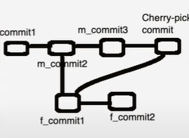

Let recreate the above example:

* Make an empty repo and create the following file.

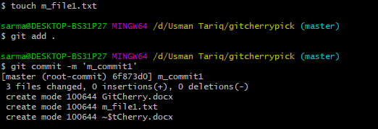

* Similarly create the other files using same commands.
* m_file2.txt
* m_file3.txt