Speaker Notes File
What is Artificial Intelligence & Machine Learning? (In Simple Words)
1-Hour Interactive Session for Students
Use with the included visuals and simple daily-life examples.

Session Overview
Time | Focus | What Students Do
0-5 min | Hook and quick poll | Raise hands, guess which apps use AI
5-15 min | History of AI | Hear a simple timeline and answer questions
15-30 min | AI vs ML vs Generative AI | Compare ideas using daily-life examples
30-45 min | How ML learns from data | Follow a step-by-step learning story
45-55 min | Activity | List 5 AI/ML tools they already use
55-60 min | Wrap-up and Q&A | Share one takeaway and ask questions

Learning Objectives
- Explain Artificial Intelligence in simple words.
- Distinguish AI, Machine Learning, and Generative AI.
- Describe how Machine Learning learns from data.
- Recognize AI/ML tools already used in daily life.

Materials
- Projector or screen.
- The two included visuals in this file.
- Whiteboard or marker for the activity.
- Optional: sticky notes or notebook paper for student responses.

Visuals to Show During Class
Visual 1: Use this at the start to show the complete session flow and keep the lesson organized.
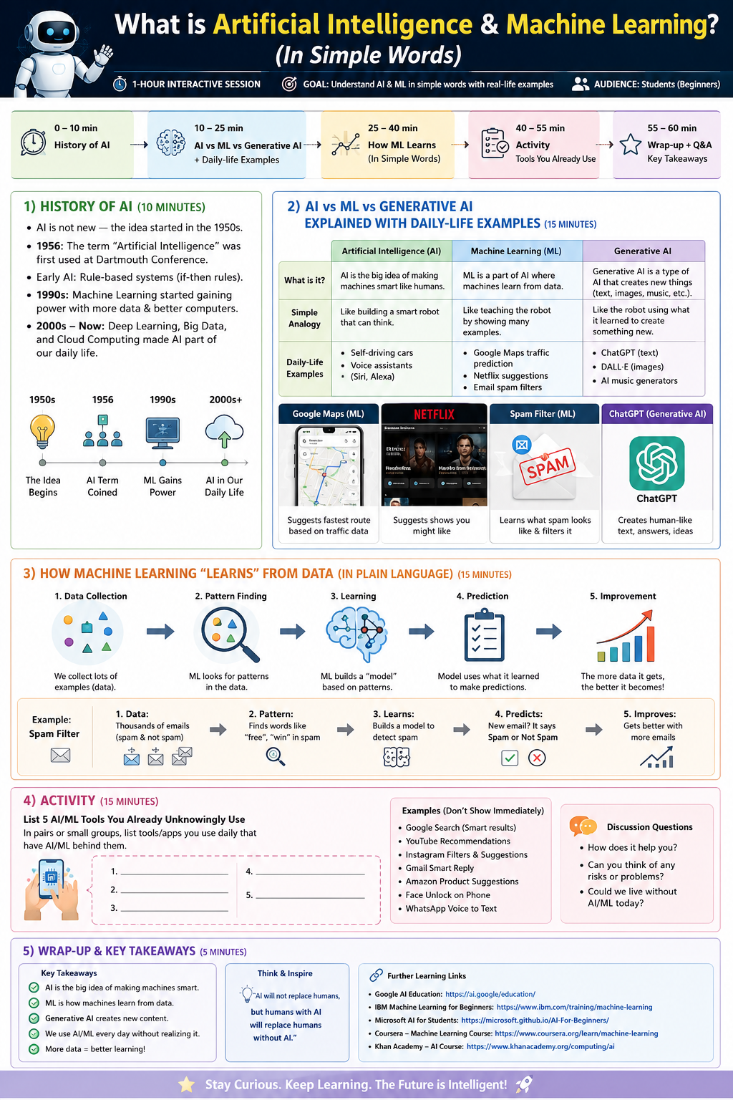
Figure 1. AI & ML session infographic
Visual 2: Use this during the explanation section or activity to keep attention high with a colorful layout.
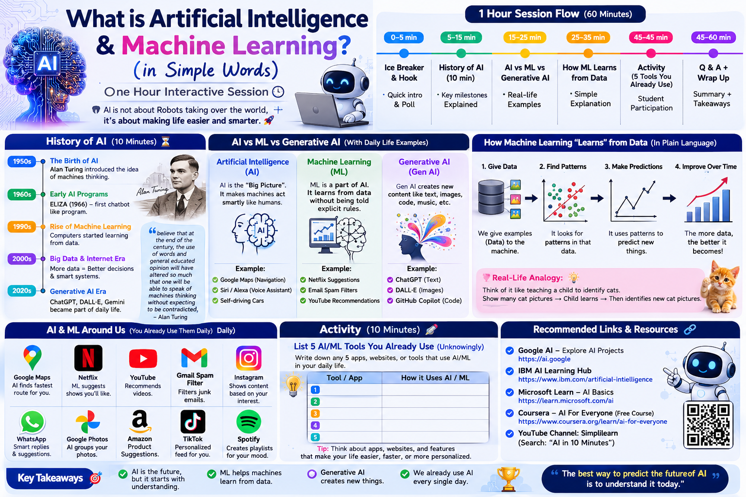
Figure 2. Alternate classroom infographic

Detailed Speaker Notes

0-5 min | Opening Hook
- Say: 'Today we will understand AI and Machine Learning in very simple words.'
- Ask: 'Who used Google Maps, YouTube, Netflix, Gmail, or ChatGPT today?'
- Pause for hands. Smile, wait a few seconds, and acknowledge every response.
- Then say: 'These tools already use AI in the background to make our life easier.'
- Show Visual 1 and point to the full session flow so students know what to expect.

5-15 min | History of AI
- Say: 'AI is not new. The idea has been around for decades.'
- Explain that the field became formal in the 1950s, and 1956 is often treated as a major starting point for AI research.
- Use a simple line: 'First came the idea of smart machines, then rules-based systems, then learning from data.'
- Mention early chatbot-like programs such as ELIZA as an example of simple machine conversation.
- Keep this part short and energetic. The goal is not memorizing dates; the goal is understanding that AI grew over time.
- Ask one question: 'What changed most: the idea, the data, or the computers?' Accept multiple answers.

15-30 min | AI vs ML vs Generative AI
- Say: 'AI is the big umbrella. Machine Learning is one way to build AI. Generative AI is a kind of AI that creates new content.'
- Use the comparison line: 'AI makes machines smart, ML lets them learn from data, and Generative AI lets them create.'
- Example 1: Google Maps suggests a route and updates with traffic.
- Example 2: Netflix suggests shows you may like.
- Example 3: Gmail filters spam.
- Example 4: ChatGPT generates text answers, explanations, and ideas.
- Make the examples feel everyday and familiar. Ask students to name one app from their own phone that feels smart.
- If students look confused, repeat the shortcut: 'AI = smart machines, ML = learning from examples, Gen AI = creating new things.'

30-45 min | How Machine Learning Learns
- Say: 'Machine Learning learns from examples, not by being told every single rule.'
- Use the child-learning analogy: 'It is like teaching a child by showing many examples instead of writing a rulebook.'
- Walk through five steps: data, patterns, model, prediction, improvement.
- Explain with spam filters: the system sees many spam and non-spam emails, learns patterns, and then predicts whether a new email is spam.
- Keep the language plain: data is examples, pattern is what repeats, model is the learned answer machine.
- Ask: 'Why do you think more examples help the system get better?' Let students answer in simple language.
- Reinforce the key idea: 'More good data usually means better learning.'

45-55 min | Activity: 5 Tools Students Already Use
- Say: 'Now let us test your everyday AI detective skills.'
- Ask students to list 5 tools/apps they use that probably contain AI or ML.
- Give them 2 minutes in pairs, then ask for answers from the class.
- Accept answers like Google Maps, YouTube, Netflix, Gmail spam filter, ChatGPT, Google Photos, Instagram recommendations, WhatsApp smart features, Amazon suggestions, or Spotify playlists.
- On the board, draw a simple two-column list: Tool / How it uses AI.
- Praise participation even if the explanation is imperfect.

55-60 min | Wrap-Up and Q&A
- Summarize in one sentence each: AI is the broader idea, ML is learning from data, and Generative AI creates new content.
- Say: 'We use AI more often than we realize.'
- End with a forward-looking line: 'The best way to understand the future of AI is to understand it today.'
- Invite questions and choose one student to repeat the three key terms in their own words.

Suggested Student Questions
- What is AI in one sentence?
- How is ML different from AI?
- What is one example of Generative AI?
- Why does ML need data?
- Which app on your phone may be using AI?

Simple Answer Key for the Activity
- Google Maps — route prediction and traffic awareness.
- YouTube — video recommendations.
- Netflix — personalized suggestions.
- Gmail — spam filtering.
- ChatGPT — text generation and question answering.

Reference Links
- Google Cloud: What is Machine Learning?: https://cloud.google.com/learn/what-is-machine-learning
- Google Maps Platform AI: https://mapsplatform.google.com/ai/
- Netflix Help: Recommendations: https://help.netflix.com/en/node/100639
- IBM: History of Artificial Intelligence: https://www.ibm.com/think/topics/history-of-artificial-intelligence
- IBM: Generative AI: https://www.ibm.com/think/topics/generative-ai

Teaching tip: keep the pace brisk, use student names often, and pause after each example so learners can guess before you explain.

