**COAL Lab # 01**

**Verilog (HDL) Programing Fundamentals**

**Name:** Muhammad Usman

**Class:** BSCS 3C1

**Reg No:** cs211208

**Lab Exercises:**

**Task 01**

**Literature Review:**

A combinational circuit is the digital logic circuit in which the output depends on the combination of inputs at that point of time with total disregard to the past state of the inputs. The digital logic gate is the building block of combinational circuits. a combinational circuit could be used to add any number of inputs, or to subtract them, or to perform other mathematical operations.

**Task:**

Implement combinational circuit using Verilog.

**Truth Table:**

|  |  |  |  |
| --- | --- | --- | --- |
| **A** | **B** | **C** | **X** |
| 0 | 0 | 0 | 0 |
| 0 | 0 | 1 | 1 |
| 0 | 1 | 0 | 1 |
| 0 | 1 | 1 | 1 |
| 1 | 0 | 0 | 1 |
| 1 | 0 | 1 | 1 |
| 1 | 1 | 0 | 1 |
| 1 | 1 | 1 | 1 |

**Block Diagram:**

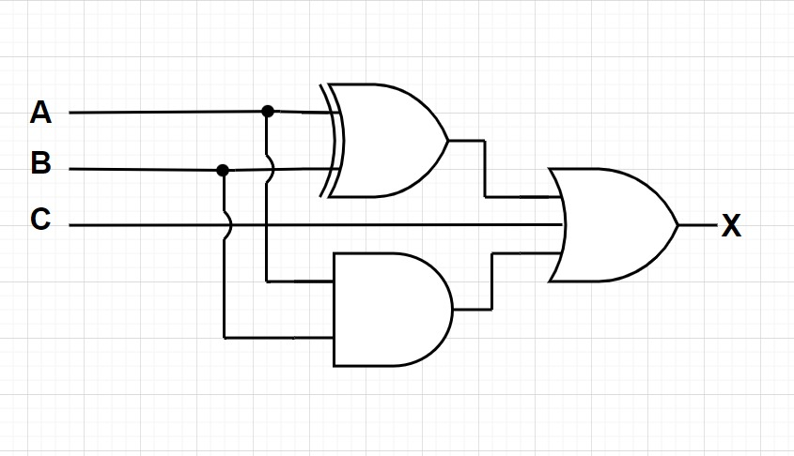

**Boolean Equation:**

Q = (A**⊕B)+(A.B)+C**

**Verilog Code:**

design.v

module combinational_circuit(A,B,C,Q);

    input A,B,C;

    output Q;

    // interim signals

    wire A_xor_B,A_and_B;

    // logic designing

    assign A_xor_B = A ^ B;

    assign A_and_B = A & B;

    assign Q = C | A_and_B | A_xor_B;

endmodule

testbench.v

module tb();

    reg A,B,C;

    wire Q;

    // module declare

    combinational_circuit dut (.A(A),.B(B),.C(C),.Q(Q));

    initial begin

      A <= 1'b0;

      B <= 1'b0;

      C <= 1'b0;

      #100

      A <= 1'b0;

      B <= 1'b0;

      C <= 1'b1;

      #100

      A <= 1'b0;

      B <= 1'b1;

      C <= 1'b0;

      #100

      A <= 1'b0;

      B <= 1'b1;

      C <= 1'b1;

      #100

      A <= 1'b1;

      B <= 1'b0;

      C <= 1'b0;

      #100

      A <= 1'b1;

      B <= 1'b0;

      C <= 1'b1;

      #100

      A <= 1'b1;

      B <= 1'b1;

      C <= 1'b0;

      #100

      A <= 1'b1;

      B <= 1'b1;

      C <= 1'b1;

      #100

    end

    initial begin

        $dumpfile("dump.vcd");

        $dumpvars(0);

    end

endmodule

**Waveforms:**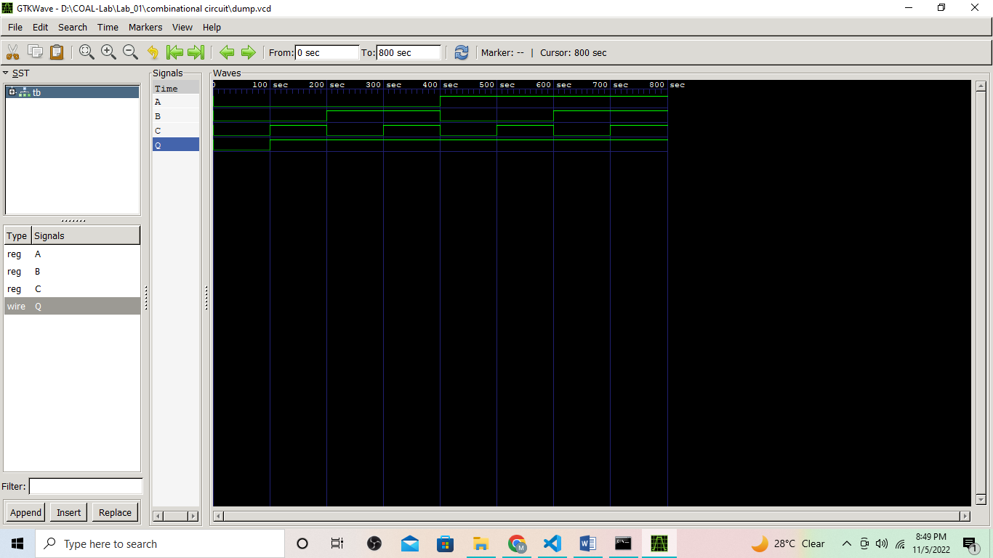

**Task 02**

**Literature Review:**

The sequential circuit is a special type of circuit that has a series of inputs and outputs. The outputs of the sequential circuits depend on both the combination of present inputs and previous outputs. The previous output is treated as the present state. They possess the ability to store the output. They also include a time sequence of inputs and internal states. The famously known sequential elements are D-Flip Flops, J-K Flip Flop, S-R Latch , etc.

**Task:**

Implement Sequential circuit using Verilog.

**Truth Table:**

|  |  |  |  |
| --- | --- | --- | --- |
| **A** | **B** | **C** | **X** |
| 0 | 0 | 0 | 0 |
| 0 | 0 | 1 | 1 |
| 0 | 1 | 0 | 1 |
| 0 | 1 | 1 | 1 |
| 1 | 0 | 0 | 1 |
| 1 | 0 | 1 | 1 |
| 1 | 1 | 0 | 1 |
| 1 | 1 | 1 | 1 |

**Block Diagram:**

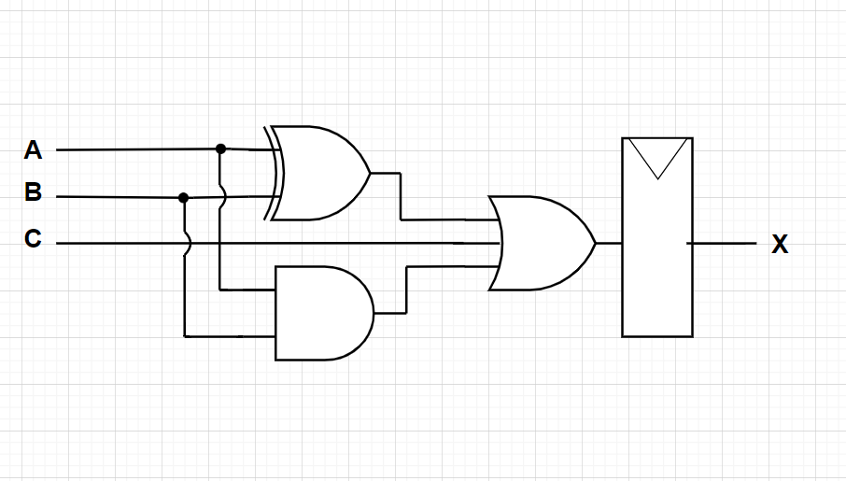

**Boolean Equation:**

Q = (A**⊕B)+(A.B)+C**

**Verilog Code:**

design.v

module sequential_circuit(A,B,C,clk,reset,Q);

    input A,B,C,clk,reset;

    output Q;

    // interim signals

    wire A_xor_B , A_and_B , A_or_B_C;

    reg flop;

    // logic designing

    assign A_xor_B = A ^ B;

    assign A_and_B = A & B;

    assign A_or_B_C = C | A_and_B | A_xor_B;

    always @(posedge clk) begin

        if(reset == 1'b1)

        begin

            flop <= 1'b0;

        end

        else begin

            flop <= A_or_B_C;

        end

    end

    assign Q = flop;

endmodule

testbench.v

module tb();

    reg A,B,C,clk,reset;

    wire Q;

    // module declare

    sequential_circuit dut (.A(A),.B(B),.C(C),.clk(clk),.reset(reset),.Q(Q));

    always begin

      clk <= 1'b0;

      #50;

      clk <= 1'b1;

      #50;

    end

    initial begin

      reset <= 1'b1;

      #100;

      reset <= 1'b0;

      A <= 1'b0;

      B <= 1'b0;

      C <= 1'b0;

      #100;

      A <= 1'b0;

      B <= 1'b0;

      C <= 1'b1;

      #100;

      A <= 1'b0;

      B <= 1'b1;

      C <= 1'b0;

      #100;

      A <= 1'b0;

      B <= 1'b1;

      C <= 1'b1;

      #100;

      A <= 1'b1;

      B <= 1'b0;

      C <= 1'b0;

      #100;

      A <= 1'b1;

      B <= 1'b0;

      C <= 1'b1;

      #100;

      A <= 1'b1;

      B <= 1'b1;

      C <= 1'b0;

      #100;

      A <= 1'b1;

      B <= 1'b1;

      C <= 1'b1;

      #100;

      $finish;

    end

    initial begin

        $dumpfile("dump.vcd");

        $dumpvars(0);

    end

endmodule

**Waveforms:**

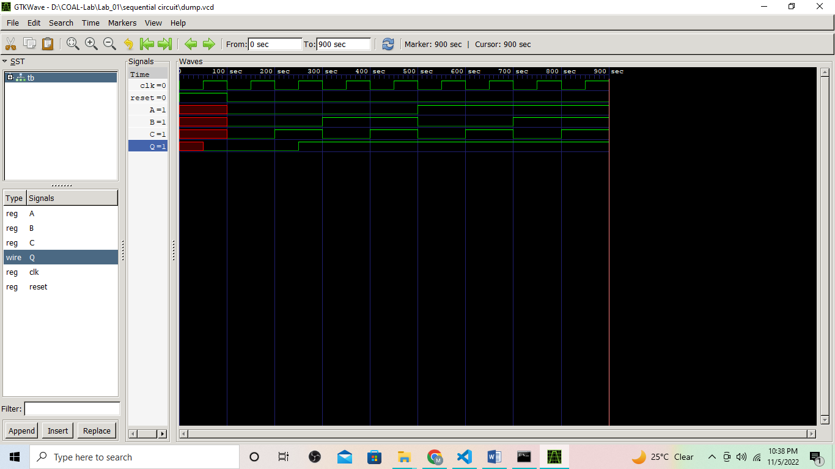

**In Lab Task:**

**Task 03**

**Literature Review:**

Half adder is a combinational arithmetic circuit that adds two numbers and produces a sum bit (s) and carry bit (c) both as output. The addition of 2 bits is done using a combination circuit called a Half adder. The input variables are augend and addend bits and output variables are sum & carry bits.

**Task:**

Implement Half adder using Verilog.

**Truth Table:**

|  |  |  |  |
| --- | --- | --- | --- |
| **A** | **B** | **S** | **C** |
| 0 | 0 | 0 | 0 |
| 0 | 1 | 1 | 0 |
| 1 | 0 | 1 | 0 |
| 1 | 1 | 0 | 1 |

**Block Diagram:**

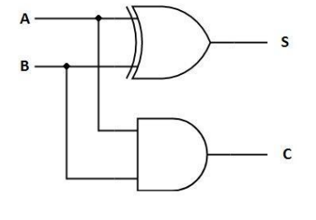

**Boolean Equation:**

S = A**⊕B**

C = A.B

**Verilog Code:**

design.v

module half_adder(A,B,S,C);

    input A,B;

    output S,C;

    assign S = A ^ B;

    assign C = A & B;

endmodule

testbench.v

module tb();

    reg A,B;

    wire S,C;

    // module declare

    half_adder dut (.A(A),.B(B),.S(S),.C(C));

    initial begin

      A <= 1'b0;

      B <= 1'b0;

      #100;

      A <= 1'b0;

      B <= 1'b1;

      #100;

      A <= 1'b1;

      B <= 1'b0;

      #100;

      A <= 1'b1;

      B <= 1'b1;

      #100;

    end

    initial begin

        $dumpfile("dump.vcd");

        $dumpvars(0);

    end

endmodule

**Waveforms:**

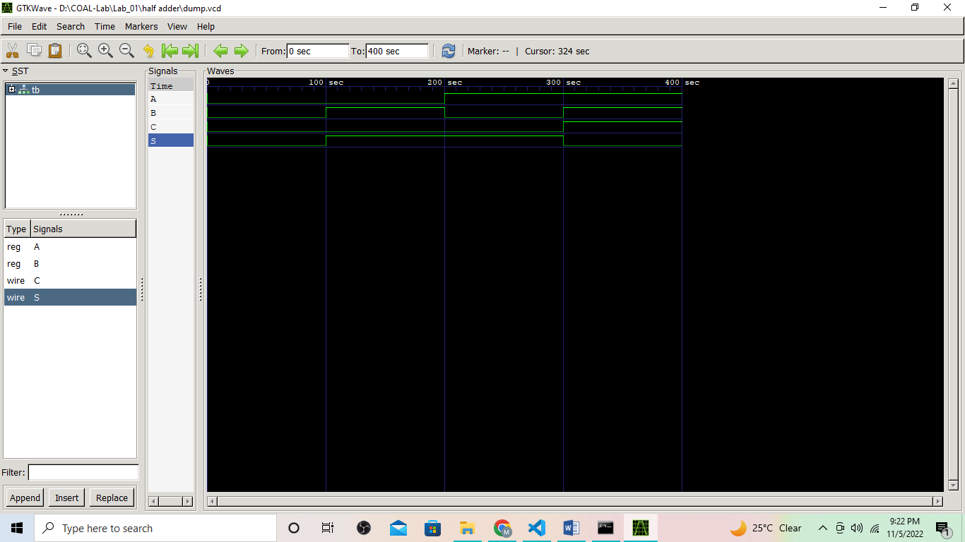

**Task 04**

**Literature Review:**

2 bit counter is a sequential circuit which stores the previous output in memory element then use it to increment the count. On every clock cycle, under defined conditions, one will add in the input and it will be stored in memory element and then for next cycle it will repeat the process until it reaches the limit of bits storage.

**Task:**

Implement 2 bit counter using Verilog.

**Truth Table:**

|  |  |  |
| --- | --- | --- |
| **Clock** | **Q1** | **Q2** |
| initial | 0 | 0 |
| 1 | 0 | 1 |
| 2 | 1 | 0 |
| 3 | 1 | 1 |
| 4 | 0 | 0 |

**Block Diagram:**

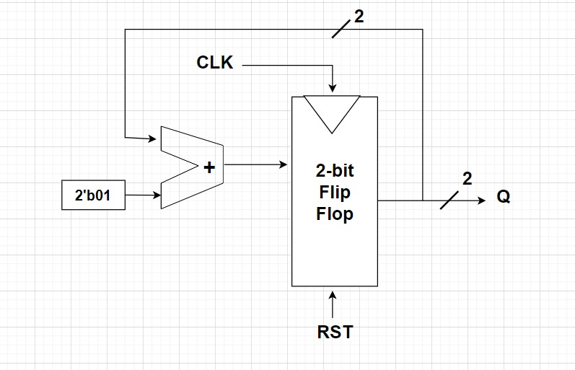

**Verilog Code:**

design.v

module two_bit_adder(input clk,reset,output [1:0]Q);

    reg [1:0] flop;

    always @(negedge clk) begin

        if(reset == 1'b1)

        begin

            flop <= 2'b00;

        end

        else begin

            flop <= flop + 2'b01;

        end

    end

    assign Q = flop;

endmodule

testbench.v

module tb();

    reg clk,reset;

    wire [1:0 ]Q;

    // module declare

   two_bit_adder dut (.clk(clk),.reset(reset),.Q(Q));

    always begin

      clk <= 1'b0;

      #50;

      clk <= 1'b1;

      #50;

    end

    initial begin

      reset <= 1'b1;

      #100;

      reset <= 1'b0;

      #500;

      $finish;

    end

    initial begin

        $dumpfile("dump.vcd");

        $dumpvars(0);

    end

endmodule

**Waveforms:**

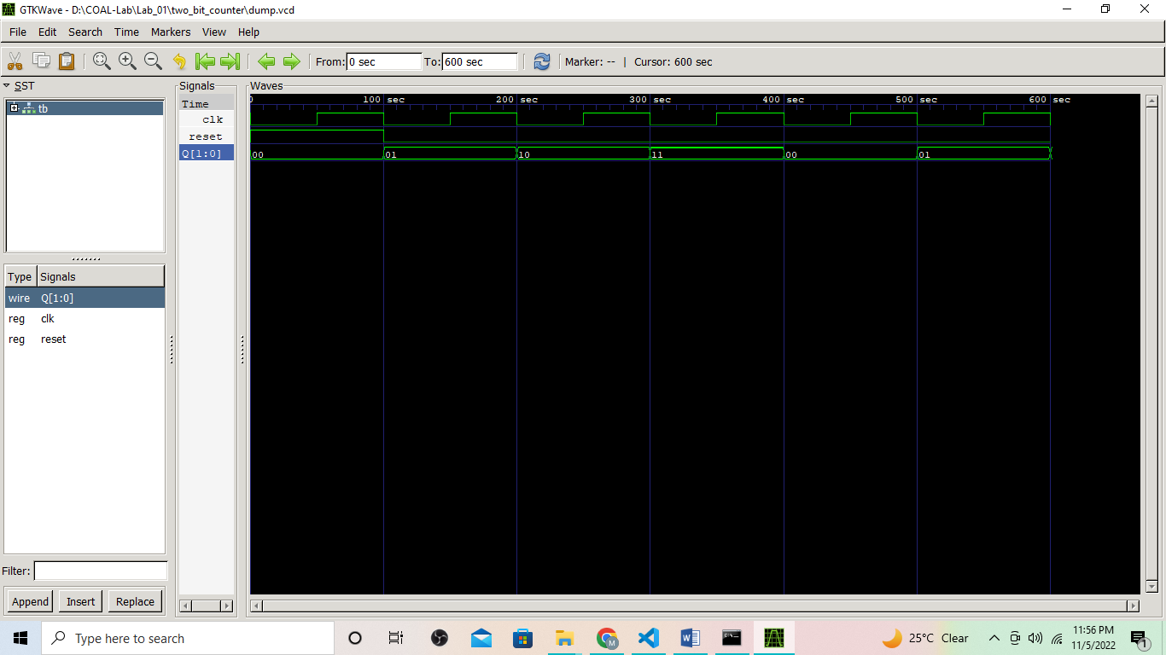

**Post Lab Task:**

**Task 05**

**Literature Review:**

A combinational circuit is the digital logic circuit in which the output depends on the combination of inputs at that point of time with total disregard to the past state of the inputs. The digital logic gate is the building block of combinational circuits. a combinational circuit could be used to add any number of inputs, or to subtract them, or to perform other mathematical operations.

**Task:**

Implement combinational circuit using Verilog.

**Truth Table:**

|  |  |  |  |  |
| --- | --- | --- | --- | --- |
| **A** | **B** | **C** | **D** | **X** |
| 0 | 0 | 0 | 0 | 1 |
| 0 | 0 | 0 | 1 | 1 |
| 0 | 0 | 1 | 0 | 0 |
| 0 | 0 | 1 | 1 | 1 |
| 0 | 1 | 0 | 0 | 0 |
| 0 | 1 | 0 | 1 | 0 |
| 0 | 1 | 1 | 0 | 1 |
| 0 | 1 | 1 | 1 | 1 |
| 1 | 0 | 0 | 0 | 1 |
| 1 | 0 | 0 | 1 | 0 |
| 1 | 0 | 1 | 0 | 1 |
| 1 | 0 | 1 | 1 | 0 |
| 1 | 1 | 0 | 0 | 0 |
| 1 | 1 | 0 | 1 | 1 |
| 1 | 1 | 1 | 0 | 0 |
| 1 | 1 | 1 | 1 | 0 |

**Block Diagram:**

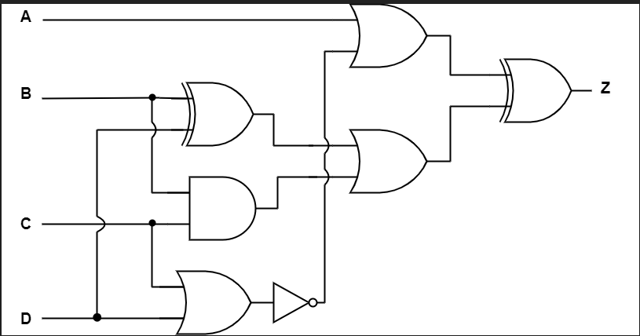

**Boolean Equation:**

Z = (A+()) ⊕ ((B⊕D)+B.C)

**Verilog Code:**

design.v

module post_lab(A,B,C,D,Q);

    input A,B,C,D;

    output Q;

    assign Q = (A|(!(C|D)))^((B^D)|(B&C));

endmodule

testbench.v

module tb();

    reg A,B,C,D;

    wire Q;

    post_lab dut(.A(A),.B(B),.C(C),.D(D),.Q(Q));

    initial begin

        A <= 1'b0;

        B <= 1'b0;

        C <= 1'b0;

        D <= 1'b0;

        #100;

        A <= 1'b0;

        B <= 1'b0;

        C <= 1'b0;

        D <= 1'b1;

        #100;

        A <= 1'b0;

        B <= 1'b0;

        C <= 1'b1;

        D <= 1'b0;

        #100;

        A <= 1'b0;

        B <= 1'b0;

        C <= 1'b1;

        D <= 1'b1;

        #100;

        A <= 1'b0;

        B <= 1'b1;

        C <= 1'b0;

        D <= 1'b0;

        #100;

        A <= 1'b0;

        B <= 1'b1;

        C <= 1'b0;

        D <= 1'b1;

        #100;

        A <= 1'b0;

        B <= 1'b1;

        C <= 1'b1;

        D <= 1'b0;

        #100;

        A <= 1'b0;

        B <= 1'b1;

        C <= 1'b1;

        D <= 1'b1;

        #100;

        A <= 1'b1;

        B <= 1'b0;

        C <= 1'b0;

        D <= 1'b0;

        #100;

        A <= 1'b1;

        B <= 1'b0;

        C <= 1'b0;

        D <= 1'b1;

        #100;

        A <= 1'b1;

        B <= 1'b0;

        C <= 1'b1;

        D <= 1'b0;

        #100;

        A <= 1'b1;

        B <= 1'b0;

        C <= 1'b1;

        D <= 1'b1;

        #100;

        A <= 1'b1;

        B <= 1'b1;

        C <= 1'b0;

        D <= 1'b0;

        #100;

        A <= 1'b1;

        B <= 1'b1;

        C <= 1'b0;

        D <= 1'b1;

        #100;

        A <= 1'b1;

        B <= 1'b1;

        C <= 1'b1;

        D <= 1'b0;

        #100;

        A <= 1'b1;

        B <= 1'b1;

        C <= 1'b1;

        D <= 1'b1;

        #100;

        $finish;

    end

    initial begin

        $dumpfile("dump.vcd");

        $dumpvars(0);

    end

endmodule

**Waveforms:**