

**Software Design and Analysis**

**Group Members:**

Muhammad Abdul Nafay (19P-0117)

Muhammad Usman (19P-0116)

Sheheryar Ali (19P-0120)

**Requirement Analysis:**

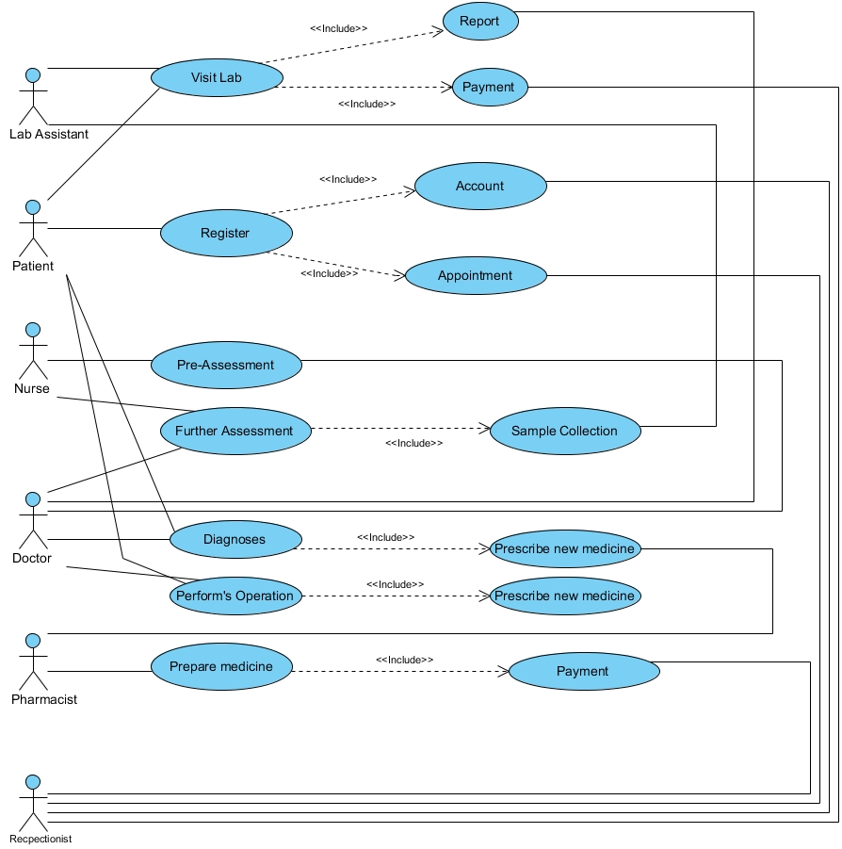**Use case diagram:**

**Activity Diagrams:** 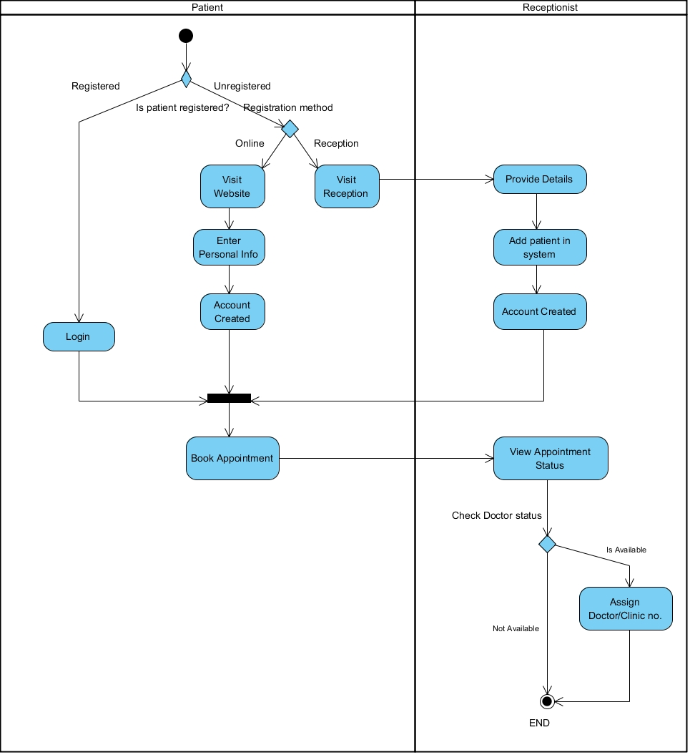

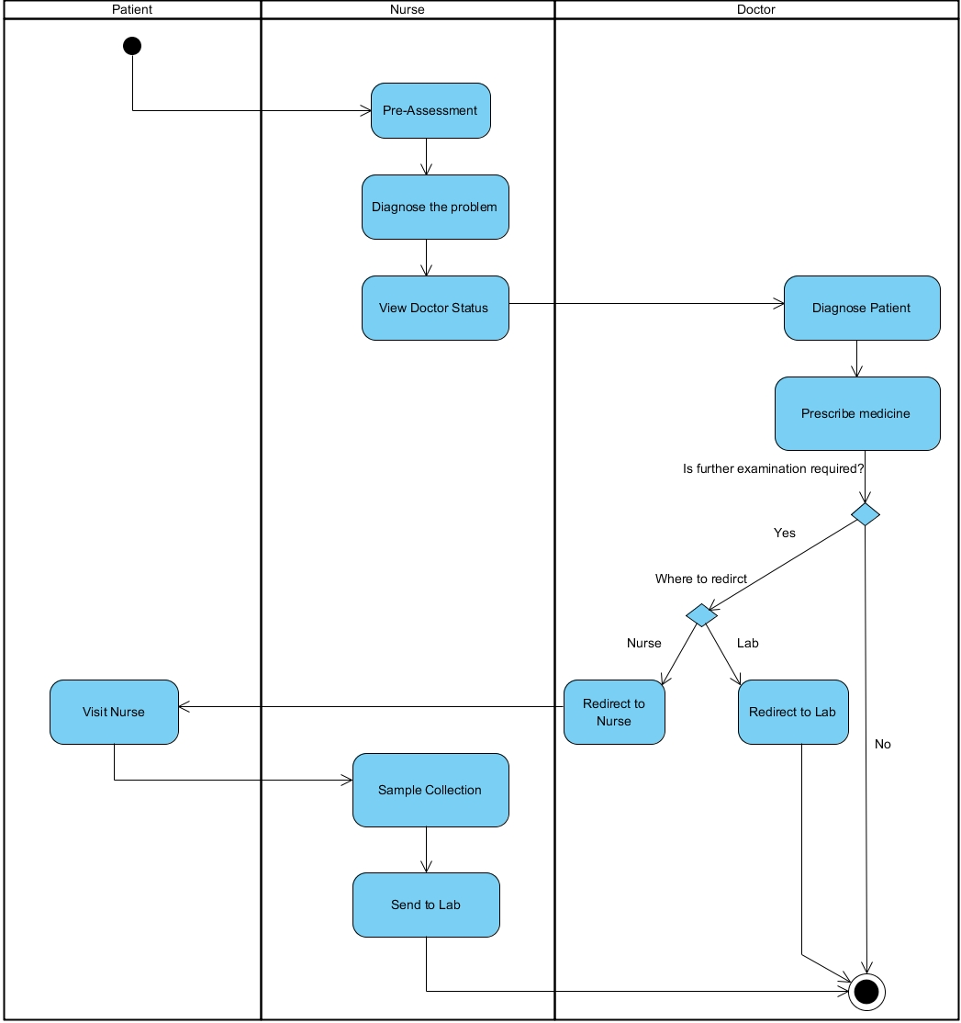

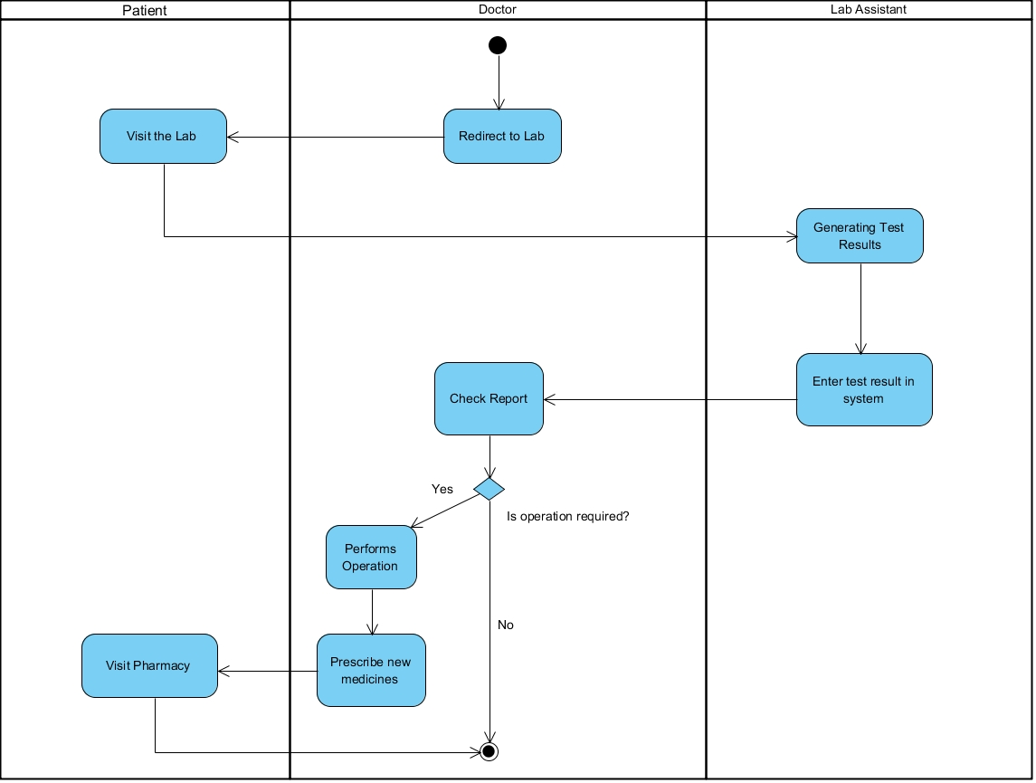

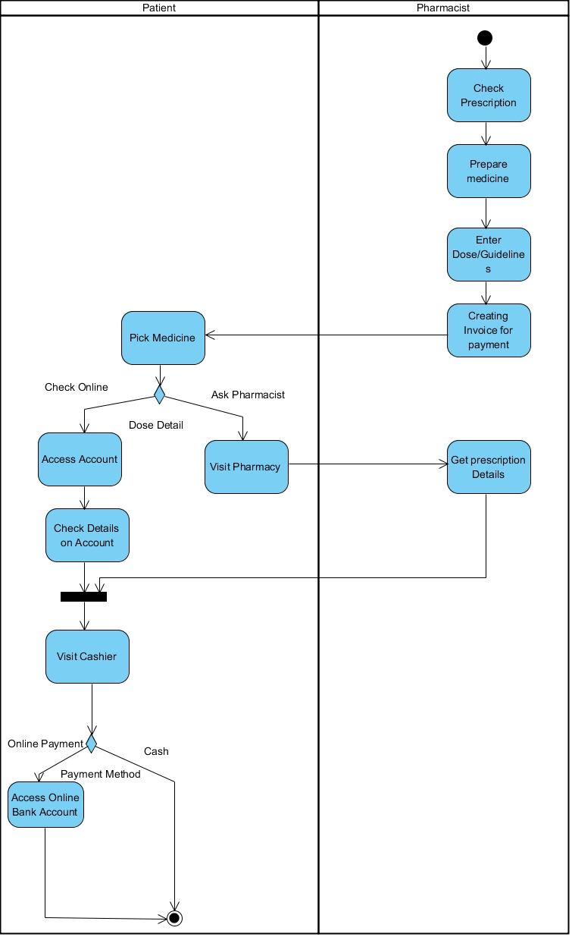

**Design Model:**

**Classes:**

|  |
| --- |
| *Person* |
| String Name  String CNIC  Int Age  String Gender  DMS dms  Input input  Output output |
| Display_Info() |

|  |
| --- |
| Patient |
| JPanel contentPane  String P_U  DMS dms  Input input  Output output  mainLogin L |
| Display_Info()  Register()  Write_Problem()  Available_Doctor()  Book_Appointment()  View_Prescription()  View_Medcine_Cost()  View_Invoice() |

|  |
| --- |
| Doctor |
| JPanel contentPane  DMS dms  Input input  Output output  String D_U  mainLogin L  String P_U  int fees  String Availaibility |
| Patient_Info()  Register()  Diagnose_Patient()  Prescribe_Medicine()  Perform_Operation()  Check_Lab_Report()  Update_Availablitiy_Status() |

|  |
| --- |
| Receptionist |
| dms : DMS  input : Input  output : Output |
| Display_All_Patients()  Display_All_Doctors()  Display_All_LabAssistant()  Display_All_Nurses()  Invoive_details()  Register_Patient()  Delete_Account() |

|  |
| --- |
| Nurse |
| JPanel contentPane  DMS dms  Input input  Output output  String N_U  mainLogin L  String P_U  String D_U  int fees |
| View_Patient_Info()  View_Doctor_Info()  Check_Availablitity()  Pre-Assessment() |

|  |
| --- |
| Lab Assistant |
| JPanel contentPane  String L_U  String P_U  DMS dms  nput input  Output output  mainLogin L |
| Perform_test() Patient_Info() |

|  |
| --- |
| Pharmacist |
| JPanel contentPane  String H_U  String P_U  DMS dms  Input input  Output output  mainLogin L  int M_Cost |
| Prescription_detail()  Prepare_medicine()  Add_Med_Cost() |

|  |
| --- |
| Input |
| Scanner input |
| getInt()  getChar()  getBool()  getString()  getLongString()  Input_INT_GUI() |

|  |
| --- |
| Output |
|  |
| display_Msg()  display_Line()  displayLine_Char()  Output_dialogbox() |

|  |
| --- |
| DMS |
| Output output |
| … |

**Programming Language:**

JavaScript (Eclipse IDE).

**Database:**

In our project we are using MS Access as our database, it requires a deriver called Ucanaccess to connect MS Access to Eclipse IDE.

**Graphical User Interface:**

We are using Windows builder repository to create our GUI interface.

**Class Diagram:**

The following is the class diagram:

**Receptionist**

**Input**

**Output**

**MS Access**

**Person**

**Patient**

**DMS**

**Lab Assistant**

**Nurse**

**Pharmacist**

**Doctor**

**Main Login**

**Inheritance**

**Composition**

**J Frame**

**Functions of the Classes:**

1. **Person:** Contains common variables that its derived classes will use.
2. **Patient:** Contains patient related functions such as personal info, view prescription, book appointment etc. It also includes its registration and profile class.
3. **Doctor:** Contains doctor related functions such as view patient info, check problem, diagnose patient, check patient test report etc. It also includes its registration and profile class.
4. **Nurse:** Performs pre-assessment and checks whether the doctor is available or not. It also includes its registration and profile class.
5. **Lab Assistant:** Is able to perform tests on the patient and update his/her database. It also includes its registration and profile class.
6. **Pharmacist:** Can check prescription details of a specific patient. It also includes its registration and profile class.
7. **Receptionist:** Has access to the complete database and can create and delete accounts. It also includes its registration and profile class.
8. **Main Login:** Main Login is our main class that takes display the login page and control the flow of the code. It creates objects of other classes when registration and profile of that particular class.
9. **Input:** Takes input based on the datatype of the value that is insert the textbox.
10. **Output:** Prints the things that are to be displayed on a window or dialog box.
11. **DMS:** This class manages all the functions related to the database (insertion, modification, print database and deletion).

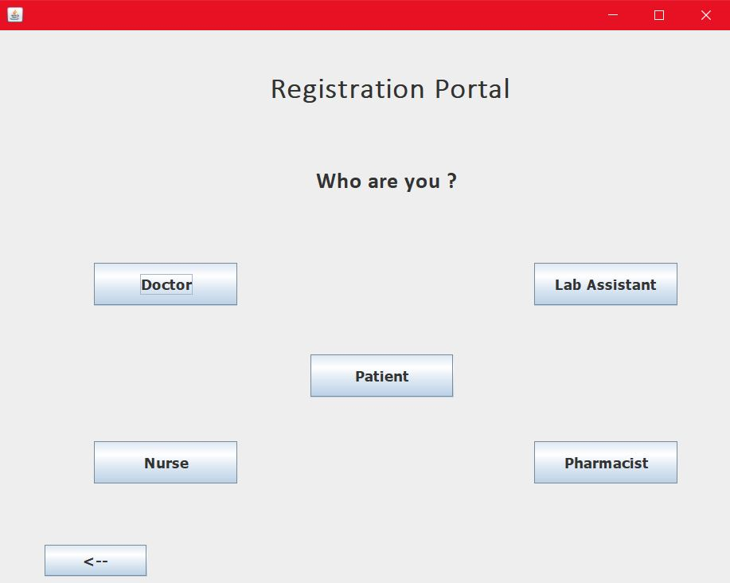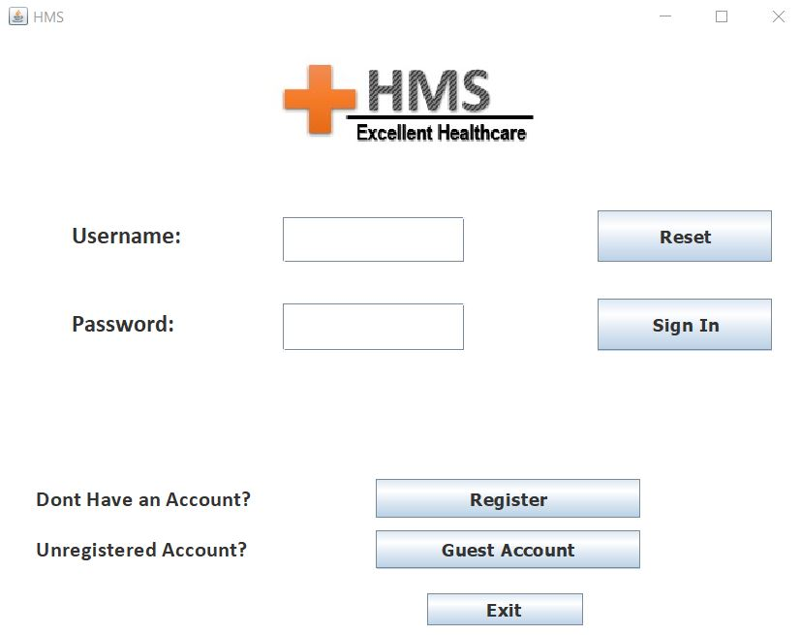**Project Demo:**

