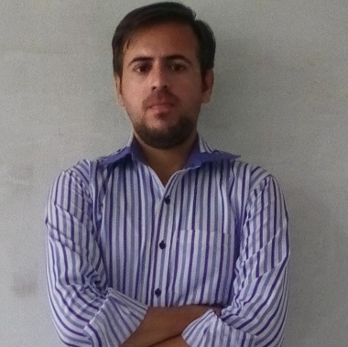

File Sharing Using Multimedia Player Application (Desktop Application using C# .net)

.NET)

2015-2016

Ideatech Software house

Malikabad plaza Six Road Rawalpindi

Currently working here as a work developer.

2016 - Current

Hycube Tech

Near Haji Chowk Sadiqadbad Rawalpindi

Working as SR Wordpress Developer

2015

Shakeel Trading Corporation

Opposite side of OJRI Camp Rawalpindi

Work as computer operator form March 2015 to August 2015.

**Muhammad Usman**

Muhammad Habib

37405-9919976-7

31-08-1990

Web developer

Dk 213/A Dhoke kashmirian Street 11, satellite town

Rawalpindi.

**Education**

**------------------------**

**------------------------**

**------------------------**

**------------------------**

**------------------------**

**--------------------------------**

**--------------------------**

**--------------------------**

**Skills**

WordPress 4.5

WAMP

Adobe Firework

Adobe Dreamweaver

Magento

Adobe Photoshop

***Software Skills***

S/O :

CNIC :

D.O.B :





















m.usman6304@gmail.com

usman_6304@yahoo.com

+92 336 5142124

+92 346 1574337

**Experience**







***Professional Skills***

HTML5/ CSS3

JavaScript / JQuery

PHP

Bootstrap

PSD to HTML

2005

Matriculation

Bajwa Public School.

Near Bilal Hospital Satellite Town Rawalpindi.

2005 - 2008

DAE (TELECOM)

Rawalpindi Institute Of technology (RIT)

In front of Ojri camp near Shamsabad Rawalpindi.

2010 - 2014

BS (Computer Science)

National University of Modern Languages – (NUML)

NUML H-9 Islamabad August 2010 – June 2014

I'm a 26 years old Computer graduated person from NUML currently working in Hycube tech .An experienced web developer, capable of designing and integrating web as per the requirements of the clients, in the required time. Aim to work in a challenging work environment where I can utilize my expertise in technical skills, towards the development and implementation of the new ideas, contributing to growth of the organization.

Sincerely

Final Year Project

**Personal info**







English

Urdu

Punjabi

**Language**

**About Me**