* **Simple Calculator App Using React-Native**

1 Runnig In Iphone :

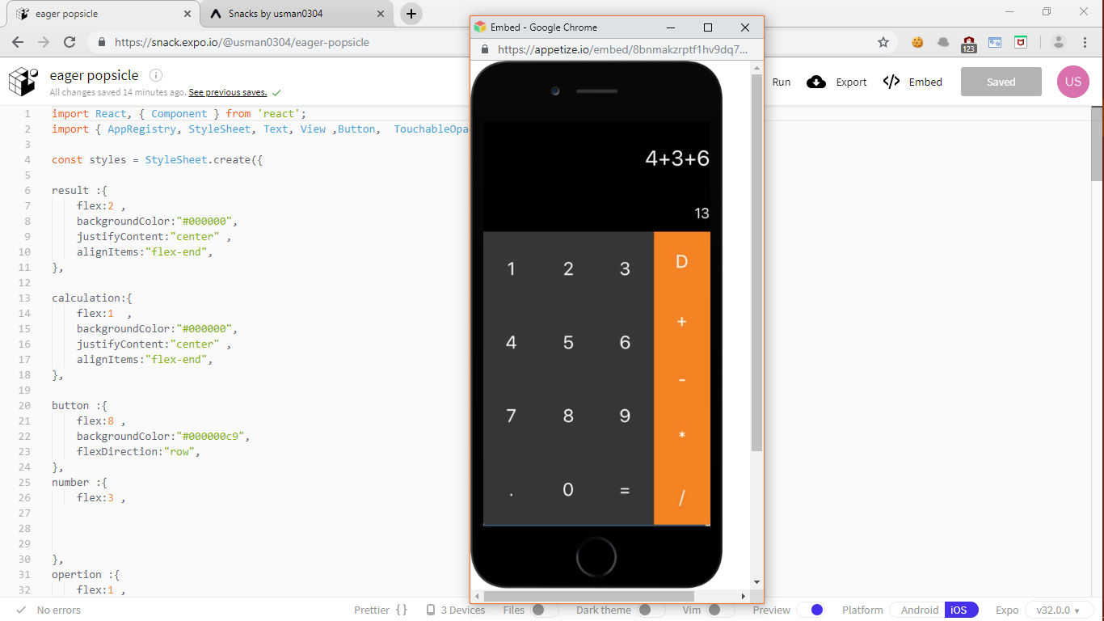

2 Runnig In Andriod Device :

