

Foodpanda

**Online food ordering application**

Section : BSCS-3F

**INSTRUCTOR:**

Ma'am Hurmat Hidayat

Sir Usman Wajid

**Submitted by:**

Asad Junaid Khan 22P-9170

Muhammad Usman 22P-9071

Muhammad Hashir 22P-9181



Introduction:

Our food ordering program, developed as part of the Object-Oriented Programming course, is a GUI based application that streamlines the process of ordering food. This program utilizes the principles of object-oriented programming, with a particular focus on inheritance, to create a modular and extensible solution.

The primary objective of our program is to provide a user-friendly interface for customers to browse through a variety of food items, customize their orders, and place them conveniently.

HOW TO RUN THE PROGRAM:

* Run the **main.exe** file located in the **Executable** folder:

  


* To locate your customer bills, open the **Database** folder in the **Executable** folder:



**Functionality:**

**The functionality of our food ordering program can be summarized into several distinct steps:**

* Firstly, the program allows users to select their desired restaurant from a list of available options. This selection determines the menu and food items that will be displayed to the user.

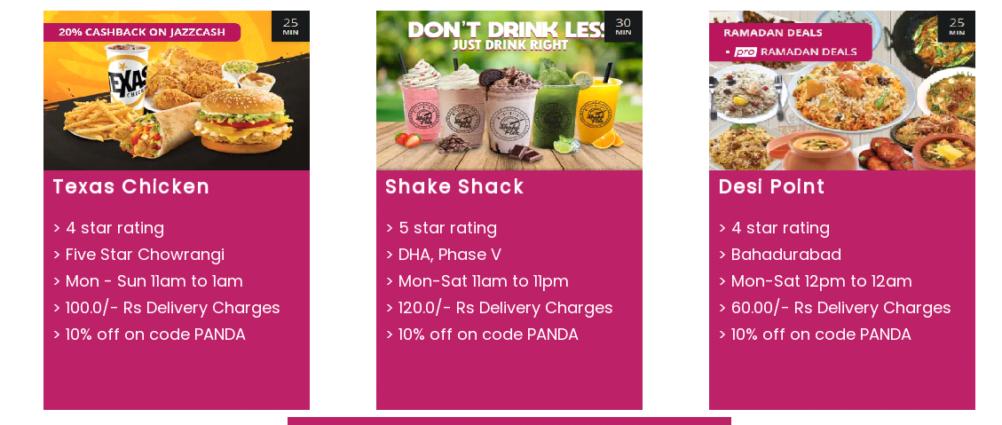

* Once a restaurant is chosen, the user can browse through the menu and select their preferred food items. The program enables them to add these items to their virtual shopping cart.

Eg:- Texas Chicken

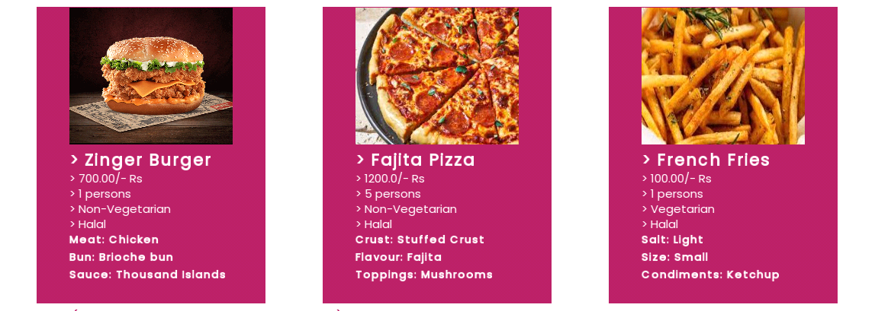

* The shopping cart provides users with the flexibility to update their order at any time. They can add or remove items, modify quantities, and see the updated total price. This feature ensures that users have complete control over their order before proceeding to checkout.



* To enhance the user experience, our program incorporates a coupon feature. Users can enter a coupon code, which, if valid, will apply a discount to the total price. This feature adds an element of savings and incentivizes users to make use of available coupons.



* Throughout the ordering process, the program continuously displays the total price in the cart. This allows users to have a clear understanding of their accumulated costs and make informed decisions accordingly.



OOP Implementation:

Total Classes: **17**

Class Names:

|  |  |
| --- | --- |
| App  Food Item  Order  Restaurant (Virtual)  Burger  Pizza  Fries  Fast Food  Karahi  BBQ | Biryani  Desi  Icecream  Shake  Icecream Shake  Dessert  State |

Inheritance:

* App <>- Dessert, Desi, FastFood
* Restaurant <- Dessert, Desi, FastFood
* FoodItem <- Burger, Fries, Pizza, BBq, Karahi, Biryani, Icecream, shake, IcecreamShake

Class Diagram:

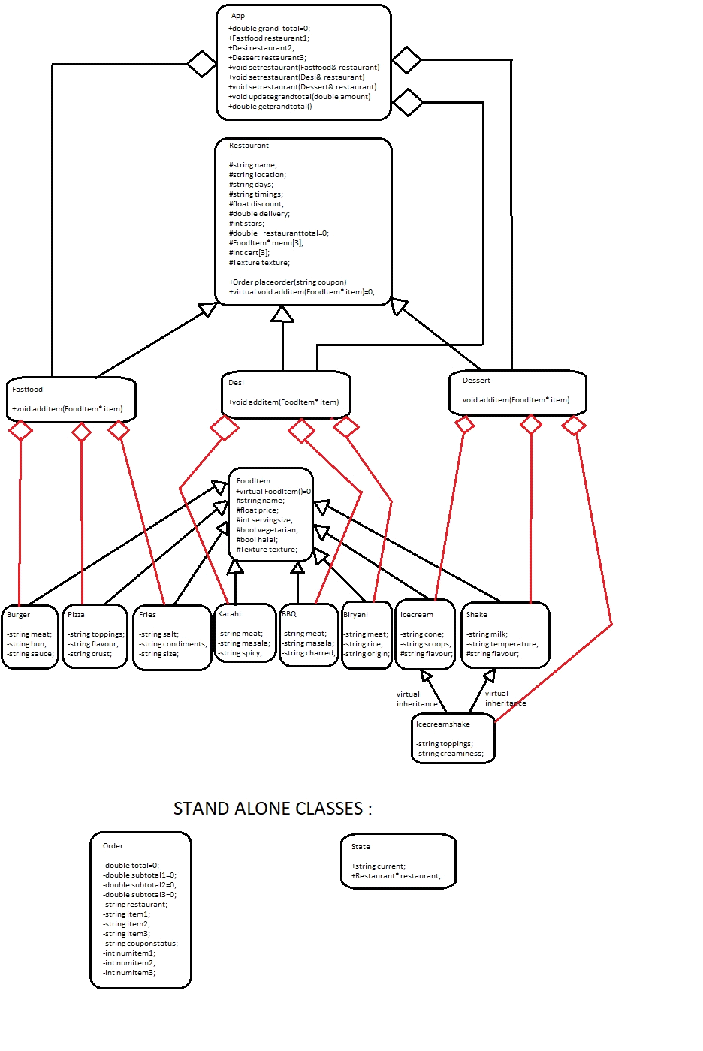

The Graphical User Interface:

**We have utilized the SFML library to program the GUI of our Foodpanda application.**

* The library files can be found in the lib & include folders in the src folder:



* The library uses a RenderWindow class’s object to instantiate a window to display the contents on.
* We have used the objects of the basic shape classes such as RectangleShape class, and other utility classes such as Text/Texture/Image etc. for each of the details you may observe in the app.
* STATE MANAGEMENT:  
  In order to logically and feasibly decide on runtime as to what content should be displayed, we have created a state class with properties such as the current state and the chosen restaurant, which enables the program to display the details accordingly. With the help of this functionality we have easily implemented a navigation functionality so that the user can easily go back and forth between multiple pages.

**REFERENCES & LINKS:**

* [**https://www.sfml-dev.org/**](https://www.sfml-dev.org/)
* [**https://www.youtube.com/playlist?list=PL6xSOsbVA1eaJnHo_O6uB4qU8LZWzzKdo**](https://www.youtube.com/playlist?list=PL6xSOsbVA1eaJnHo_O6uB4qU8LZWzzKdo)
* **Images copyrights owned by: (**[**https://www.foodpanda.pk/**](https://www.foodpanda.pk/)**)**