#### ELECTRONIC DEVICES & CIRCUIT

#### MINI PROJECT REPORT

## 

### SUBMITTED TO:

#### Ma’am ZAINAB

### SUBMITTED BY:

#### Muhammad Usman Noor

### REG.NO.

#### 2021-MC-16

DEPARTMENT OF MECHATRONICS & CONTROL ENGINEERING, UET LAHORE

## TABLE OF CONTENT:

**1.INTRODUTION1**

1.1 TRASFORMER1

1.2. DIODES1

1.3. CAPACITOR…………………………………………………………………………………………………...2

1.4. VOLTAGE REGULATOR……………………………………………………………………………………..2

# **2.METHODOLOGY 4**

2.1. STEP DOWN AC VOLTAGE4

2.2. RECTIFICATION5

2.3. FILTERATION…………………………………………………………………………………………………6

2.4. VOLTAGE REGULATION…………………………………………………………………………………….7

**3.PCB LAYOUT & 3D VISULIZATION**………………………………………………………………………………………………………….7

**4.VERO BOARD**………………………………………….…………………………………………………………………………………………….8

**5.CONCLUSION & ENHANCEMENT**………………………………………………………………………………………………………….9

**6. REFERENCE**………………………………………………………………………………………………………………………………………….9

**7. APPENDIX**………………………………………………………………………………………………………………………………………….10

# **INTRODUCTION:**

We are making a 5volt **DC** supply by **220v** AC. For this purpose, we use **9-0-9** transformer a **capacitor, diodes& 5volt dc regulator.**

* 1. Transformer:

Transformer is a device which can step up or step down the ac voltage supply. The transformer we use is shown in fig. we give 220v ac and it convert it into 9v or 18v because it is **9-0-9** transformer.

The middle black wire is at zero & the other two blue are at 9v. The copper wire is wounded inside it to step up or step down the ac voltage.

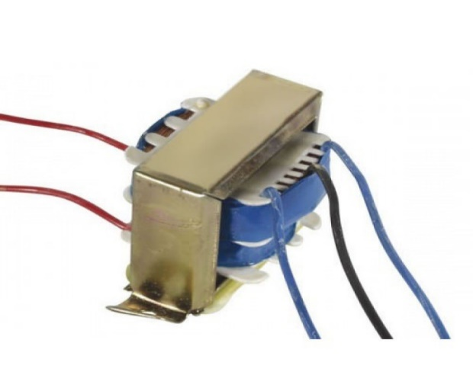It has been over 100 years since the introduction of the first commercial Transformer when the mass production began. Since then, many additional modifications were developed to support various applications, such as electromagnetic, relays, pumps or elements. The general concept of Chassis Mounting Transformers is around the usage of magnetic induction between coils to convert current and or voltage levels without changing the frequency. Today, we are proudly introducing our own branded RS PRO Mains Transformer, packed in a chassis mount configuration. Our chassis type Mount Transformer provides a primary voltage rating of 230 V ac and power rating of 20 VA for exceptional isolating qualities. The two separate secondary windings can be connected either in series or parallel to give a wide range of output voltage and current options [1]

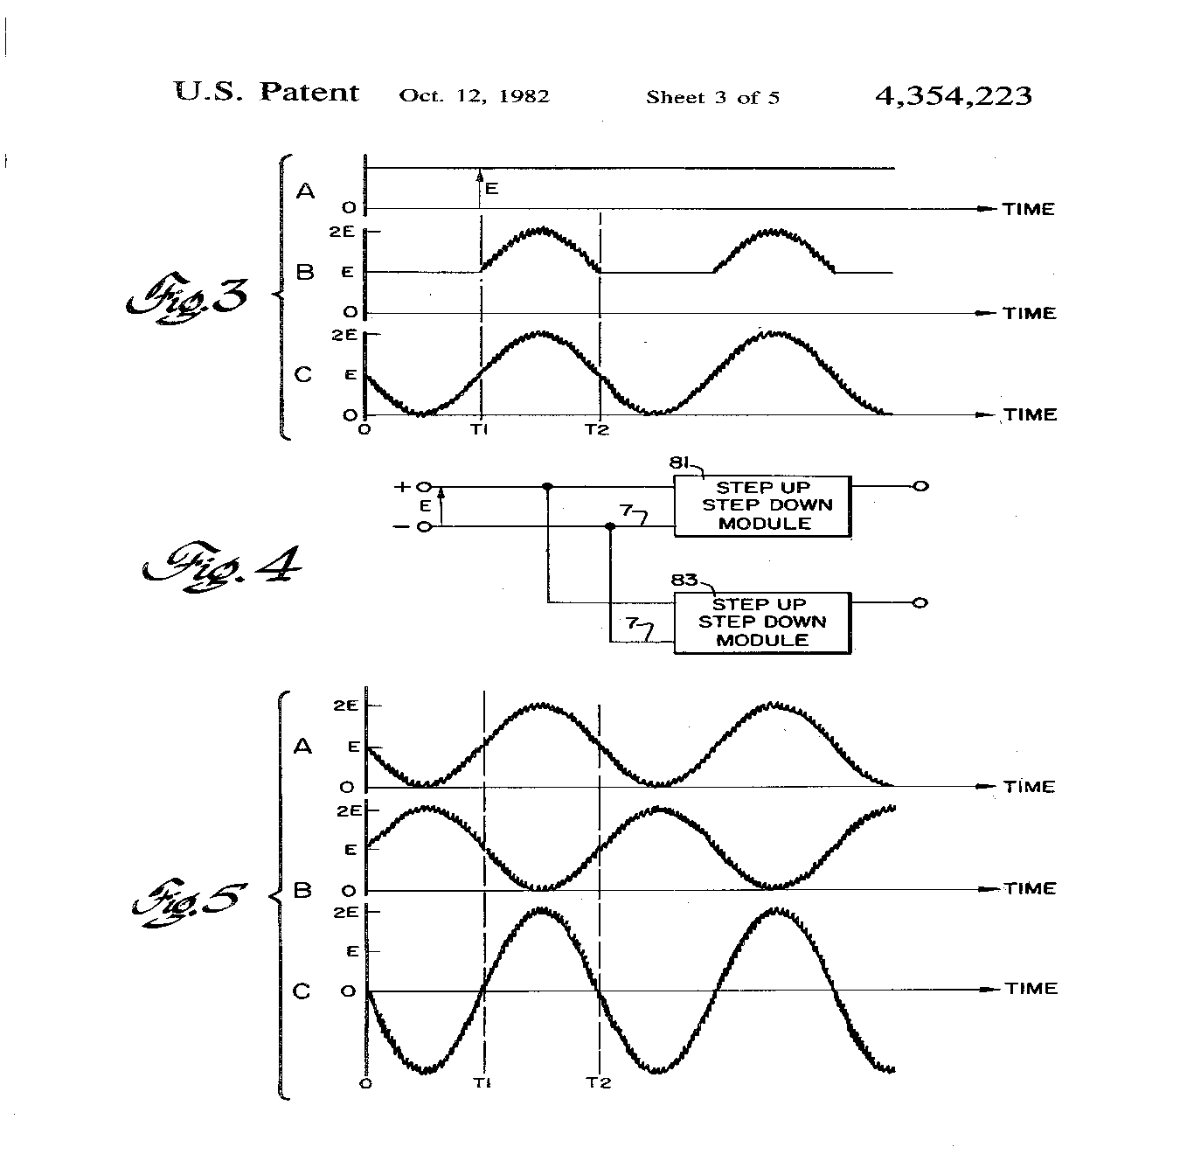 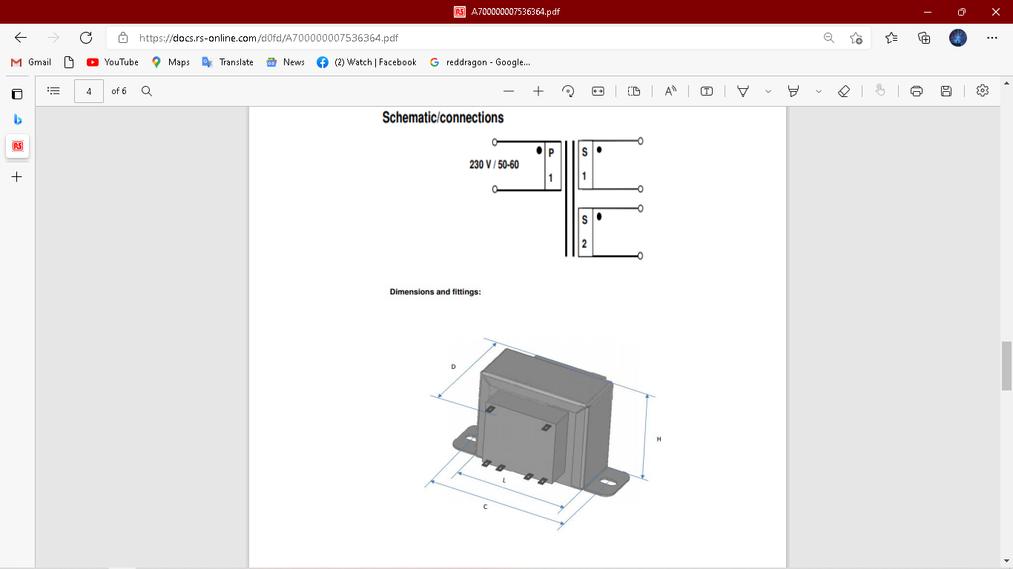

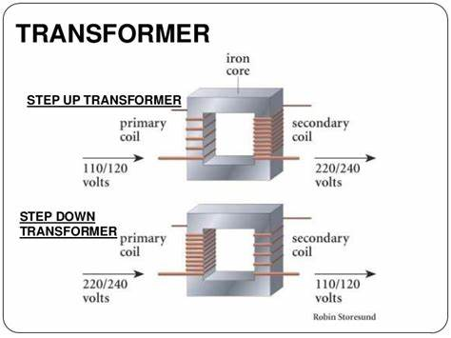

* 1. Diodes:

Diodes are the PN junction used to rectify the ac voltage to make it dc it only allows current to flow in forward bias direction. The diodes wee use are show in fig.

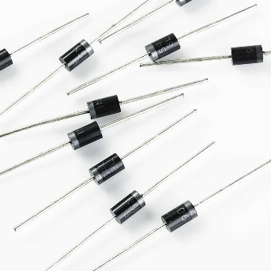A diode is a device which allows current flow through only one direction. That is the current should always flow from the Anode to cathode. The cathode terminal can be identified by using a grey bar as shown in the picture above.

For **1N4007 Diode**, the maximum current carrying capacity is 1A it withstands peaks up to 30A. Hence, we can use this in circuits that are designed for less than 1A.  The reverse current is 5uA which is negligible. The power dissipation of this diode is 3W. [2]

****Applications of Diode****

* Can be used to prevent reverse polarity problem
* Half Wave and Full Wave rectifiers
* Used as a protection device
* Current flow regulators

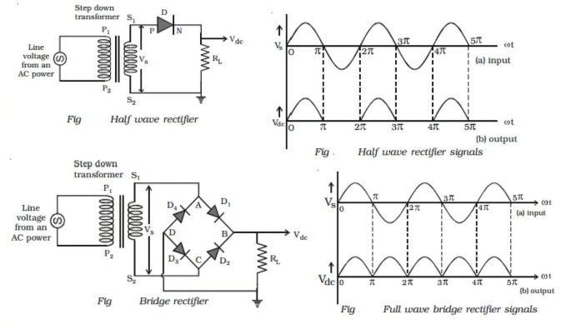

* 1. Capacitor:

We use **1000uf** & **0.1uf** capacitor for filtration. The capacitor are shown in fig. the capacitor are used to remove the pulses in the dc supply after we rectify it.

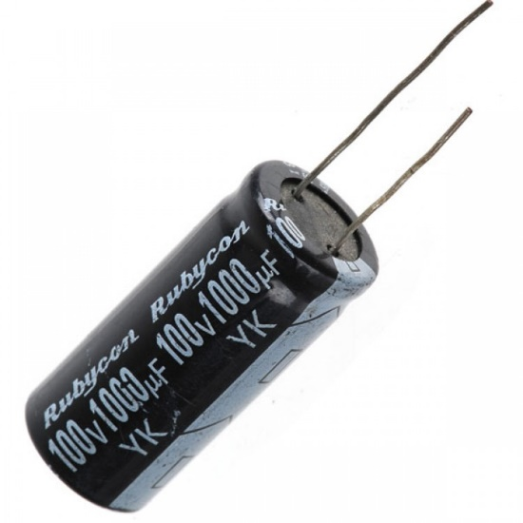 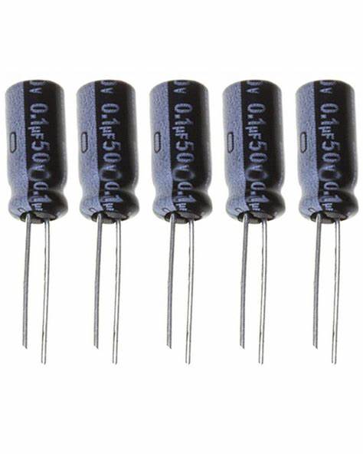

The [capacitor](https://www.elprocus.com/what-is-electrolytic-capacitor-construction-symbols-adavantages/) is a reactive component, used in analog electronic [filters](https://www.elprocus.com/types-active-filters-and-applications/) because the capacitor impedance is a function of frequency. The capacitor that affects a signal can be frequency-dependent. So, this property is widely used in designing the filter. Analog electronic filters like LPF can be used to execute a function of predefined signal processing. The main function of this filter is to allow low frequencies and block high frequencies. Similarly, an HPF allows high frequencies and blocks low frequencies. The electronic filter can be made with the help of analog components like resistors, capacitors, transistors, op-amps, and inductors. This article discusses an overview of the filter capacitor and it’s working. [3]

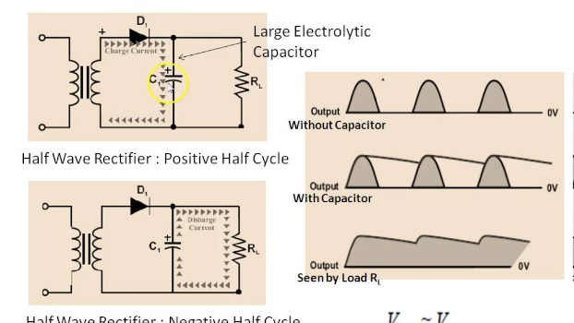 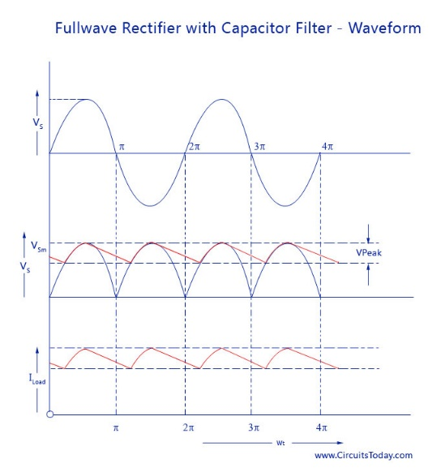

* 1. Voltage Regulator:

The purpose of regulator is to convert high voltage to low voltage and dissipates the rest of the voltage as heat. We use 7805 voltage regulator which gives 5v dc 9v or 12v dc. The voltage regulator has 3 pins input output and the middle one is ground. The voltage regulator is shown in fig.

The **7805 Voltage Regulator** IC is a commonly used voltage regulator that finds its application in most of the electronics projects. It provides a constant +5V output voltage for a variable input voltage supply. [4]

****7805 Regulator Features****

* 5V Positive Voltage Regulator
* Minimum Input Voltage is 7V
* Maximum Input Voltage is 25V
* Operating current(IQ) is 5mA
* Internal Thermal Overload and Short circuit current limiting protection is available.
* Junction Temperature maximum 125 degree Celsius
* Available in TO-220 and KTE package

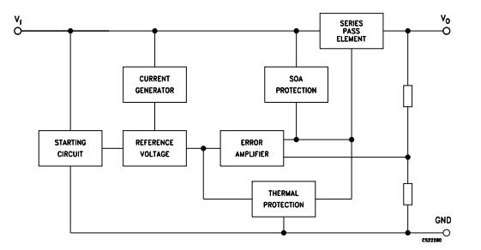 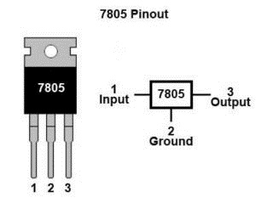

1. METHODOLOGY:
   1. Step down AC voltage

As we are converting 220V AC into a 5V DC, first we need a step-down transformer to reduce such high voltage. Here we have used 9-0-9 1A step-down transformer, which convert 220V AC to 9V AC. In transformer there are primary and secondary coils which step up or step down the voltage according to the no of turn in the coils.

Selection of proper transformer is very important. Current rating depends upon the Current requirement of **Load circuit** (circuit which will use the generate DC). The voltage rating should be more than the required voltage. Means if we need 5V DC, transformer should at least have a rating of 7V, because voltage regulator IC 7805 at least need 2V more i.e. 7V to provide a 5V voltage.

* 1. Rectification

Rectification is the process of removing the negative part of the Alternate Current (AC), hence producing the partial DC. This can be achieved by using 4 diodes. Diodes only allow current to flow in one direction. In first half cycle of AC diode D2 & D3 are forward biased and D1 and D4 are reversed biased, and in the second half cycle (negative half) Diode D1 and D4 are forward biased and D2 and D3 are reversed biased. This Combination converts the negative half cycle into positive.

* 1. Filtration

The output after the Rectification is not a proper DC, it is oscillation output and has a very high ripple factor. We don’t need that pulsating output, for this we use Capacitor. Capacitor charge till the waveform goes to its peak and discharge into Load circuit when waveform goes low. So when output is going low, capacitor maintains the proper voltage supply into the Load circuit, hence creating the DC. Now how the value of this filter capacitor should be calculated. Here is the formulae:

C = I * t / V

C= capacitance to be calculated

I= Max output current (let’s say 500mA)

t= 10ms,

We will get wave of 100Hz frequency after converting 50Hz AC into DC, through full wave bridge rectifier. As the negative part of the pulse is converted into positive, one pulse will be counted two. So the Time period will be 1/100= .01 Second= 10ms

V = Peak voltage – voltage given to voltage regulator IC (+2 more than rated means 5+2=7)

9-0-9 is the RMS value of transforms so peak voltage is Vrms * 1.414= 9* 1.414= 12.73v

Now 1.4v will be dropped on 2 diodes (0.7 per diode) as 2 will be forward biased for half wave.

So 12.73 – 1.4 = 11.33v

When capacitor discharges into load circuit, it must provide 7v to 7805 IC to work so finally V is:

V = 11.33 – 7= 4.33v

So now C = I * t / V

C = 500mA * 10ms / 4.33 = .5 * .01 / 4.33 = 1154uF ~ 1000uF

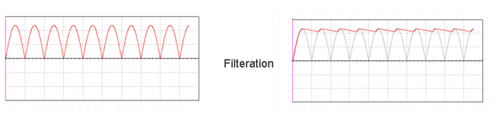

* 1. Voltage Regulation

A voltage regulator IC 7805 is used to provide a regulated 5v DC. Input voltage should be 2volts more than the rated output voltage for proper working of IC, means at least 7v is needed, although it can operate in input voltage range of 7-20V. Voltage regulators have all the circuitry inside it to provide a proper regulated DC. Capacitor of  0.01uF should be connected to the output of the 7805 to eliminate the noise, produced by transient changes in voltage.

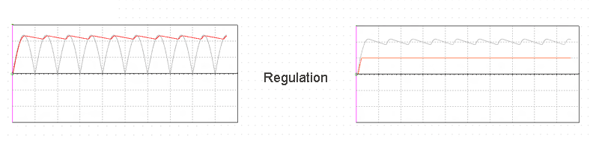

Here is the complete circuit diagram for cell phone charger circuit:

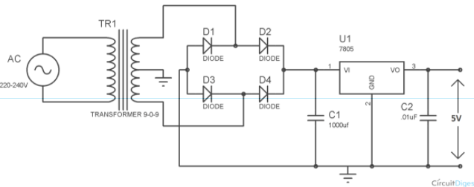

1. PCB Layout & 3D Visulization:

I make this circuit on proteus and the pcb layout & 3D visulization is given below.

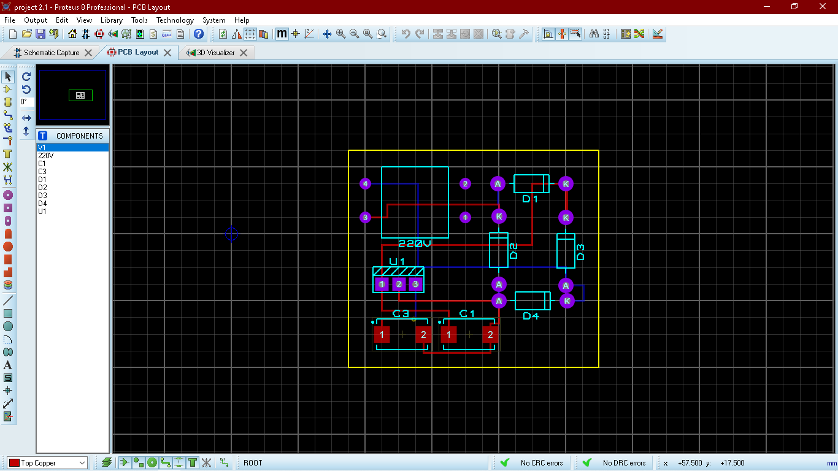 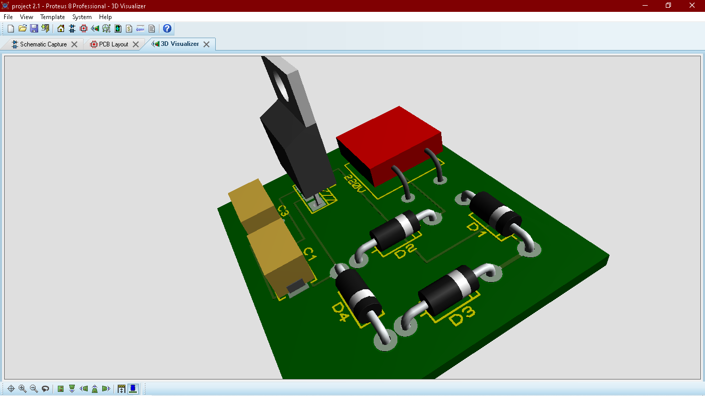

1. VERO BOARD:

# 

1. Conclusion & Enhancement:

From this we can get a dc 5voltage. I am thinking of using zenor diodes to make the 5volt constant and use it to operate some load.

1. References

|  |  |
| --- | --- |
| [1] | [Online]. Available: https://docs.rs-online.com/d0fd/A700000007536364.pdf. |
| [2] | [Online]. Available: https://components101.com/diodes/1n4007-diode. |
| [3] | [Online].Available:https://www.elprocus.com/what-is-a-filter-capacitor-working-and-its-applications/#:~:text=The%20capacitor%20is%20a%20reactive%20component%2C%20used%20in,property%20is%20widely%20used%20in%20designing%20the%20filter.. |
| [4] | [Online]. Available: https://components101.com/ics/7805-voltage-regulator-ic-pinout-datasheet. |

1. Appendix:
2. 1000uf 50volt capacitor.
3. 0.1uf capacitor.
4. 7805 voltage regulator.
5. 9-0-9 transformer.
6. Connector.
7. Diodes.