**ELECTRONIC DEVICES & CIRCUIT**

**MINI PROJECT REPORT**

## 

### **SUBMITTED TO:**

#### Ma’am ZAINAB

### **SUBMITTED BY:**

#### **USMAN NOOR**

### **REG.NO.**

#### **2021-MC-12**

**DEPARTMENT OF MECHATRONICS & CONTROL ENGINEERING, UET LAHORE**

**Contents**

**1. Project Amplifier : 3**

**2. Transistor: 3**

2.1 Purpose: 3

**3. Resistor: 3**

**4. Capacitor: 4**

**5. Circuit Diagram: 5**

5.1PCB Layout: 6

**6. Methodology: 6**

**7. Calculation: 7**

**8. Conclusion: 7**

# Project Amplifier :

Audio amplifiers are to reproduce input audio signals at sound-producing output elements, with desired volume and power levels. It is the basic circuit configuration that is required to amplify, the audio signal received through a device like a microphone or an audio signal that is to be transmitted out through a speaker, a radio device or a wireless transmitter etc.

The components used in this project are:

1. **Transistor**
2. **2.2k resistor**
3. **22 microfarad capacitors**
4. **3.5mm jack**
5. **Speaker**
6. **PCB board**

# Transistor:

A transistor is a semiconductor device used to amplify or switch electrical signals and power. The transistor is one of the basic building blocks of modern electronics. It is composed of semiconductor material, usually with at least three terminals for connection to an electronic circuit.

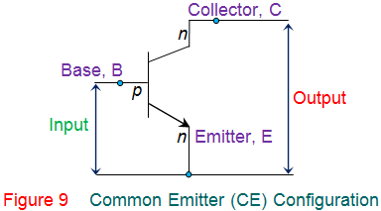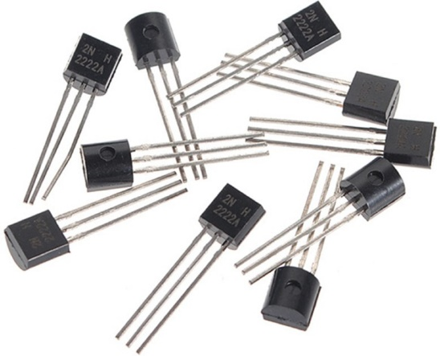

## 2.1 Purpose:

A transistor is an electronic component that is used in circuits to either amplify or switch electrical signals or power, allowing it to be used in a wide array of electronic devices. A transistor consists of two PN diodes connected back to back. It has three terminals namely emitter, base and collector.

# Resistor:

A device having resistance to the passage of an electric current. It has electrical resistance that is used in an electric circuit for protection, operation, or current control. You can measure the value of resistance of a resistor by using a multimeter or the color code that is on the resistor.

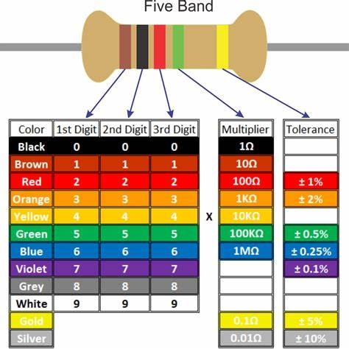

There are two types of resistor **1.** Metal Film **2.** Ceramics

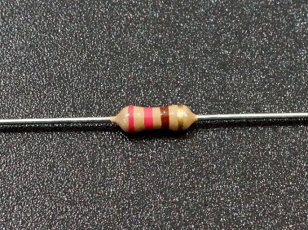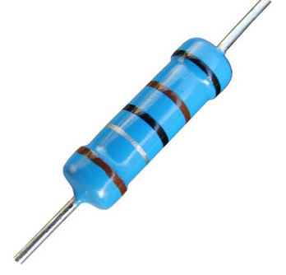

# Capacitor:

A device used to store an electric charge, consisting of one or more pairs of conductors separated by an insulator. It stores electrical energy, consists of two conductors in close proximity which are insulated from each other. A simple example of such a storage device is the parallel-plate capacitor. Capacitors of different values are available to us.

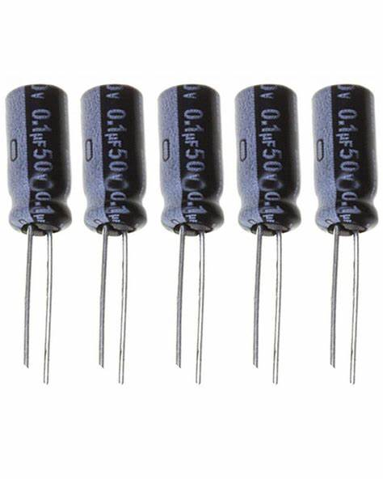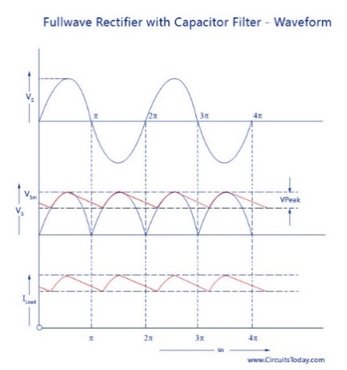

The [capacitor](https://www.elprocus.com/what-is-electrolytic-capacitor-construction-symbols-adavantages/) is a reactive component, used in analog electronic [filters](https://www.elprocus.com/types-active-filters-and-applications/) because the capacitor impedance is a function of frequency. The capacitor that affects a signal can be frequency-dependent. So, this property is widely used in designing the filter. Analog electronic filters like LPF can be used to execute a function of predefined signal processing. The main function of this filter is to allow low frequencies and block high frequencies. Similarly, an HPF allows high frequencies and blocks low frequencies. The electronic filter can be made with the help of analog components like resistors, capacitors, transistors, op-amps, and inductors. This article discusses an overview of the filter capacitor and it’s working

**Other elements of the circuit include a jack, a small speaker and a PCB board**.

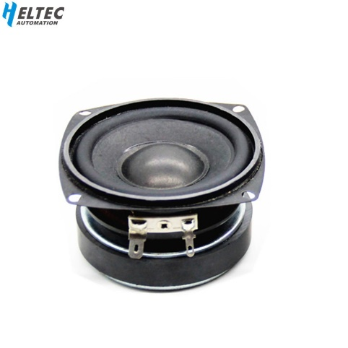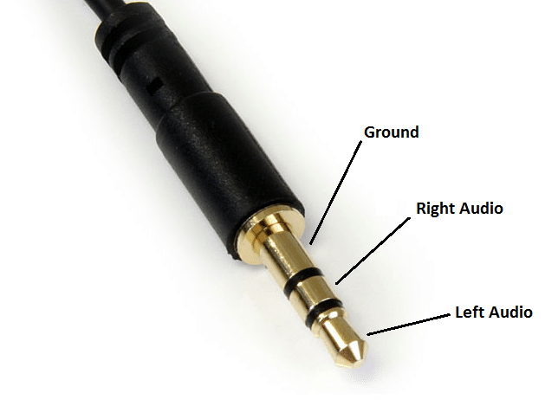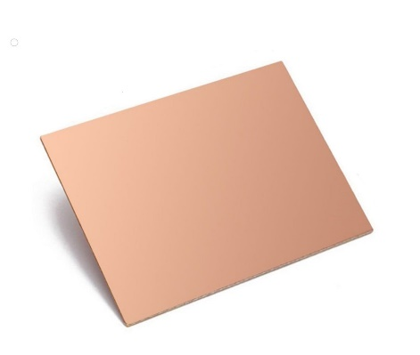

The input signal is applied with the help of any mic. As it reaches the transistor, the movements of majority and the minority charge carriers take place. If the transistor is of n-p-n-type, in that case, the connections of the supply are provided in such a way that the width of the depletion region should be less which indicates that the transistor should be in fully conducting mode.

# Circuit Diagram:

The circuit diagram given to us s as follow:

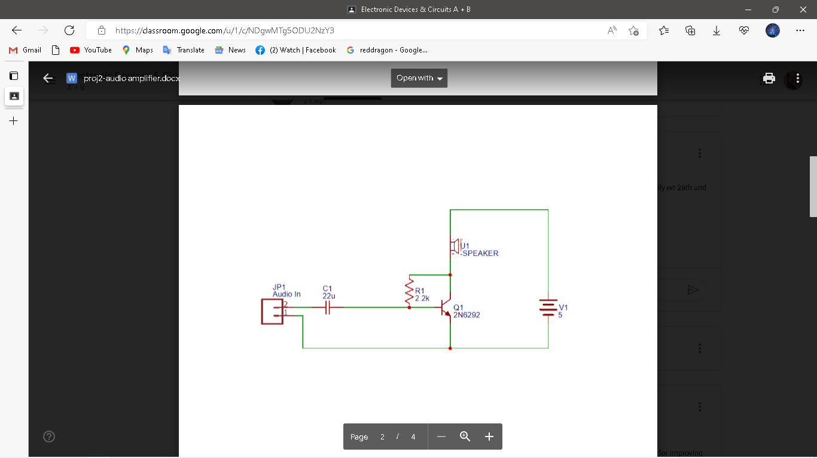

## PCB Layout:

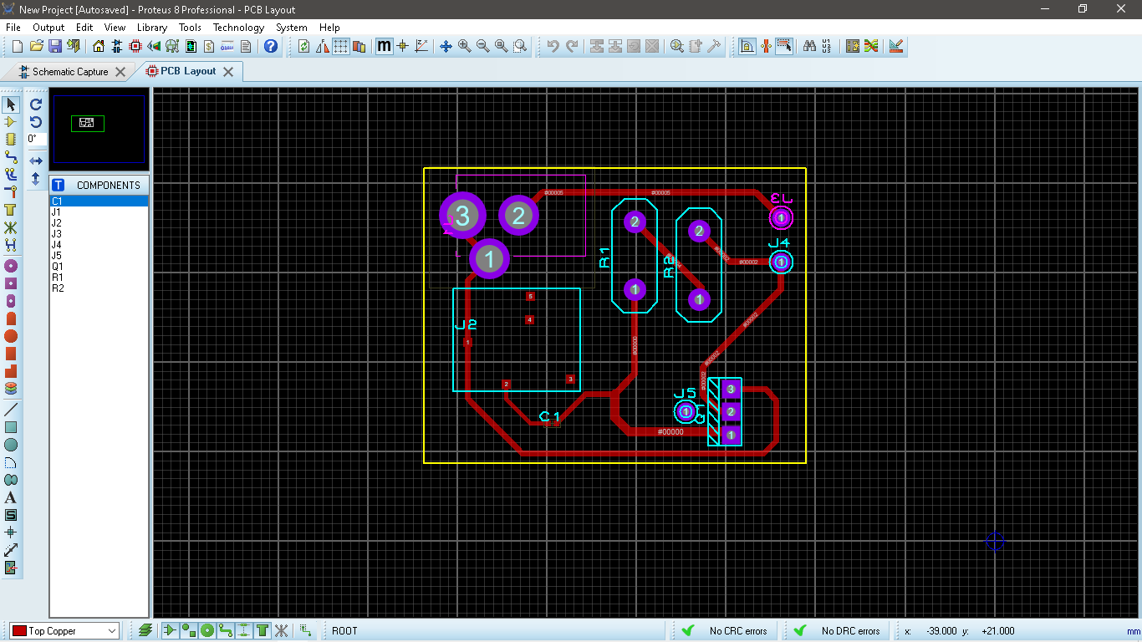

# Methodology:

1. Prepare a PCB board by using a plane copper PCB board. Create a PCB design and paste it on the board by using a hot iron.

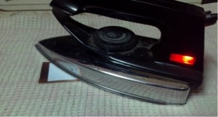

1. Make sure to clean the board properly before you design it. Complete the process of etching for the design to stick on the board. If there are any incomplete paths, use a black permanent marker to complete it
2. . And put it in the ferric chloride solution

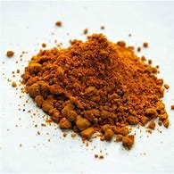

1. Drill holes for component placement.

. 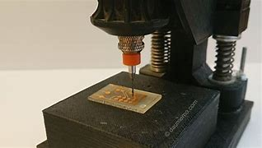

1. It is important to test the circuit on a breadboard before you solder the components on the board. After soldering the components, check for the proper working of the circuit.

# Calculation:

Vin = 7.35V

Vcc = 7.35-3.75 =6.6V

Ic ­= 0.775A

IB  = (Vcc - VBE) / RB

IB = (6.6- 0.7)/4.4 =1.34mA

Current Gain = β = Ic / IB

**β= 578 (gain)**

# Conclusion:

Etching is always the most taxing part of the project. Adjusting the speaker to the right value was also difficult but consistent efforts

The final product is shown below

