Taqdir Ali

Taqdir.ali@oslab.khu.ac.kr

Demo harness

Life-log Mapping and Representation -Version 2.5

1. Database configuration
   1. Download Microsoft SQL Server 2012 from Microsoft official website
   2. Install the Management Studio and set its password and login
   3. Where Server name is (local) or your system name
   4. Authentication is set to “SQL Server Authentication”



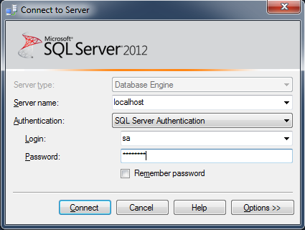

* 1. Create a database with Name “DBMiningMindsV1_5”

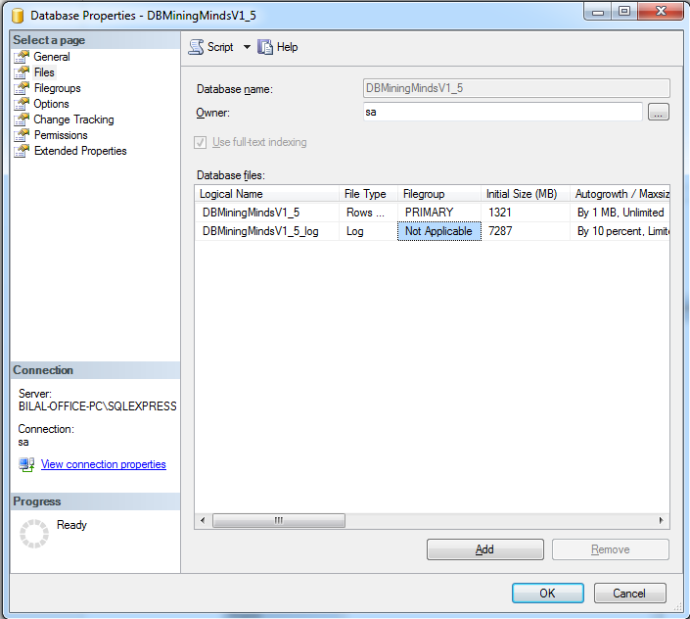

* 1. Select the database “DBMiningMindsV1_5” and right click and select new query

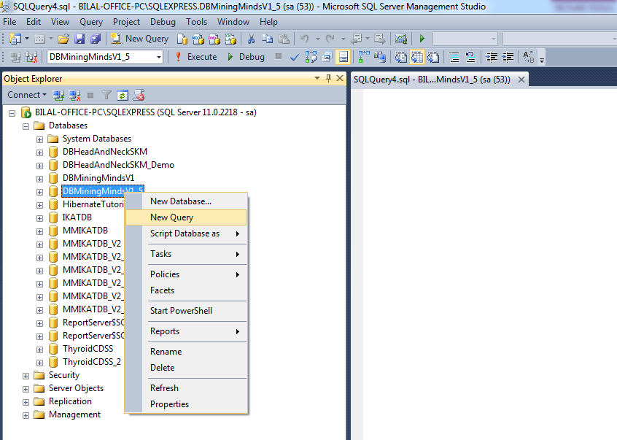

* 1. Download the script of database schema “MiningMindsLLMRSchema.sql”
  2. Open the “MiningMindsLLMRSchema.sql” file.
  3. Copy all the queries and paste into new query window.

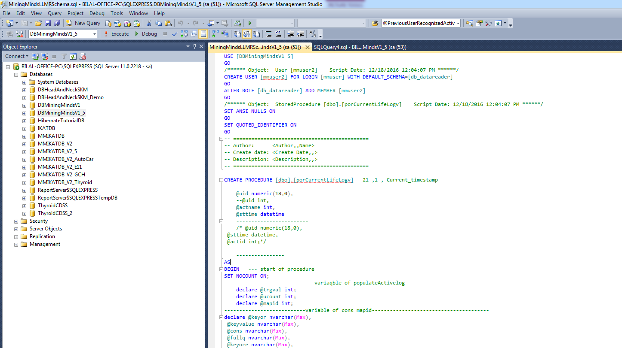

* 1. Then execute the query, it will create the whole schema of database and create stored procedure in selected database.
  2. Now download the script of database data “MiningMindsLLMRData.sql”
  3. And follow steps g, h, and i for “MiningMindsLLMRData.sql” file, it will import the data instances to the selected database.
  4. Database is ready for the working

1. JDK and JAVA_HOME
   1. Make sure JDK is installed, and “JAVA_HOME” variable is added as Windows environment variable
2. Apache Maven installation
   1. Download Apache maven and install it using following steps
   2. Visit [Maven official website](http://maven.apache.org/download.cgi), download the Maven zip file,

For example: apache-maven-3.2.2-bin.zip.

* 1. Unzip it to the folder you want to install Maven.

(Assume you unzip to this folder – C:\Program Files\Apache\maven)

1. Add MAVEN_HOME
   1. Add MAVEN_HOME variables in the Windows environment, and point it to your Maven folder.
2. Add to PATH
   1. Update PATH variable, append Maven bin folder, so that you can run the Maven’s command everywhere.
3. Verify the maven installation
   1. Done, to verify it, run mvn –version in the command prompt. For more detail of maven installation visit the following link.

( <https://www.mkyong.com/maven/how-to-install-maven-in-windows/>)

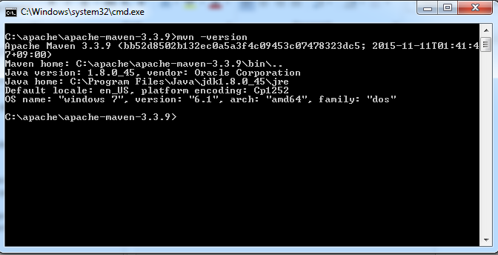

1. Download and Install Apache Tomcat
   1. Go to [http://tomcat.apache.org](http://tomcat.apache.org/) ⇒ Downloads ⇒ Tomcat 8.0 ⇒ "8.0.{xx}" (where {xx} is the latest upgrade number) ⇒ Binary Distributions ⇒ Core ⇒ "ZIP" package (e.g., "apache-tomcat-8.0.{xx}.zip", about 8 MB).
   2. Create your project directory, say "d:\myProject" or "c:\myProject".
   3. UNZIP the downloaded file into your project directory. Tomcat will be unzipped into directory "d:\myProject\apache-tomcat-8.0.{xx}".
   4. For more detail to install Apache Tomcat visit the following link <https://www.ntu.edu.sg/home/ehchua/programming/howto/Tomcat_HowTo.html>
2. Download source file src and pom file into the appropriate project folder
3. Start Command Prompt
4. Change the directory to your project directory and folder
5. Run “mvn clear install” command

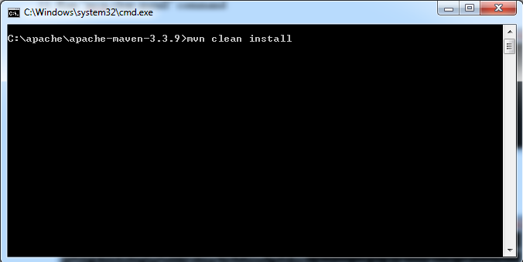

1. Project will be built successfully

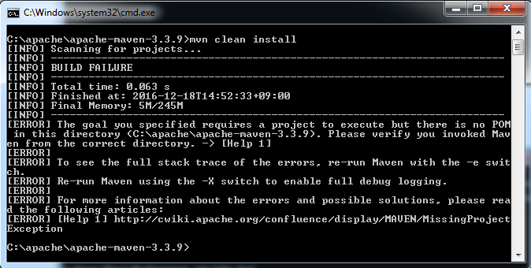

1. Go to Project folder and access the target folder to copy *MMDataCurationRestfulService.war* file
2. Go to apache-tomcat\webapps folder and paste war file there.
3. Go to apache-tomcat\bin and start the tomcat server by clicking “startup.bat” file

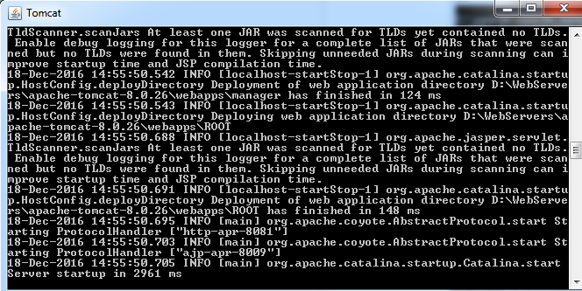

1. Open browser to test apache-tomcat
2. Give url : <http://localhost:8081/MMDataCurationRestfulService/webresources/DataCuration/User/12/>



Currently we set the port to 8081 instead of default 8080. You can change according to available ports on your system.

1. Now all the following CRUD operations are ready to use.
2. It means the services are ready for persisting and retriving using differet provided methods
   1. DCL provides 23 different CRUD functions
   2. ICL provides 28 different CRUD functions
   3. SCL provides 43 different CRUD functions
   4. SL provides 16 different CRUD functions
3. Following are the detail links and input JSON with corresponding POST and GET request types.

Following are the URIs of the Restful web services for Data Curation Layer, Information Curation Layer, Service Curation Layer and Supporting Layer to persist, retrieve and edit information in Intermediate database. There are only two methods (GET and POST) have used. For each layer I have created separate URIs with corresponding layer name.

Each web service returns List of objects in JSON format and input parameter will pass in URI in GET while in POST the JSON object should serialize.

Following are the URIs with corresponding input in URI or Input JSON.

**Data Curation Layer**

**User Authentication**

[http://163.180.116.194:8081/MMDataCurationRestfulService/webresources/DataCuration/ValidateUser](http://163.180.116.194:8080/MMDataCurationRestfulService/webresources/DataCuration/ValidateUser)

{

"emailAddress":"taqdir@test.com",

"password":"12345"

}

**Register User**

[http://163.180.116.194:8081/MMDataCurationRestfulService/webresources/DataCuration/RegisterUser](http://163.180.116.194:8080/MMDataCurationRestfulService/webresources/DataCuration/RegisterUser)

{

"userID":null,

"firstName":"TestRestful 2",

"lastName":"TestRestful 2",

"middleName":"TestRestful 2",

"genderId":1,

"dateOfBirth":"1981 10 12 00:00:00",

"contactNumber":"323656",

"emailAddress":"taqdir22@test.com",

"martialStatusId":1,

"activityLevelId":1,

"activityLevelDescription":null,

"occupationId":1,

"password":"12345",

"userTypeID":1

}

**Retrieve User By User ID**

[http://163.180.116.194:8081/MMDataCurationRestfulService/webresources/DataCuration/User/12](http://163.180.116.194:8080/MMDataCurationRestfulService/webresources/DataCuration/User/12)

**Retrieve User By Expert ID**

[http://163.180.116.194:8081/MMDataCurationRestfulService/webresources/DataCuration/UserListByExpertID/1](http://163.180.116.194:8080/MMDataCurationRestfulService/webresources/DataCuration/UserListByExpertID/1)

**Update User**

[http://163.180.116.194:8081/MMDataCurationRestfulService/webresources/DataCuration/UpdateUser](http://163.180.116.194:8080/MMDataCurationRestfulService/webresources/DataCuration/UpdateUser)

{

"userID":35,

"firstName":"TestRestful",

"lastName":"TestRestful",

"middleName":"TestRestful",

"genderId":1,

"dateOfBirth":"1981 10 12 00:00:00",

"contactNumber":"323656",

"emailAddress":"taqdir@test.com",

"martialStatusId":1,

"activityLevelId":1,

"activityLevelDescription":null,

"occupationId":1,

"password":"12345",

"userTypeID":1

}

**Save users Risks factors**

[http://163.180.116.194:8081/MMDataCurationRestfulService/webresources/DataCuration/AddUserRiskFactors](http://163.180.116.194:8080/MMDataCurationRestfulService/webresources/DataCuration/AddUserRiskFactors)

{

"userRiskFactorId":null,

"userId":35,

"riskFactorId":1,

"statusId":1

}

**Get users Risks factors By User ID**

[http://163.180.116.194:8081/MMDataCurationRestfulService/webresources/DataCuration/RiskFactors/1](http://163.180.116.194:8080/MMDataCurationRestfulService/webresources/DataCuration/RiskFactors/1)

**Update users Risks factors**

[http://163.180.116.194:8081/MMDataCurationRestfulService/webresources/DataCuration/UpdateUserRiskFactors](http://163.180.116.194:8080/MMDataCurationRestfulService/webresources/DataCuration/UpdateUserRiskFactors)

{

"userRiskFactorId":3,

"userId":35,

"deviceID":1,

"riskFactorId":1,

"statusId":1

}

**Add Physiological factors**

[http://163.180.116.194:8081/MMDataCurationRestfulService/webresources/DataCuration/AddPhysiologicalFactors](http://163.180.116.194:8080/MMDataCurationRestfulService/webresources/DataCuration/AddPhysiologicalFactors)

{

"physiologicalFactorId":null,

"userId":35,

"weight":63.2,

"height":5.9,

"date":"2014 05 02 00:00:00",

"idealWeight":60.0,

"targetWeight":61.2

}

**Retrieve User Physiological Factors by User ID**

[http://163.180.116.194:8081/MMDataCurationRestfulService/webresources/DataCuration/PhysiologicalFactors/1](http://163.180.116.194:8080/MMDataCurationRestfulService/webresources/DataCuration/PhysiologicalFactors/1)

**Update Physiological factors**

[http://163.180.116.194:8081/MMDataCurationRestfulService/webresources/DataCuration/UpdatePhysiologicalFactors](http://163.180.116.194:8080/MMDataCurationRestfulService/webresources/DataCuration/UpdatePhysiologicalFactors)

{

"physiologicalFactorId":173,

"userId":35,

"weight":63.2,

"height":5.9,

"date":"2014 05 02 00:00:00",

"idealWeight":60,

"targetWeight":61.2

}

**Add User Facilities**

[http://163.180.116.194:8081/MMDataCurationRestfulService/webresources/DataCuration/AddUserFacilities](http://163.180.116.194:8080/MMDataCurationRestfulService/webresources/DataCuration/AddUserFacilities)

{

"id":null,

"userFacilityId":null,

"userId":35,

"facilityId":1

}

**Retrieve User facilities by User ID**

[http://163.180.116.194:8081/MMDataCurationRestfulService/webresources/DataCuration/UserFacilities/35](http://163.180.116.194:8080/MMDataCurationRestfulService/webresources/DataCuration/UserFacilities/35)

**Update User Facilities**

[http://163.180.116.194:8081/MMDataCurationRestfulService/webresources/DataCuration/UpdateUserFacilities](http://163.180.116.194:8080/MMDataCurationRestfulService/webresources/DataCuration/UpdateUserFacilities)

{

"userFacilityId":2,

"userId":35,

"facilityId":2

}

**Save users User Disabilities**

[http://163.180.116.194:8081/MMDataCurationRestfulService/webresources/DataCuration/AddUserDisabilities](http://163.180.116.194:8080/MMDataCurationRestfulService/webresources/DataCuration/AddUserDisabilities)

{

"userDisabilityID":null,

"userID":35,

"disabilityID":1,

"statusID":1

}

**Get User Disabilities By User ID**

[http://163.180.116.194:8081/MMDataCurationRestfulService/webresources/DataCuration/UserDisabilities/1](http://163.180.116.194:8080/MMDataCurationRestfulService/webresources/DataCuration/RiskFactors/1)

**Update users User Disabilities**

[http://163.180.116.194:8081/MMDataCurationRestfulService/webresources/DataCuration/UpdateUserDisabilities](http://163.180.116.194:8080/MMDataCurationRestfulService/webresources/DataCuration/UpdateUserDisabilities){

"userDisabilityID":1,

"userID":35,

"disabilityID":2,

"statusID":1

}

**Save User Schedule**

[http://163.180.116.194:8081/MMDataCurationRestfulService/webresources/DataCuration/AddUserSchedule](http://163.180.116.194:8080/MMDataCurationRestfulService/webresources/DataCuration/AddUserSchedule)

{

"userScheduleID":null,

"userID":35,

"scheduledTask":"Meeting with professor",

"startTime":"2015 05 02 02:30:00",

"endTime":"2015 05 02 03:30:00"

}

**Update User Schedule**

[http://163.180.116.194:8081/MMDataCurationRestfulService/webresources/DataCuration/UpdateUserSchedule](http://163.180.116.194:8080/MMDataCurationRestfulService/webresources/DataCuration/UpdateUserSchedule)

{

"userScheduleID":1,

"userID":35,

"scheduledTask":"Meeting with professor",

"startTime":"2015 05 02 01:30:00",

"endTime":"2015 05 02 02:30:00"

}

**Get User Schedule By User id and Start time, End time**

[http://163.180.116.194:8081/MMDataCurationRestfulService/webresources/DataCuration/GetUserScheduleByIDandTime](http://163.180.116.194:8080/MMDataCurationRestfulService/webresources/DataCuration/GetUserScheduleByIDandTime)

{

"userID":35,

"startTime":"2015 05 02 01:30:00",

"endTime":"2015 05 02 04:30:00"

}

**Information Curation Layer**

[http://163.180.116.194:8081/MMDataCurationRestfulService/webresources/InformationCuration/GetFoodLogByUserIDDateRange](http://163.180.116.194:8080/MMDataCurationRestfulService/webresources/InformationCuration/AddFoodLog)

{

"userId":35,

"startTime":"2016 05 10 01:30:00",

"endTime":"2016 05 13 04:30:00"

}

[http://163.180.116.194:8081/MMDataCurationRestfulService/webresources/InformationCuration/AddFoodLog](http://163.180.116.194:8080/MMDataCurationRestfulService/webresources/InformationCuration/AddFoodLog)

{

"foodLogID":null,

"userId":35,

"foodName":"Chicken",

"eatingTime":"2016 05 10 02:30:01"

}

**Register Device**

[http://163.180.116.194:8081/MMDataCurationRestfulService/webresources/InformationCuration/RegisterDevice](http://163.180.116.194:8080/MMDataCurationRestfulService/webresources/InformationCuration/RegisterDevice)

{

"deviceId":null,

"deviceName":"SmartWatchGPS",

"deviceTypeId":3,

"deviceModel":"Samsung",

"registrationDate":"2015 05 01 00:00:00"

}

**Update Device**

[http://163.180.116.194:8081/MMDataCurationRestfulService/webresources/InformationCuration/UpdateDevice](http://163.180.116.194:8080/MMDataCurationRestfulService/webresources/InformationCuration/UpdateDevice)

{

"deviceId":23,

"deviceName":"SmartWatchGPSUpdated",

"deviceTypeId":3,

"deviceModel":"SamsungUpdate",

"registrationDate":"2015 05 02 00:00:00"

}

**Retrieve Device by id**

[http://163.180.116.194:8081/ MMDataCurationRestfulService/webresources/InformationCuration/Device/23](http://163.180.116.194:8080/MMDataCurationRestfulService/webresources/InformationCuration/UpdateDevice)

**Subscribe Device for user**

[http://163.180.116.194:8081/MMDataCurationRestfulService/webresources/InformationCuration/SubscribeUserDevice](http://163.180.116.194:8080/MMDataCurationRestfulService/webresources/InformationCuration/SubscribeUserDevice)

{

"userDeviceID":null,

"userID":23,

"deviceID":1,

"subscriptionStatusID":1,

"registerDate":"2015 05 02 00:00:00"

}

**Subscribe only sensors of interest**

[http://163.180.116.194:8081/MMDataCurationRestfulService/webresources/InformationCuration/subscribeToSensorsOfInterest](http://163.180.116.194:8080/MMDataCurationRestfulService/webresources/InformationCuration/subscribeToSensorsOfInterest)

[{

"userDeviceID":62,

"userID":33,

"deviceID":1,

"subscriptionStatusID":1,

"registerDate":"2015 10 12 00:00:00"

},

{

"userDeviceID":63,

"userID":33,

"deviceID":2,

"subscriptionStatusID":1,

"registerDate":"2015 10 12 00:00:00"

}]

**Update User Device**

[http://163.180.116.194:8081/MMDataCurationRestfulService/webresources/InformationCuration/UpdateUserDevice](http://163.180.116.194:8080/MMDataCurationRestfulService/webresources/InformationCuration/UpdateUserDevice)

{

"userDeviceID":62,

"userID":23,

"deviceID":1,

"subscriptionStatusID":1,

"registerDate":"2014 05 02 00:00:00"

}

**Retrieve User Device by ID**

[http://163.180.116.194:8081/ MMDataCurationRestfulService/webresources/InformationCuration/UserDevice/1](http://163.180.116.194:8080/MMDataCurationRestfulService/webresources/InformationCuration/UpdateUserDevice)

**Add User Recognized Activity**

[http://163.180.116.194:8081/MMDataCurationRestfulService/webresources/InformationCuration/AddUserRecognizedActivity](http://163.180.116.194:8080/MMDataCurationRestfulService/webresources/InformationCuration/AddUserRecognizedActivity)

{

"userRecognizedActivityId":4,

"userId":35,

"activityId":3,

"startTime":"2015 12 04 19:16:01"

}

**Get User Recognized Activity by user id, start time and end time**

[http://163.180.116.194:8081/MMDataCurationRestfulService/webresources/InformationCuration/GetUserRecognizedActivity](http://163.180.116.194:8080/MMDataCurationRestfulService/webresources/InformationCuration/GetUserRecognizedActivity)

{

"userId":39,

"startTime":"2015 05 02 02:30:01",

"endTime":"2015 05 02 02:45:49"

}

**Get User accumulate Recognized Activity by user id, start time and end time (Default)**

[http://163.180.116.194:8081/MMDataCurationRestfulService/webresources/InformationCuration/GetUserRecognizedActivityAccumulate](http://163.180.116.194:8080/MMDataCurationRestfulService/webresources/InformationCuration/GetUserRecognizedActivityAccumulate)

{

"userId":39,

"startTime":"2015 05 12 18:18:59",

"endTime":"2015 05 12 18:19:02"

}

**Add User Detected Location**

[http://163.180.116.194:8081/MMDataCurationRestfulService/webresources/InformationCuration/AddUserDetectedLocation](http://163.180.116.194:8080/MMDataCurationRestfulService/webresources/InformationCuration/AddUserDetectedLocation)

{

"userDetectedLocationId":null,

"userId":35,

"locationLabel":"Office",

"startTime":"2015 05 02 02:30:01"

}

**Get User Detected Location by user id, start time and end time**

[http://163.180.116.194:8081/MMDataCurationRestfulService/webresources/InformationCuration/GetUserDetectedLocation](http://163.180.116.194:8080/MMDataCurationRestfulService/webresources/InformationCuration/GetUserDetectedLocation)

{

"userId":35,

"startTime":"2015 05 02 02:30:01",

"endTime":"2015 05 02 02:45:49"

}

**Add User Recognized Activity Log**

[http://163.180.116.194:8081/MMDataCurationRestfulService/webresources/InformationCuration/AddUserRecognizedActivityLog](http://163.180.116.194:8080/MMDataCurationRestfulService/webresources/InformationCuration/AddUserRecognizedActivityLog)

{

"userRecognizedActivityLogId":4,

"userId":35,

"activityId":3,

"startTime":"2015 05 02 02:30:01",

"endTime":"2015 05 02 02:45:49",

"duration":3

}

**Get User Recognized Activity log by user id, start time and end time**

[http://163.180.116.194:8081/MMDataCurationRestfulService/webresources/InformationCuration/GetUserRecognizedActivityLog](http://163.180.116.194:8080/MMDataCurationRestfulService/webresources/InformationCuration/GetUserRecognizedActivityLog)

{

"userId":35,

"startTime":"2015 05 02 02:30:01",

"endTime":"2015 05 02 02:45:49"

}

**Add User Recognized Activity Accumulate (Accumulate)**

[http://163.180.116.194:8081/MMDataCurationRestfulService/webresources/InformationCuration/AddUserRecognizedActivityAccumulate](http://163.180.116.194:8080/MMDataCurationRestfulService/webresources/InformationCuration/AddUserRecognizedActivityAccumulate)

{

"userRecognizedActivityAccumulateID":null,

"userId":39,

"activityId":4,

"activityDate":"2015 05 14 02:30:01",

"duration":48

}

**Update User Recognized Activity Accumulate (Accumulate)**

[http://163.180.116.194:8081/MMDataCurationRestfulService/webresources/InformationCuration/UpdateUserRecognizedActivityAccumulate](http://163.180.116.194:8080/MMDataCurationRestfulService/webresources/InformationCuration/UpdateUserRecognizedActivityAccumulate)

{

"userRecognizedActivityAccumulateID":3,

"userId":39,

"activityId":4,

"activityDate":"2015 05 14 03:30:01",

"duration":169

}

**Get User Recognized Activity Accumulate By User And Date (Accumulate)**

[http://163.180.116.194:8081/MMDataCurationRestfulService/webresources/InformationCuration/GetUserRecognizedActivityAccumulateByUserAndDate](http://163.180.116.194:8080/MMDataCurationRestfulService/webresources/InformationCuration/GetUserRecognizedActivityAccumulateByUserAndDate)

{

"userId":39,

"activityDate":"2015 05 14 03:30:01"

}

**Get User Recognized Activity Accumulate By User And Date Range (Accumulate)**

[http://163.180.116.194:8081/MMDataCurationRestfulService/webresources/InformationCuration/GetUserRecognizedActivityAccumulateByUserAndDateRange](http://163.180.116.194:8080/MMDataCurationRestfulService/webresources/InformationCuration/GetUserRecognizedActivityAccumulateByUserAndDateRange)

{

"userId":39,

"startTime":"2015 05 12 00:00:00",

"endTime":"2015 05 14 03:30:01"

}

**Service Curation Layer**

**Retrieve ProfileData**

[http://163.180.116.194:8081/MMDataCurationRestfulService/webresources/ServiceCuration/ProfileData/2](http://163.180.116.194:8080/MMDataCurationRestfulService/webresources/ServiceCuration/ProfileData/2)

**save users Preferred activities**

[http://163.180.116.194:8081/MMDataCurationRestfulService/webresources/ServiceCuration/AddUserPreferredActivities](http://163.180.116.194:8080/MMDataCurationRestfulService/webresources/ServiceCuration/AddUserPreferredActivities)

{

"userPreferredActivityId":null,

"userId":35,

"activityId":1,

"preferenceLevelId":1

}

**Retrieve User preferred activities by User ID**

[http://163.180.116.194:8081/MMDataCurationRestfulService/webresources/ServiceCuration/UserPreferredActivities/35](http://163.180.116.194:8080/MMDataCurationRestfulService/webresources/ServiceCuration/UserPreferredActivities/35)

**Update users Preferred activities**

[http://163.180.116.194:8081/MMDataCurationRestfulService/webresources/ServiceCuration/UpdateUserPreferredActivities](http://163.180.116.194:8080/MMDataCurationRestfulService/webresources/ServiceCuration/UpdateUserPreferredActivities)

{

"userPreferredActivityId":4,

"userId":35,

"activityId":3,

"preferenceLevelId":1

}

**Add User Goal**

[http://163.180.116.194:8081/MMDataCurationRestfulService/webresources/ServiceCuration/AddUserGoal](http://163.180.116.194:8080/MMDataCurationRestfulService/webresources/ServiceCuration/AddUserGoal)

{

"userGoalId":null,

"userId":35,

"weightStatusId":1,

"dailyCaloriesInTake":2451,

"idealWeight":62.3,

"goalDescription":"test goal",

"totalCaloriesToBurn":2354,

"burnedCalories":2356,

"date":"2015 05 02 02:30:01",

"dailyBurnedCal":125,

"weklyBurnedCal":1254,

"monthlyBurnedCal":2542,

"quarterlyBurnedCal":3215,

"bMI":122.32

}

**Retrieve User Goal by User ID**

[http://163.180.116.194:8081/MMDataCurationRestfulService/webresources/ServiceCuration/UserGoal/35](http://163.180.116.194:8080/MMDataCurationRestfulService/webresources/ServiceCuration/UserGoal/35)

**Get User Goal by user id, start date and end date**

[http://163.180.116.194:8081/MMDataCurationRestfulService/webresources/ServiceCuration/RetrieveUserBurnedCaloriesByDate](http://163.180.116.194:8080/MMDataCurationRestfulService/webresources/ServiceCuration/RetrieveUserBurnedCaloriesByDate)

{

"userId":17,

"startDate":"2015 01 11 01:30:01",

"endDate":"2015 01 13 03:45:49"

}

**Add Activity Plan**

[http://163.180.116.194:8081/MMDataCurationRestfulService/webresources/ServiceCuration/AddActivityPlan](http://163.180.116.194:8080/MMDataCurationRestfulService/webresources/ServiceCuration/AddActivityPlan)

{

"activityPlanId":null,

"userGoalId":4653,

"planDescription":"test plan",

"explanation":"test plan ex"

}

**Retrieve Activity Plan by User goal ID**

[http://163.180.116.194:8081/MMDataCurationRestfulService/webresources/ServiceCuration/ActivityPlan/37](http://163.180.116.194:8080/MMDataCurationRestfulService/webresources/ServiceCuration/ActivityPlan/37)

**Add Activity Recommendation**

[http://163.180.116.194:8081/MMDataCurationRestfulService/webresources/ServiceCuration/AddActivityRecommendation](http://163.180.116.194:8080/MMDataCurationRestfulService/webresources/ServiceCuration/AddActivityRecommendation)

{

"activityRecommendationId":null,

"activityPlanId":4653,

"description":"test plan recomm",

"timestamp":"2015 01 11 01:30:01"

}

**Add Activity Recommendation Log**

[http://163.180.116.194:8081/MMDataCurationRestfulService/webresources/ServiceCuration/AddActivityRecommendationLog](http://163.180.116.194:8080/MMDataCurationRestfulService/webresources/ServiceCuration/AddActivityRecommendationLog)

{

"activityRecommendationLogId":null,

"activityPlanId":4653,

"description":"test plan recomm",

"timestamp":"2015 01 11 01:30:01"

}

**Retrieve Activity Recommendation log by Activity Plan ID**

[http://163.180.116.194:8081/MMDataCurationRestfulService/webresources/ServiceCuration/ActivityRecommendationLog/40](http://163.180.116.194:8080/MMDataCurationRestfulService/webresources/ServiceCuration/ActivityRecommendationLog/40)

**Retrieve Activity Recommendation by Activity Plan ID**

[http://163.180.116.194:8081/MMDataCurationRestfulService/webresources/ServiceCuration/ActivityRecommendation/40](http://163.180.116.194:8080/MMDataCurationRestfulService/webresources/ServiceCuration/ActivityRecommendation/40)

**Get Activity Recommendation by user id and date rang**

[http://163.180.116.194:8081/MMDataCurationRestfulService/webresources/ServiceCuration/RetrieveActivityRecommendationByUserAndDate](http://163.180.116.194:8080/MMDataCurationRestfulService/webresources/ServiceCuration/RetrieveActivityRecommendationByUserAndDate)

{

"userID":2,

"startTimestamp":"2014 01 11 01:30:01",

"endTimestamp":"2015 01 11 01:30:01"

}

**Get Activity Recommendation log by user id and date rang**

[http://163.180.116.194:8081/MMDataCurationRestfulService/webresources/ServiceCuration/RetrieveActivityRecommendationLogByUserAndDate](http://163.180.116.194:8080/MMDataCurationRestfulService/webresources/ServiceCuration/RetrieveActivityRecommendationLogByUserAndDate)

{

"userID":2,

"startTimestamp":"2014 01 11 01:30:01",

"endTimestamp":"2015 01 11 01:30:01"

}

**Retrieve user rewards by user id**

[http://163.180.116.194:8081/MMDataCurationRestfulService/webresources/ServiceCuration/UserRewards/2](http://163.180.116.194:8080/MMDataCurationRestfulService/webresources/ServiceCuration/UserRewards/2)

**Add User Rewards**

[http://163.180.116.194:8081/MMDataCurationRestfulService/webresources/ServiceCuration/AddUserRewards](http://163.180.116.194:8080/MMDataCurationRestfulService/webresources/ServiceCuration/AddUserRewards)

{

"userRewardID":null,

"userID":35,

"rewardPoints":5,

"rewardDescription":"test plan recomm",

"rewardDate":"2015 01 11 01:30:01",

"rewardTypeID":1

}

**Update User Rewards**

[http://163.180.116.194:8081/MMDataCurationRestfulService/webresources/ServiceCuration/UpdateUserRewards](http://163.180.116.194:8080/MMDataCurationRestfulService/webresources/ServiceCuration/UpdateUserRewards)

{

"userRewardID":1126,

"userID":35,

"rewardPoints":5,

"rewardDescription":"test updated rewards",

"rewardDate":"2015 01 25 01:30:01",

"rewardTypeID":1

}

**Add Situation**

[http://163.180.116.194:8081/MMDataCurationRestfulService/webresources/ServiceCuration/AddSituation](http://163.180.116.194:8080/MMDataCurationRestfulService/webresources/ServiceCuration/AddSituation)

{

"userID":35,

"situationCategoryID":2,

"situationDescription":"test situation",

"situationDate":"2015 01 13 01:30:01"

}

**Update Situation**

[http://163.180.116.194:8081/MMDataCurationRestfulService/webresources/ServiceCuration/UpdateSituation](http://163.180.116.194:8080/MMDataCurationRestfulService/webresources/ServiceCuration/UpdateSituation)

{

"situationID":1,

"userID":35,

"situationCategoryID":2,

"situationDescription":"test situation",

"situationDate":"2015 01 13 01:30:01"

}

**Get Situation by user id**

[http://163.180.116.194:8081/MMDataCurationRestfulService/webresources/ServiceCuration/Situation/1](http://163.180.116.194:8080/MMDataCurationRestfulService/webresources/ServiceCuration/Situation/1)

**Get situation by user id, start time and end time**

[http://163.180.116.194:8081/MMDataCurationRestfulService/webresources/ServiceCuration/RetrieveSituationByUserIDDate](http://163.180.116.194:8080/MMDataCurationRestfulService/webresources/ServiceCuration/RetrieveSituationByUserIDDate)

{

"userID":35,

"startDate":"2015 05 10 02:30:01",

"endDate":"2015 05 14 02:45:49"

}

**Get Situation by Situation id**

[http://163.180.116.194:8081/MMDataCurationRestfulService/webresources/ServiceCuration/SituationBySituationID/1](http://163.180.116.194:8080/MMDataCurationRestfulService/webresources/ServiceCuration/SituationBySituationID/1)

**Add Recommendation**

[http://163.180.116.194:8081/MMDataCurationRestfulService/webresources/ServiceCuration/AddRecommendation](http://163.180.116.194:8080/MMDataCurationRestfulService/webresources/ServiceCuration/AddRecommendation)

{

"recommendationID":null,

"recommendationIdentifier":"A0001",

"situationID":1,

"recommendationDescription":"Recommendation Description",

"recommendationTypeID":1,

"conditionValue":"condition Value",

"recommendationLevelID":1,

"recommendationStatusID":1,

"recommendationDate":"2015 01 13 01:30:01"

}

**Update Recommendation**

[http://163.180.116.194:8081/MMDataCurationRestfulService/webresources/ServiceCuration/UpdateRecommendation](http://163.180.116.194:8080/MMDataCurationRestfulService/webresources/ServiceCuration/UpdateRecommendation)

{

"recommendationID":1,

"recommendationIdentifier":"A0001",

"situationID":1,

"recommendationDescription":"Recommendation Description updated",

"recommendationTypeID":1,

"conditionValue":"condition Value Updated",

"recommendationLevelID":1,

"recommendationStatusID":1,

"recommendationDate":"2015 01 13 01:30:01"

}

**Get Recommendation by user id**

[http://163.180.116.194:8081/MMDataCurationRestfulService/webresources/ServiceCuration/Recommendation/35](http://163.180.116.194:8080/MMDataCurationRestfulService/webresources/ServiceCuration/Recommendation/35)

**Get Recommendation by user id, start time and end time**

[http://163.180.116.194:8081/MMDataCurationRestfulService/webresources/ServiceCuration/RetrieveRecommendationByUserIDDate](http://163.180.116.194:8080/MMDataCurationRestfulService/webresources/ServiceCuration/RetrieveRecommendationByUserIDDate)

{

"userID":35,

"startDate":"2015 01 12 02:30:01",

"endDate":"2015 01 17 02:45:49"

}

**Add Recommendation Exception**

[http://163.180.116.194:8081/MMDataCurationRestfulService/webresources/ServiceCuration/AddRecommendationException](http://163.180.116.194:8080/MMDataCurationRestfulService/webresources/ServiceCuration/AddRecommendationException)

{

"recommendationExceptionID":null,

"recommendationID":1,

"exception":"Testing Exception",

"customRule":"custom Rule for testing",

"exceptionReason":"exception Reason Testing"

}

**Update Recommendation Exception**

[http://163.180.116.194:8081/MMDataCurationRestfulService/webresources/ServiceCuration/UpdateRecommendationException](http://163.180.116.194:8080/MMDataCurationRestfulService/webresources/ServiceCuration/UpdateRecommendationException)

{

"recommendationExceptionID":1,

"recommendationID":1,

"exception":"Testing Exception updated",

"customRule":"custom Rule for testing updated",

"exceptionReason":"exception Reason Testing updated"

}

**Get Recommendation Exception by Recommendation ID**

[http://163.180.116.194:8081/MMDataCurationRestfulService/webresources/ServiceCuration/RecommendationException/35](http://163.180.116.194:8080/MMDataCurationRestfulService/webresources/ServiceCuration/RecommendationException/35)

**Add Recommendation Explanation**

[http://163.180.116.194:8081/MMDataCurationRestfulService/webresources/ServiceCuration/AddRecommendationExplanation](http://163.180.116.194:8080/MMDataCurationRestfulService/webresources/ServiceCuration/AddRecommendationExplanation)

{

"recommendationExplanationID":null,

"recommendationID":1,

"factExplanation":"Testing Exception",

"factCategoryID":1

}

**Update Recommendation Explanation**

[http://163.180.116.194:8081/MMDataCurationRestfulService/webresources/ServiceCuration/UpdateRecommendationExplanation](http://163.180.116.194:8080/MMDataCurationRestfulService/webresources/ServiceCuration/UpdateRecommendationExplanation)

{

"recommendationExplanationID":1,

"recommendationID":1,

"factExplanation":"Testing Exception",

"factCategoryID":1

}

**Get RecommendationExplanation by RecommendationID**

[http://163.180.116.194:8081/MMDataCurationRestfulService/webresources/ServiceCuration/RecommendationExplanation/1](http://163.180.116.194:8080/MMDataCurationRestfulService/webresources/ServiceCuration/RecommendationExplanation/1)

**Add Facts**

[http://163.180.116.194:8081/MMDataCurationRestfulService/webresources/ServiceCuration/AddFacts](http://163.180.116.194:8080/MMDataCurationRestfulService/webresources/ServiceCuration/AddFacts)

{

"factID":null,

"situationID":1,

"factDescription":"This is first test of facts",

"supportingLinks":"www.google.com",

"factDate":"2015 05 09 01:30:01",

"factStatusID":1

}

**Update Facts**

[http://163.180.116.194:8081/MMDataCurationRestfulService/webresources/ServiceCuration/UpdateFacts](http://163.180.116.194:8080/MMDataCurationRestfulService/webresources/ServiceCuration/UpdateFacts%20)

{

"factID":1,

"situationID":1,

"factDescription":"This is first test of facts Updated",

"supportingLinks":"www.googleUpdate.com",

"factDate":"2015 05 09 01:30:01",

"factStatusID":1

}

**Get Facts by user id**

[http://163.180.116.194:8081/MMDataCurationRestfulService/webresources/ServiceCuration/Facts/35](http://163.180.116.194:8080/MMDataCurationRestfulService/webresources/ServiceCuration/Recommendation/35)

**Get Facts by user id, start time and end time**

[http://163.180.116.194:8081/MMDataCurationRestfulService/webresources/ServiceCuration/RetrieveFactsByUserIDDate](http://163.180.116.194:8080/MMDataCurationRestfulService/webresources/ServiceCuration/RetrieveFactsByUserIDDate)

{

"userID":35,

"startDate":"2015 01 12 02:30:01",

"endDate":"2015 01 17 02:45:49"

}

**Add Achievements**

[http://163.180.116.194:8081/MMDataCurationRestfulService/webresources/ServiceCuration/AddAchievements](http://163.180.116.194:8080/MMDataCurationRestfulService/webresources/ServiceCuration/AddAchievements)

{

"achievementID":null,

"userID":1,

"achievementValue":"23",

"achievementDescription":"Testing Description",

"achievementDate":"2015 05 16 01:30:01",

"supportingLink":"www.google.com",

"achievementStatusID":1

}

**Update Achievements**

[http://163.180.116.194:8081/MMDataCurationRestfulService/webresources/ServiceCuration/UpdateAchievements](http://163.180.116.194:8080/MMDataCurationRestfulService/webresources/ServiceCuration/UpdateAchievements)

{

"achievementID":1,

"userID":39,

"achievementValue":"20",

"achievementDescription":"Testing Description Updated",

"achievementDate":"2015 05 16 12:30:01",

"supportingLink":"www.googleUpdated.com",

"achievementStatusID":1

}

**Get Achievements by user id**

[http://163.180.116.194:8081/MMDataCurationRestfulService/webresources/ServiceCuration/Achievements/39](http://163.180.116.194:8080/MMDataCurationRestfulService/webresources/ServiceCuration/Achievements/39)

**Get Achievements by user id, start time and end time**

[http://163.180.116.194:8081/MMDataCurationRestfulService/webresources/ServiceCuration/RetrieveAchievementsByUserIDDate](http://163.180.116.194:8080/MMDataCurationRestfulService/webresources/ServiceCuration/RetrieveFactsByUserIDDate)

{

"userID":39,

"startDate":"2015 05 16 02:30:01",

"endDate":"2015 05 16 02:45:49"

}

**Supporting Layer**

**Add Recommendation Feedback**

[http://163.180.116.194:8081/MMDataCurationRestfulService/webresources/SupportingLayer/AddRecommendationFeedback](http://163.180.116.194:8080/MMDataCurationRestfulService/webresources/SupportingLayer/AddRecommendationFeedback)

{

"recommendationFeedbackID":null,

"recommendationID":1,

"userID":35,

"rate":1,

"reason":"I like it",

"feedbackDate":"2015 05 02 02:30:01"

}

**Update Recommendation Feedback**

[http://163.180.116.194:8081/MMDataCurationRestfulService/webresources/SupportingLayer/UpdateRecommendationFeedback](http://163.180.116.194:8080/MMDataCurationRestfulService/webresources/SupportingLayer/UpdateRecommendationFeedback)

{

"recommendationFeedbackID":2,

"recommendationID":2,

"userID":35,

"rate":0,

"reason":"I dislike it, updating test",

"feedbackDate":"2015 05 02 02:30:01"

}

**Get Recommendation Feedback by RecommendationID**

[http://163.180.116.194:8081/MMDataCurationRestfulService/webresources/SupportingLayer/RecommendationFeedback/1](http://163.180.116.194:8080/MMDataCurationRestfulService/webresources/SupportingLayer/RecommendationFeedback/1)

**Get Recommendation Feedback by User ID**

[http://163.180.116.194:8081/MMDataCurationRestfulService/webresources/SupportingLayer/RecommendationFeedbackByUserID/1](http://163.180.116.194:8080/MMDataCurationRestfulService/webresources/SupportingLayer/RecommendationFeedbackByUserID/1)

**Add Activity Feedback**

[http://163.180.116.194:8081/MMDataCurationRestfulService/webresources/SupportingLayer/AddActivityFeedback](http://163.180.116.194:8080/MMDataCurationRestfulService/webresources/SupportingLayer/AddActivityFeedback)

{

"activityFeedbackID":null,

"recognizedActivityID":77301,

"userID":2,

"rate":1,

"reason":"I like it",

"feedbackDate":"2015 05 02 02:30:01"

}

**Update Activity Feedback**

[http://163.180.116.194:8081/MMDataCurationRestfulService/webresources/SupportingLayer/UpdateActivityFeedback](http://163.180.116.194:8080/MMDataCurationRestfulService/webresources/SupportingLayer/UpdateActivityFeedback)

{

"activityFeedbackID":1,

"recognizedActivityID":77301,

"userID":2,

"rate":1,

"reason":"I like it",

"feedbackDate":"2015 05 02 02:30:01"

}

**Get Activity Feedback by RecognizedActivityID**

[http://163.180.116.194:8081/MMDataCurationRestfulService/webresources/SupportingLayer/ActivityFeedback/77302](http://163.180.116.194:8080/MMDataCurationRestfulService/webresources/SupportingLayer/ActivityFeedback/77302)

**Get Activity Feedback by UserID**

[http://163.180.116.194:8081/MMDataCurationRestfulService/webresources/SupportingLayer/ActivityFeedbackByUserID/](http://163.180.116.194:8080/MMDataCurationRestfulService/webresources/SupportingLayer/ActivityFeedbackByUserID/)2

**Add Expert Review**

[http://163.180.116.194:8081/MMDataCurationRestfulService/webresources/SupportingLayer/AddExpertReview](http://163.180.116.194:8080/MMDataCurationRestfulService/webresources/SupportingLayer/AddExpertReview)

{

"expertReviewID":null,

"userID":35,

"userExpertID":2,

"reviewDescription":"testing review desc",

"reviewDate":"2016 05 12 02:30:01",

"reviewStatusID":1

}

**Update Expert Review**

[http://163.180.116.194:8081/MMDataCurationRestfulService/webresources/SupportingLayer/UpdateExpertReview](http://163.180.116.194:8080/MMDataCurationRestfulService/webresources/SupportingLayer/UpdateExpertReview)

{

"expertReviewID":116,

"reviewStatusID":2

}

**Get Expert Review by User ID**

[http://163.180.116.194:8081/ MMDataCurationRestfulService/webresources/SupportingLayer/ExpertReview/2](http://163.180.116.194:8080/MMDataCurationRestfulService/webresources/SupportingLayer/UpdateExpertReview)

**Get Expert Review by User ID and Date Range**

[http://163.180.116.194:8081/MMDataCurationRestfulService/webresources/SupportingLayer/GetExpertReviewByUserIDDateRange](http://163.180.116.194:8080/MMDataCurationRestfulService/webresources/SupportingLayer/GetExpertReviewByUserIDDateRange)

{

"userID":35,

"startDate":"2016 05 12 01:30:01",

"endDate":"2016 05 12 20:45:49"

}

**Add Facts Feedback**

[http://163.180.116.194:8081/MMDataCurationRestfulService/webresources/SupportingLayer/AddFactsFeedback](http://163.180.116.194:8080/MMDataCurationRestfulService/webresources/SupportingLayer/AddFactsFeedback)

{

"factsFeedbackID":null,

"factID":1,

"userID":35,

"rate":1,

"reason":"I like it",

"feedbackDate":"2015 05 09 02:30:01"

}

**Update Facts Feedback**

[http://163.180.116.194:8081/MMDataCurationRestfulService/webresources/SupportingLayer/UpdateFactsFeedback](http://163.180.116.194:8080/MMDataCurationRestfulService/webresources/SupportingLayer/UpdateFactsFeedback%20)

{

"factsFeedbackID":2,

"factID":1,

"userID":35,

"rate":2,

"reason":"I dislike it",

"feedbackDate":"2015 05 08 02:30:01"

}

**Get Facts Feedback by FactID**

[http://163.180.116.194:8081/MMDataCurationRestfulService/webresources/SupportingLayer/FactsFeedback/1](http://163.180.116.194:8080/MMDataCurationRestfulService/webresources/SupportingLayer/RecommendationFeedback/1)

**Get Facts Feedback by UserID**

[http://163.180.116.194:8081/MMDataCurationRestfulService/webresources/SupportingLayer/FactsFeedbackByUserID/39](http://163.180.116.194:8080/MMDataCurationRestfulService/webresources/SupportingLayer/FactsFeedbackByUserID/39)

Version 2.0: New and Updated Functions

Data Curation Layer

http://163.180.116.194:8081/MMDataCurationRestfulService/webresources/DataCuration/IsUserExist

{

"emailAddress":"taqdir@test.com"

}

**Supporting Layer**

[http://163.180.116.194:8081/MMDataCurationRestfulService/webresources/InformationCuration/GetUserRecognizedActivityAccumulateByUserAndDateRange](http://163.180.116.194:8080/MMDataCurationRestfulService/webresources/InformationCuration/GetUserRecognizedActivityAccumulateByUserAndDateRange)

{

"userId":0,

"startTime":"2015 05 09 00:00:00",

"endTime":"2015 07 29 03:30:01"

}

[http://163.180.116.194:8081/MMDataCurationRestfulService/webresources/InformationCuration/GetUserRecognizedActivityAccumulateByActivitiesAndDateRange](http://163.180.116.194:8080/MMDataCurationRestfulService/webresources/InformationCuration/GetUserRecognizedActivityAccumulateByActivitiesAndDateRange)

{

"activityIDs":"1,2,3",

"startTime":"2015 05 09 00:00:00",

"endTime":"2015 07 29 03:30:01"

}

[http://163.180.116.194:8081/MMDataCurationRestfulService/webresources/ServiceCuration/RetrieveRecommendationByDateRangeActivityIDs](http://163.180.116.194:8080/MMDataCurationRestfulService/webresources/ServiceCuration/RetrieveRecommendationByDateRangeActivityIDs)

{

"situationCategoryIDs":"3,7,8",

"startDate":"2015 05 17 02:30:01",

"endDate":"2015 07 29 02:45:49"

}

Information Curation Layer

**Add User Recognized Activity**

[http://163.180.116.194:8081/MMDataCurationRestfulService/webresources/InformationCuration/AddUserRecognizedActivity](http://163.180.116.194:8080/MMDataCurationRestfulService/webresources/InformationCuration/AddUserRecognizedActivity)

{

"userRecognizedActivityId":null,

"userId":35,

"activityId":3,

"startTime":"2015 05 02 02:30:01"

}

**Add User Detected Location**

[http://163.180.116.194:8081/MMDataCurationRestfulService/webresources/InformationCuration/AddUserDetectedLocation](http://163.180.116.194:8080/MMDataCurationRestfulService/webresources/InformationCuration/AddUserDetectedLocation)

{

"userDetectedLocationId":null,

"userId":35,

"locationLabel":"Office",

"startTime":"2015 05 02 02:30:01"

}

**Get User Detected Location by user id, start time and end time**

[http://163.180.116.194:8081/MMDataCurationRestfulService/webresources/InformationCuration/GetUserDetectedLocation](http://163.180.116.194:8080/MMDataCurationRestfulService/webresources/InformationCuration/GetUserDetectedLocation)

{

"userId":35,

"startTime":"2015 05 02 02:25:01",

"endTime":"2015 05 02 02:49:49"

}

**Add User Recognized Emotion**

[http://163.180.116.194:8081/MMDataCurationRestfulService/webresources/InformationCuration/AddUserRecognizedEmotion](http://163.180.116.194:8080/MMDataCurationRestfulService/webresources/InformationCuration/AddUserRecognizedEmotion)

{

"userRecognizedEmotionId":null,

"userId":35,

"emotionLabel":"Sadness",

"startTime":"2015 05 10 02:45:05"

}

**Get User Recognized Emotion by user id, start time and end time**

[http://163.180.116.194:8081/MMDataCurationRestfulService/webresources/InformationCuration/GetUserRecognizedEmotionByUserIDDateRange](http://163.180.116.194:8080/MMDataCurationRestfulService/webresources/InformationCuration/GetUserRecognizedEmotionByUserIDDateRange)

{

"userId":35,

"startTime":"2015 05 10 02:29:01",

"endTime":"2015 05 11 02:45:49"

}

**Add User Recognized HLC**

[http://163.180.116.194:8081/MMDataCurationRestfulService/webresources/InformationCuration/AddUserRecognizedHLC](http://163.180.116.194:8080/MMDataCurationRestfulService/webresources/InformationCuration/AddUserRecognizedHLC)

{

"userRecognizedHLCId":null,

"userId":35,

"hLCLabel":"Commuting",

"startTime":"2015 05 10 02:45:05"

}

**Get User Recognized HLC by user id, start time and end time**

[http://163.180.116.194:8081/MMDataCurationRestfulService/webresources/InformationCuration/GetUserRecognizedHLCByUserIDDateRange](http://163.180.116.194:8080/MMDataCurationRestfulService/webresources/InformationCuration/GetUserRecognizedHLCByUserIDDateRange)

{

"userId":35,

"startTime":"2015 05 10 02:29:01",

"endTime":"2015 05 11 02:45:49"

}

**Add User Preferred Location**

[http://163.180.116.194:8081/MMDataCurationRestfulService/webresources/InformationCuration/AddUserPreferredLocation](http://163.180.116.194:8080/MMDataCurationRestfulService/webresources/InformationCuration/AddUserPreferredLocation)

{

"userPreferredLocationId":null,

"userId":35,

"latitude":0.21352345654,

"longitude":0.21434443654,

"locationLabel":"Office",

"locationDescription":"Suwon"

}

**Add User Preferred Location**

[http://163.180.116.194:8081/MMDataCurationRestfulService/webresources/InformationCuration/UpdateUserPreferredLocation](http://163.180.116.194:8080/MMDataCurationRestfulService/webresources/InformationCuration/UpdateUserPreferredLocation)

{

"userPreferredLocationId":2,

"userId":35,

"latitude":0.22121212121,

"longitude":0.23131313131,

"locationLabel":"Office2",

"locationDescription":"Suwon2"

}

**Get User Preferred Location By User ID**

[http://163.180.116.194:8081/MMDataCurationRestfulService/webresources/ServiceCuration/UserPreferredLocation/35](http://163.180.116.194:8080/MMDataCurationRestfulService/webresources/InformationCuration/UserPreferredLocation/35)

Service Curation Layer

**Get User current context by user id.**

[http://163.180.116.194:8081/MMDataCurationRestfulService/webresources/ServiceCuration/UserCurrentContext/35](http://163.180.116.194:8080/MMDataCurationRestfulService/webresources/ServiceCuration/UserCurrentContext/35)