Cover-Page

1. Database configuration
   1. Microsoft SQL Sever 2008 R2
   2. Install the database and set its password “123” and login “sa”
   3. Where Server name is (local)
   4. Authentication isset to “SQL Server Authentication”

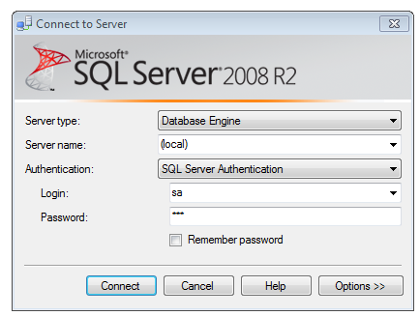

* 1. Create a database with Name “MMLLM”

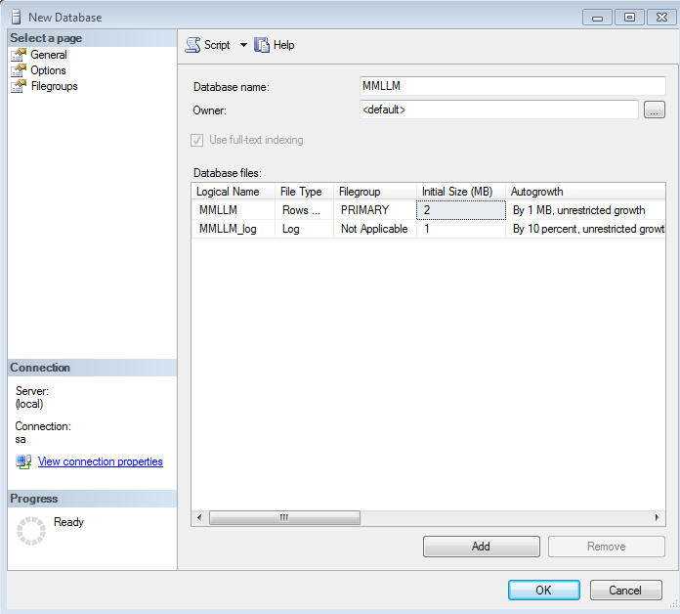

* 1. Select the database “MMLLM” and right click and select new query

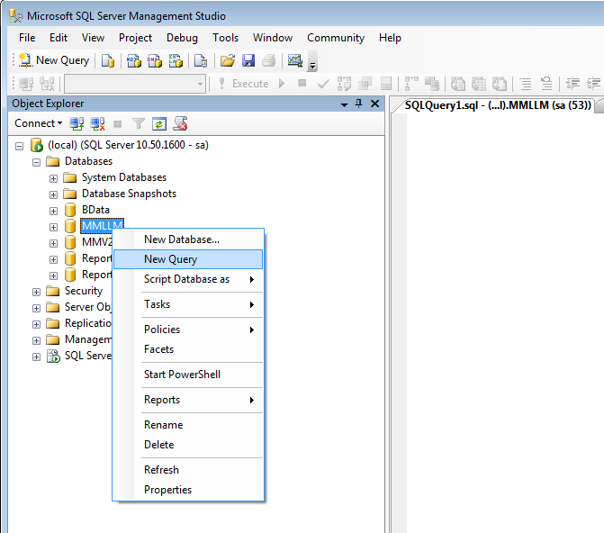

* 1. Download the “MMLLMscript.sql”
  2. Open the MMLLMscript.sql file.
  3. Copy all the queries and paste into new query window.

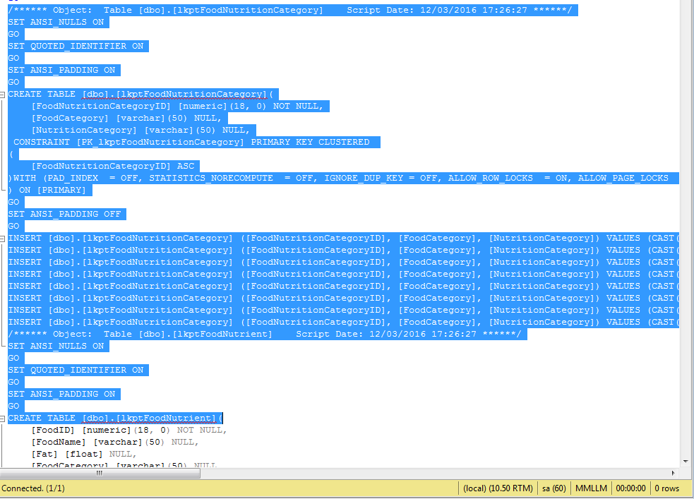

* 1. Then Execute the query
  2. Database is ready for the working

1. JDK and JAVA_HOME
   1. Make sure JDK is installed, and “**JAVA_HOME**” variable is added as Windows environment variable
2. Download Apache Maven and install it
   1. Visit [Maven official website](http://maven.apache.org/download.cgi), download the Maven zip file,

for example : apache-maven-3.2.2-bin.zip. Unzip it to the folder you want to install Maven.

(Assume you unzip to this folder – C:\Program Files\Apache\maven)

1. Add MAVEN_HOME
   1. Add  MAVEN_HOME variables in the Windows environment, and point it to your Maven folder.
2. Add to PATH
   1. Update PATH variable, append Maven bin folder, so that you can run the Maven’s command everywhere.
3. Verification
   1. Done, to verify it, run mvn –version in the command prompt.

**( https://www.mkyong.com/maven/how-to-install-maven-in-windows/)

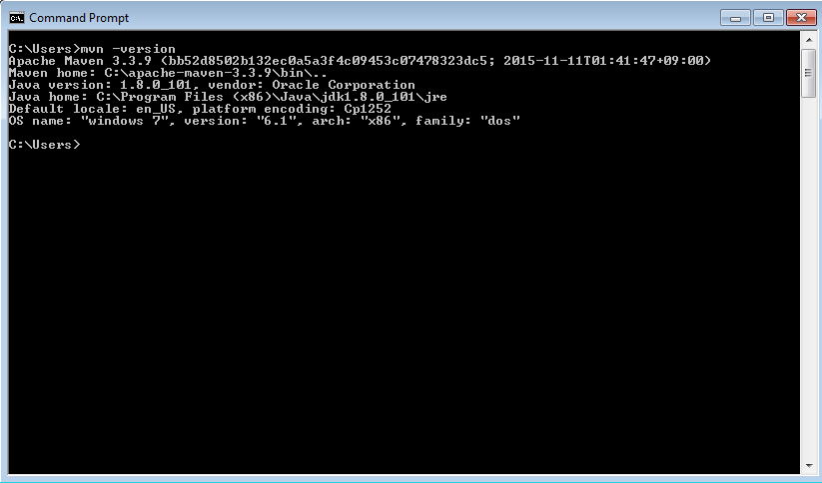

1. Download and Install Apache Tomcat
   1. Goto [http://tomcat.apache.org](http://tomcat.apache.org/) ⇒ Downloads ⇒ Tomcat 8.0 ⇒ "8.0.{*xx*}" (where {*xx*} is the latest upgrade number) ⇒ Binary Distributions ⇒ Core ⇒ "**ZIP**" package (e.g., "apache-tomcat-8.0.{*xx*}.**zip**", about 8 MB).
   2. Create your project directory, say "d:\myProject" or "c:\myProject". UNZIP the downloaded file into your project directory. Tomcat will be unzipped into directory "d:\myProject\apache-tomcat-8.0.{*xx*}".
   3. For **ease of use**, we shall shorten and rename this directory to "d:\myProject\tomcat".

**( https://www.ntu.edu.sg/home/ehchua/programming/howto/Tomcat_HowTo.html)

1. Download src and pom file into the appropriate project folder
2. Start Command Prompt
3. Change the directory to your project directory and folder
4. Run “mvn clear install” command

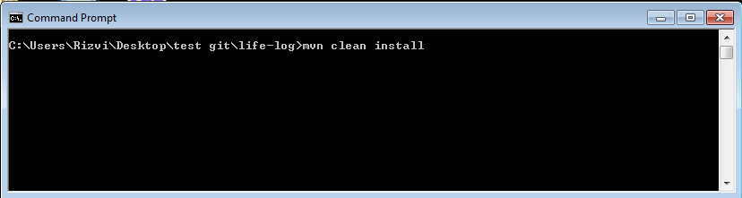

1. Project will be built successfully

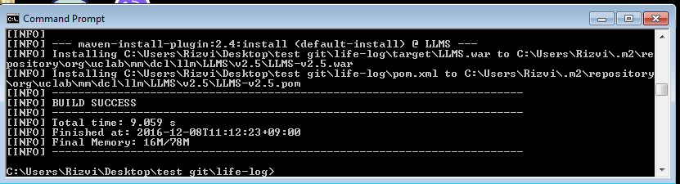

1. Go to Project folder and access the target folder to copy *LLMS.war* file
2. Go to apache-tomcat\webapps folder and paste war file there.
3. Go to apache-tomcat\bin and start the tomcat server

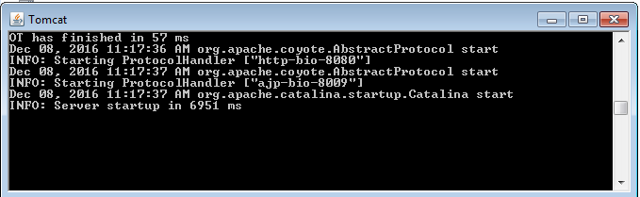

1. Open browser to test apache-tomcat

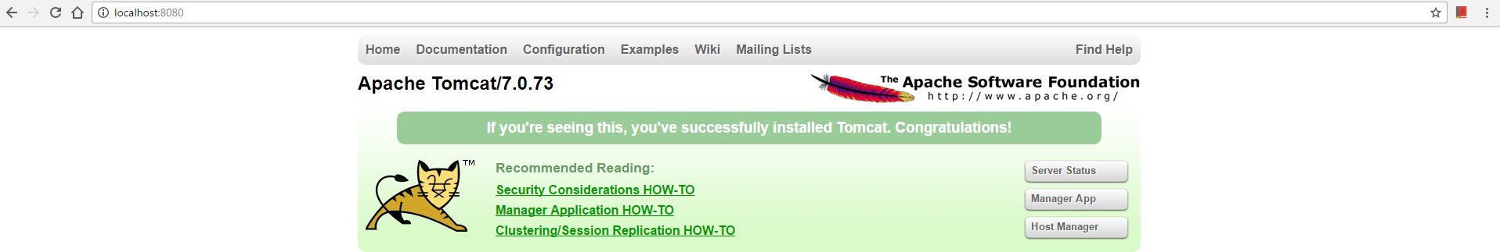

1. Give url : <http://localhost:8080/LLMS/sc/servicecommunicator/TotalViolations/>



1. Now run service: <http://localhost:8080/LLMS/sc/servicecommunicator/PhysicalMonitoring/> it will start monitoring service.

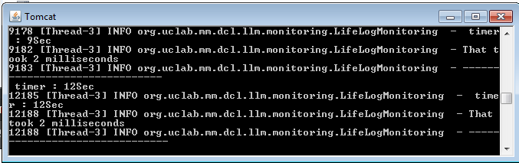

1. Enter the data now in database with following query

insert into tblUserRecognizedActivity

values(1, 35, 3, CURRENT_TIMESTAMP, CURRENT_TIMESTAMP,3)

insert into tblUserRecognizedActivity

values(6, 36, 3, CURRENT_TIMESTAMP, CURRENT_TIMESTAMP,3)

def words = ['ant', 'buffalo', 'cat', 'dinosaur']

def wordsWithSizeGreaterThanFour = words.findAll { it.length() > 4 }

after 1 min and 2 min duration u will get notification on tomcat server

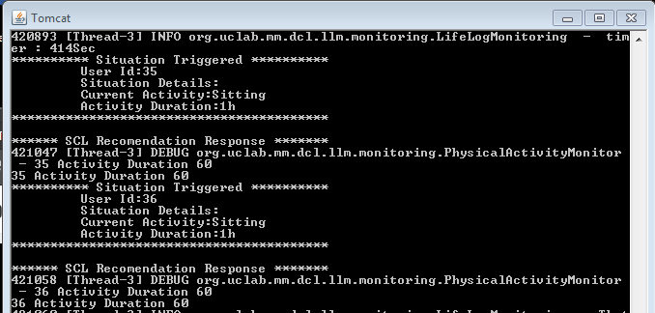

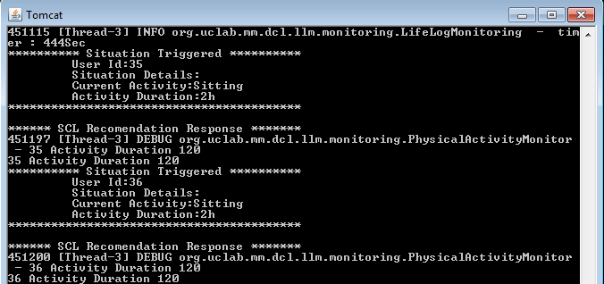

1. The services are available to return data in JSON format. That can be used further.