Taqdir Ali

Taqdir.ali@oslab.khu.ac.kr

Demo harness

Expert-Driven Knowledge Acquisition

Intelligent-Knowledge Authoring Tool-Version 2.5

1. Database configuration
   1. Download Microsoft SQL Server 2012 from Microsoft official website
   2. Install the Management Studio and set its password and login
   3. Where Server name is (local) or your system name
   4. Authentication is set to “SQL Server Authentication”

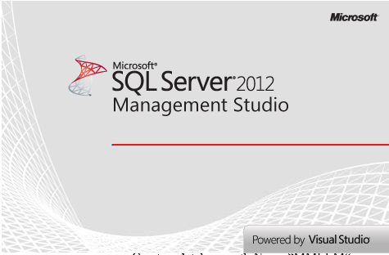

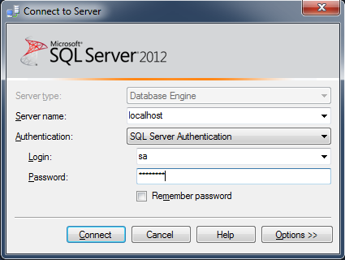

* 1. Create a database with Name “MMIKATDB_V2”

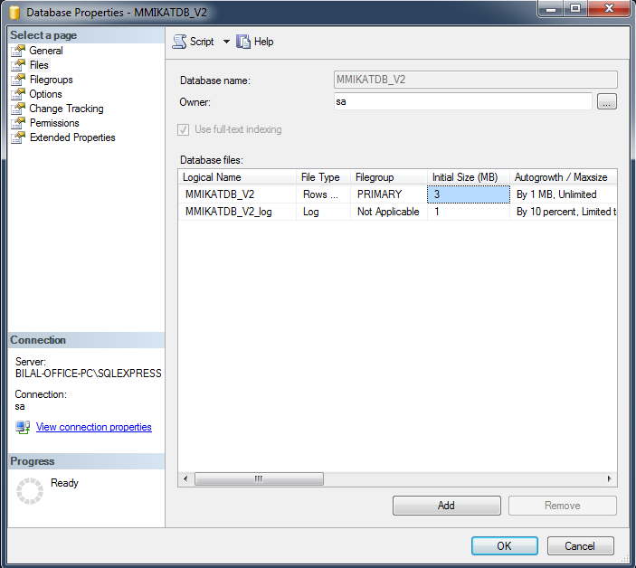

* 1. Select the database “MMIKATDB_V2” and right click and select new query

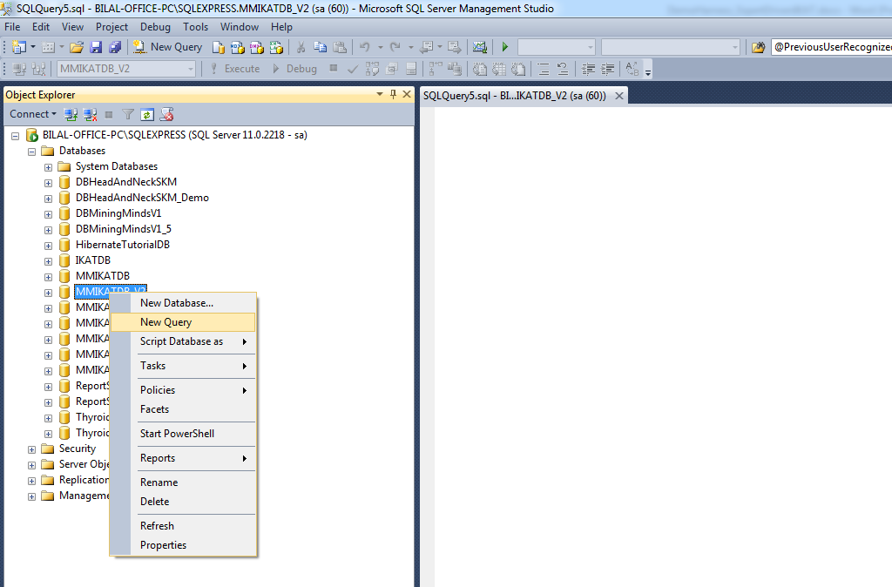

* 1. Download the script of database schema “MiningMindsIKATSchema.sql”
  2. Open the “MiningMindsIKATSchema.sql” file.
  3. Copy all the queries and paste into new query window.

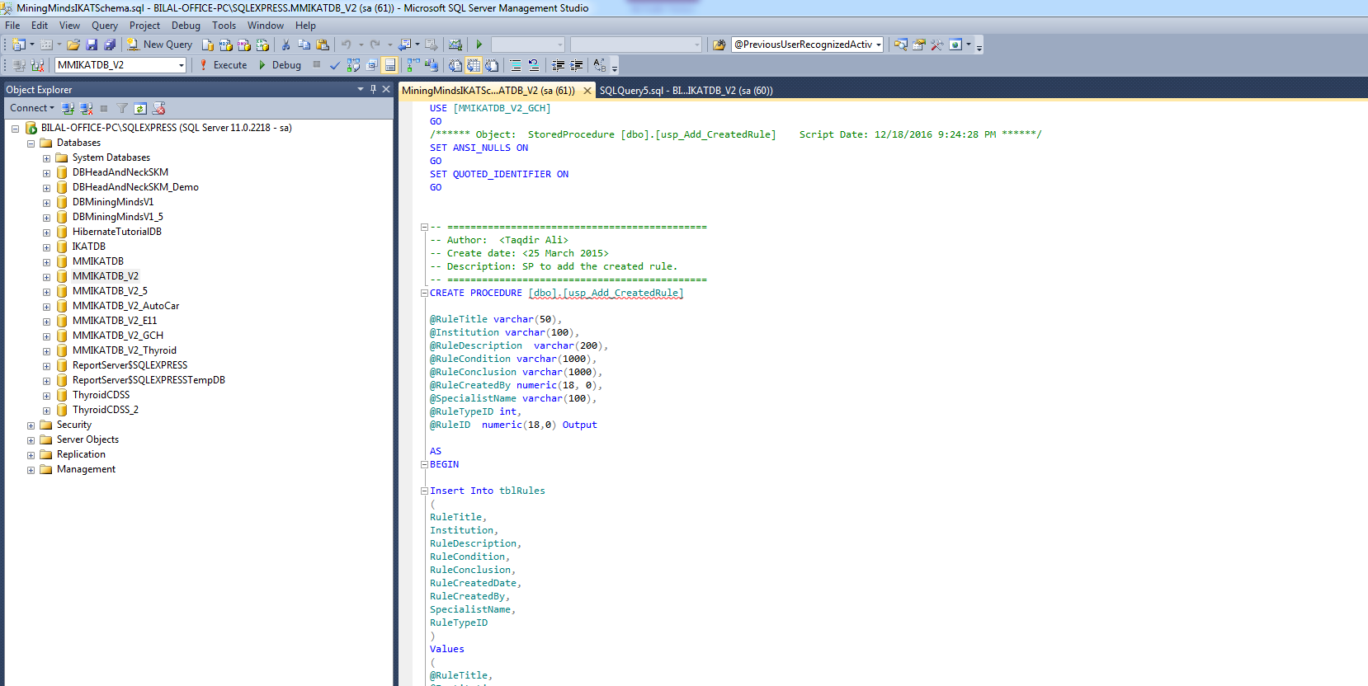

* 1. Then execute the query, it will create the whole schema of database.
  2. Now download the script of database data “MiningMindsIKATData.sql”
  3. And follow steps g, h, and i for “MiningMindsIKATData.sql” file, it will import the data instances to the selected database.

1. JDK and JAVA_HOME
   1. Make sure JDK is installed, and “JAVA_HOME” variable is added as Windows environment variable
2. Apache Maven installation
   1. Download Apache maven and install it using following steps
   2. Visit [Maven official website](http://maven.apache.org/download.cgi), download the Maven zip file,

For example: apache-maven-3.2.2-bin.zip.

* 1. Unzip it to the folder you want to install Maven.

(Assume you unzip to this folder – C:\Program Files\Apache\maven)

1. Add MAVEN_HOME
   1. Add MAVEN_HOME variables in the Windows environment, and point it to your Maven folder.
2. Add to PATH
   1. Update PATH variable, append Maven bin folder, so that you can run the Maven’s command everywhere.
3. Verify the maven installation
   1. Done, to verify it, run mvn –version in the command prompt. For more detail of maven installation visit the following link.

( <https://www.mkyong.com/maven/how-to-install-maven-in-windows/>)

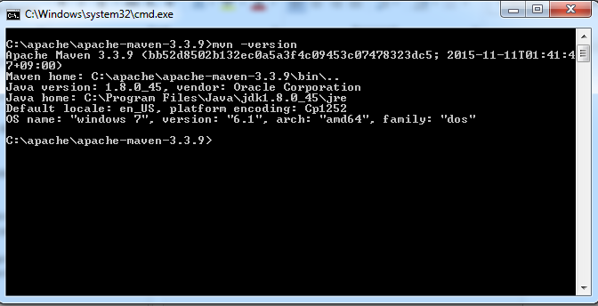

1. Download and Install Apache Tomcat
   1. Go to [http://tomcat.apache.org](http://tomcat.apache.org/) ⇒ Downloads ⇒ Tomcat 8.0 ⇒ "8.0.{xx}" (where {xx} is the latest upgrade number) ⇒ Binary Distributions ⇒ Core ⇒ "ZIP" package (e.g., "apache-tomcat-8.0.{xx}.zip", about 8 MB).
   2. Create your project directory, say "d:\myProject" or "c:\myProject".
   3. UNZIP the downloaded file into your project directory. Tomcat will be unzipped into directory "d:\myProject\apache-tomcat-8.0.{xx}".
   4. For more detail to install Apache Tomcat visit the following link <https://www.ntu.edu.sg/home/ehchua/programming/howto/Tomcat_HowTo.html>
2. Download source file src and pom file into the appropriate project folder
3. Start Command Prompt
4. Change the directory to your project directory and folder
5. Run “mvn clear install” command

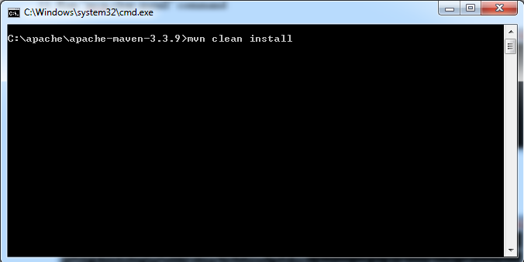

1. Project will be built successfully

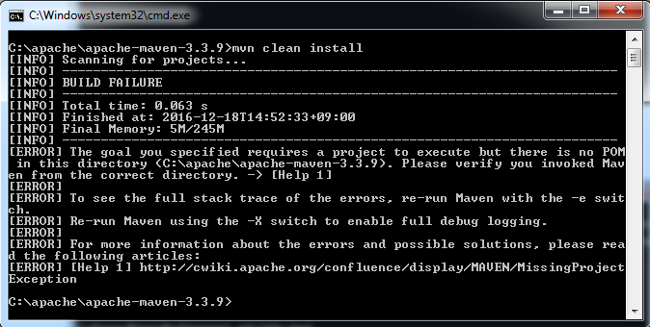

1. Go to Project folder and access the target folder to copy *AuthoringEnvironment.war* file
2. Go to apache-tomcat\webapps folder and paste war file there.
3. Go to apache-tomcat\bin and start the tomcat server by clicking “startup.bat” file

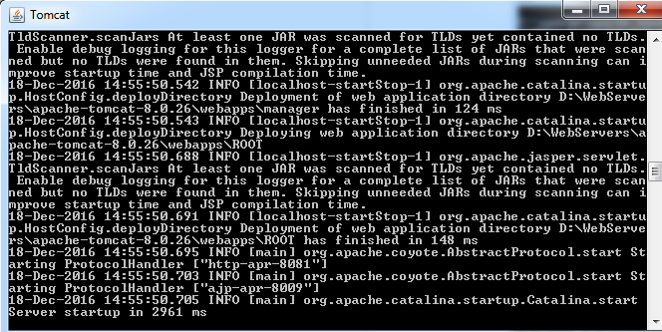

1. Open browser to test apache-tomcat
2. Give url : [http://localhost: 8081/AuthoringEnvironment/login](http://localhost:8081/MMDataCurationRestfulService/webresources/DataCuration/User/12/)
3. It will render the login view to authenticate the domain expert as a user



Currently we set the port to 8081 instead of default 8080. You can change according to available ports on your system.

1. In login id write "john" and password "test123" and click login button.
2. The dashboard view will appear with the Rules List of existing rules in the knowledge base.

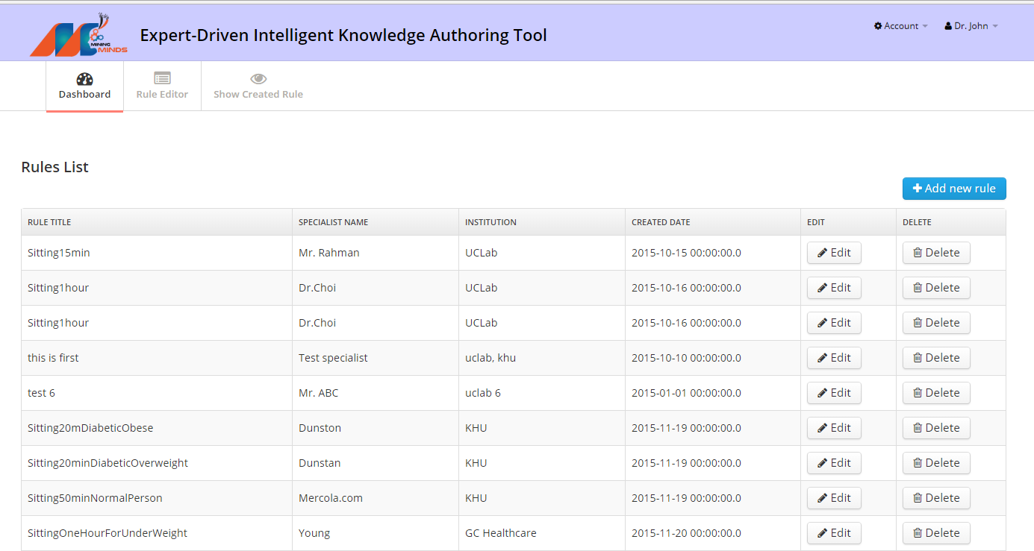

1. If you want to add new rule then click "Add new rule" button.
2. It will render the rule editor view in adding mode.

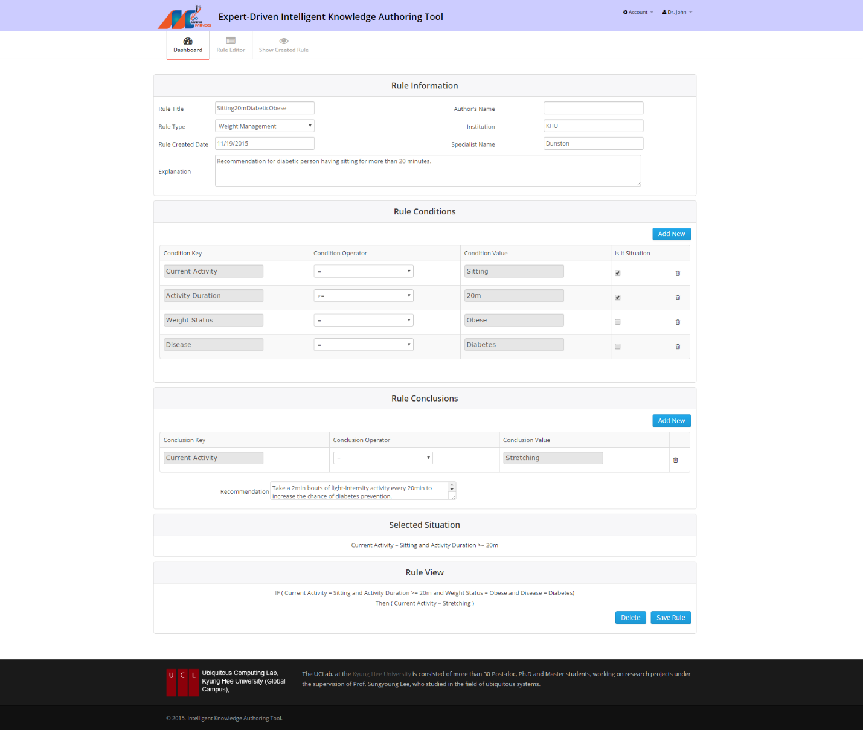

1. First put the meta information about the rule like rule title, Author's name, Rule Type, Institution, Rule created date and others.
2. Add required conditions (can be multiple) by clicking "Add New" button in Rule Conditions slot.
3. Select the check box under the "Is it situation" column, if that particular conditional fact is situation.
4. Similarly, add single or multiple conclusions by clicking "Add new" button in the Rule Conclusion slot.
5. If you want to write some other recommendation then use the Recommendation box.
6. The selected situation and written rule will be shown in Selected Situation slot and Rule View slot, respectively.
7. Finally, click the Save Rule button to persist the new rule into the knowledge base.
8. The same steps can follow to edit the existing rules after clicking the Edit button on dashboard to the corresponding rule.