Bupa iPAC — Business Purpose & Complete Flow Documentation
Sources: iPAC System Design Document v1.0 (Sep 2019, updates Nov–Dec 2020), pac.docx, iPAC codebase, and DATABASE_FUNCTIONALITY_DOCUMENTATION.md.

Audience: New developers, business analysts, QA, support, and project handover teams.

Table of contents
1. Executive summary
2. Business problem and purpose
3. Who uses iPAC and when
4. Big picture — how the business works
5. Entry from CRM
6. Main screen and premium concepts
7. New business pricing journey
8. Renewal pricing journey
9. Save, calculate, approve, and post
10. Administration — factor maintenance
11. Supporting modules
12. Security and roles
13. End-to-end flow diagrams
14. Module-to-code map
15. Glossary

1. Executive summary
iPAC (Insurance Pricing and Administration for Corporate) replaces a manual Excel-based corporate pricing process. Pricers used to collect sales data, run Excel macros for estimated prices, and email managers for approvals. iPAC centralizes that into one system integrated with Microsoft Dynamics CRM.

In one sentence:

A corporate pricer opens a CRM quote in iPAC, models claims and loss ratios, the system calculates premiums using actuarial factors, managers approve if discounts exceed authority, and final rates are posted back to CRM.

2. Business problem and purpose

Before iPAC (manual process)

Step | Manual world
1 | Sales sends quotation data to the corporate pricing team
2 | Pricers capture data in Excel sheets
3 | Excel macros produce an initial estimated price (not final)
4 | Pricing manager adjusts price using Target Loss Ratio, Claim Experience, and other parameters
5 | Approvals and final rates communicated back to sales/CRM informally

Problems: No single audit trail, inconsistent formulas, slow handoffs, risk of wrong version of spreadsheet.

What iPAC solves

Goal | How iPAC delivers it
Single source of truth | One opportunity record per CRM quote option in SQL Server
Consistent calculation | InRule engine (C# premium logic) + admin-maintained factor tables
CRM integration | Load members/products from CRM; post premium back when done
Governance | Authority matrix — discounts above user level need approval
Audit | Every save, submit, approve, post logged in Audit History
Renewal analytics | Technical Result reports (claims by hospital, member movement, statistics) for renewal pricing

Business domain
Corporate group medical insurance pricing for Bupa Saudi Arabia:

- New business — first-time or new quote pricing (Claims Data + Target Loss Ratio tabs).
- Renewal — existing contract renewal (Technical Result tab + renewal authority / price increase).
- What-If — trial policy changes without posting to CRM until restored.

3. Who uses iPAC and when

Role | What they do in iPAC
Corporate pricer / underwriter | Model claims, set target LR, adjust factors, save, request approval, post rates
Pricing manager / Head / Director / CFO | Approve or reject when discount exceeds subordinate authority
Sales (via CRM) | Triggers iPAC by clicking IPAC CALCULATION or IPAC (READ-ONLY) — does not price inside iPAC
iPAC administrator | Upload factor batches (cost curve, deductibles, renewal scoring, etc.) via Admin area
Reports administrator | Access reporting screens in Admin
IT / integration | CRM sync (Windows Service), IBM URL decrypt, RPA underwriting feed

4. Big picture — how the business works
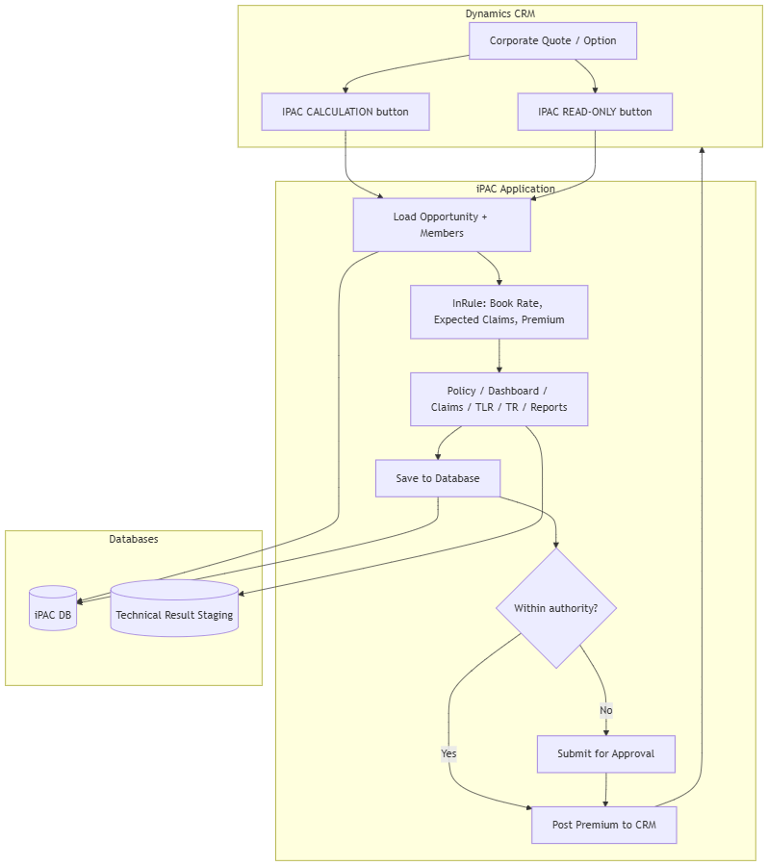

Two parallel “modes” of work

Mode | When | Main tabs | Outcome
New business | OpportunityType = New, IsRenewal = false | Policy Design, Dashboard, Claim Data, Target Loss Ratio | Rates from book rate + claim adj + target LR
Renewal | IsRenewal = true | Policy Design, Dashboard, Technical Result, renewal statistics | Price increase % from TR + authority matrix → next year gross rates

5. Entry from CRM

Two ways to open iPAC (from design document)

CRM button | Business meaning | iPAC behavior
IPAC CALCULATION | Full pricing session | User can Save, Calculate, and Post (if authority allows)
IPAC (READ-ONLY) | View only | Save and Post disabled; for review or audit

Technical entry (what happens behind the scenes)
1. CRM opens a URL with an encrypted opportunity identifier.
2. IIS Windows Authentication identifies the user.
3. iPAC checks AD department against AuthorizedDepartments and loads CRM user + role into session.
4. IBM API decrypts the URL token.
5. Angular loads: Opportunity/GetAll → list of quote options for that company.
6. If multiple quotations exist (revisions from sales), user selects one; older options may be read-only.
7. First open may sync CRM data into iPAC DB and run InRule once using loading factor and target loss ratio to produce initial rates.

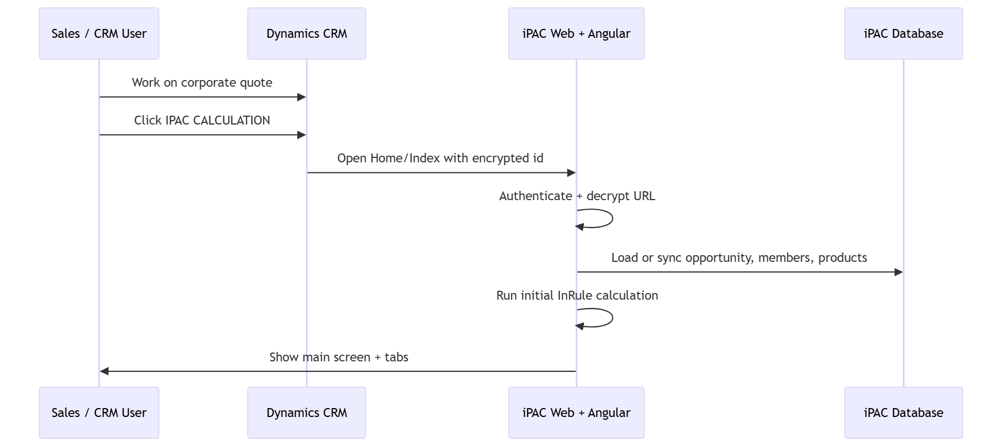

Code touchpoints: HomeController.Index, app.component.ts, iPacSessionInfo.GetAll, Opportunity/GetIBMDecryptResponse.

6. Main screen and premium concepts
When an opportunity is loaded, the top of the main screen has three business blocks (design document §1.2.2).

A. Opportunity details
- Company, broker, inception date, group size, etc. (from CRM, stored in Opportunity).
- Broker commission stored with LEVI adjustment; UI may show commission without LEVI (1.5%) for display consistency.

B. Distribution of members
- Breakdown by product and member type (employee, wife, child, senior, parent).
- Shows rate, count, and total per segment.
- More info opens deeper member distribution detail.

C. Premium summary (key business formulas)
These terms appear throughout training and audits:

Term | Business meaning (simple)
Expected Claims | Total medical cost after factors and claim adjustment, across benefit lines (Standard, Maternity, Dental, etc.)
Book Rate | Same cost building blocks before claim adjustment
Office Rate | Expected Claims ÷ loading factor
Office Rates LR | Expected Claims ÷ Office Rate
Targeted LR (Loss Ratio) | Expected Claims ÷ Net Premium
Discount | 1 − (Targeted LR ÷ Office Rates LR)
Net Premium | Sum of (each benefit cost ÷ its target LR)
Gross Premium | Net Premium ÷ (1 − commission)
Total Premium (VAT inclusive) | Gross × 1.05 (VAT)

Navigation tabs (what pricer works on)

Tab | New business | Renewal | Purpose
Policy Design | ✓ | ✓ | Benefits, network, deductibles, what-if scenarios
Dashboard | ✓ | ✓ | Member distribution charts
Claim Data | ✓ | — | Projection + experience (new only)
Target Loss Ratio | ✓ | — | Set LR, scheme rates, authority matrix (new only)
Technical Result | — | ✓ | Renewal analytics and price increase
Reports | ✓ | ✓ | Policy + rates printable views
Notes | ✓ | ✓ | Team comments
Audit History | ✓ | ✓ | Who changed what and when

Save and Post area
- Comment box — reason text before save or post (audit).
- Save — persists claims, TLR, cost change, configuration to database; recalculates as needed.
- Post — sends approved premium/rates to CRM; sets opportunity to Posted when successful.

7. New business pricing journey
This is the path for a new corporate quote (not renewal).

Step 1 — Policy Design
Business: Show how the policy is structured (benefits, network, room, deductibles, limits).

Area | User can
Benefit / Network / Room | View; some fields editable
Limits, deductibles, maternity/dental/optical flags | Adjust for pricing scenario
What-If Scenario | Change benefits to model customer requests

What-If rules (important):

- Save on what-if → saves scenario, recalculates book rate/rates, disables Post to CRM for this opportunity.
- Restore → returns to original policy and factors, re-enables Post, recalculates with current cost curve and benefit factors.

Tables: Product, BenefitDetail, Scenario, ScenarioPolicy, OpportunityConfigration.

Step 2 — Dashboard
Business: Visual check of who is being insured.

- Members by age band, relationship, nationality.
- Validates demographics before accepting claim/LR inputs.

API: Opportunity/GetDashboardSummary, GetMembersDistribution.

Step 3 — Claim Data (new only)
Business: Build the claims story for the quote — projection for current year + experience for prior years + adjustments.

3a. Current claims projection

Input | Rule
No of claims | Total claims for current year
Projection date | Default: inception − 1 year; user may change
12+1 months grid | Members and claim expense per month

Calculated columns (per month):

- Member factor — first month 100%; later months vs first month.
- Day factor — proration for partial first/last month.
- Seasonality — from SeasonalityFactor table (admin batch).
- Weight — member factor × day factor × seasonality.

Footer summary:

Metric | Formula / meaning
Total Cost | Sum of claim expense
Completion | Weighted completion % (months with claims > 0)
Ultimate Cost | Total Cost ÷ Completion
Ultimate # of Claims | No of Claims ÷ Completion
Avg. Members | Weighted average lives

3b. Insurer discount (cost change)
- System calculates Bupa vs other insurer discount.
- User may override with mandatory reason (dropdown + comment).

3c. Previous years claim experience
- Two prior years: PER beginning/end, reported claims, # claims, insurer dropdown.
- Burning cost = reported claims ÷ population exposed to risk.
- Claims experience adjustment derived; user may override with New Claims Adj. + upload + reason.

Calculated claim adjustment:

Calculated Claim Adj. = (Credibility × Reported Claims) / Book Rate − 1

Tables: ClaimData, ClaimProjectionData, ClaimExperienceData, CostChangeFactor.

API: Claim/GetClaimProjection, GetClaimExperience, Create; save via Opportunity/SaveOpportunity.

Step 4 — Target Loss Ratio (new only)
Business: Decide how much premium to charge relative to expected claims — the core pricing decision for new business.

4a. Loss ratio sections

Section | Who edits
Current Target LR | Read-only (system state)
New Target LR | Pricer edits Standard, Maternity, Dental, Other

Default LR logic (conceptual):

Default LR ≈ 1 − loading factor (weighted by network and scheme expected claims vs book rate)

Scheme applicability:

- Standard / Dental / Other — need employee, child, or wife in scheme.
- Maternity — needs wife in scheme.

4b. Rate summary
Shows office rate, expected claims, net/gross written premium, discount margin, contribution per life, VAT inclusive total, and approval required flag from authority matrix.

4c. Scheme rate & scheme summary
- Per scheme rates for employee, wife, child, senior, parent.
- Per scheme claim and LR metrics (only schemes with members).

4d. Cost change factors (per scheme)
Pricer may adjust for schemes with members:

Factor | Effect
Cost curve % | Scales base cost curve
Seniors factor | Multiplier on employee rate for seniors
Maternity load | Wife vs employee rate gap
Targeted gross rate for employee | When no employees/children
Parent factor | Multiplier for parents

Adjust Rates helper — reverse calculator: enter desired employee/wife/senior/parent rate → system suggests LR/factors.

4e. Authority matrix (governance)
For each scheme (seniors separated), system computes minimum contribution and maximum loss ratio per authority tier:

Authority tier (example) | Used for
Managers / Sr. Managers | First approval band
Head | Higher band
Director | Higher band
CFO / CEO | Highest band

Discount threshold compares target LR to total max LR across the group.

If discount is too deep → Submit for Approval before post.

Tables: TargetLossRatio, AuthorityMatrix, OpportunityAuthorityMatrix, NetworkAuthorityMatrix.

API: TargetLoss/GetCurrentLossRatio, Opportunity/CalaculatePremium, GetNetworkAuthorityMatrix.

New business — end-to-end flow (business steps)
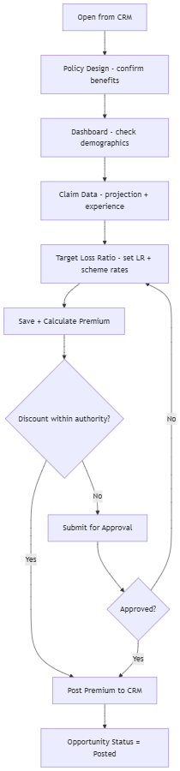

8. Renewal pricing journey
For renewal opportunities (IsRenewal = true), Claim Data and Target Loss Ratio tabs are not the primary path. Instead Technical Result (TR) drives pricing.

Technical Result screen layout

Area | Function
Left dropdown | Select refresh date of technical result data (multiple snapshots)
TR tabs | Member movement, claims summary, statistics, monthly distribution, etc.
Right panel | Report content for selected tab

Data source: Technical Result staging database (TRConStr), linked by Opportunity.TechnicalResultID.

Key tab — Statistics (renewal pricing hub)
This is the main renewal pricing workspace.

Section | Business purpose
Actual statistical report | Actual claims by scheme; medical underwriting excluded/reserved; in-house clinic cost (manual entry)
Projected statistical report | Apply IBNR; projected medical cost and projected loss ratio
Inflation / Shortfall | Product/demographic mix; inflation & shortfall % (editable with reason)
Removed cases | Default 0%; range −100% to +100% (2020 change)
Delegates & Ex-gratia | Default 0%; editable with reason
Contingency | 0%
AmbHIV | 0.8% historically; 0% if inception after 1 Jan 2021 (2020 change)
Commission | Prior year commission
Credibility adjustment | From TR calculation
Authority matrix | Min contribution / max LR (renewal variant)
Member distribution | Previous vs next year lives
Gross rates | Previous year vs next year rates
Price increase (PI) | User adjusts % by member type/scheme OR enters target rate → system computes PI

Next year gross rate logic:

Next Year Rate = Previous Year Rate × (1 + Price Increase %)

If previous rates missing → Renewal Manual Rates from database.

Apply / Reset rates — Apply PI to all schemes; Reset restores PI to manager-approved final increase from authority matrix.

Other Technical Result tabs (analytics)

Tab | Business use
Member Movement | Lives and premium/cost/LR movement
Claims Summary | Claims by status, in/out patient, network, option, relationship
Monthly Distribution | Claims and premium by month
Financial Position | Yearly premium, claims, LR, inflation, credibility
Loss Profile | Loss development view
Hospital | Export hospital utilization
Nationality | Nationality breakdown
GQL Claims | Large claim analysis
Frequent Users | High utilizers; save medical conditions
Underwriting | Search members; add reserve/exclude; save → recalculates projected LR
Pre-Authorization | Pre-auth listing and filters

APIs: TechnicalResultReport/* (30+ endpoints).

Renewal post: PostPremiumRenewal includes price increase, IBNR, renewal config — different from new business post.

Renewal — end-to-end flow
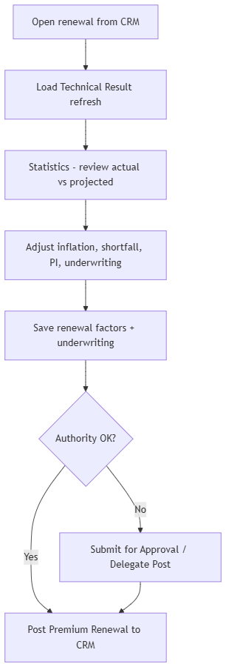

9. Save, calculate, approve, and post

Save (business)
When: Pricer finishes a tab (claims, TLR, TR statistics, policy what-if, etc.).

What happens:

1. Angular OpportunityService gathers changed data (claims, TLR, cost change, delegate ex-gratia, pricing adequacy).
2. Validates required sections.
3. POST Opportunity/SaveOpportunity → OpportunityService.SaveOpportunity (transaction).
4. Stored procedures update ClaimData, TargetLossRatio, OpportunityRates, RenewalConfigration, etc.
5. AuditTrail row (Save).
6. UI refreshes premium summary.

Status: Typically InProgress or RenewalSaved.

Calculate premium
When: User triggers recalculation (often with Save).

What happens: Opportunity/CalaculatePremium → InRuleEngine reads factor tables (by batch effective date) + opportunity data → updates rates and premium summary.

Submit for approval
When: Targeted discount or price increase exceeds user's authority level (from AuthorityMatrix / renewal matrix).

What happens:

1. POST Opportunity/SubmitForApproval
2. Status → PenddingApproval / SentToManager
3. Email notifications (sp_InsertEmailNotifications)
4. Manager approves/rejects in process (CRM or iPAC depending on org process)

Status | Meaning
Approve | Manager accepted; pricer may post
Reject | Must revise pricing

Post premium to CRM
When: Pricer (or delegate) is within authority and ready to finalize.

What happens:

1. POST Opportunity/PostPremium (new) or renewal variant with PI/IBNR.
2. Retrieve.PostPremiumGroup (WCF to CRM).
3. On success: IsPosted = true, IPACStatus = Posted, audit PostPremium.
4. CRM quote shows final rates for sales.

Delegate post: User posts on behalf of higher authority — extra audit type DelegatePost and email workflow.

GWP (Gross Written Premium) validation: Additional checks and attachments for large premium movements.

Status lifecycle (database + UI)
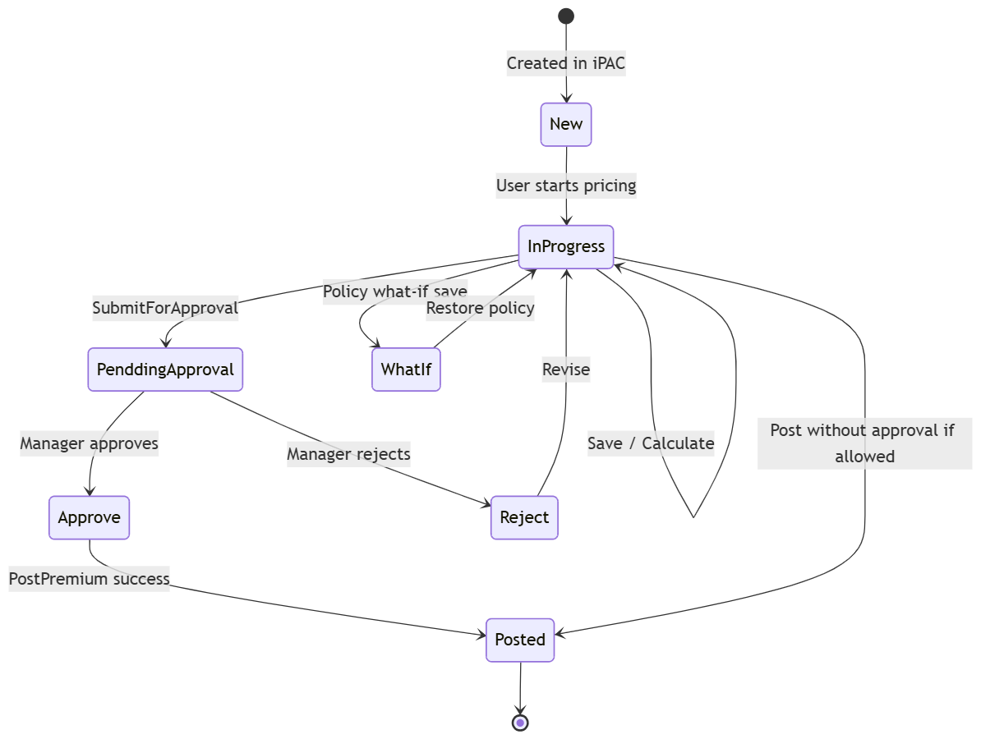

10. Administration — factor maintenance
Who: iPAC administrators (not day-to-day pricers).

Why: Premium math depends on dated factor tables. Administrators upload Excel batches that become effective for pricing on given dates.

Factor types (from design document)

Factor | Business effect
Cost Curve | Base medical cost by demographics
Option Cost | Option-level cost adjustments
Deductibles / Deductible Cap | Deductible pricing factors
Benefit Limits Factor | Limits impact on premium
Nationality master + Nationality Factor | Nationality pricing
Room master + Room factor | Room category pricing
Payment Frequency Factor | Payment term adjustment
Credibility Factor | Credibility weighting in experience
Plan NWK Factor | Plan/network factor
Completion Factor | Claim completion curves
Seasonality Factor | Monthly seasonality in projection
Renewal* tables | Renewal scoring, discount, authority LR, lives/tenure ranges, MOH, mega-cases, shortfall by provider

Batch upload process (business)
1. Admin opens /Admin/{Factor}/Upload.
2. Downloads Excel template, fills factors for start/end effective dates.
3. Uploads → validation stored procedure → creates Batch row.
4. On success, pricers using opportunities with inception in range pick up new factors on next Calculate.

Tables: Batch, factor tables (e.g. CostCurve, Deductible), ConfigurationType.

11. Supporting modules

Reports
- Printable/exportable policy design, member distribution, rates by subscription type.
- Admin pricing reports and financial renewal reports (sp_GetPricingReport, sp_GetFinancialReportForRenewal).

Notes
- Team collaboration: Note table; Note/GetNotes, SaveNote.

Audit History
- Every significant action: user, role, area, old/new data snapshot.
- Used for compliance and dispute resolution.
- Audit/GetAuditHistory.

MOH calculation (Ministry of Health)
- Separate route /mohcalculation for MOH impact on member distribution and pricing (renewal/new per config flags).

Mega-cases
- Large group special rules: credibility, book rate, claim checks (/megacasesusers).

User delegation
- Temporary transfer of approval authority between users (UserDelegation).

Windows Service (background)

Job | Business value
CRM opportunity sync | Keeps iPAC aligned with CRM master data
CRM user/role sync | Maps CRM roles to iPAC authority
Factor upload reminders | Emails admins when factors need refresh

12. Security and roles

Check | Business rule
Windows login | User must be on corporate network / domain
Department | AD department must be in AuthorizedDepartments
CRM user | Must exist in CRM and not be disabled
iPAC role | CRM role mapped to iPAC Role with authority level
Admin | IsAdmin for /Admin factor screens
Read-only CRM button | iPAC enforces read-only on save/post

13. End-to-end flow diagrams

Complete system — from CRM click to posted rates
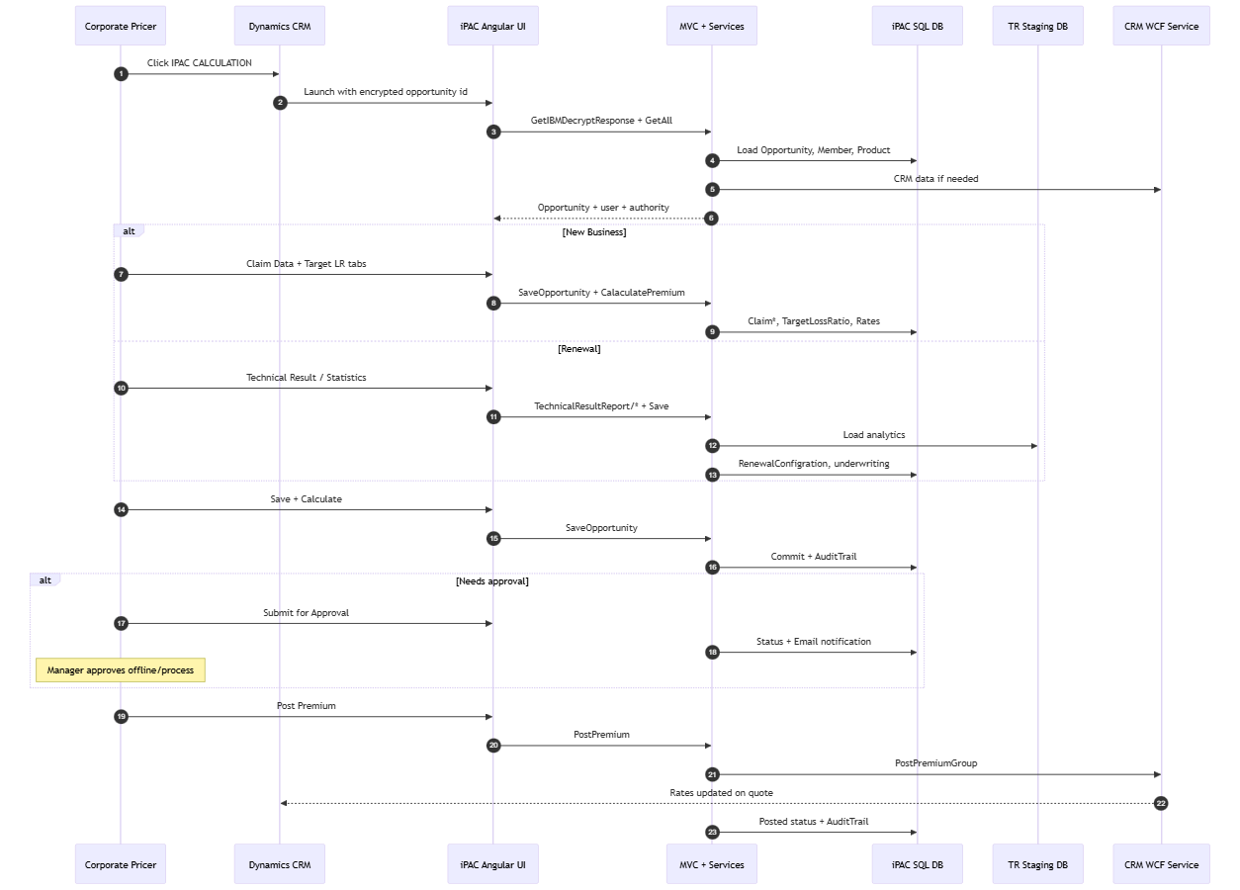

14. Module-to-code map

Business module | Angular route / area | MVC controller | Main DB tables
Load opportunity | app.component | Home, Opportunity | Opportunity, Member, Product
Main / opportunity shell | /opportunity | Opportunity | Opportunity, OpportunityPremiumSummary
Policy design | /policydesign | Opportunity, PolicyDesign | Product, BenefitDetail, Scenario
Dashboard | /dashboard | Opportunity | MembersDistribution
Claim data | /projection | Claim | ClaimData, ClaimProjectionData, ClaimExperienceData
Target LR | /targetlr | TargetLoss, Opportunity | TargetLossRatio, AuthorityMatrix
Technical result | /technicalresult | TechnicalResultReport | TR DB + RenewalConfigration
Reports | /reports, /summaryreport | SummaryReport | Report SPs / views
Notes | /notes | Note | Note
Audit | /audit | Audit | AuditTrail
Admin factors | /Admin/* | Admin controllers | Batch, factor tables
MOH | /mohcalculation | MOHFactors | MOHFactor
Mega-cases | /megacasesusers | MegaCases | MegaCases*

15. Glossary

Term | Meaning
Opportunity | One pricing workspace in iPAC (usually one CRM quote option)
Quote / Option | CRM identifier for a specific pricing alternative
Book Rate | Expected medical cost before claim adjustment
Expected Claims | Cost after claim adjustment
Target LR | Target loss ratio — claims ÷ premium goal
Office Rate / Office LR | Reference rate/LR from loading factor
IBNR | Incurred but not reported — reserve in renewal statistics
PI | Price increase % for renewal
TR | Technical Result — renewal claims analytics dataset
InRule | In-process premium calculation engine (Bupa.Ipac.InRule)
Batch | Dated upload of admin factor tables
Authority matrix | Min contribution / max LR bands per management level
Post | Push final rates to CRM
What-If | Trial policy scenario; blocks CRM post until restore
LEVI | Commission adjustment (1.5%) in display logic
GWP | Gross written premium governance
MOH | Ministry of Health regulatory impact
Delegate post | Posting premium with delegated higher authority

Related documents

Document | Content
README.md | Setup and build
DEVELOPER_GUIDE.md / docs/ | Technical architecture
DATABASE_FUNCTIONALITY_DOCUMENTATION.md | All tables and columns
pac.docx (source) | iPAC System Design Document v1.0 — module screen-level detail

This document describes business behavior as implemented in Bupa iPAC. For screen-level field definitions and historical change notes (*2* removed cases range, *3* AmbHIV), refer to the original design document `pac.docx`.

