MS&AMD Module Flow Diagrams
Sequence and flow diagrams derived from MS&AMD_Module_Flow_Presentation.pptx — Saudi Aramco MS&AMD (Medical Services & Affiliation Management Department) and BUPA Arabia Automated Communication System.

1. System Overview & User Roles
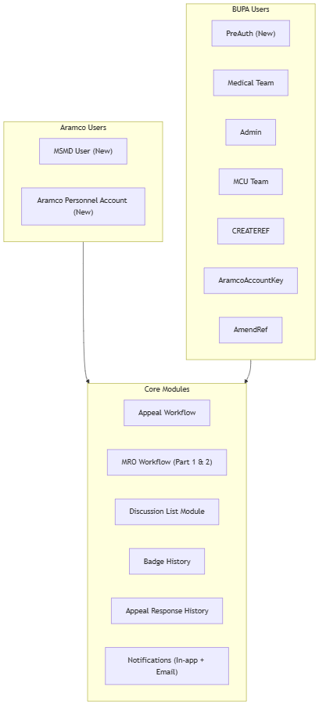

2. High-Level Appeal Workflow
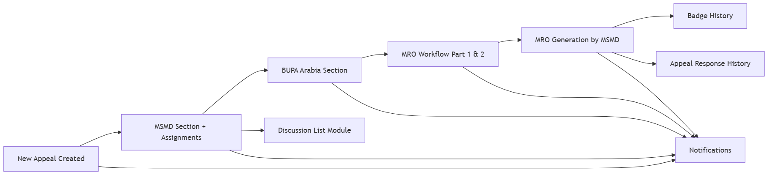

3. Flow 1 — Appeal Lifecycle (End-to-End)
flowchart TD
Start([Start]) --> S1
S1["Step 1: Appeal Created<br/>By BUPA Key Account OR<br/>Aramco Personnel Key Account"]
S1 --> S2{"Step 2: Edit / Cancel?"}
S2 -->|Edit| S1
S2 -->|Cancel| End([End])
S2 -->|Proceed| S3
S3["Step 3: MSMD Login View<br/>MSMD sees created appeals"]
S3 --> S4["Step 4: MSMD Edit Mode<br/>Opens appeal in edit modal<br/>Completes MSMD section<br/>Assigns case to BUPA team"]
S4 --> S5["Step 5: BUPA Team View<br/>Assigned case visible to BUPA users"]
S5 --> S6["Step 6: BUPA Response<br/>BUPA Team submits response"]
S6 --> Done([Appeal cycle complete])

4. Flow 1 — Appeal Sequence Diagram
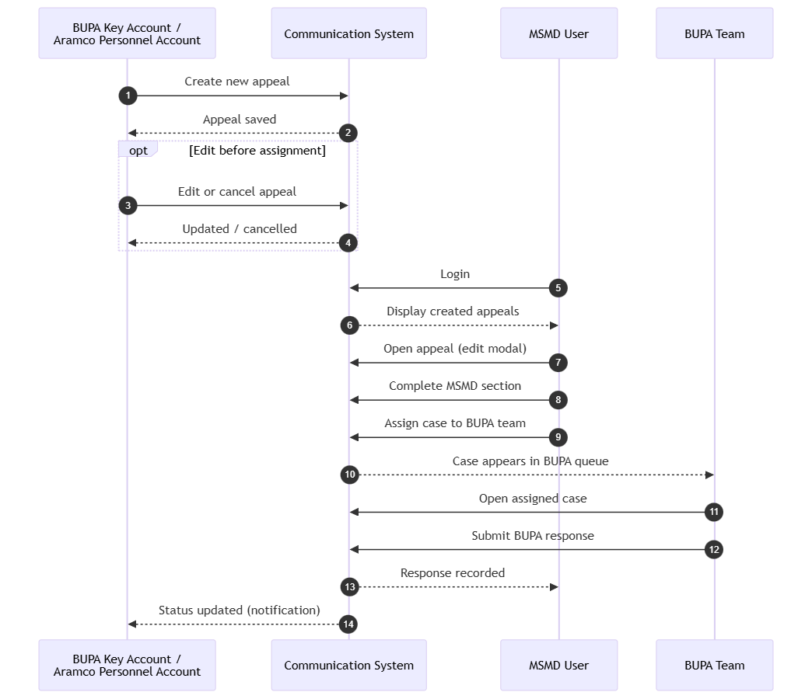

5. Flow 2 — MRO Process (Overview)
flowchart LR
A["Select MRO Category"] --> B["MRO Part 1<br/>(MSMD)"]
B --> C["Assign to<br/>BUPA Team"]
C --> D["MRO Part 2<br/>(BUPA Team)"]
D --> E["Final MRO Generation<br/>(MSMD)"]
E --> F["PDF Generated &<br/>Auto-Attached"]

6. Flow 2 — MRO Detailed Steps
flowchart TD
Start([Appeal with MRO category]) --> S1
S1["Step 1: Select MRO Category<br/>MRO button becomes visible"]
S1 --> S2["Step 2: MRO Form Part 1<br/>Form prefilled from appeal data<br/>MSMD completes Part 1<br/>MSMD assigns to BUPA team"]
S2 --> S3["Step 3: BUPA Team opens MRO case<br/>MRO button visible to BUPA"]
S3 --> S4["Step 4: BUPA Team updates Part 2<br/>Completes Part 2 section"]
S4 --> S5["Step 5: Generate MRO button<br/>visible to MSMD"]
S5 --> S6["Step 6: MSMD enters recommendation<br/>Generates MRO PDF"]
S6 --> S7["Step 7: Final MRO form<br/>automatically attached to case"]
S7 --> End([MRO complete])

7. Flow 2 — MRO Sequence Diagram
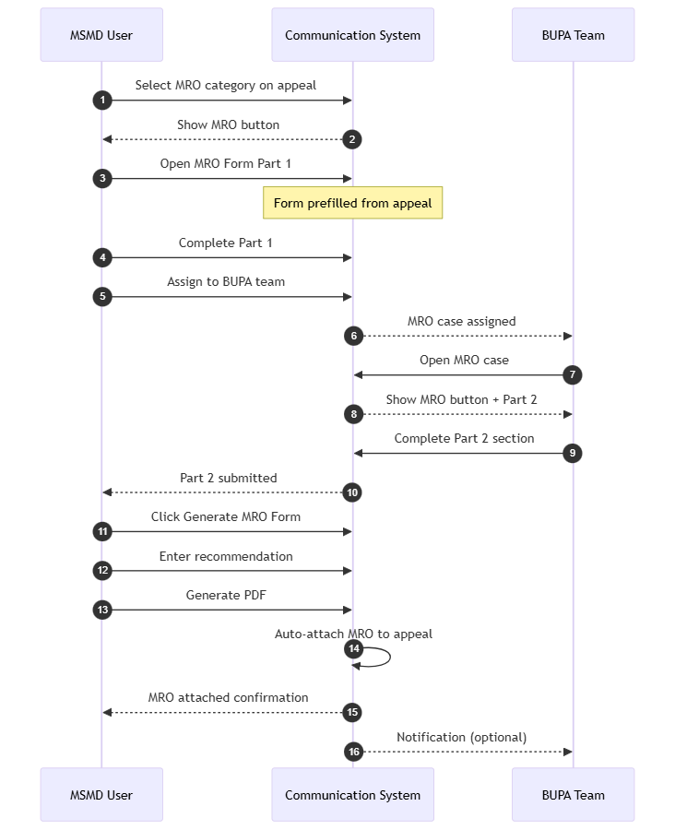

8. Discussion List Module
flowchart TD
A["MSMD sets discussion date<br/>on assigned case(s)"] --> B["On matching date,<br/>cases appear in Discussion List"]
B --> C["MSMD selects multiple cases<br/>for bulk discussion"]
C --> D["Discussion pop-up opens"]
D --> E{"Navigate cases"}
E -->|Next| D
E -->|Previous| D
E -->|Done| F([Discussion complete])

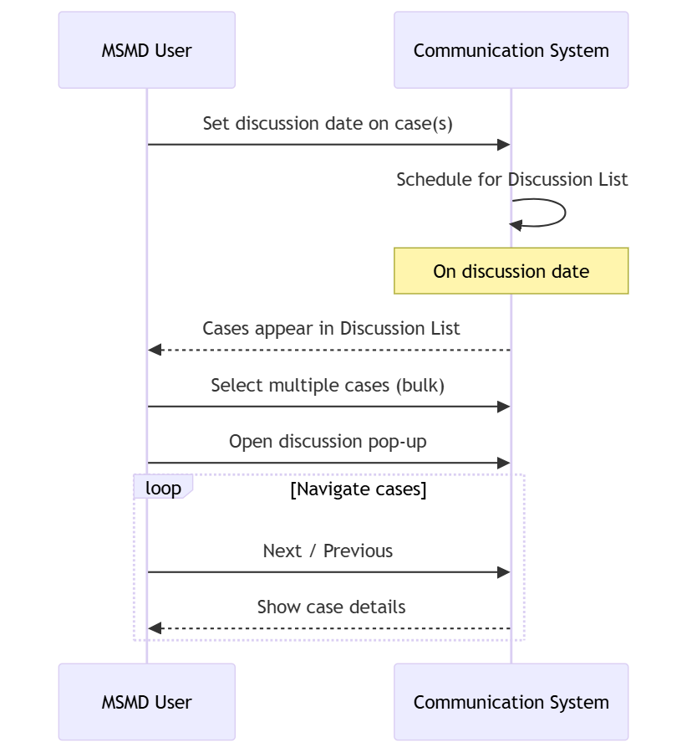

9. History & Audit Modules
flowchart LR
subgraph User["Any Authorized User"]
U1["View Badge Number History"]
U2["View Appeal Response History"]
end
subgraph Data["System Records"]
BH["Badge History<br/>(per badge number)"]
ARH["Appeal Response History<br/>(per case)"]
end
U1 --> BH
U2 --> ARH

10. Notification Flow
flowchart TD
Events["System Events<br/>(Appeal created, assigned,<br/>response submitted, MRO generated,<br/>discussion scheduled)"]
Events --> InApp["In-App Notification Icon"]
Events --> Email["Email Notification"]
InApp --> User["User sees alert in portal"]
Email --> User

sequenceDiagram
participant Actor as User (MSMD / BUPA / Creator)
participant System as Communication System
participant Notify as Notification Service
participant Recipient as Target User
Actor->>System: Trigger workflow action<br/>(assign, respond, generate MRO, etc.)
System->>Notify: Publish event
Notify->>Recipient: In-app notification (icon/badge)
Notify->>Recipient: Email notification
Recipient->>System: View notification / open case

11. Landing Page by Role
flowchart TD
Login([User Login]) --> Role{User Role?}
Role -->|MSMD User| LP1["MSMD Landing Page<br/>Appeals queue, assignments,<br/>MRO, Discussion List"]
Role -->|Other Users| LP2["Other User Landing Page<br/>Role-specific views<br/>(BUPA, Aramco, Admin, etc.)"]
LP1 --> Actions1["Create / review appeals<br/>Assign to BUPA<br/>Generate MRO<br/>Manage discussions"]
LP2 --> Actions2["Create appeals<br/>Submit responses<br/>View history"]

12. Complete System Interaction (Master Sequence)
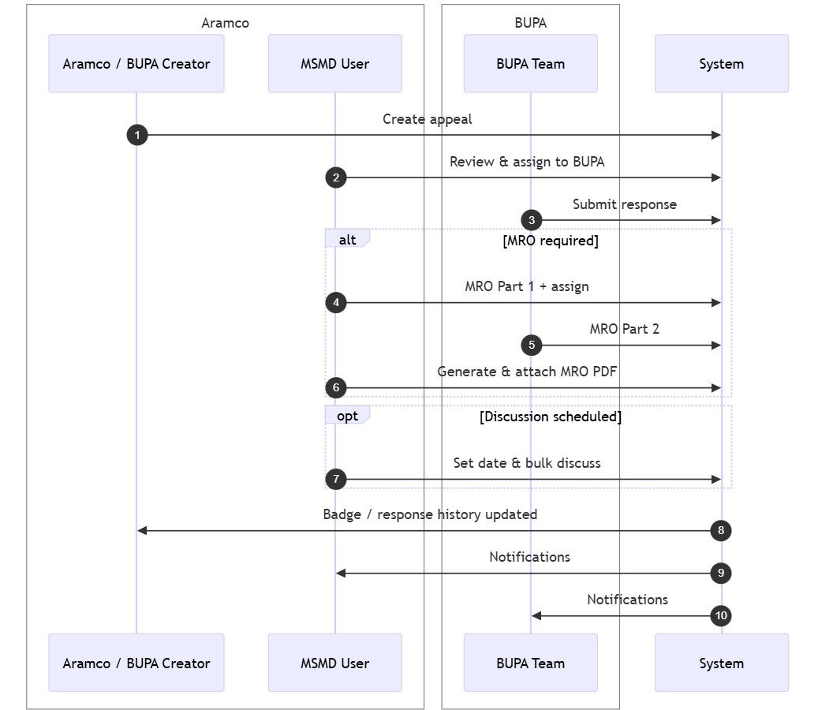

Summary Mapping (Slides → Diagrams)

Presentation section | Diagram(s)
Slides 2–3 (Roles & overview) | #1, #2, #11
Slides 6–11 (Flow 1 — Appeal) | #3, #4
Slides 12–19 (Flow 2 — MRO) | #5, #6, #7
Slides 20–21 (Discussion) | #8
Slides 22–24 (History) | #9
Slides 25–26 (Notifications) | #10
All flows combined | #12

Source: docs/MS&AMD_Module_Flow_Presentation.pptx

