
Document Reference : iPAC SYSTEM DESIGN DOCUMENT
Version : 1.0
Update Date : 16 Sep 2019
Distribution : IT

iPAC SYSTEM Design document v1.0

Document History
Date | Modified By | Description | Ver.
16/09/2019 | Adel Alsaadi | initial | 1.0
25-Nov-2020 | Lokesh Narayanappa | Allow Removed Cases for Renewal Opportunity to accept Positive Values – refer *2* for changes
10-Dec-2020 | Lokesh Narayanappa | AmbHIV Value will be 0% for Renewal Opportunity whose Inception Date is Greater than 1st Jan 2021 – refer *3* for changes

Document Owners
Owners | Title | Description | Ver.
Adel Alsaadi | Specialist - .net | iPAC Design Document | 1.0

Reviewers
Reviewers | Title | Description
Lokesh Narayanappa | Manager – InRule Applications , IT | Reviewed the document and provided my comments

Distribution List
Name | Description
IT Development Team | Design and Develop iPAC and integrate with CRM

Contents
1. Overview 4
1.1 Background 4
1.2 iPAC Modules Design: 4
1.2.1 Loading Opportunity and Select Quotation: 4
1.2.2 iPAC Main Screen: 5
1.2.3 Administration - Batch Upload: 7
1.2.4 Policy Design: 7
1.2.5 Dashboard: 9
1.2.6 Claim data: 11
1.2.7 Target Loss Ratio: 13
1.2.8 Technical result: 15
1.2.9 Reports: 27
1.2.10 Notes: 28
1.2.11 Audit History: 28
1.3 iPAC workflow: 29

Overview

1.1 Background
Currently the process for pricing a corporate quotation is done manually by corporate pricing team. The process involves collecting data from sales team, capture data into excel sheets, run Excel Macro to calculate initial price (estimated, not final), then pricing manger adjust price based on parameters like Target Loss Ratio and Claim Experience, etc.

1.2 iPAC Modules Design:
- Loading Opportunity and Select Quotation
- iPAC Main Screen
- Batch Upload
- Policy Design
- Dashboard
- Claim data - New
- Target Loss Ratio - New
- Technical result - Renewal
- Reports
- Notes
- Audit History

1.2.1 Loading Opportunity and Select Quotation:
There is two ways to open iPAC from CRM by:
- Click on “IPAC CALCULATION” button to open iPAC Application.
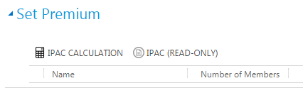
- Click on “IPAC (READ-ONLY)” button to open iPAC Application in read only mode and disabling save and post button.
Shot from CRM showing the iPAC buttons

By clicking “iPAC Calculation” button, a new page will be opened and you will be welcomed with the loading opportunity screen to load Data from CRM using CRM services into iPAC Database if not loaded before, and run InRule engine for the first time to calculate cost and loading factor to get the rate based on target Loss Ratio from loading factor.
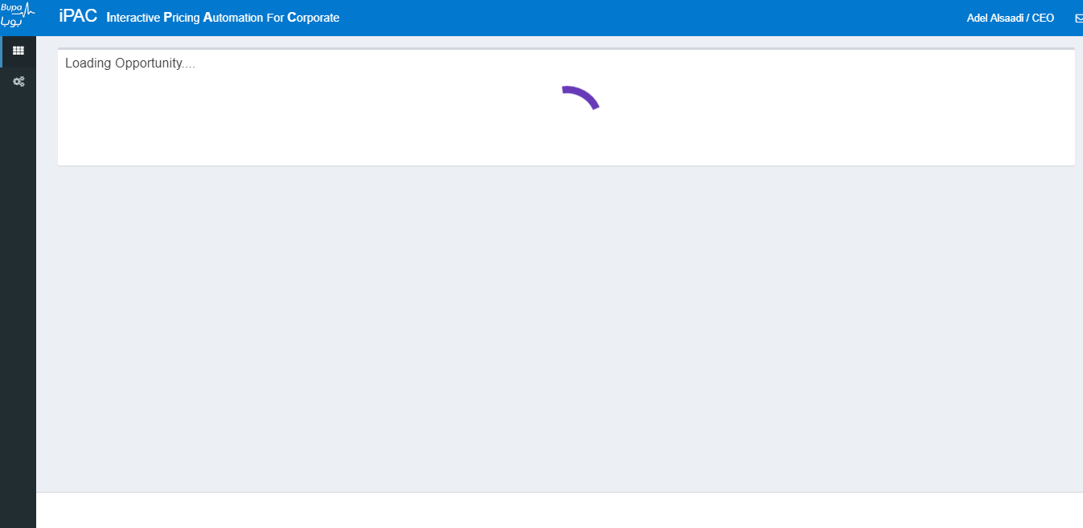
Incase of any revison on the qoutation or changes done by sales and sent again to pricing system within CRM, then iPAC will let the user to choose one from the List to load, in this case all the previos quotations will be set to read only.
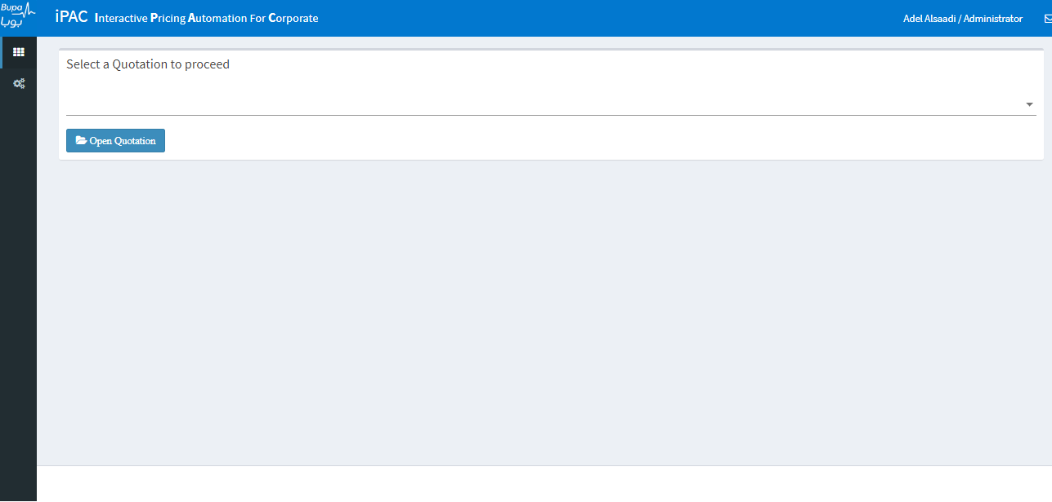

1.2.2 iPAC Main Screen:
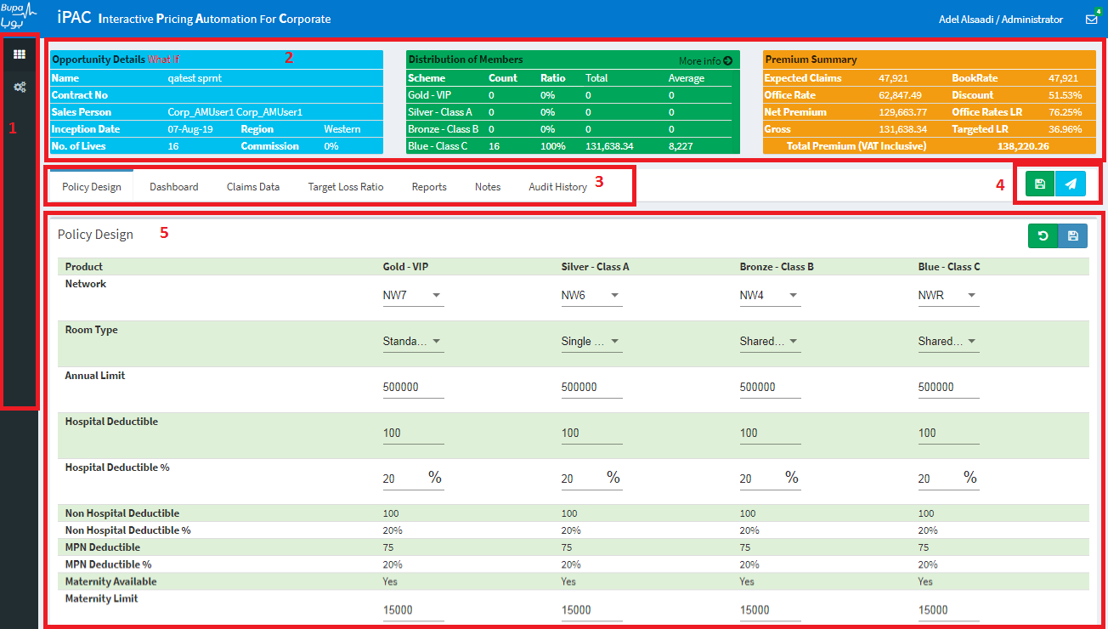
- Two icons button to select iPAC or batch upload configuration .
- This section has three parts:
  - Opportunity Details displays data from CRM commission stored in iPAC with LEVI but always displayed for users without the LEVI (1.5%).
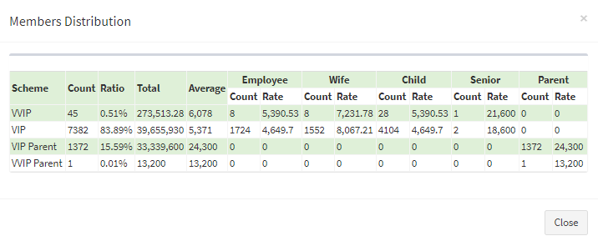
  - Distribution of Members displays data based on products and type showing rate and count and total. User can click on More info option to show more details.
  - Premium Summary displays the summery of the cost and premium.
Expected Claims: the total cost of (Standard + Maternity + Neonatal + Dental + Congenital + Optical + Vaccination + Physiotherapy) after applying factors and Claim Adj.
Book Rate: the total cost of (Standard + Maternity + Neonatal + Dental + Congenital + Optical + Vaccination + Physiotherapy) after applying factors
Office Rate: Expected Claims / loading Factor
Discount: 1 - Targeted LR / Office Rates LR
Net Premium: the total premium of the (cost / Loss Ratio) = (Standard/StandardLR + Maternity/MaternityLR + Neonatal/OtherLR + Dental/DentalLR + Congenital/OLR + Optical/OLR + Vaccination/OLR + Physiotherapy/OLR)
Office Rates LR: Expected Claims / Office Rate
Gross: Net Premium / (1 - Commission)
Targeted LR: Expected Claims / Net Premium
Total Premium (VAT Inclusive): Gross * 1.05
- This section allows user to switch between different iPAC functionality (Policy Design, Dashboard, Claims Data (New only), Target Loss Ratio (New only), Technical Result (Renewal only), Reports, Notes, Audit History).The details of each functionality is explained later part of document.
- Save and Post Button + an input box to insert a comment before saving and calculation or post rate to CRM.
- Main Section of the system to show the clicked tab content.

Administration - Batch Upload:
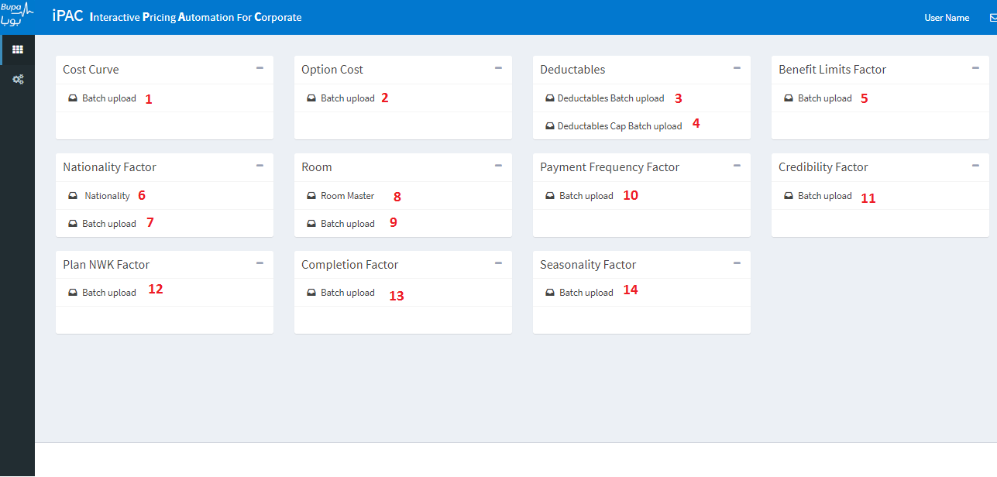
- Cost Curve
- Option Cost
- Deductibles factor
- Deductibles Cap factor
- Benefit Limits Factor
- Nationality master
- Nationality Factor
- Room Master
- Room factor
- Payment Frequency Factor
- Credibility Factor
- Plan NWK Factor
- Completion Factor
- Seasonality Factor
Below is the excel templates.

Policy Design:
This Tab shows the policy design for the Single Account or the combined policy for the related group in one view showing only this items:
Benefit | What-If Scenario
Network | Editable
Room Type | Editable
Annual Limit | Editable
Hospital Deductible | Editable
Hospital Deductible % | Editable
Non Hospital Deductible
Non Hospital Deductible %
MPN Deductible
MPN Deductible %
Maternity Available
Maternity Limit | Editable
Dental Limit | Editable
Dental Benefit
Optical Limit | Editable
Optical Benefit
Vaccination Available
Physiotherapy Available
Congenital Available
Dialysis Limit
Organ Transportation Limit
Mortal Transportation Limit
Neonatal Screening Limit
PreAuthorization
Benchmark Accommodation
Benchmark Consultation
Special Handling
ExGratia

What-If Scenario:
User can change any benefit of the policy to accommodate any pricing scenario desired by customers.
 | Save Button : Save the desirable policy and calculate the Bookrate and rates based on the changes for what-if Scenario and disables the post to CRM functionality for this opportunity.
 | Restore Button: Restore original policy, Loss Ratio, Cost Curve Factor, Seniors Factor and Maternity Load and enables the post to CRM functionality.  Note: Restoring will always calculate based on the current cost curve and benefits factors

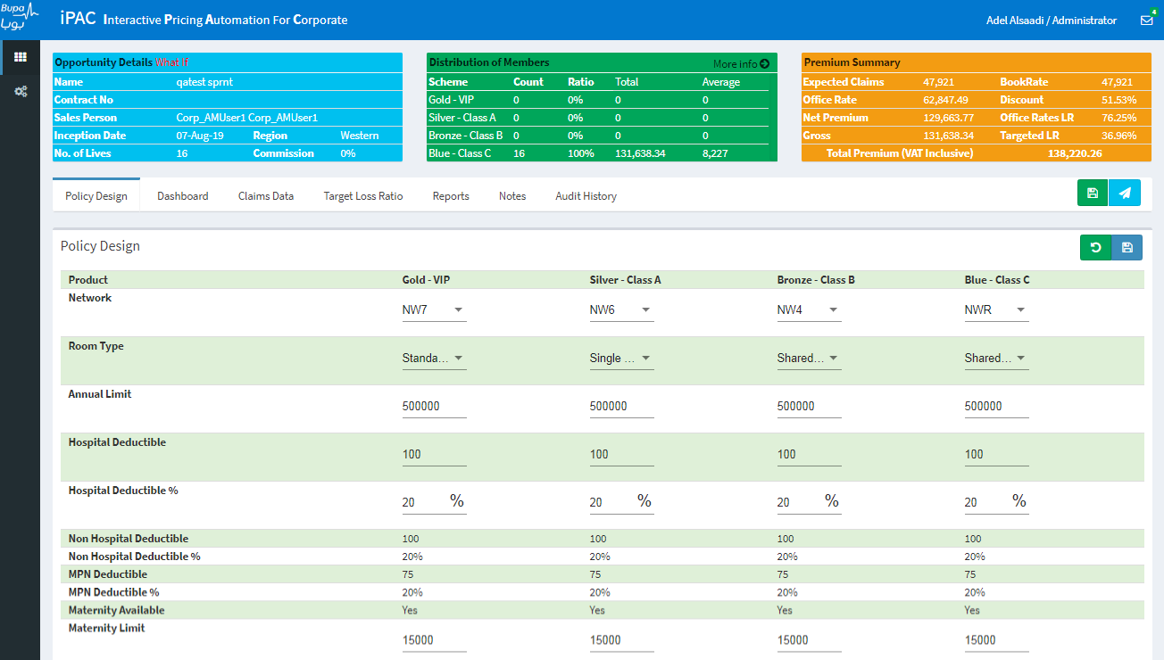

Dashboard:
Showing Members Distribution by Age Band, Relation and Nationality
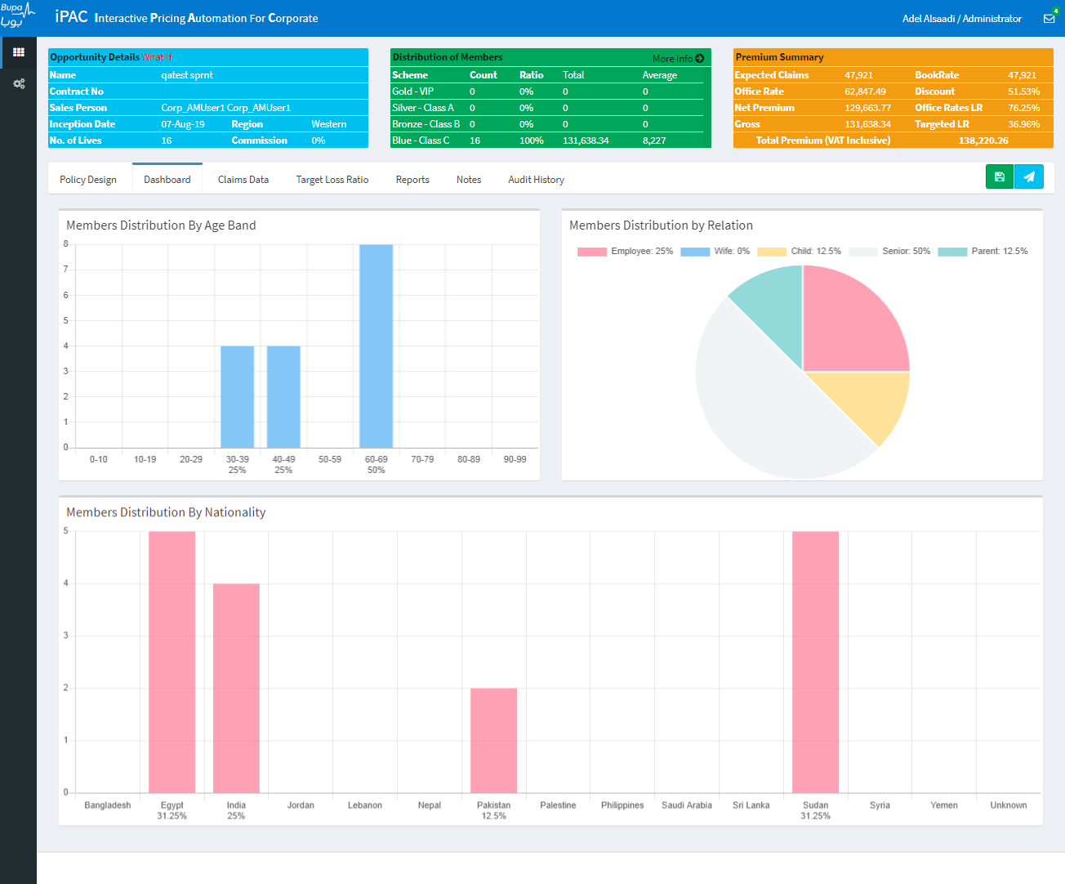

Claim data:
Claim data section is only for new opportunity.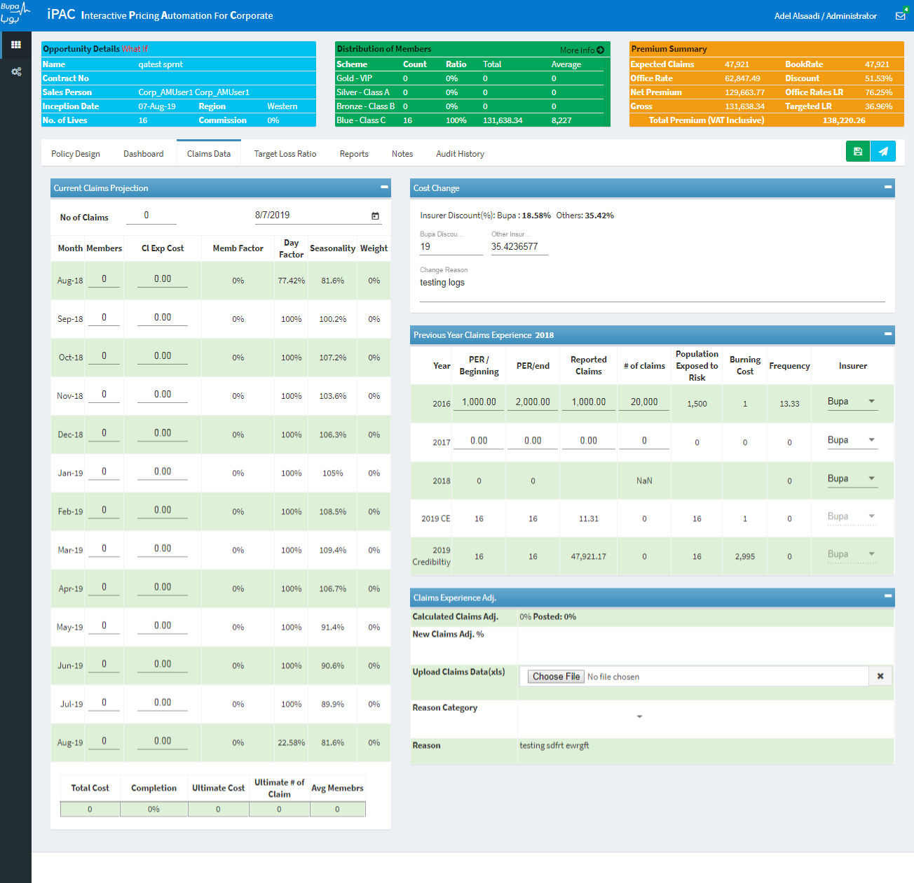
- Current Claims Projection: Input for No of claim and current claim projection date (cannot be changed after save). The table will be filed with no. of members for each month and their claim in it. Completion will be calculated based on the month that have members and claim more 0.
No of Claims: Input field for the total no of claim for the current year.
Projection Date: By default, 1 year minus the inception date. User can change it too if needed.
Month: Every month from Projection Date Month for 12+1 Months
Members: No of members for that month
Cl Exp Cost: the claim expenses of that month
Member Factor: first month will be 100% next month will be new month / first month
Day Factor: First month day factor = (Number of days between project date and this month Last day date) / (this month Last day). And other = 1, except last month = 1 - First month day factor.
Seasonality: Loaded from iPAC Database (Seasonality Factor table).
Weight: Member Factor % * day Factor % * Seasonality Factor %
And here is the footer of the projection table summary:
Total Cost: SUM (Cl Exp Cost)
Completion: SUM (Weight Factor with Claims>0) / SUM (Weight Factor)
Ultimate Cost: Total Cost / Completion
Ultimate # of Claim: No of Claims / Completion
Avg. Members: Sum (Members) * Sum (Member Factor) / Sum (Member Factor)
- Cost Change for Insurer Discount adjustment: the calculated insurers discount is calculated for Bupa and other. The user has the choice to change it and a proper reason need to be provided.
- Previous Year Claims Experience: Fill the table to calculate claim experience Adj.:
PER/Beginning: Input for 2 previous years and will be matching current lives count in the opportunity for the rest.
PER/end: Input for 2 previous years and will be matching current lives count in the opportunity for the rest.
Reported Claims: Input for 2 previous years
# of claims: Input for 2 previous years
Population Exposed to Risk: (PER Beginning + PER end) / 2
Burning Cost: N Reported Claims / Population Exposed to Risk
Frequency: N # of Claims / Population Exposed to Risk
Insurer: Select the Insurer the Company has tied up the previous year from the Drop down list.
- Claims Experience adjustment: you can see the Claim Experience Adj. (based on the inputs from above points 1 and 2). User can still change it using New Claims Adj. option and upload a file to support the changes and provide a prober reason from the drop down list and write a proper comment.
Calculated Claim Adj. = Credibility Reported Claims /Book Rate - 1

Target Loss Ratio:
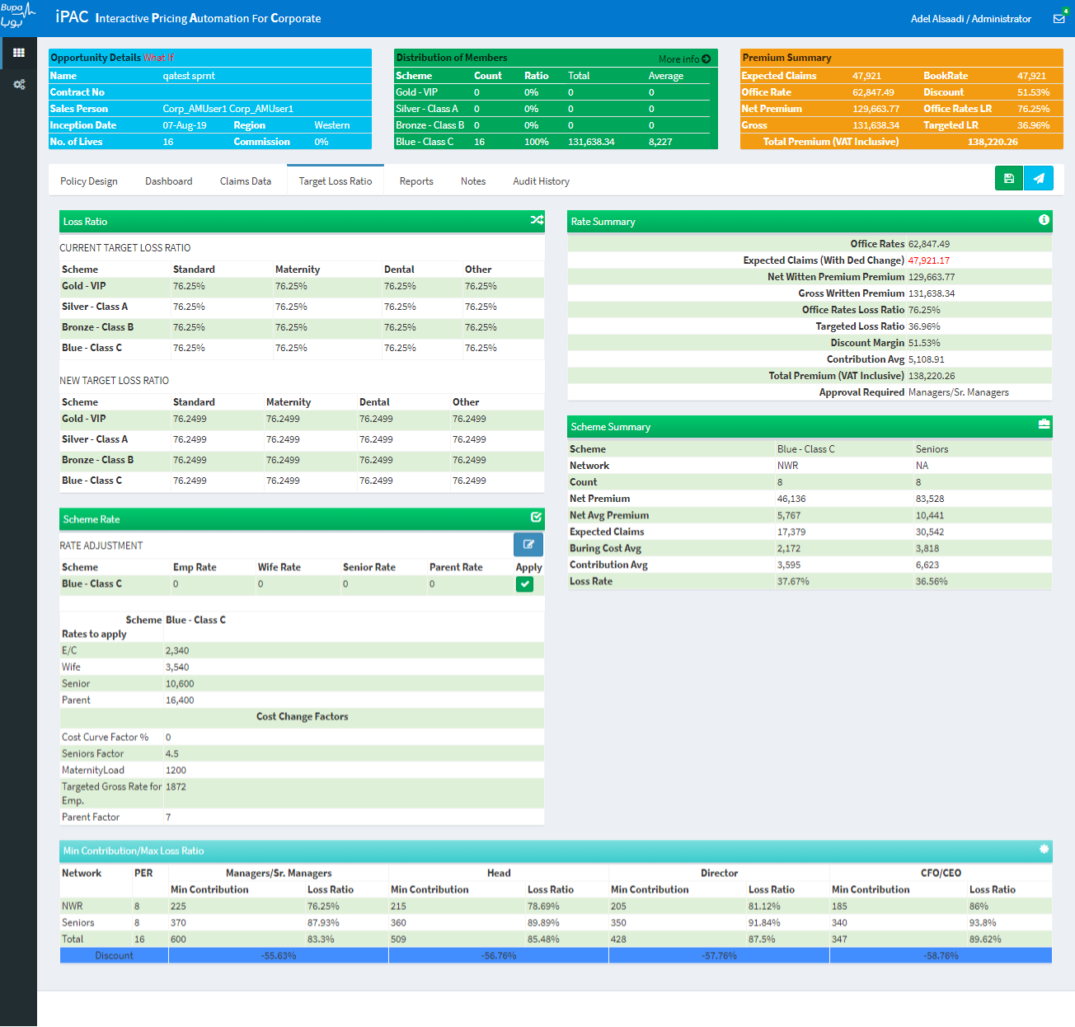
- Loss Ratio: it has two section Current Target Loss Ratio (Read Only), and New Target Loss Ratio (Edit: User can change it here and when save it will update the current. The user can change the Standard (Dental and Other will automatically change to it), Maternity, Dental and Other.
  - Default value for Loss Ratio = 1 – LoadingFactor (SUM (Loading Per (for network) * (Scheme Expected Claims / total Book Rate / Network Count) * Network Count))
  - Standard, Dental and Other (to be effective required employee, child or wife only in the scheme).
  - Maternity (to be effective required wife only in the scheme).
- Rate Summary: It shows claim and office/target LR… and the approval required.
Office Rates: Expected Claims / loading Factor
Expected Claims: the total cost of (Standard + Maternity + Neonatal + Dental + Congenital + Optical + Vaccination + Physiotherapy) after applying factors and Claim Adj.
Net Witten Premium: the total premium of the (cost / Loss Ratio) = (Standard/StandardLR + Maternity/MaternityLR + Neonatal/OtherLR + Dental/DentalLR + Congenital/OLR + Optical/OLR + Vaccination/OLR + Physiotherapy/OLR)
Gross Witten Premium: Net Witten Premium / (1 - Commission)
Office Rates Loss Ratio: Expected Claims / Office Rate
Targeted Loss Ratio: Expected Claims / Net Premium
Discount Margin: 1 - Targeted LR / Office Rates LR
Contribution Avg.: (Net Premium – Expected Claims) / No. of Lives
Total Premium (VAT Inclusive): Gross Witten Premium * 1.05
Approval Required: Where is Targeted Loss Ratio fall in the authority matrix
- Scheme Rate: the rate for each schemes for (Employee, child, wife, senior and parent)
- Scheme Summary: it shows the claim and office/target LR per scheme that has members only and for the seniors too.
- Cost Change Factors: for schemes that has members only user can change:
  - Cost Curve Factor%: to be applied on the cost curve to adjust the base cost for each schemes.
  - Seniors Factor: will be multiplied by the employee rate to get the seniors rate.
  - Maternity Load: will show the different between employee rates and wife and can be adjust only if there are no wives or the maternity cost is zero (default load is configured in iPAC for each network).
  - Targeted Gross Rate for Emp.: adjust only if there are no employees or child.
  - Parent Factor: will be multiplied by the employee rate to get the parents rate.
- Adjust Rates: a helper calculator tool for schemes that has members only:
  - Employee Rate: enter a desire rate and it will calculate the Loss ratio for standard, dental and other to get that rate. Can be used only if there is employee or child.
  - Wife Rate: enter a desire rate and it will calculate the Loss ratio for maternity to get that rate. Can be used only if there are wives.
  - Senior Rate: enter a desire rate and it will calculate the senior factor.
  - Parent Rate: enter a desire rate and it will calculate the parent factor.
- Authority Matrix: for scheme that has members only and seniors iPAC will calculate Minimum Contribution and maximum Loss Ratio for each schemes and the seniors for each authority:
  - Managers/Sr. Managers
  - Head
  - Director
  - CFO/CEO
And the discount threshold based the total minimum contribution and maximum loss ratio for each authority.
Authority Matrix will be calculated for each schemes (schemes will have seniors removed) and the seniors and a configuration is already in iPAC with each network minimum Contribution and maximum Loss Ratio will be loaded and the calculation:
PER: number of lives in each schemes without the seniors and the seniors in separate row.
Min Contribution: (Burring Cost / network max Loss Ratio – Burring Cost) if not less than network minimum contribution
Max Loss Ratio: Burring Cost / (Burring Cost + Min Contribution)
For the total:
Total Min Contribution: SUM (PER * Min Contribution)
Total Max Loss Ratio: SUM (Max Loss Ratio * Min Contribution / (1 - Max Loss Ratio) * PER) / SUM (Min Contribution / (1 - Max Loss Ratio) * PER)
Discount: -(1 - (target Loss Ratio / Total Max Loss Ratio)

Technical result:
This the main tab screen for renewal and it will host inside all the technical result tabs that needed to price a renewal opportunity:
The screen is divided into three parts:
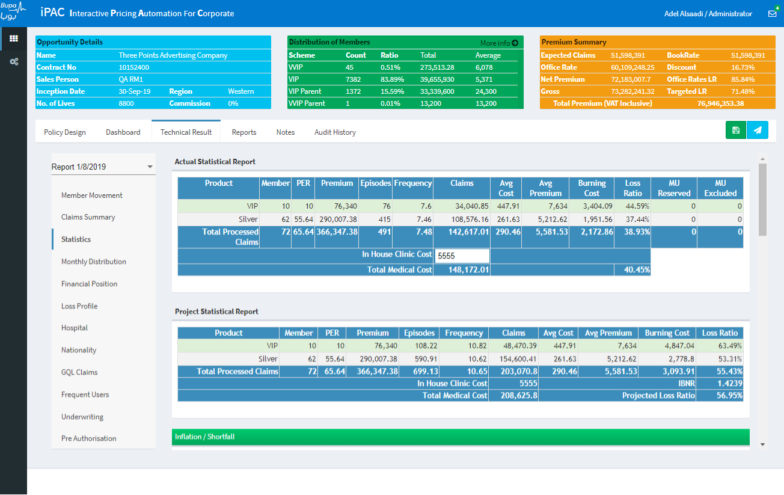
Drop down list on the left side, it will list all the available reports for each refresh. Below it the TR items tabs which user can click. The content for each option is displayed on the right side space. User can switch between multiple refresh dates in iPAC and price it. Below is the discription for each tabs:

1.2.8.1 Member Movement:
For members’ movement, total premium, cost and loss ratio.
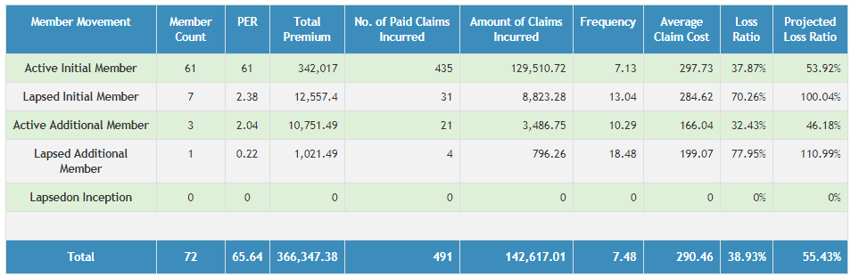

1.2.8.2 Claims Summary:
  - Total claims by status
  - Processed claims by in/out patient
  - Processed claims by in/out network
  - Processed claims by options
  - Processed claims by relationship
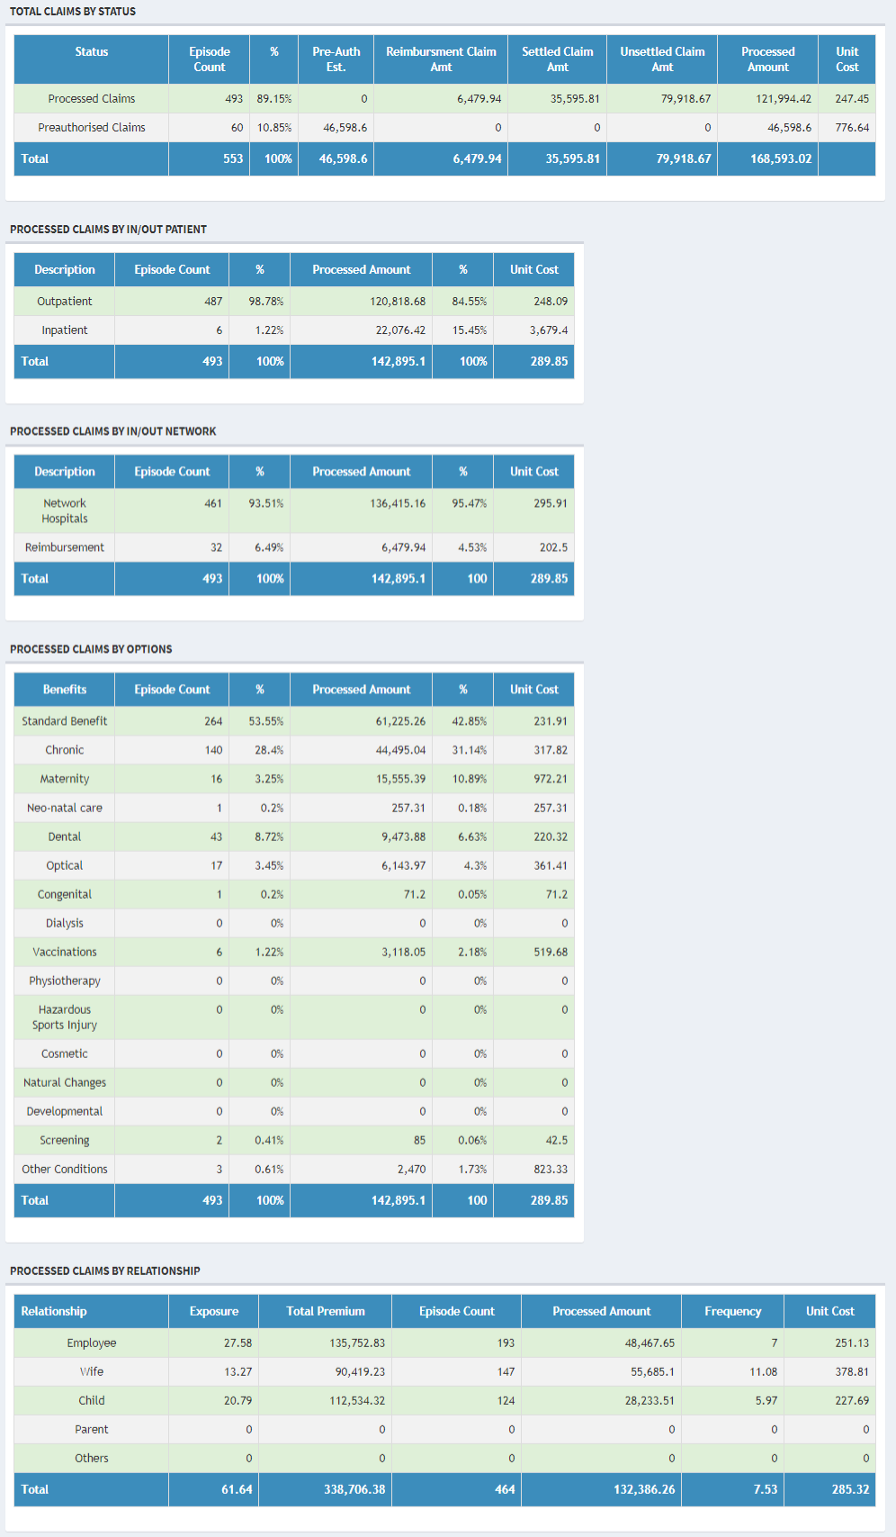

1.2.8.3 Statistics:
The landing tabs for pricing in renewal and user can see current actual claim and the projected claim based on claim completion and the pricing tool:
- Actual Statistical Report: It is showing the actual statistic per scheme and total medical underwriting excluded and reserved amount. And user can enter in house clinic cost manually.
- Project Statistical Report: Applying IBNR on the actual data and calculated the total medical cost and projected loss ratio.
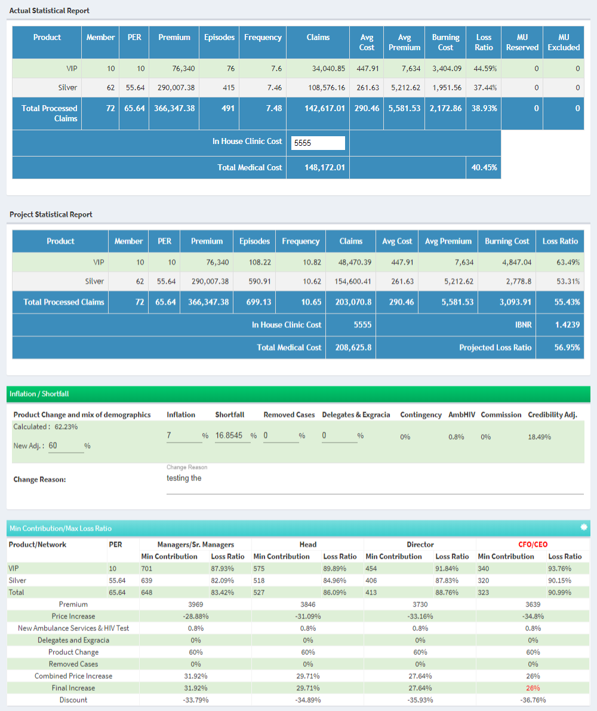
- Inflation / Shortfall:
    - Product Change and mix of demographics: Calculated and user can change it but need to provide a proper reason in the change reason box.
    - Inflation: calculated but can be changed with a proper reason entered is required.
    - Shortfall: calculated but can be changed with a proper reason entered is required.
    - Removed Cases: Default is Zero and can be changed with a proper reason. (*2* The range for removed cases has been changed from [0 to -100]% to [-100 to 100]%)
    - Delegates & Exgracia: Default is Zero and can be changed with a proper reason.
    - Contingency: 0%
    - AmbHIV: 0.8% (*3* Default value is changed from .8% to 0% for Opportunities whose Inception Date is Greater than 1 Jan 2021)
    - Commission: Previous Year Commission
    - Credibility Adj.: Calculated from TR.
- Authority Matrix (Min Contribution/Max Loss Ratio)

- Previous Members Distribution
- Next Year Members Distribution
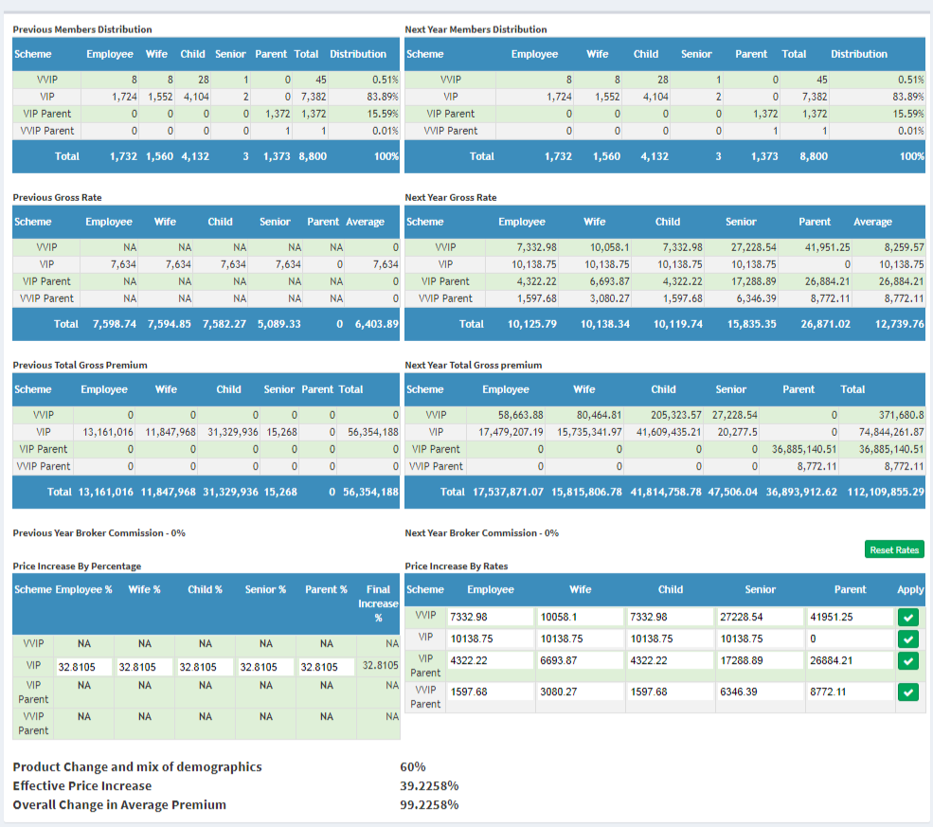
- Previous Gross Rate
- Next Year Gross Rate: Next Year Rates = Previous Year Rates * Price Increase % (refer point 11). If previous year rates are not available, iPAC will pick the Default Manual Rates for each member type and Network from Database and displays on screen.

- Previous Total Gross Premium = Previous Members Distribution * Previous Gross Rate
- Next Year Total Gross premium = Next Year Members Distribution * Next Year Gross Rate

- Price Increase(PI) by Percentage: User can change the PI for any member type at any scheme.
- Price Increase by Rates: User can change the desired rate and system will calculate the PI percentage. Apply button need to be clicked to apply the PI. [Rest Rates] button can be used to reset the PI % to the Final Increase for Manager from the Authority Matrix. Incase


1.2.8.4 Monthly Distribution:
Claims and premium distribution by month.
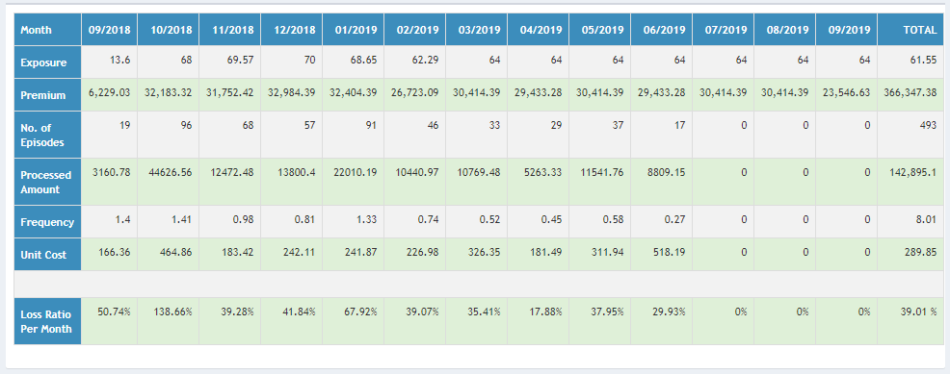

1.2.8.5 Financial Position
- Yearly premiums and claims and calculated Loss ratio.
- Yearly Inflation.
- Inflation / Shortfall
- Yearly Weight
- Credibility (3 years)
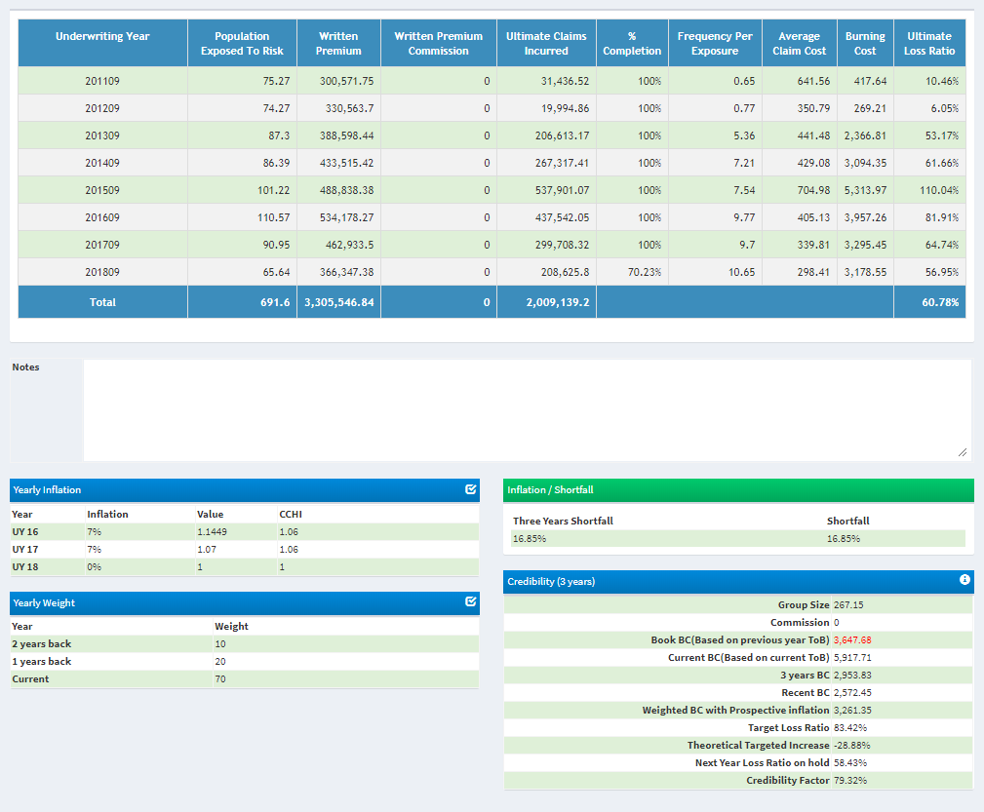

1.2.8.6 Loss Profile
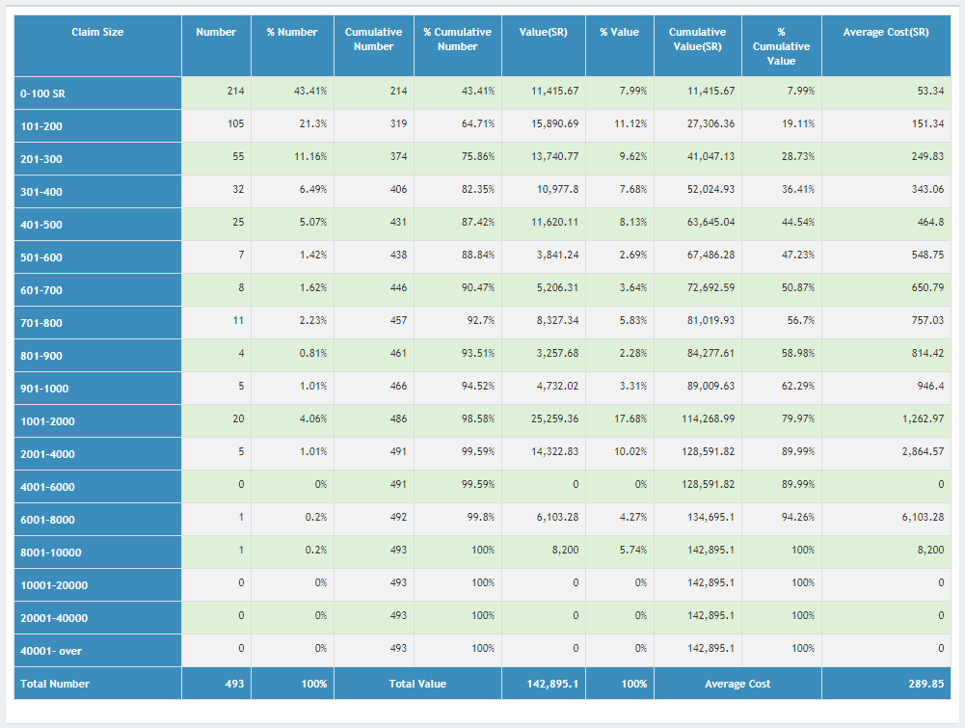

1.2.8.7 Hospital:
User can export the list to EXCEL file.
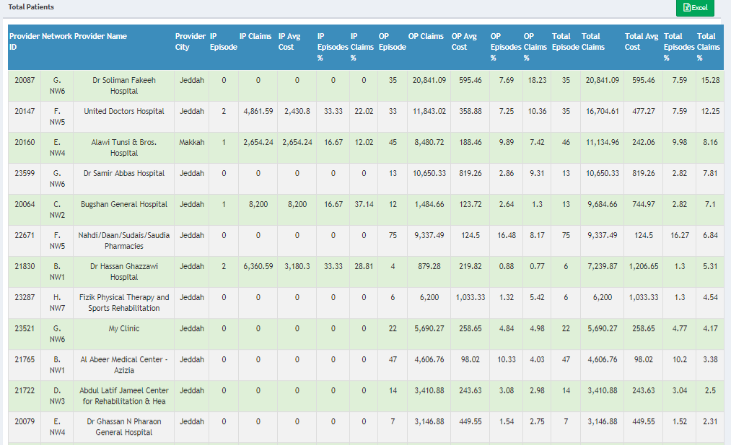

1.2.8.8 Nationality
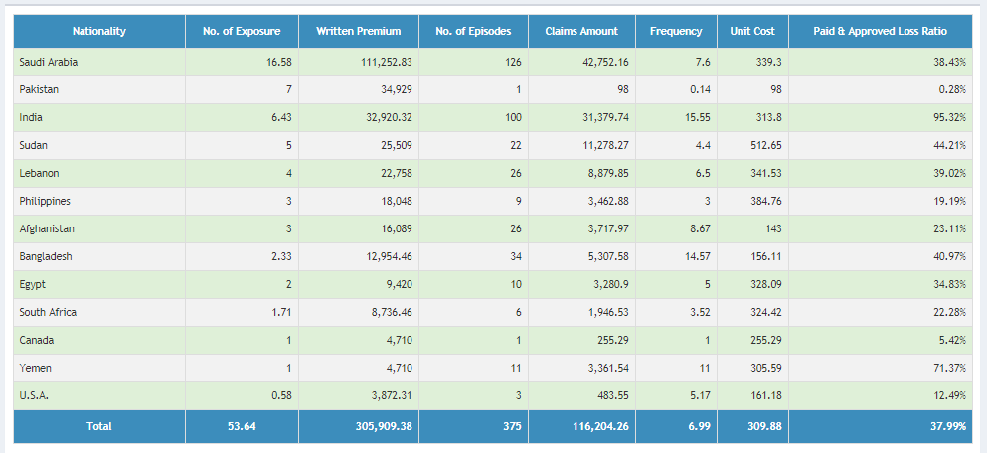

1.2.8.9 Claims:
User can export the list to EXCEL file.
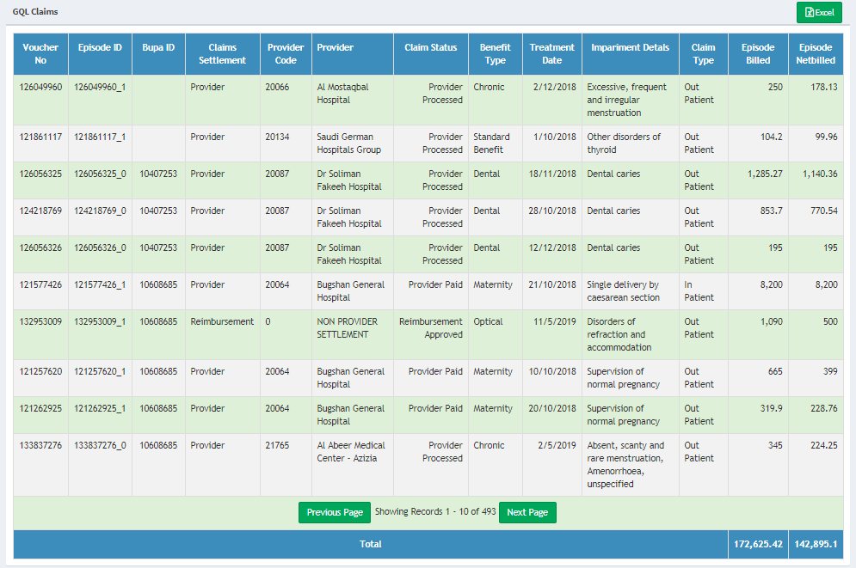

1.2.8.10 Frequent Users:
User can export the list to EXCEL file. And save medical condition.
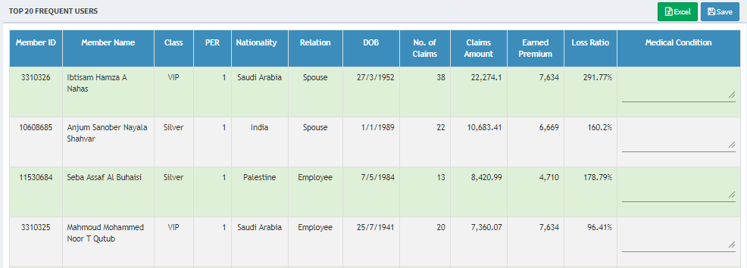

1.2.8.11 Underwriting
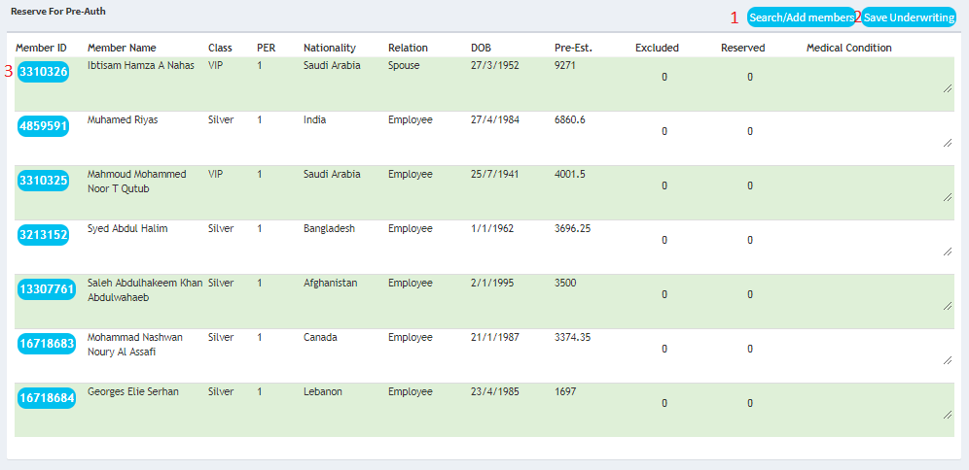
- Search/Add members: Add members for reserve or exclude amount and adding medical condition notes. When user click on it a popup window will show: where user can search by minimum pre estimation and global search text for any text in the table like name nationality member id and relation. And then user can select from the top table to add member to the selected members below table and user can perform multiple search criteria to select and then add them one time to the main table by clicking [Update Members] button.
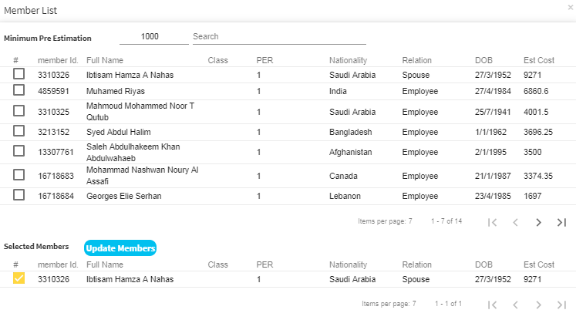
- Save underwriting: save the underwriting changes and recalculate Projected Loss Ratio in statistic.
- Click on [MemberID] from the list Member – PreAuthorization list will popup.
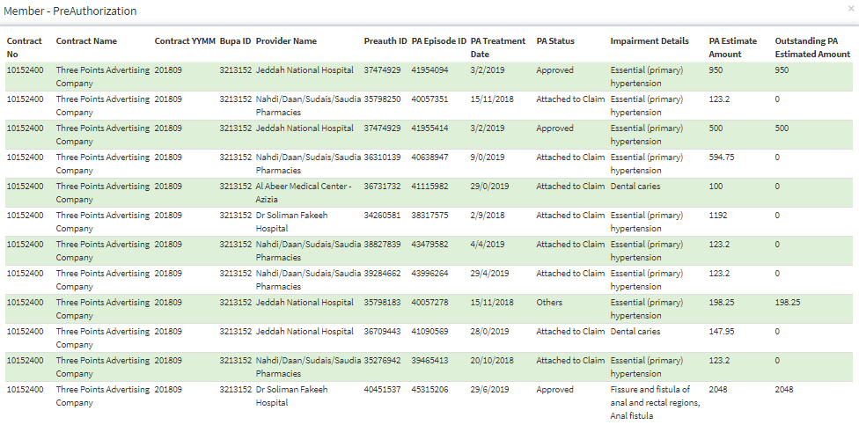

1.28.12 Pre Authorization:
User can export the list to EXCEL file. And filter result by:
- Approved
- Attached to claim
- Part Approved
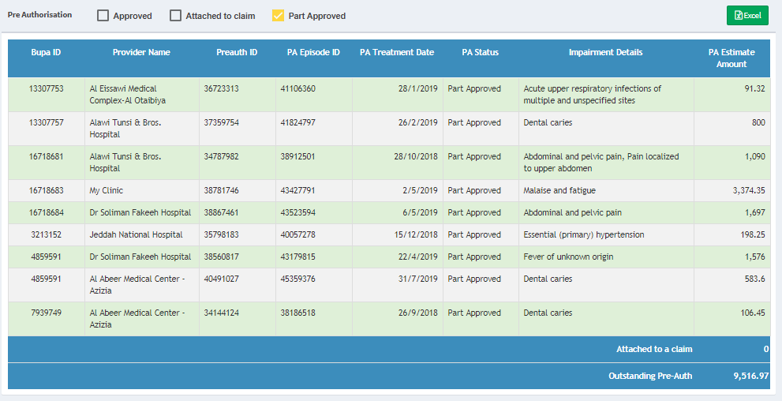

Reports:
The report will show policy design and members distribution and rates per subscription type.
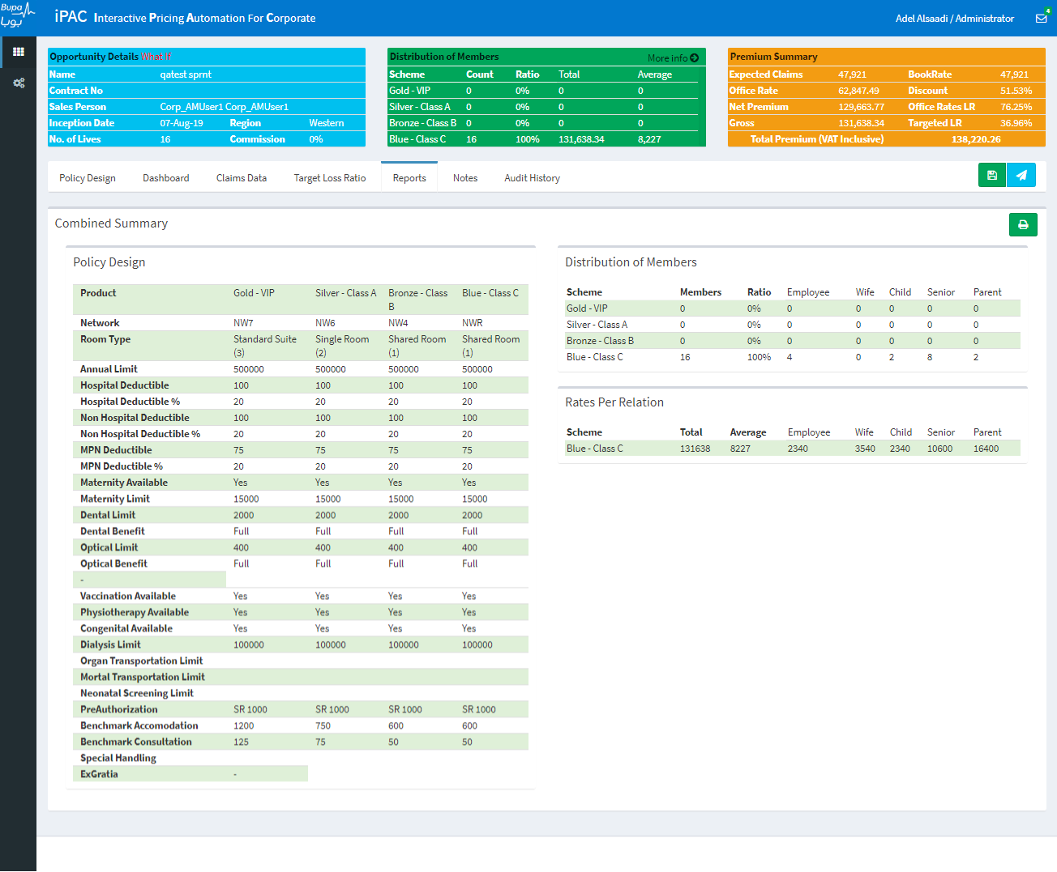

Notes:
Users can exchange notes and comments on the systems.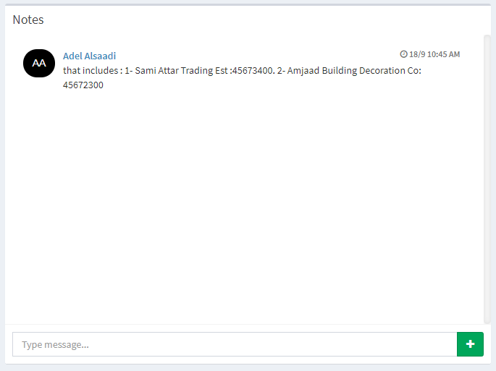

Audit History:
Any Changes in system will be tracked with changes, user info and change date.
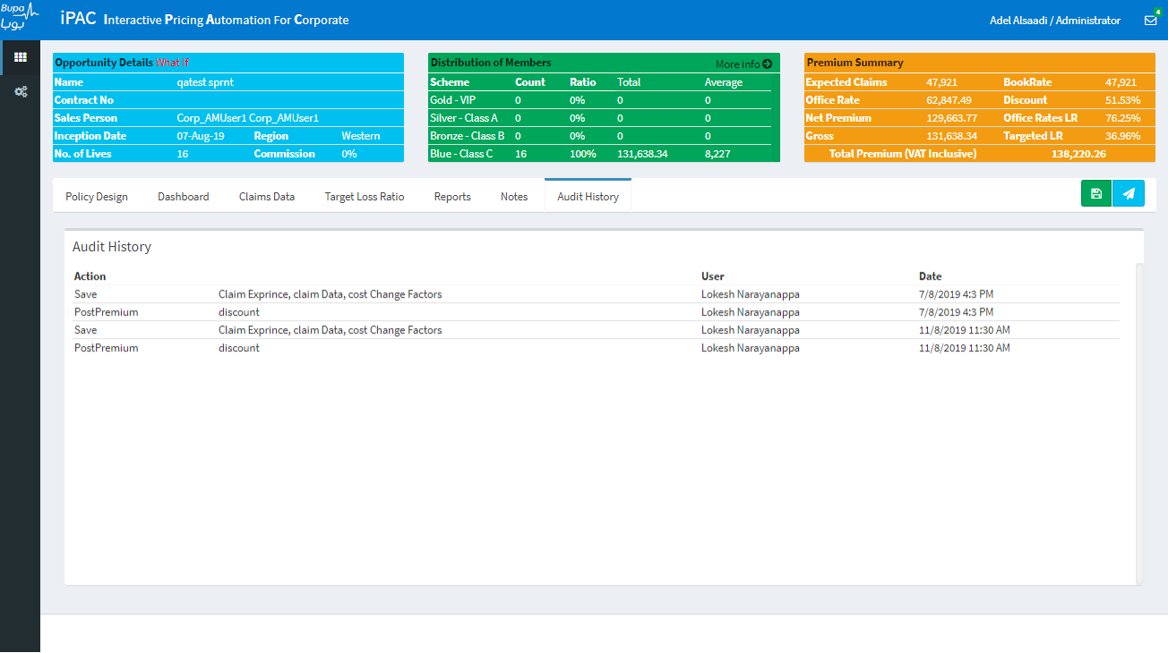

iPAC workflow:
Attached a file to explain all the workflow.

