**­­­­­­DEPARTMENT OF COMPUTER & SOFTWARE ENGINEERING**

**COLLEGE OF E&ME, NUST, RAWALPINDI**



**Subject Name: EC-210 Logic and Sequential Design**

**Project Report**

**Submitted To:**

**Professor Dr. M. Salman/ LE Malyka Awais**

**Submitted By:**

**Usman Awan REG # 480836**

**DE-45/SYN:A DEPT: Computer Engineering**

**Submission Date: 05/06/2024**

**Title: 4 bit Password Security System**

**Table of contents:**

|  |  |  |
| --- | --- | --- |
| **S. no.** | **Contents** | **Page** |
| 1. | Introduction to security systems | 1 |
| 2. | Hardware implementation   * Hardware/Software required * Circuit schematics * Implementation of Password set and input * Implementation of Password validation * Implementation of feedback | 4 |
| 3. | Software simulation   * Hardware/Software required * Circuit schematics * Implementation of Password set and input * Implementation of Password validation * Implementation of encryption/decryption * Implementation of feedback | 10 |

**Introduction to Security Systems:**

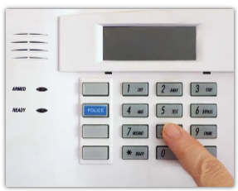Security and protection devices are used in homes, schools, offices, stores, warehouses, and hospitals to guard persons and property against fire, break-ins, and other hazards. Warning mechanisms also protect automobiles and trucks from theft. They are used at airports and other public buildings to detect weapons, explosives, and contraband. They are used on airplanes and ships to warn of dangers both within the vessels and without. Government agencies use highly sophisticated electronic equipment to detect various means of espionage, sabotage, and subversion and to prevent surprise attacks.

Whereas police departments, fire departments, and security guards offer active protection, warning and detection devices are passive and preventive. The earliest such preventive means consisted

of locks on doors and bars on windows. Since the 1960s, however, the great increase in domestic crime, airplane hijackings, and international terrorism has inspired the invention of numerous, far more sophisticated security devices and measures.

**Hardware Implementation**

**Hardware/Software Required:**

**Software: Proteus 8 Professional**

**Hardware:**

|  |  |  |
| --- | --- | --- |
| **S. no.** | **Contents** | **Qty** |
| 1. | PC | 1 |
| 2. | Breadboards | 2 |
| 3. | 4001 Quad NOR Gate | 1 |
| 4. | 4070 Quad XOR Gate | 1 |
| 5. | Eight Position DIP switches | 2 |
| 6. | 10 Kilo-ohm resistor | 10 |
| 7. | 470 ohm resistor | 2 |
| 8. | Pushbutton switches | 1 |
| 9. | 9V battery | 1 |
| 10. | Light emitting diodes | 2 |
| 11. | 1N914 switching diodes | 4 |
| 11. | Connecting wires | --- |

**Circuit schematics:**

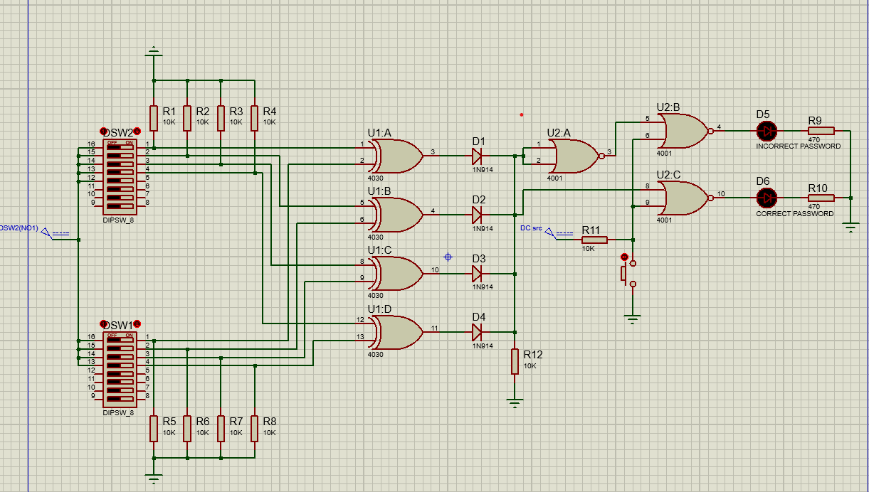

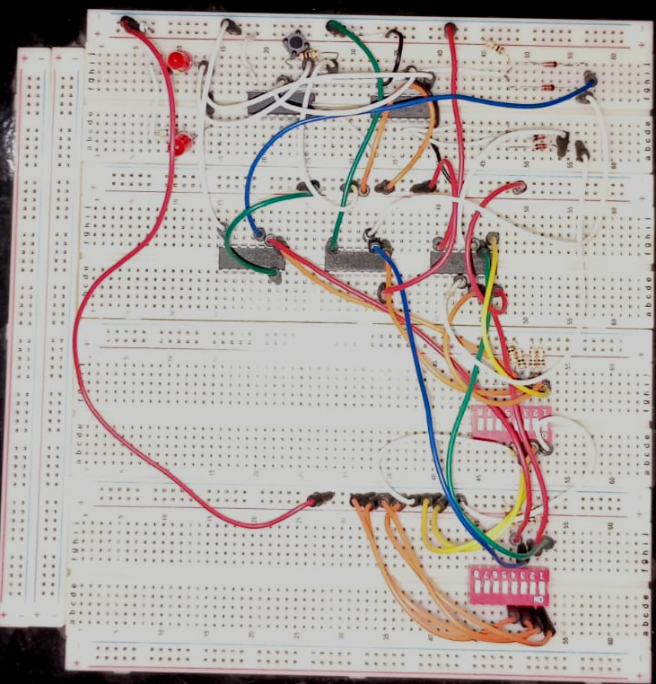

**Implementation of password set and input:**

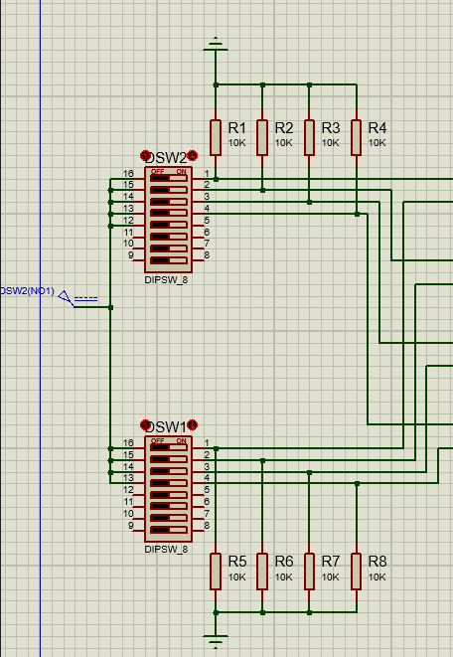

* There are two switches in the input section. The first switch sets the password and is the “hidden part” of the circuit. The locked configuration of the DIP switch stores the password pattern. The second switch takes input from the user. It is the “visible part” of the circuit.

**Implementation of password validation:**

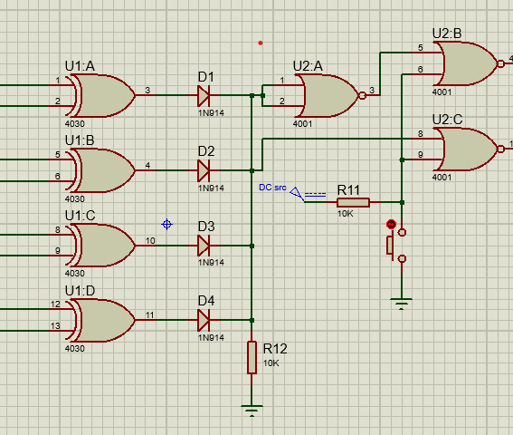

* Password validation is carried out by an assembly of XOR and NOR gates. When user input is equivalent to the set password, it is validated. Validation is triggered by a push button which saves battery life and ultimately the cost.

**Implementation of feedback:**

* When the pushbutton is triggered, password is validated, and the user receives feedback by virtue of 2 LEDS. If the password is correct, the first one turns on, and when the password is incorrect, the second one turns on.

**Software Implementation**

**Hardware/Software Required:**

**Software: Proteus 8 Professional**

**Hardware:**

|  |  |  |
| --- | --- | --- |
| **S. no.** | **Contents** | **Qty** |
| 1. | PC | 1 |
| 2. | 10K resistors | 64 |
| 3. | 4030 Quad XOR Gates | 32 |
| 4. | 7 SEGMENT Displays | 12 |
| 5. | Four Position DIP switches | 8 |
| 6. | 4511 SEVEN SEGMENT Decoder | 12 |
| 7. | Switches | 3 |
| 8. | 7485 4-bit Magnitude Comparator | 4 |
| 9. | Quad input AND Gate | 1 |
| 10. | Light emitting diodes | 12 |
| 11. | 4042 D-Latch | 4 |

**Circuit schematics:**

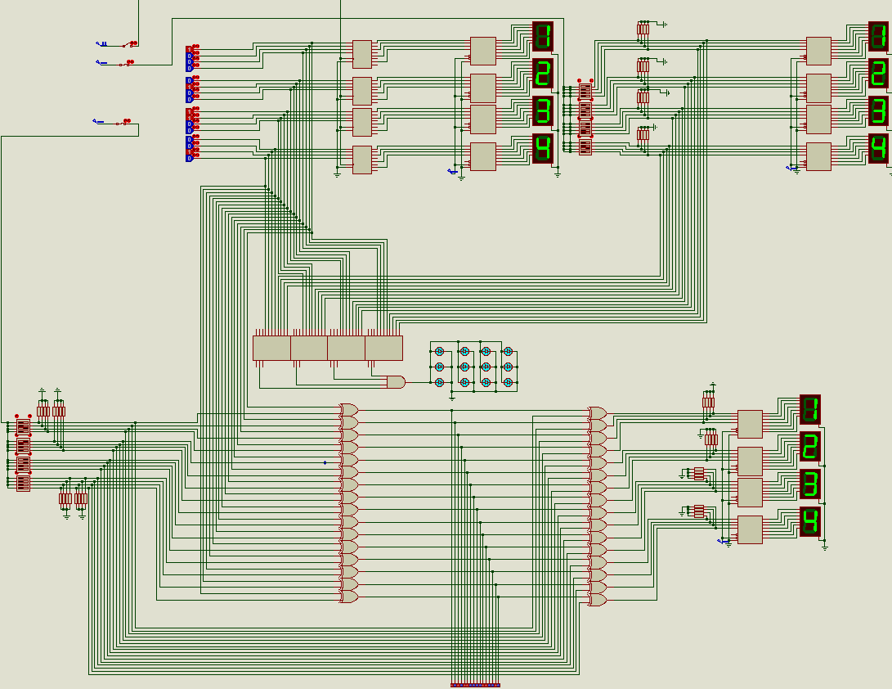

**Implementation of Password set and input:**

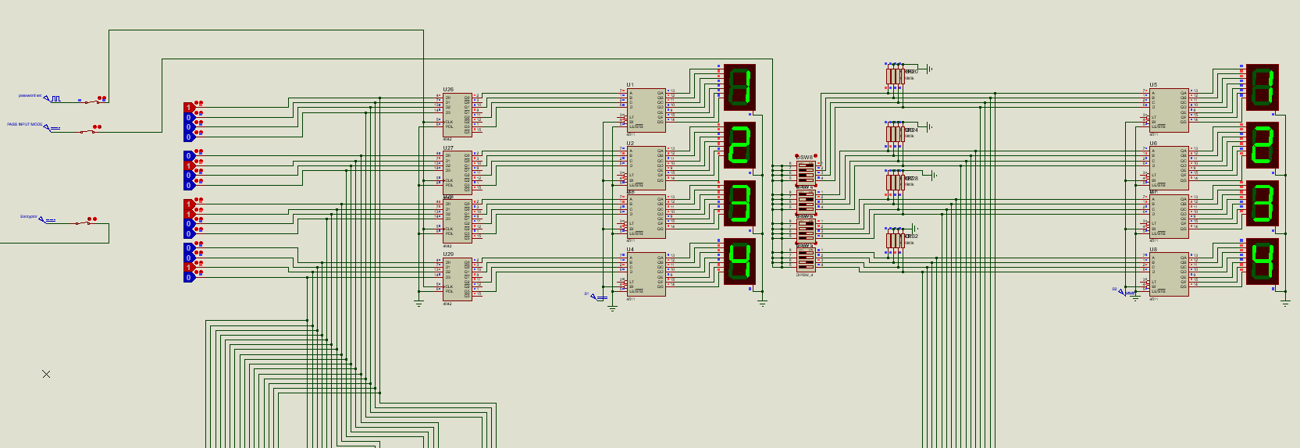

* The control unit of the system consists of three switches:
  + **Pass store switch:** When triggered, allows the user to store the password by using DIP switches. This is the “hidden part” of the circuit.
  + **Pass input switch:** When triggered, allows the user to give input to the security system by using DIP switches. This is the “visible part” of the circuit.

**Implementation of Password validation:**

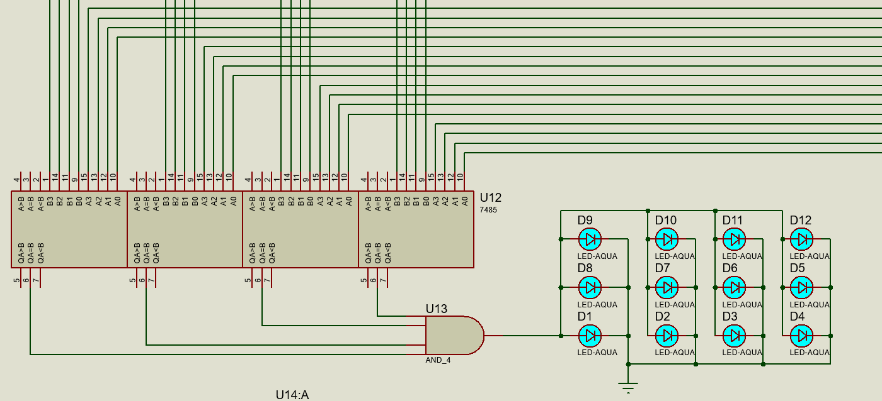

* The validation part of the system has four 4-bit comparators comparing the total 32 bits of the password and the input.
* If all the digits are equal, the compared results go through an AND Gate and the LEDs turn on indicating that a valid input was entered.

**Implementation of encryption/decryption:**

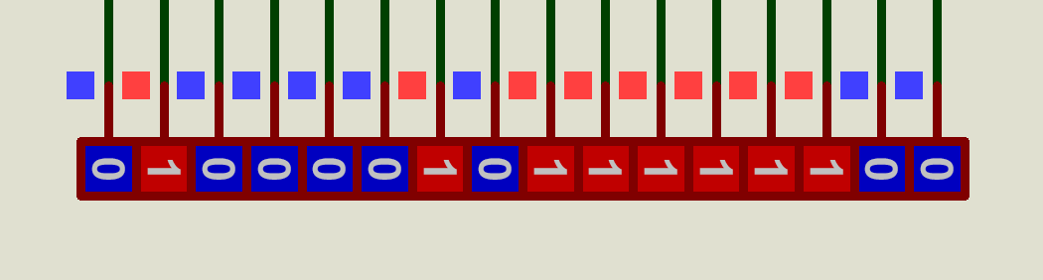

* The encryptor circuit bitwise adds the SET Password with the secret key. The secret key here is the last 4 digits of my registration ID: 0836. Bitwise XOR operation is used for encryption.
* The decryptor circuit decodes the encrypted binary string.

**Implementation of feedback:**

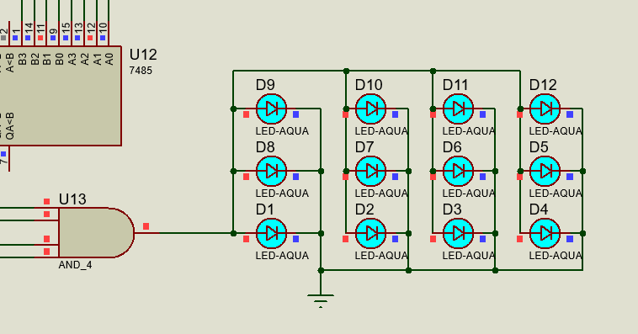

* LED-AQUA diodes indicate if Set Password and User Input match.

**Conclusion and References:**

In conclusion, the security system uses storage and comparison elements to secure sensitive information or resources. And different types of components are employed in this system.

In building this project, almost all the concepts learnt throughout the course were utilized. The circuit is complex and multipurpose. The hardware implementation is simplified due to cost constraints.

We also gained valuable experience of working as a team in building this project.

References:

Digital Logic Design by Morris M. Mano

https://kids.britannica.com/students/article/security-system/276969#

Laurin Rinder/Shutterstock.com