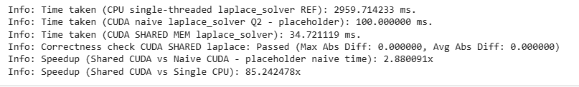  
  
  
For specs: Google Colab T4 TPU used