UNIVERSITY OF CENTRAL PUNJAB
Faculty of Information Technology



Project Phase 1

Submitted To: Ms.Aneela Mehmood
Name: Muhammad Usman
REG N0: L1F22BSCS1076
Section: G-10

Introduction:

This project is a lexical analyzer that reads a program file and identifies keywords, identifiers, numbers, operators, punctuations, and reports errors with line numbers. It helps understand how tokens in a program are recognized, which is a key step in compiler design.

1. Language Overview

Language Name:
P++ (Punjabi++)

Overview:
P++ is a Punjabi-inspired programming language that brings the logic and structure of C++ into a cultural and linguistic framework familiar to Punjabi speakers.
It uses Punjabi keywords and simple syntax to make coding feel natural, expressive, and inclusive.
Just like C++ extended C, P++ extends logic with culture making programming easier to understand for beginners who think in Punjabi.

Design Purpose:
The purpose of P++ is to eliminate the language barrier in learning programming.
By using Punjabi words instead of English keywords, students can:
- Understand programming logic faster
- Focus on reasoning, not memorization
- Feel comfortable learning in their mother tongue

Aim:
The main aims of P++ are:
- Simplify programming logic using Punjabi syntax.
- Promote linguistic inclusion in computing education.
- Support education by introducing regional-language coding tools.
- Help learners transition smoothly from native logic to C++ or Java.
- Encourage creativity and confidence among non-English-speaking students.

Regex Table:

Token Type | Regular Expression (Regex)
Keyword | Je_tu | Nai_te | Ikojya |Diyo |Sahi | Ghalat | Lena | Wakhao | Rakam | Lafz | Ruk | Khokla | Yan |Aur| Ashariye
Identifier | [a-z A-Z _][a-z A-Z 0-9 _]*
Integer | (+|-)?[0-9]+ OR [0-9]+
Float | (+|-)?[0-9]+\(.)[0-9]+ OR [0-9]+\(.)[0-9]+
Exponential | [0-9]+(\.[0-9]+)?[eE][+|-]?[0-9]+
String | `"([^\"] OR (“)[a-z A-Z 0-9 (.)] (“)
Character | `'([^\'] OR (‘)[a-z A-Z 0-9 (.)] (‘)
Operator | "<-" | "=" | "==" | "!=" | "<=" | ">=" | "<" | ">" | "jorna" | "ghatana" | "zarab" | "taqseem" | "%"
Punctuation | "{", "}", "<<", ">>", ";", ",", ":"

Finite Automata:

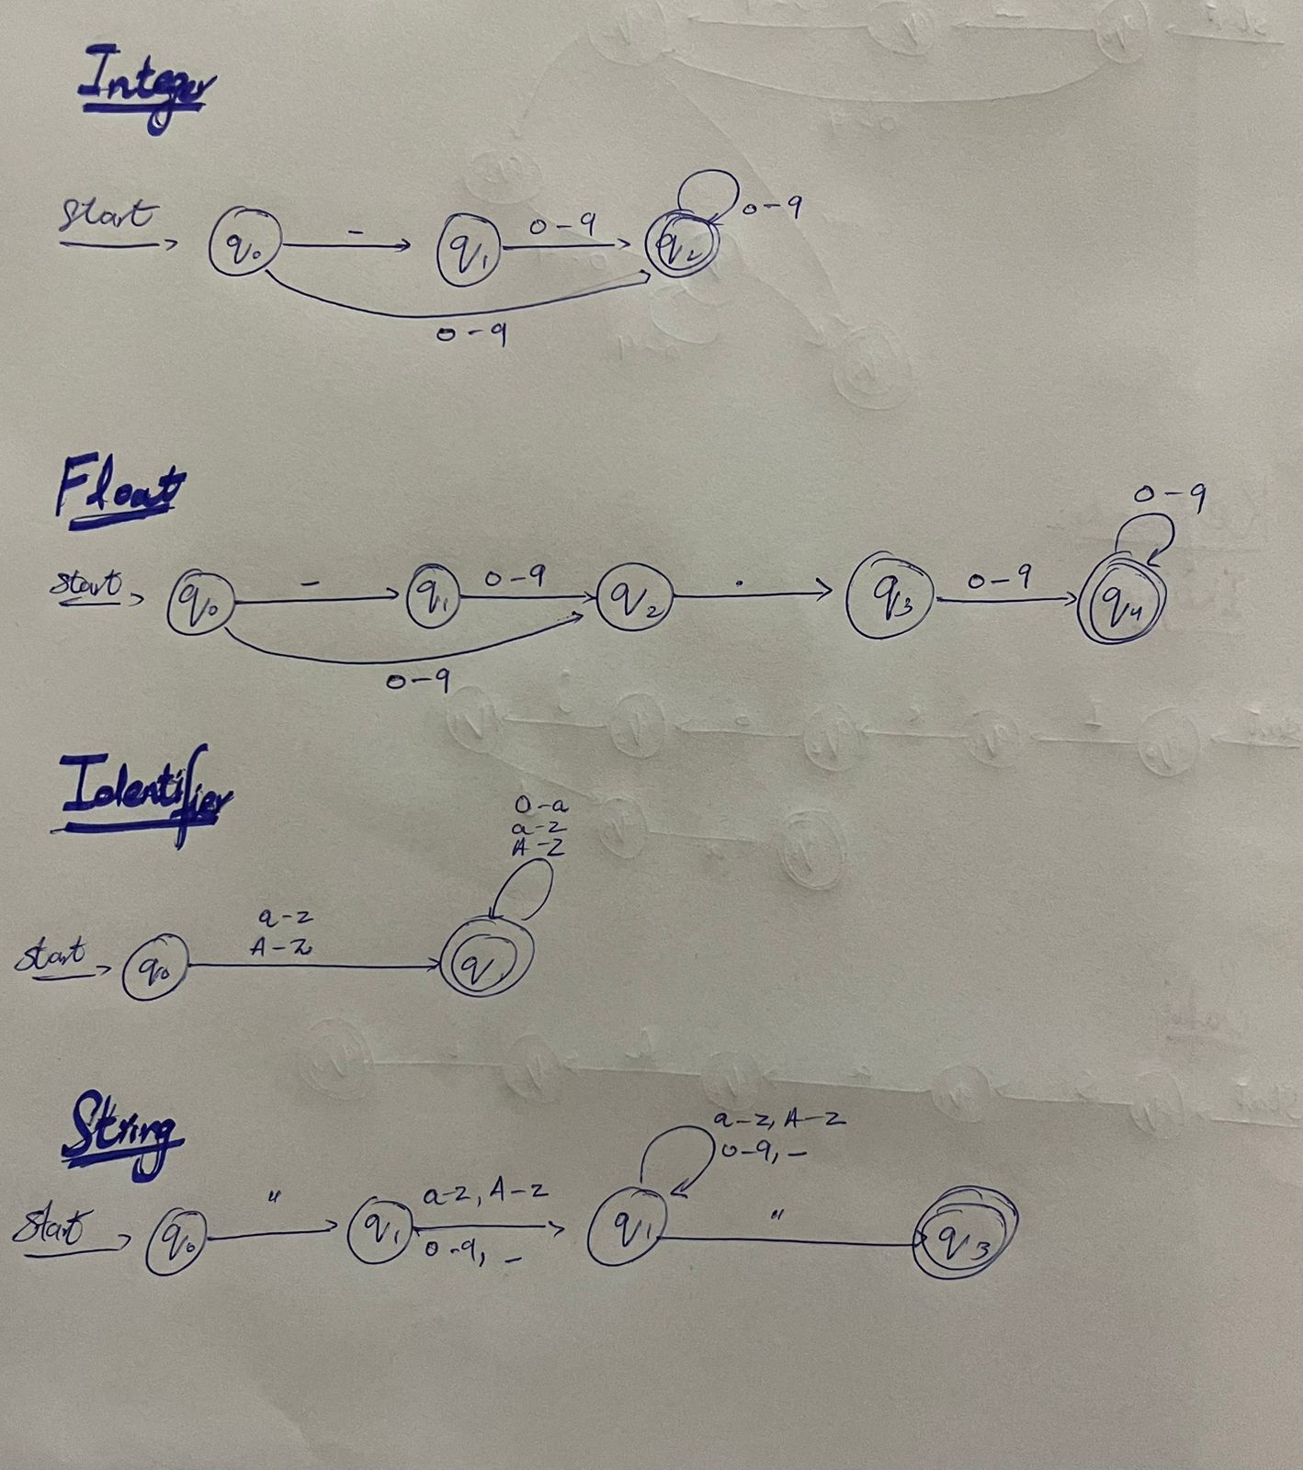

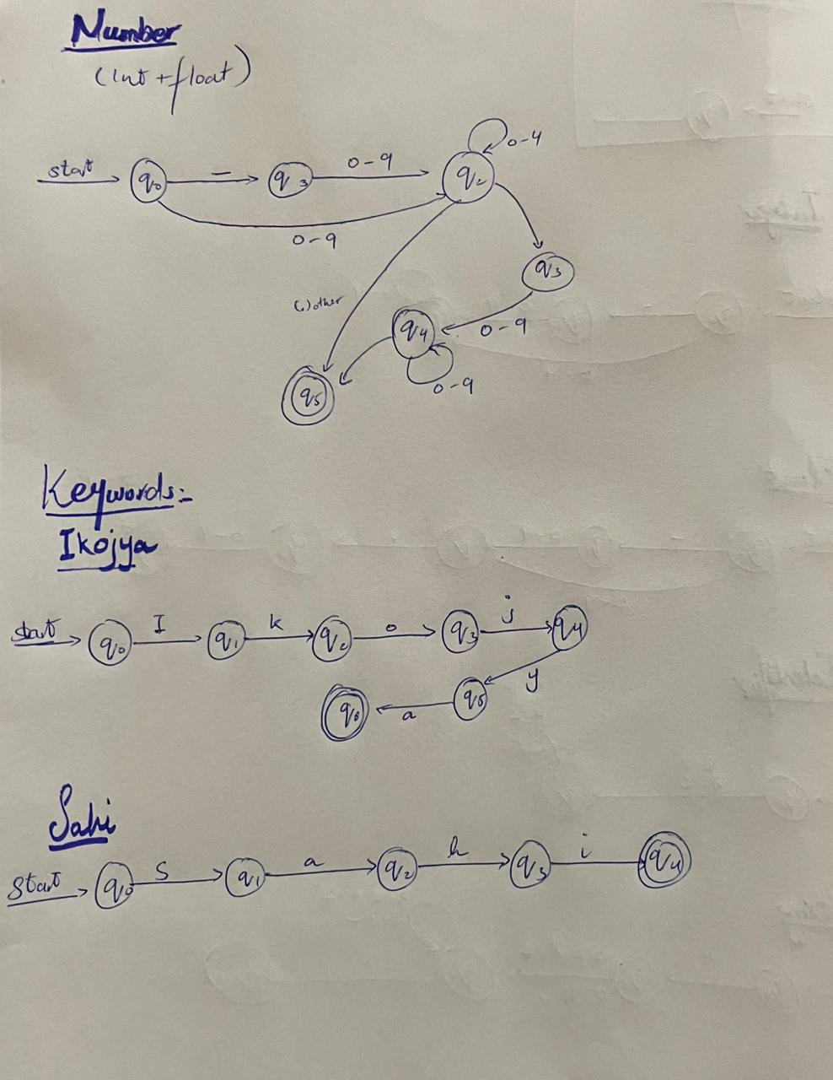

Keywords:

Keyword | Meaning | Example (from code) | Explanation
Je_tu | if | Je_tu << !Ghalat >>  {  Wakhao "Negation works!";  } | Used to check a condition and execute a block of code if the condition is true.
Nai_te | else | Nai_te  {  Wakhao "Number is small";  } | Executes when the if condition is false.
Wakhao | cout / print / output | Wakhao "Number is greater than 5"; | Displays text or variable values on the screen.
Lena | cin / input | Lena number; | Takes input from the user.
Ruk | break | Je_tu << i == 3 >>  {  Ruk; // break  } | Immediately exits from a loop or switch statement.
Diyo | return | Diyo 0; | Sends a value back from a function or ends its execution.
Rakam | int | Rakam x = 10; | Used to declare integer variables
Ashariye | float | Ashariye decimal=13.2; | Used to declare decimal or real number variables.
Sahi | true | Sahi truth = Sahi; | Represents a true logical value.
Ghalat | false | Ghalat lie = Ghalat; | Represents a false logical value.

Operators and Punctuations:
Category | Operator / Punctuation | Description
Operator | <- | Assign a value to a variable
Operator | = | Assign or compare values
Operator | == | Check if two values are equal
Operator | != | Check if two values are not equal
Operator | <= | Less than or equal to
Operator | >= | Greater than or equal to
Operator | < | Less than
Operator | > | Greater than
Operator | jorna | Add two values
Operator | ghatana | Subtract one value from another
Operator | zarab | Multiply two values
Operator | taqseem | Divide one value by another
Operator | % | Get remainder of division
Punctuation | { | Start a block of code
Punctuation | } | End a block of code
Punctuation | << | Start an expression or condition
Punctuation | >> | End an expression or condition
Punctuation | ; | End a statement
Punctuation | , | Separate items or values
Punctuation | : | Used for special syntax or labels

