**Hello-World**

**Saylani Batch 4**

**(AI and Data Science Class-1)**

**Step 1 : Console**

1. Search (Anaconda)
2. Anaconda prompt
3. Python
4. print ("Hello World")

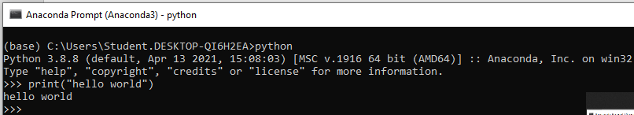

**Step 2: Create physical file main.py on Spyder (IDE)**

1. go to search bar
2. write spyder
3. click on spyder (IDE)
4. go to file option
5. create new file
6. write hello world incode



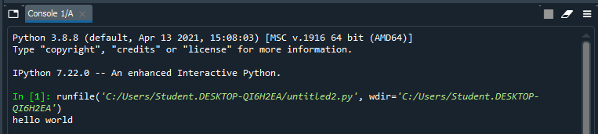

**Step 3: Create physical file main.py**

1. Create the folder or directory
2. Press Window+R then write cmd then hit enter and type code .
3. Explore and create new file main.py
4. print ("Hello World")

[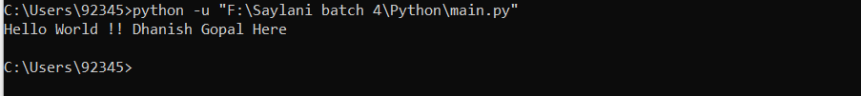](https://user-images.githubusercontent.com/127156113/224865756-f8782f03-9e63-4206-ba35-d07bc1efb5ed.png)

**Step 4: Create Jupyter Notebook**

1. Go to search bar
2. Write jupyter notebook
3. click on jupyter notebook icon
4. It will automatically open in browser
5. Go the right corner click on new file after it select python 3
6. After clicking notebook will be appear.
7. Write code , print(“hello world”)

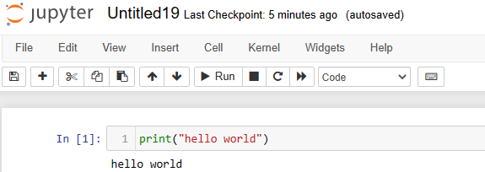

**Step 5: Open in IDE**

* Select the any IDE
  + open VS code
    - Create .py file
      * And run it [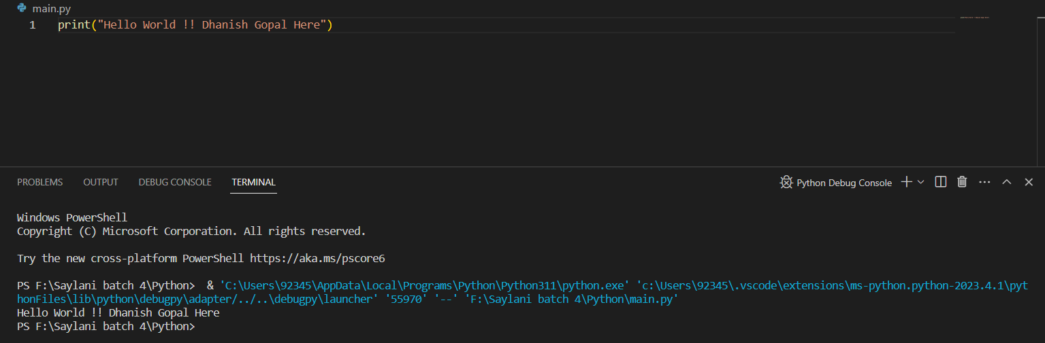](https://user-images.githubusercontent.com/127156113/224865777-101d5627-4084-4a4c-bbe6-7400a72775c4.png)

**Step 6: Google Colab**

1. Open your browser
2. Search foe google colab, for using google colab you must have google account to use it.
3. Go to left corner click file create new notebook.
4. Write code and press shift+enter to run the code

