**Hello-World**

**Saylani Batch 4**

**(AI and Data Science Class-1)**

**Step 1 : Console**

1. Search (Anaconda)
2. Anaconda prompt
3. Python
4. print ("Hello World")

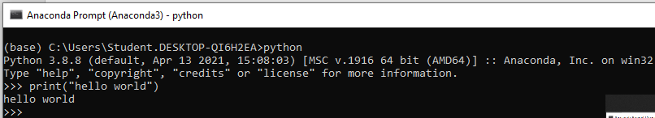

**Step 2: Create physical file main.py on Spyder (IDE)**

1. go to search bar
2. write spyder
3. click on spyder (IDE)
4. go to file option
5. create new file
6. write hello world incode



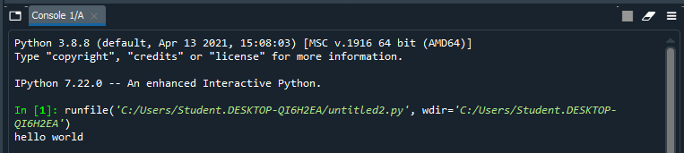

**Step 3: Print in Python Console.**

1. Create the folder or directory
2. Go to search bar and search Python(3.11)CONSOLE .Then hit enter and type code .
3. print ("Hello World")

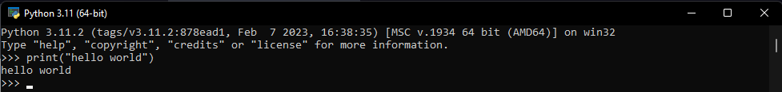

**Step 4: Create Jupyter Notebook**

1. Go to search bar
2. Write jupyter notebook
3. click on jupyter notebook icon
4. It will automatically open in browser
5. Go the right corner click on new file after it select python 3
6. After clicking notebook will be appear.
7. Write code , print(“hello world”)

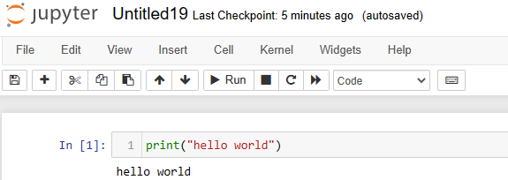

**Step 5: Open in VS-CODE IDE :**

1. Firstly install vs code in your system.
2. After installation go to search bar search vs-code
3. Open it, create a physical file after it type code.
4. Print(“hello world”)

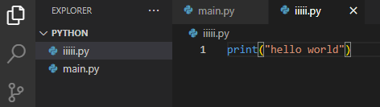

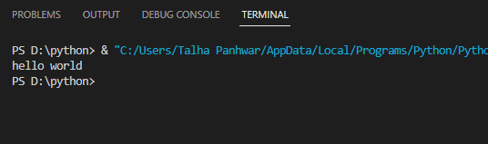

**Step 6: Google Colab**

1. Open your browser
2. Search foe google colab, for using google colab you must have google account to use it.
3. Go to left corner click file create new notebook.
4. Write code and press shift+enter to run the code

