# Architectural Design

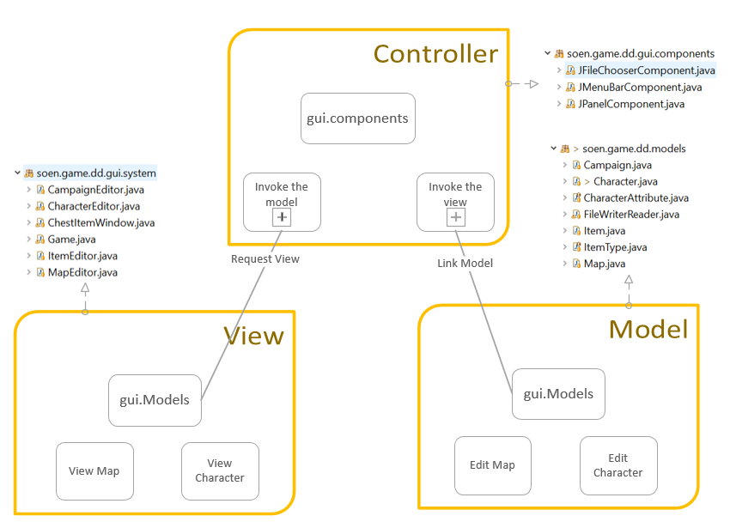

The architecture design diagram was constructed to ensure that model can be controlled by the Controller via requesting model and then linking the model to view. View include the GUI that builds the interface. We have also created a module for file saving, and a module for testing.

# Design Description

Using MVC architecture, the components were implemented with respect to each module. The Model has the character, item, map, and campaign models to implemented there. The View has the characterEditer, itemEditer, mapEditer, and campaignEditer interface. The Swing Framework was used to create the interface for players to choose from a list of menu.

Also, we have considered using enum whenever necessary to create the fixed options for many attributes like the menu listings, character attributes, and item types. Also, we have put the Junit unit testing in the TestObject framework.

# Appendix

Fighter class:

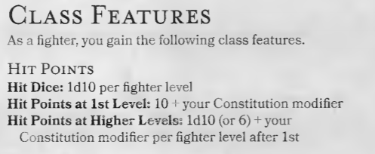

Ability Score when leveling up for Fighter Class. Other Classes?

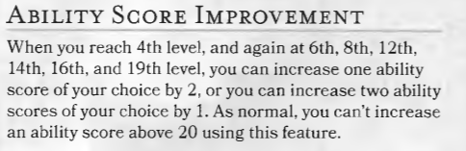

4d6?

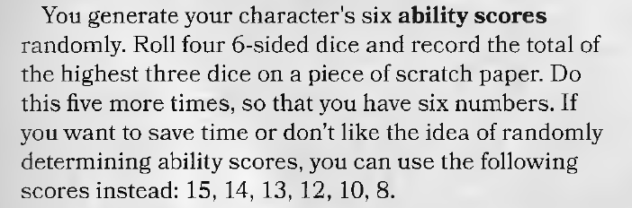

Ability Score builder. (race is needed?)

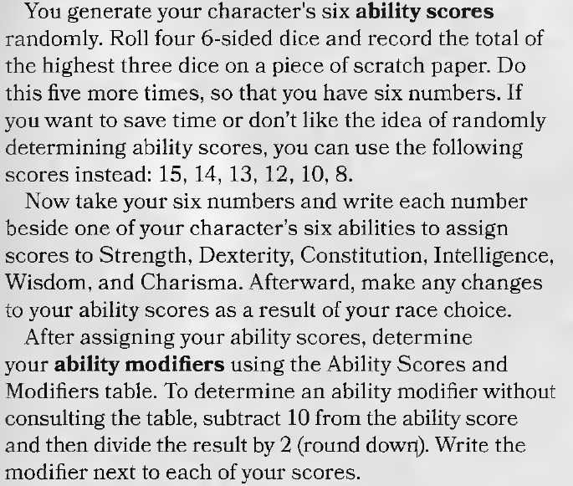

Race ability scores:

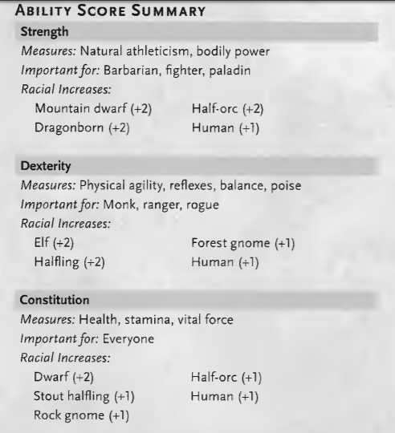

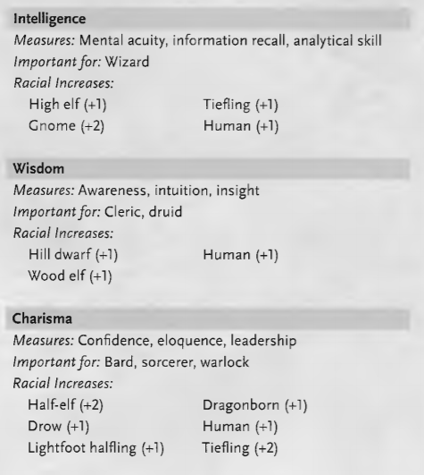

Maximum Hit Die (Hitpoint)

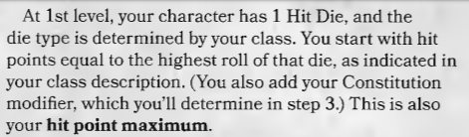

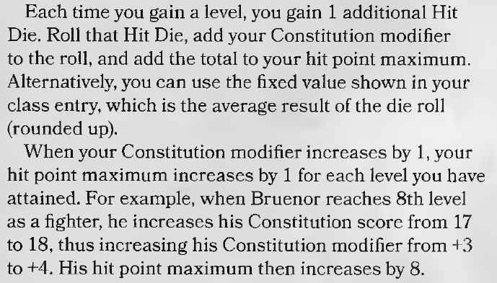

AC basics

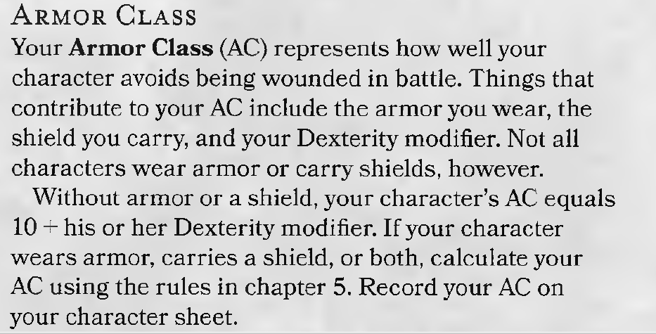

Attack Bonus basics

