Potential of Bihar Handicrafts (Threats s& Opportunities) With Context to Patna
¹Md. Aatir Usmani, ²Akshay Kumar Pandey, ³Mukund Murari, ⁴Uday Bhanu Shukla, ⁵Aradhya Rai, ⁶Zobya Arzoo
¹UG – St. Xavier’s College of Management & Technology, Patna, Bihar, India
²UG – St. Xavier’s College of Management & Technology, Patna, Bihar, India
³UG – St. Xavier’s College of Management & Technology, Patna, Bihar, India
⁴UG – St. Xavier’s College of Management & Technology, Patna, Bihar, India
⁵UG – St. Xavier’s College of Management & Technology, Patna, Bihar, India
⁶Xavier University, Patna, Bihar, India
Emails: ¹Usmaniaatir721@gmail.com , ²akshayk91818@gmail.com , ³mukundmurari18@gmail.com , ⁴udayshukla488@gmail.com , ⁵raiaradhya94@gmail.com , ⁶zobyaarzoo@gmail.com

Abstract
The handicraft sector of Bihar, particularly in Patna, represents a rich blend of cultural heritage, skilled artistry, and economic potential. This research explores the opportunities and threats faced by Bihar’s traditional crafts—including Madhubani painting, Sikki craft, Bhagalpuri silk, Sujni embroidery, Tikuli art, bamboo craft, and stone craft. Primary data were collected from 101 consumers in Patna through a structured Google Form survey and from 20 artisans across various craft clusters through structured questionnaires. Secondary data were reviewed through academic literature, government reports, journals, and published studies. The study reveals strong consumer appreciation for Bihar handicrafts, high cultural value perception, and a widespread desire for greater promotion and visibility. However, artisans face significant challenges including high raw material costs, middlemen exploitation, seasonal demand fluctuations, lack of training, poor online presence, and limited direct market access. The findings indicate substantial opportunities through digital platforms, government schemes, craft tourism, organised haats, and skill-based interventions. The research concludes that Patna holds immense potential to become a central hub for Bihar’s handicraft revival, provided systemic challenges are addressed through policy support, direct marketing channels, skill training, and consumer awareness initiatives.
Keywords: Bamboo craft; Bhagalpuri silk; Bihar handicrafts; Craft tourism; Madhubani painting; Middlemen; Sikki craft; Sujni embroidery; Tikuli art

1. INTRODUCTION
India’s handicraft tradition is globally admired for its extraordinary diversity, cultural depth, and artistic excellence. Bihar contributes significantly to this heritage with crafts such as Madhubani painting—recognised under the Geographical Indication (GI) tag—Sikki craft, Sujni embroidery, Bhagalpuri silk weaving, stone carving, Tikuli art, and bamboo craft. These crafts not only represent centuries-old artistic traditions but also sustain thousands of artisan families across the state (Ministry of Textiles, 2021).

Patna, as the economic, cultural, and commercial capital of Bihar, provides a crucial marketplace for handicraft consumption and distribution. With increasing urbanisation, a growing middle class, rising disposable incomes, and digital adoption, Patna presents immense opportunities for the handicraft sector both locally and globally. The presence of Shilpgram and government emporiums further positions Patna as a natural hub for Bihar’s craft ecosystem.

Despite this potential, artisans continue to face debilitating systemic challenges: limited market access, inconsistent income, absence of modern marketing channels, dominance of middlemen, and inadequate skilling support. Consumer surveys simultaneously indicate strong cultural attachment and genuine willingness to support handmade products, revealing a significant supply-demand gap (Jagatramka et al., 2022).

This paper analyses opportunities and threats from the perspectives of both consumers and artisans, using Patna as the focal point. A mixed-methods approach combines primary quantitative data from 101 consumer respondents and 20 artisans with an extensive secondary literature review to produce an integrated, data-driven assessment of the sector’s current state and future potential.
2. LITERATURE REVIEW
2.1 Handicrafts as a Cultural and Economic Asset
The Indian handicraft sector serves as a lifeline of the rural economy and a key instrument for women’s empowerment. Of approximately 3.1 million handicraft workers in India, around 87.4% reside in rural areas and 81% are women (Handicraft Sector in India, 2023). Handicraft exports reached approximately USD 4.3 billion in 2021–22, with the United States accounting for 38% of total demand. Bihar’s crafts—particularly Madhubani painting and Bhagalpuri silk—carry significant export potential (Sharma, 2019).

2.2 Problems Faced by Artisans
Research on loom weavers in Bhagalpur found that scarcity of raw materials (Garrett Mean Score: 54.12), high commission charges by middlemen (52.17), and frequent price fluctuations (49.05) are the most severe constraints (Bhagalpur Weavers Study, 2022). Artisans also suffer from lack of design innovation, absence of branding support, insufficient government scheme penetration, and exploitation by intermediaries (Khan & Verma, 2020).

2.3 Impact of Organised Interventions
The Jeevika programme in Madhubani demonstrated the transformative power of collective interventions: total monthly sales of participating craftswomen surged from Rs. 18,900 to Rs. 1,46,100 after joining Producer Groups, while average savings increased more than tenfold (Crafting Change, 2021). The COVID-19 pandemic severely disrupted the sector—a study of Shilpgram artisans in Patna found 85% faced raw material procurement issues, 85% had no access to micro-finance, and 70% reported reduced income during lockdown (Jagatramka et al., 2022).

2.4 Consumer Behaviour and Digital Opportunity
Urban consumers value handicrafts for authenticity, cultural connection, uniqueness, and aesthetic appeal, though pricing and accessibility remain barriers (Gupta, 2018). Bihar’s e-commerce potential is constrained by digital literacy gaps—only 24.6% of Bihar’s population possesses basic ICT skills (E-commerce in Bihar, 2023)—yet consumer awareness of the utilitarian and sustainable aspects of handicrafts significantly increases demand (Indian Handicrafts: A Sustainable Future, 2022).

2.5 Tourism as a Demand Catalyst
Bihar’s tourist arrivals grew from 19.37 million in 2011 to 35.08 million in 2019. Tourism creates direct employment in the souvenir and handicrafts industries and serves as a key demand driver for craft products (Role and Relevance of Tourism in Bihar, 2022). Craft tourism represents an underexploited opportunity to connect artisans with high-spending domestic and international visitors.

2.6 Gaps in Literature
Existing research lacks studies that: (a) focus specifically on Patna as a handicraft consumption market; (b) directly compare consumer expectations with artisan realities using matched primary data; and (c) provide an integrated threat-opportunity framework for the Bihar handicraft sector. This study addresses all three gaps.
3. OBJECTIVES OF THE STUDY
• To analyse consumer awareness, craft recognition, and purchase behaviour toward Bihar handicrafts in Patna.
• To understand artisans’ income patterns, key challenges, and marketing gaps.
• To compare consumer expectations with artisan realities through gap analysis.
• To identify key threats and opportunities for Bihar’s handicraft sector.
• To suggest evidence-based policy and business recommendations.
4. DATA AND METHODOLOGY
4.1 Research Design
This study adopts a mixed-methods research design, combining quantitative survey data with qualitative interpretive analysis. The dual-perspective approach—surveying both consumers and artisans—enables a comprehensive assessment of the handicraft ecosystem.

4.2 Primary Data
Consumer data were collected from 101 respondents across Patna through a structured Google Form questionnaire (November 2025), using convenience sampling. The questionnaire captured demographics, craft recognition, purchase behaviour, Likert-scale perception statements (1–5), and open-ended suggestions.

Artisan data were collected from 20 artisans across Patna’s craft clusters (Danapur, Phulwari, Kankarbagh, Raja Bazar, Boring Road, Patna Sahib) through structured face-to-face questionnaires (December 2025), using purposive sampling to ensure multi-craft representation.

4.3 Secondary Data
Secondary data were drawn from peer-reviewed journals, government reports (Ministry of Textiles, Bihar Industries Department), the Handloom Census of India, EPCH reports, and prior academic studies on Bihar’s artisan economy, tourism, and e-commerce.

4.4 Analytical Tools
Analysis employed Likert scale mean scoring, frequency distribution, and comparative gap analysis. Problem severity was assessed on a 1–5 scale (1 = not a problem, 5 = very severe). Consumer perceptions were quantified by percentage agreement (Agree + Strongly Agree) and mean Likert scores.
5. RESULTS AND DISCUSSION
5.1 Consumer Analysis
5.1.1 Sample Profile
A total of 101 valid consumer responses were collected. The sample comprised 50.5% male and 49.5% female respondents—a near-perfectly balanced gender distribution.

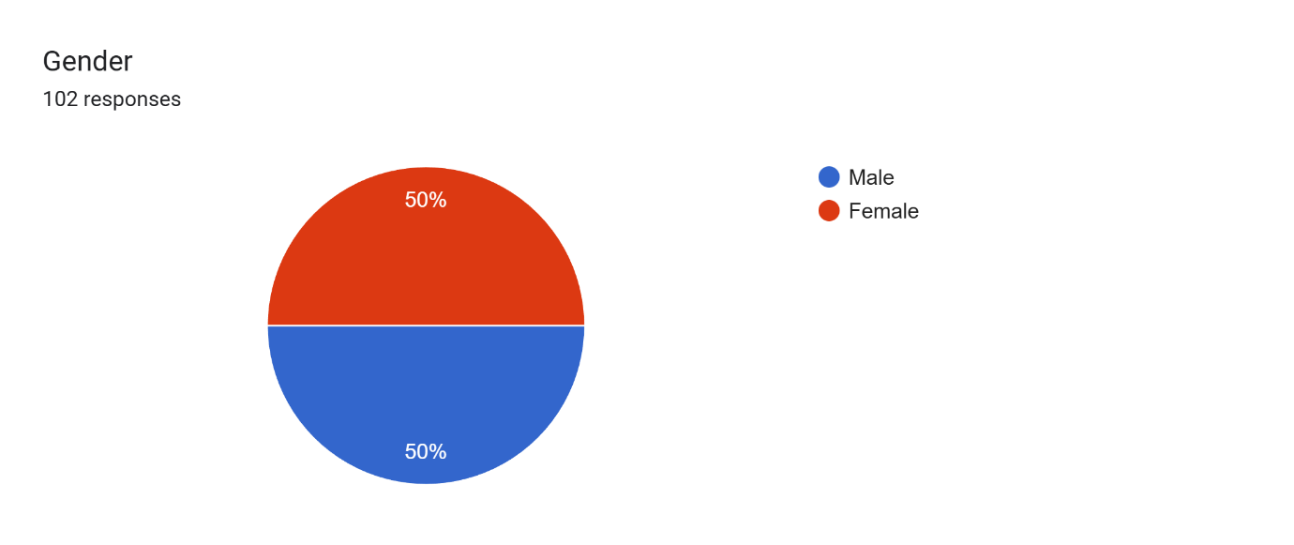
FIGURE 1. Gender distribution of consumer respondents (n = 101)

The age profile was dominated by the 18–25 cohort (64.4%), followed by Below 18 (15.8%), 26–35 (8.9%), 36–50 (5.9%), and 51+ (5.0%). Respondents were drawn from across Patna’s localities including Patna City, Danapur, Kankarbagh, Boring Road, Patna Sahib, and Phulwari, ensuring geographic representativeness.

5.1.2 Awareness and Craft Recognition
Awareness of Bihar handicrafts was remarkably high: 98.0% of respondents confirmed awareness with only 2 (2.0%) reporting unawareness. Madhubani Painting emerged as the most widely recognised craft (86.3%), followed by Bamboo Craft (46.1%), Bhagalpuri Silk (44.1%), Stone Craft (28.4%), Tikuli Art (19.6%), Sikki Craft (14.7%), and Sujni Embroidery (6.9%), indicating targeted promotional need for lesser-known crafts.

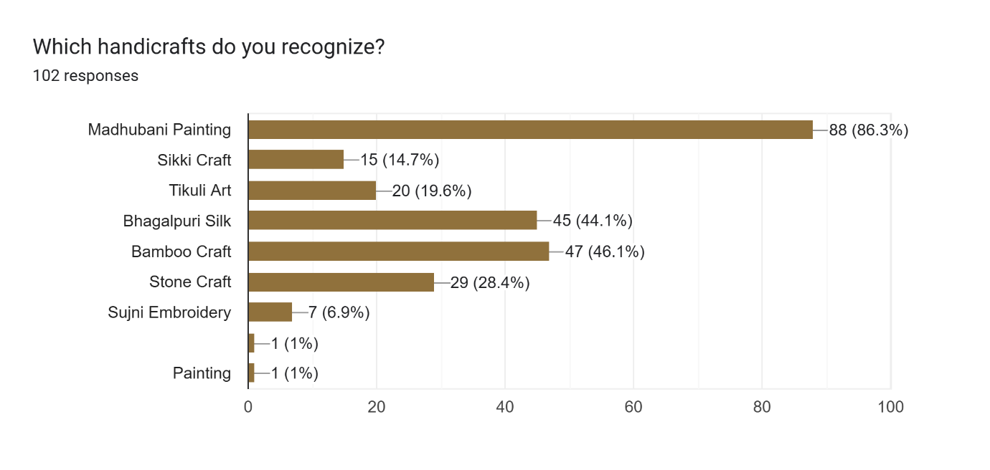
FIGURE 2. Handicraft recognition among consumers (n = 102)

5.1.3 Purchase Behaviour
Approximately 74.5% of surveyed consumers had previously purchased a Bihar handicraft. Exhibition/Mela was the most popular channel (61.8%), followed by local markets (55.9%). Online websites were used by only 7.8% of respondents and Government Emporiums by 8.8%, confirming that physical, event-driven retail dominates while online penetration remains critically low.

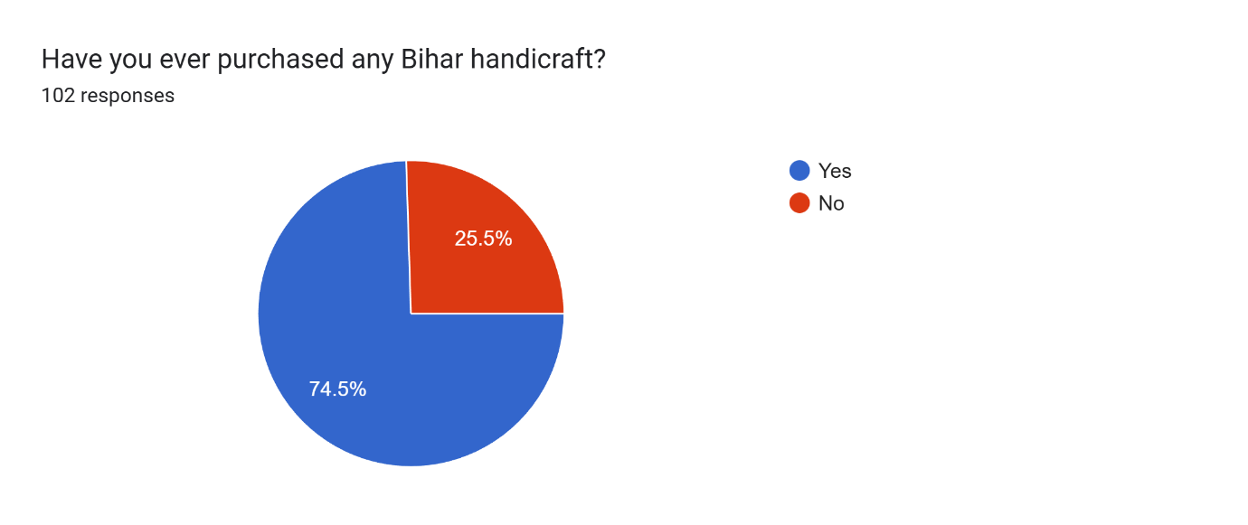
FIGURE 3. Consumer handicraft purchase behaviour (n = 102)

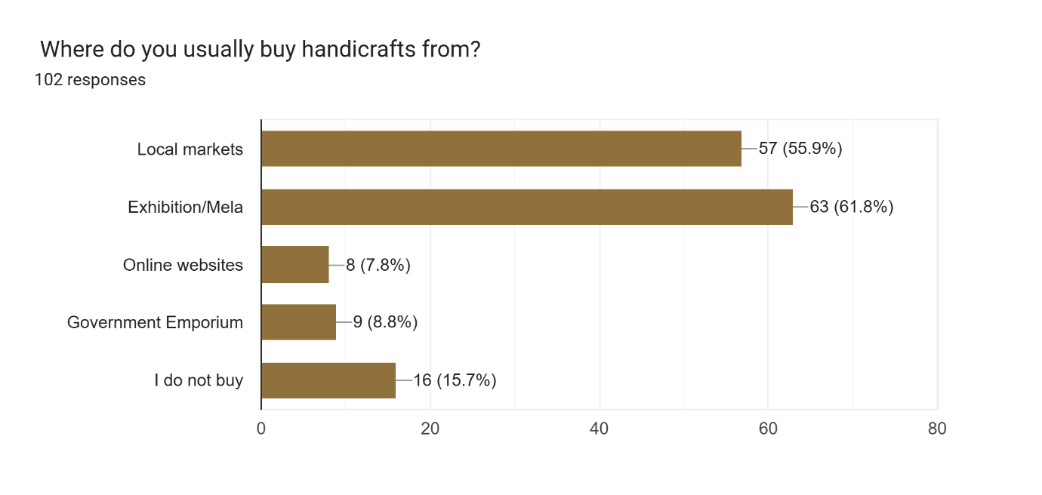
FIGURE 4. Preferred purchasing channels for Bihar handicrafts (n = 102)

5.1.4 Consumer Perception (Likert Scale Analysis)
Respondents evaluated seven perception statements on a five-point Likert scale. Results reveal strong positive sentiment, particularly regarding cultural value, promotion need, and online availability.

Table 1. Consumer Perception – Likert Scale Results (n = 101)
Statement | Mean | Agree+SA
Bihar handicrafts are culturally valuable | 4.06 | 83.2%
Should be promoted more in Patna | 4.30 | 88.1%
Online availability should increase | 4.12 | 79.2%
Handicrafts are good gift items | 4.20 | 82.2%
Quality is satisfactory | 3.78 | 61.4%
Prefer over machine-made products | 3.53 | 49.5%
Handicrafts are overpriced | 3.10 | 36.6%

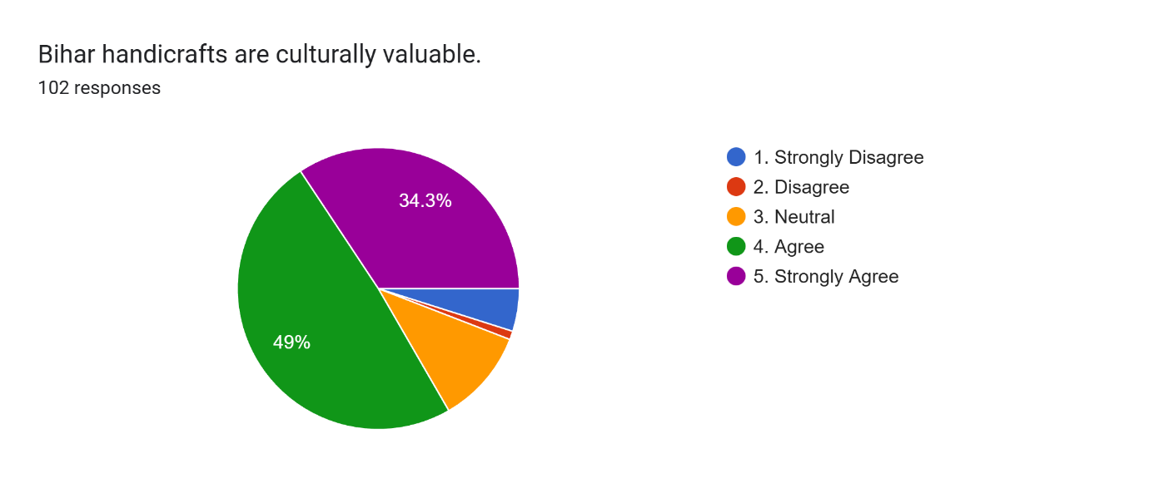
FIGURE 5. Culturally valuable (n = 102)

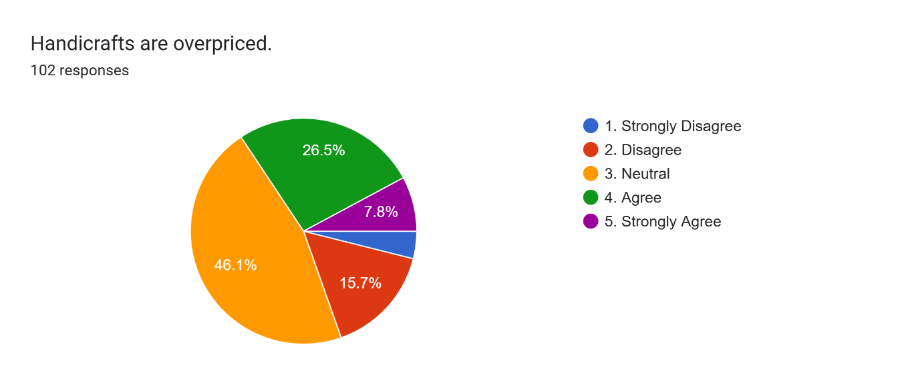
FIGURE 6. Handicrafts are overpriced (n = 102)

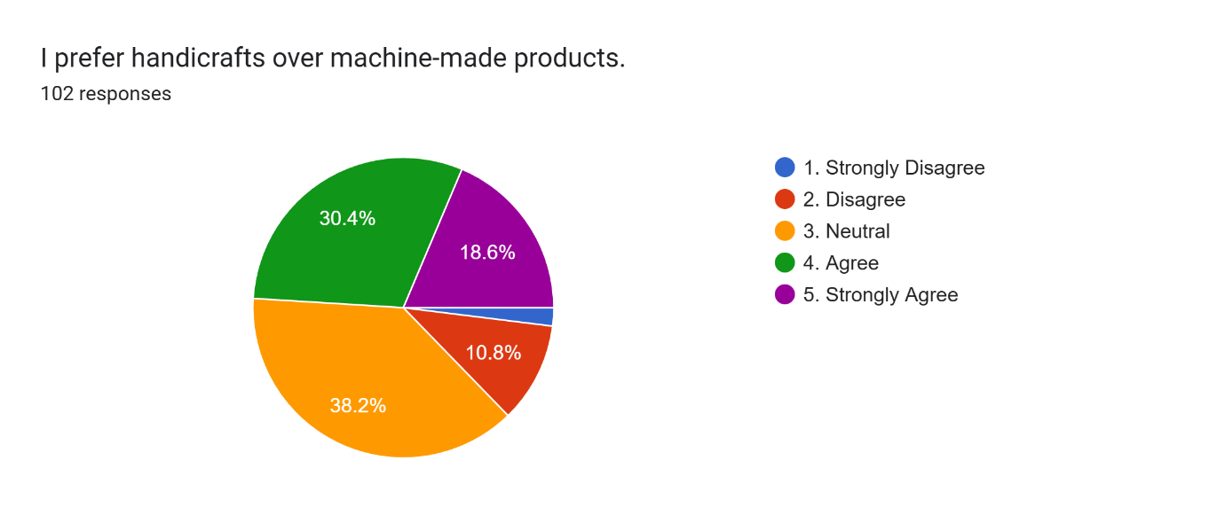
FIGURE 7. Prefer handicrafts over machine-made (n = 102)

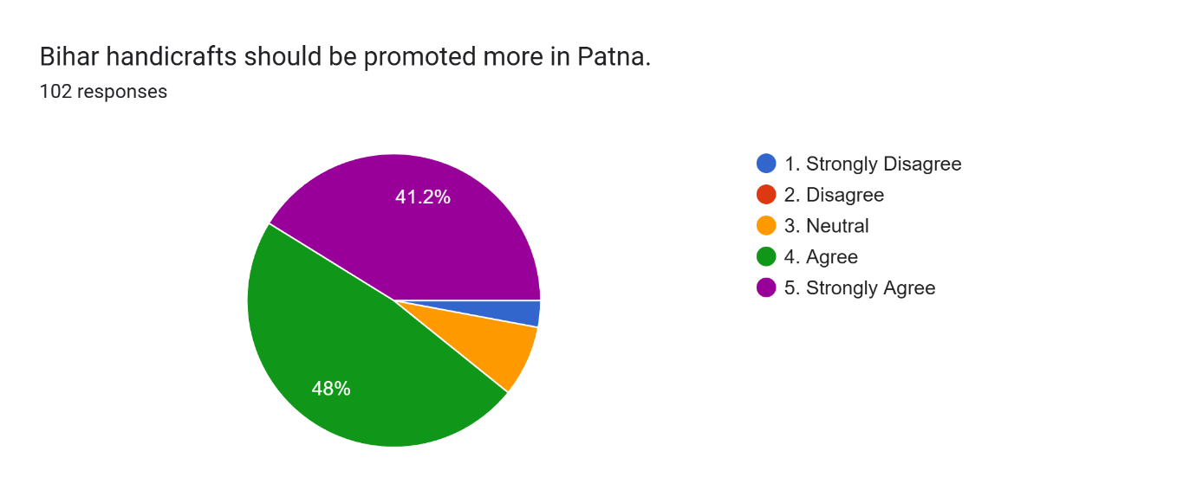
FIGURE 8. Should be promoted more in Patna (n = 102)

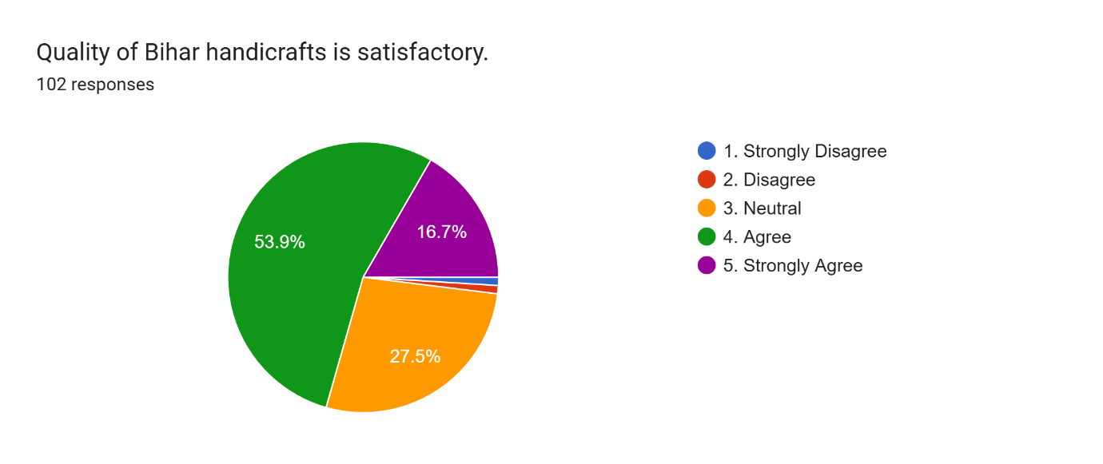
FIGURE 9. Quality is satisfactory (n = 102)

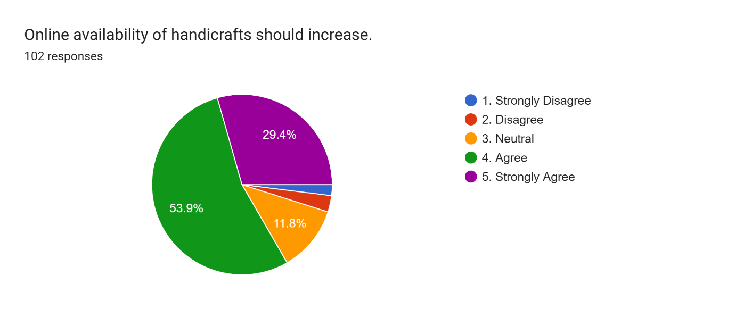
FIGURE 10. Online availability should increase (n = 102)

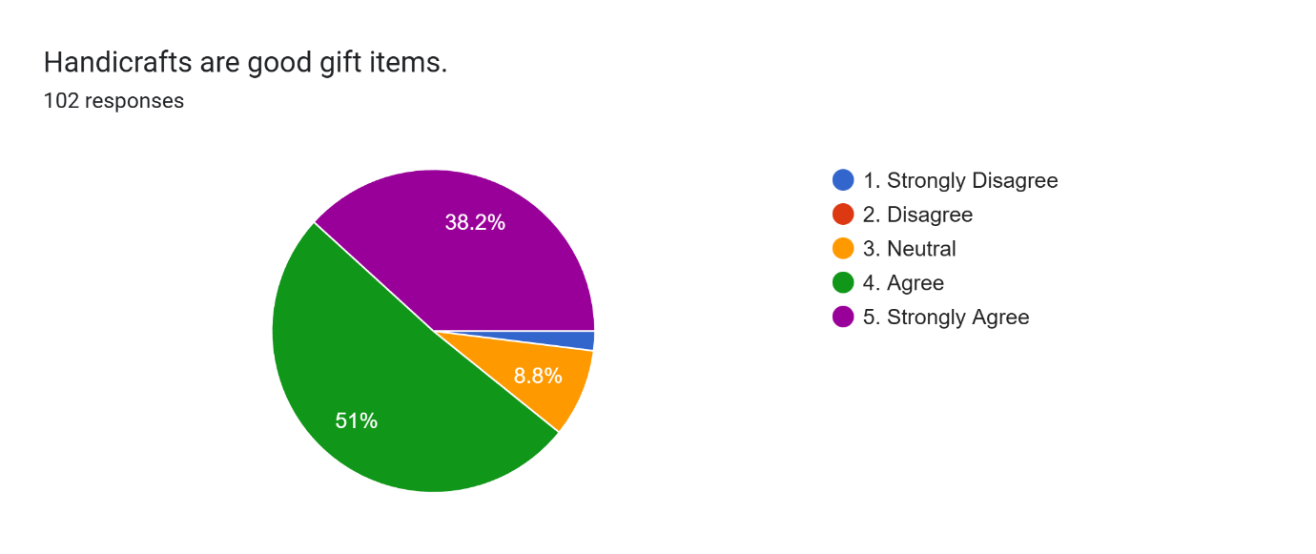
FIGURE 11. Handicrafts are good gift items (n = 102)

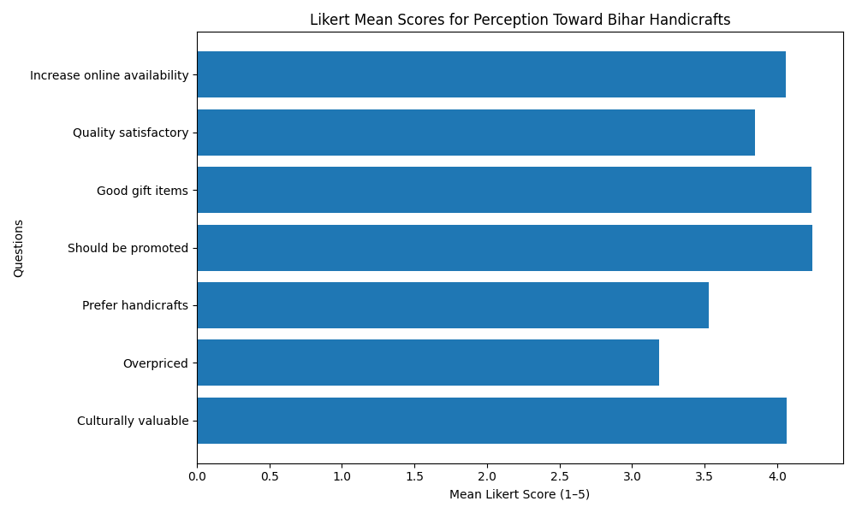
FIGURE 12. Likert mean scores – consumer perception toward Bihar handicrafts

The highest agreement was recorded for promotion needs (88.1%, mean 4.30) and cultural value (83.2%, mean 4.06). The relatively lower preference over machine-made products (49.5%) indicates that while emotional affinity is strong, functional competition from mass-produced goods remains real. Approximately one-third found handicrafts overpriced, highlighting the need for better value communication.

5.1.5 Key Consumer Suggestions
Recurring themes from open-ended responses included: a permanent craft market in Patna modelled on Delhi Haat; handicraft education in schools and colleges; expanded social media promotion; pop-up stalls in malls; reduced middlemen in the supply chain; and increased government-sponsored exhibitions.

5.2 Artisan Analysis
5.2.1 Profile and Craft Types
Twenty artisans were surveyed, representing Bamboo Craft (35%), Madhubani Painting (30%), Bhagalpuri Silk (15%), Sujni Embroidery (10%), Sikki Craft (5%), and other crafts (5%). 75% were full-time practitioners; the remainder combined handicrafts with farming or other employment. Artisans were drawn from Phulwari, Danapur, Raja Bazar, Kankarbagh, Ashiyana, Boring Road, and Patna Sahib.

5.2.2 Income Distribution
The income profile reveals deeply precarious livelihoods. A striking 55% of surveyed artisans earn less than Rs. 5,000 per month, with only 10% earning above Rs. 20,000. This is consistent with national literature on artisan income volatility.

Table 2. Artisan Monthly Income Distribution (n = 20)
Income Bracket | No. | %
Rs. 0 – 5,000 | 11 | 55%
Rs. 5,001 – 10,000 | 4 | 20%
Rs. 10,001 – 20,000 | 3 | 15%
Above Rs. 20,000 | 2 | 10%

5.2.3 Key Challenges
Artisans rated problem severity on a 1–5 Likert scale. Raw material cost (4.35) and middlemen profit extraction (4.10) are the most acute problems. Finance access (3.80) and tool/machine gaps (3.85) also scored high, while workspace issues were least severe (2.80).

Table 3. Artisan Problem Severity – Mean Scores (1–5)
Problem Dimension | Mean (1–5)
Raw material cost | 4.35
Middlemen take excessive profit | 4.10
Direct sales can increase income | 4.05
Tool / machine gap | 3.85
Finance / capital access | 3.80
Training / skill upgradation | 3.10
Workspace problems | 2.80

5.2.4 Digital Readiness
45% of artisans expressed interest in selling online “with help”; 30% already conducted small-scale sales via WhatsApp or Instagram; 15% lacked smartphones entirely; and only 10% distrusted online platforms. With targeted digital literacy training, the majority of artisans can be transitioned to digital channels.

5.2.5 Craft Bazaar Potential
50% of artisans believed a permanent organised craft bazaar in Patna would increase their income “a lot”; 40% expected it to “increase a bit”. This overwhelming positive sentiment, combined with evidence from Delhi Haat and Hyderabad Haat, makes establishing a dedicated craft market one of the most impactful single interventions available.

5.3 Gap Analysis: Consumer Expectations vs. Artisan Realities
The gap analysis synthesises both survey perspectives to identify structural mismatches in the handicraft ecosystem. Consumer enthusiasm is consistently high, yet artisan-side constraints systematically prevent that demand from being met.

Table 4. Gap Analysis: Consumer Expectations vs. Artisan Realities
Dimension | Consumer Expectation | Artisan Reality | Gap
Availability | More permanent outlets | Limited to haats & exhibitions | High
Online Presence | E-commerce access (79.2%) | Most untrained / unequipped | Very High
Promotion | Better marketing (88.1%) | No marketing support or budget | Very High
Pricing | Overpriced (36.6%) | Raw materials expensive (4.35/5) | High
Quality | Durability & consistency | Tools & materials uneven | Medium
Design | Contemporary styles | Lack innovation training | Medium

6. THREATS AND OPPORTUNITIES FRAMEWORK
6.1 Key Threats
• High and unstable input costs (mean severity 4.35/5) directly compress artisan margins.Raw Material Volatility:
• Intermediaries capture a disproportionate share of the retail price (4.10/5), leaving insufficient returns for artisans.Middlemen Exploitation:
• Only 49.5% of consumers prefer handicrafts over machine-made alternatives.Machine-Made Competition:
• 15% of artisans lack smartphones; digital literacy is critically low.Digital Divide:
• Irregular order flow creates income volatility that discourages full-time craft engagement.Seasonal Demand:
• Insufficient intergenerational knowledge transfer risks gradual erosion of traditional craft skills.Skill Erosion:

6.2 Key Opportunities
• 90% of artisans expect income growth from an organised market; consumer demand for physical outlets is strong.Permanent Craft Bazaar:
• 79.2% of consumers demand online access; most artisans are willing to sell online with support.Digital Commerce:
• Bihar’s GI-tagged crafts provide a competitive differentiator; stronger branding can justify premium pricing.GI Tag and Branding:
• PM Vishwakarma Yojana and state-level initiatives offer financial and infrastructure support awaiting wider artisan penetration.Government Schemes:
• Bihar’s Buddhist, Jain, and Gandhi circuits attract millions of visitors; integrating craft tourism creates reliable high-value demand.Craft Tourism:
• Consumer voices strongly advocate incorporating handicraft education into school and college curricula.Educational Integration:
• The Jeevika model demonstrates the transformative potential of Producer Groups for craft artisans.SHG and Cooperative Scaling:
7. CONCLUSION
Bihar’s handicrafts represent a sector of immense cultural significance and untapped economic potential, particularly in Patna where consumer awareness is near-universal (98%), appreciation is strong (83.2% find handicrafts culturally valuable), and purchase intent is high (74.5%). Yet artisans remain trapped in a cycle of low income—a stark 55% earn below Rs. 5,000 per month—middlemen dependency, raw material price volatility, and marketing isolation.

The fundamental challenge is not one of demand but of structural supply-side failures preventing artisans from reaching consumers at fair prices. The gap is most acute in online presence, organised marketing infrastructure, and promotional investment. The opportunities are equally clear: a permanent craft bazaar, digital commerce enablement, GI-tag branding, tourism integration, and SHG strengthening represent a coherent intervention portfolio that, if implemented collectively, could transform Patna into a major hub for Bihar’s handicraft economy.

In short: consumers want to buy, and artisans want to sell — but the system connecting them is broken. Fixing that bridge is the defining policy imperative for Bihar’s handicraft sector. The opportunities decisively outweigh the threats, provided the structural gaps are systematically addressed.
ACKNOWLEDGEMENTS
The authors gratefully acknowledge the participation of all consumer respondents and artisans who contributed their time and experiences to this research. Special thanks to the faculty and administration of St. Xavier’s College of Management & Technology, Patna, for their institutional support, and to the artisan communities at Shilpgram and across Patna’s craft clusters for their invaluable insights.
REFERENCES
Crafting Change: Empowering Women Artisans through Madhubani and Jeevika. (2021). Journal of Rural Development Studies, 14(2), 55–72.
E-commerce in Bihar: A Comprehensive Study on Challenges and Opportunities. (2023). Journal of Business and Commerce, Bihar, 7(1), 10–28.
Gupta, P. (2018). Consumer behaviour toward handicrafts in urban India. Journal of Marketing and Consumer Research, 45, 12–28.
Handicraft Sector in India: An Instrument for Rural Economic Growth and Women Empowerment. (2023). Indian Journal of Rural Economy, 11(2), 45–67.
Indian Handicrafts: A Sustainable Future of Utilitarian Consumer Goods. (2022). Journal of Sustainable Consumption, 8(1), 23–41.
Jagatramka, R., Prasad, R., & Thakur, S. (2022). The effect of pandemic on Shilpgram of Patna, Bihar. Journal of Cultural Heritage and Artisan Economy, 3(1), 55–72.
Khan, M., & Verma, D. (2020). Problems of artisans in Bihar: An empirical study. Economic Review Weekly, 58(14), 33–42.
Loom Weavers of Bhagalpur: Constraints in Production and Marketing. (2022). Agricultural Economics and Rural Development Journal, 9(3), 88–101.
Ministry of Textiles, Government of India. (2021). Handicraft Development Report. New Delhi: Ministry of Textiles.
Role and Relevance of Tourism in Bihar. (2022). Bihar Tourism Studies, 4(2), 10–28.
Rural–Urban Linkages in Bihar’s Manufacturing Sector. (2017). Economic and Political Weekly, 52(18), 72–80.
Sharma, R. (2019). Handicrafts of India: Issues and challenges. Journal of Cultural Economics, 43(2), 101–118.
Study on Entrepreneurial Activities Undertaken by Women SHG Members of Patna District. (2020). International Journal of Social Science and Economic Research, 5(8), 2112–2128.

