Business Requirements Document
Workforce Management Console (WFMC)
Integrated workforce, attendance, roster, leave, camp accommodation, training & TBT, HSE and compliance platform for waste collection operations — LOT 3, LOT 4 and LOT 5
Field | Detail
Document title | Business Requirements Document — Workforce Management Console
Document reference | TAJ-OPS-BRD-2026-014
Version | 1.2 (for vendor review — supersedes v1.1)
Date | 03 August 2026
Prepared by | Vaishak A. — Operations & Analytics Manager, Tajmee'e
Intended recipient | IWMP platform development team
Reference prototype | Tajmee_Workforce_Console.html (interactive HTML prototype, supplied with this document)
Classification | Internal — commercial in confidence

Approvals
Name | Role | Signature | Date
 | Director of Operations
 | HR Manager
 | IT / Digital Lead
Vaishak A. | Operations & Analytics Manager (Author)

Revision history
Ver. | Date | Author | Change summary
0.1 | 28 Jun 2026 | Vaishak A. | Initial draft from HTML prototype walkthrough
1.0 | 02 Jul 2026 | Vaishak A. | Issued for review — KPI popup drill-downs and EOM nomination workflow
1.1 | 03 Jul 2026 | Vaishak A. | TBT calendar added; Reports / Administration / Settings moved out of scope; DFD, snapshots and function checklist added
1.2 | 03 Aug 2026 | Vaishak A. | Camp Management module added — camp master, employee room & bed mapping, capacity vs occupancy, allocation & transfer workflow, capacity planner; DFD, checklist and snapshots updated

Contents
1. Purpose of this document
2. Business background and problem statement
3. Objectives and success measures
4. Scope
5. Users and role-based access
6. Solution overview and module map
7. Functional requirements (by module)
8. Data model and master data
9. Data flows
10. Integrations
11. Non-functional requirements
12. Assumptions, dependencies and constraints
13. Acceptance and delivery approach
14. Glossary
Appendix A. Function checklist — vendor response sheet
Appendix B. Prototype snapshots

1. Purpose of this document
This BRD defines the business and functional requirements for a Workforce Management Console (WFMC) to be developed on the IWMP platform for Tajmee'e. It should be read together with the interactive HTML prototype supplied alongside it. The prototype is a working, clickable reference: every screen, workflow, popup, validation and export described here already behaves as intended in the prototype, so where wording leaves room for interpretation, the prototype behaviour is the requirement. Appendix B contains snapshots of the key screens; Appendix A is a consolidated function checklist for the vendor's line-by-line response.

2. Business background and problem statement
Tajmee'e (a Tadweer Group company) operates municipal waste collection across multiple concession areas. The workforce in scope covers three collection LOTs at steady state and in mobilization:
Parameter | Combined scope (LOT 3 · 4 · 5)
Workforce | Approx. 2,000 staff at full mobilization (drivers, labours, supervisors and support roles)
Fleet | 365 vehicles across compactors, hook loaders and light vehicles
Assets | 70,000 bins deployed across sectors and routes
Accommodation | Majority of the field workforce housed in company-managed labour camps across four locations
Shifts | Morning, Evening and Night, seven days with staggered weekly offs
Manpower supply | Mixed model — direct hires plus contractor-supplied manpower under manning contracts

Today this workforce is administered on spreadsheets, manual attendance consolidation and email-based approvals. At this scale that creates recurring problems: no single live source of truth; legal-document expiries tracked by hand; attendance shortage visible only after the shift; camp accommodation managed on paper with no reliable room-and-bed register, making occupancy, welfare inspections and mobilization planning guesswork; and leave, exits, training, TBT and disciplinary records scattered across files with no workflow or audit trail. The WFMC replaces this with one web console covering the employee lifecycle end to end — including where each employee sleeps.

3. Objectives and success measures
# | Objective | Success measure
O1 | Single source of truth for workforce master data | 100% of active employees maintained in WFMC; Excel master retired within 60 days of go-live
O2 | Zero missed legal-document renewals | All expiries alerted at configured lead times; zero roster-ineligible driver deployments
O3 | Same-day visibility of attendance vs roster | Shortage by LOT and shift on the dashboard by 08:00 daily
O4 | Workflow-driven approvals with audit trail | 100% of leave, disciplinary and TBT publications processed in-system with SLA tracking
O5 | Structured safety communication | Monthly TBT calendar published before month start; delivery and attendance logged per talk
O6 | Full accommodation traceability | Every camp resident mapped to a room and bed; live occupancy accuracy 100%; zero double-allocated beds
O7 | Scalable to new LOTs and Emirates | New LOT or camp onboarded through configuration only — no code change

4. Scope

4.1 In scope
- Ten functional modules: Dashboard, Employee Management, Attendance & Timesheet, Roster & Job Assignment, Leave Management, Camp Management, Training Management (including the TBT calendar), Disciplinary & HSE, Notifications, and User Profile.
- Employee lifecycle: onboarding (single and bulk), document repository, probation, exits and final clearance.
- Biometric attendance capture, timesheets and regularization workflow.
- Weekly roster planning with drag-and-drop reassignment, conflict detection and job assignment (vehicle, route, supervisor, sector, depot).
- Leave workflows aligned to UAE Labour Law, planner calendar, encashment queue and exit clearance.
- Camp management: camp master with capacity definition, employee-to-room-and-bed mapping, capacity vs occupancy dashboards, allocation and transfer workflow, room/bed maps and capacity planning for mobilization intake.
- Training sessions, competency matrix, certificate validity tracking and materials library.
- TBT calendar: monthly plan creation with weekly subjects, draft / publish workflow, yearly calendar view, delivery and attendance logging, and exports.
- HSE incident register with investigation, CAPA and progressive-discipline management.
- Compliance notification engine (8 trigger types) across bell, email, SMS and push channels.
- Employee of the Month nomination, review and announcement workflow with auto-compiled employee evidence.
- In-module data exports (Excel, PDF, CSV, print) on every table and calendar — these remain in scope even though the standalone Reports Center module does not (see 4.2).

4.2 Out of scope (this phase)
- Reports Center module (standard report library and custom report builder) — deferred; in-module exports cover the immediate need.
- Administration module (role / permission editor, approval-matrix screens, master-data editors, audit-log viewer) — handled through the IWMP platform's existing administration capability. The access model in section 5 must still be enforced.
- Settings module — notification lead times and similar parameters managed as configuration values by the platform administrator.
- Camp facilities operations (mess menus, maintenance ticketing, transport scheduling) — the camp module covers the accommodation register and capacity only; facilities operations may follow in a later phase.
- Payroll calculation and WPS file generation (WFMC exports approved timesheets to Oracle payroll).
- Recruitment / ATS; vehicle maintenance (Maximo); route optimisation (IWMP core).
- Employee self-service mobile app (later phase; the console itself must be mobile-responsive).
Note for the vendor: prototype screens exist for the deferred modules. They indicate future direction only and must not be estimated or built in this phase.

5. Users and role-based access
Six roles at launch. Although the Administration screens are out of scope, the access model itself is mandatory: permissions per module and per action (view / create / edit / approve / export), plus LOT-level and camp-level data scoping, enforced through the IWMP platform's administration capability.
Role | Typical users | Access summary
System Administrator | IT / Digital team | Full access, managed at platform level
Operations Manager | Ops & Analytics Manager, Area Managers | All modules; approves leave, OT, disciplinary; announces EOM; publishes rosters and TBT calendars; adds camps and approves capacity changes
HR Manager / Officer | HR team | Employee, leave, exits, disciplinary, training; bed allocation for new joiners; approvals per matrix
LOT Supervisor | Site supervisors | Own-LOT scope: attendance, roster view, leave endorsement, incident reporting, TBT delivery logging, nominations
Camp Boss | Camp administrators | Own-camp scope: room / bed occupancy view, transfer requests, handover confirmations, occupancy register export
Viewer | Directors, finance, client reporting | Read-only dashboards; no personal-document access

6. Solution overview and module map
Single web application; left navigation grouped into Overview, Workforce and Compliance areas. Global search (Ctrl+K) finds any employee by name, ID, passport, Emirates ID, phone, vehicle plate, route, LOT or shift. Light and dark themes; responsive to mobile.
# | Module | Purpose in one line | Snapshot
1 | Dashboard | Live KPIs with popup drill-downs, LOT dashboards, trends, EOM workflow | Fig. 2–4
2 | Employee Management | Master database, profiles, onboarding, bulk upload, documents | Fig. 5–7
3 | Attendance & Timesheet | Biometric register, punch detail, shortage analysis, timesheets | Fig. 8
4 | Roster & Job Assignment | Weekly roster board, drag-and-drop, daily job cards, headcount planning | Fig. 9
5 | Leave Management | Requests, approvals, planner, exits and clearance, encashment | Fig. 10
6 | Camp Management | Camp master, room & bed mapping, capacity vs occupancy, allocation, capacity planning | Fig. 11–13
7 | Training Management | Sessions, competency matrix, certificates, TBT calendar (create / publish / yearly view) | Fig. 14–15
8 | Disciplinary & HSE | Incident register, investigation and CAPA, progressive discipline | Fig. 16
9 | Notifications | Expiry and event engine, alert buckets, channel templates | Fig. 17
10 | User Profile | Account, favourites, pinned employees, personal activity | —

7. Functional requirements
Numbered per module, prioritised MoSCoW (M = Must, S = Should, C = Could). All Must items are required for go-live. Appendix A consolidates every requirement into a single checklist for the vendor's response.

7.1 Dashboard (FR-DSH)
Ref | Requirement | Pri.
DSH-01 | Eight KPI cards: Total Workforce, Active Employees, Today’s Attendance, Absent Today, Open Vacancies, Resignations in Process, Training Compliance %, 12-month Turnover %. Values animate and refresh from live data. | M
DSH-02 | Clicking any KPI card opens an in-place popup listing the underlying records (no page redirect), with a live text filter, Excel export of the filtered list, and optional row click-through to the employee profile (Fig. 3). | M
DSH-03 | Training Compliance popup lists only the employees pulling the number down, sorted by expired certificates. | M
DSH-04 | Attendance vs roster trend (14 days) with LOT filter chips; supporting charts: designation, nationality mix, shift distribution by LOT, age and service profile. | M
DSH-05 | One card per LOT: attendance %, allocated / present / absent / on-leave, vacancies, supervisors, mobilization status, with drill-down popup. | M
DSH-06 | 35-day attendance heatmap calendar. | S
DSH-07 | Employee of the Month widget: current winner, previous winners, Nominate and Review & Announce actions. | M
DSH-08 | EOM nomination form auto-compiles an evidence card on employee selection — ID, position, LOT, depot, service years, 35-day attendance %, late arrivals, training score, OT shifts — plus record checks (active warnings, incidents, expired certificates, prior wins) (Fig. 4). | M
DSH-09 | Eligibility flags (active warning, open incident, recent prior win) require Operations Manager override at approval. | M
DSH-10 | Review & Announce lists pending nominations side by side; Announce updates the widget, publishes an all-staff notice and files a certificate to the employee’s documents; Decline returns feedback. | M
DSH-11 | Vacancy drill-down popup by LOT and position with a raise-requisition action. | S

7.2 Employee Management (FR-EMP)
Ref | Requirement | Pri.
EMP-01 | Employee master table over the full workforce matching the Manpower Master Data schema; search, multi-filter (LOT, status, position, contractor, depot), sort, pagination, column show / hide, frozen first column, export to CSV / Excel / PDF / print (Fig. 5). | M
EMP-02 | Master export reproduces the existing 29-column Manpower Master workbook layout exactly. | M
EMP-03 | Employee profile with hero summary and five tabs: Overview (identity, legal, employment, compliance status with days-to-expiry, leave balances, accommodation with camp / room / bed), Documents, Attendance, Training, Timeline (Fig. 7). | M
EMP-04 | Document repository per employee across ten document types with drag-and-drop upload, preview, replace and missing-document indicators. | M
EMP-05 | Onboarding form with mandatory-field validation and inline highlighting; edit mode reuses the form. | M
EMP-06 | Bulk upload wizard in five steps: template download, upload, validation, duplicate detection on Employee ID / passport / Emirates ID with downloadable error report, preview and import with batch reference (Fig. 6). | M
EMP-07 | Status lifecycle (Active, On Leave, Inactive, Proceeding Resignation, Resigned, Terminated) driving roster, attendance, camp and alert behaviour; exit releases the employee’s bed automatically at last working day. | M
EMP-08 | Organisation chart view; employee pinning for quick access. | C

7.3 Attendance & Timesheet (FR-ATT)
Ref | Requirement | Pri.
ATT-01 | Ingest punches from depot biometric devices on a 10-minute polling cycle with manual sync and last-sync indicator. | M
ATT-02 | Daily register with per-employee status, punches, hours and route; filters and full export set (Fig. 8). | M
ATT-03 | Punch-detail popup with device, shift window and exception; individual timesheet download; regularization request into the approval workflow. | M
ATT-04 | Shortage / extra manpower vs roster by LOT and shift; shortage above a configurable threshold (default 5%) auto-escalates. | M
ATT-05 | Monthly attendance workbook; timesheet summaries by employee, LOT and shift. | M
ATT-06 | Configurable grace window, OT approval flag, night / holiday hour classification. | S

7.4 Roster & Job Assignment (FR-ROS)
Ref | Requirement | Pri.
ROS-01 | Weekly roster board — employees as rows, days as columns, shift chips with route, weekly-off markers, LOT selector (Fig. 9). | M
ROS-02 | Drag-and-drop reassignment with rule enforcement: double assignment blocked; drop on weekly-off raises an OT approval. | M
ROS-03 | Week-level conflict check: double assignments and rest-hour violations with counts. | M
ROS-04 | Daily job assignment: employee, date, vehicle, route, supervisor, sector, shift, depot; job card pushed to the driver tablet on publish. | M
ROS-05 | Publish releases the roster to supervisors and notice outputs; changes sync on republish. | M
ROS-06 | Headcount planner and 14-day coverage heat map. | S

7.5 Leave Management (FR-LVE)
Ref | Requirement | Pri.
LVE-01 | Leave request capture (self or on-behalf) with UAE Labour Law types, balance check, attachments and roster-impact warning. | M
LVE-02 | Approval workflow: LOT Supervisor endorsement, then Operations Manager (HR added for long leave); timestamped steps; SLA breach escalates. | M
LVE-03 | Requests register with workflow-trail popup and approve / reject actions; approval flags the roster gap (Fig. 10). | M
LVE-04 | Monthly leave planner calendar with approved absences and UAE public holidays. | S
LVE-05 | Exit tracker: notice period, last working day, clearance checklist (including camp checkout and bed handover), exit interview, settlement gate. | M
LVE-06 | Encashment queue with daily-rate basis and payroll hand-off. | S

7.6 Camp Management (FR-CMP)
Ref | Requirement | Pri.
CMP-01 | Camp master: add / edit camps with name, location, blocks, rooms per block, beds per room (capacity auto-computed live in the form), camp boss, status (Operational / Mobilizing), facilities and approval documents. Adding a camp auto-generates its full room-and-bed registry so allocation can begin immediately (see Add camp in Fig. 11 header). | M
CMP-02 | Employee-to-bed mapping: every camp-housed employee is mapped to exactly one camp, room number and bed number. Accommodation type per employee: Camp / Own accommodation / Pending allocation. Camp, room and bed are visible on the employee profile (Fig. 7). | M
CMP-03 | Capacity vs occupancy dashboard: KPI cards for total bed capacity, occupied beds, vacant beds and pending allocations; stacked occupancy chart per camp; camp-housed residents by LOT (Fig. 11). | M
CMP-04 | Camp cards with live occupancy percentage (colour-graded: green / amber ≥85% / red ≥95%) and block / room / bed configuration summary, opening the camp’s room-and-bed map. | M
CMP-05 | Room-and-bed map per camp: block-wise room grid with per-room occupancy count and per-bed occupancy squares; colour coding for fully vacant and full rooms; room-wise export (Fig. 12). | M
CMP-06 | Room popup: occupant list with bed numbers linking to employee profiles, vacant-bed assign action and per-occupant transfer action. Shift-mixing guidance surfaced (night-shift residents roomed together where possible). | M
CMP-07 | Allocation and transfer workflow: employee, target camp (with live vacancy count), room and bed dropdowns restricted to vacant beds only; double-occupancy prevented at save; confirming a new bed automatically releases the previous one; effective date and reason codes (new joiner, shift change, depot change, welfare / medical, room maintenance); camp boss and security notified. | M
CMP-08 | Bed allocation register: all camp residents and pending allocations with camp, room, bed, LOT, depot and shift; filters and full export set; row click opens the transfer form pre-filled. | M
CMP-09 | Capacity planner: month-by-month projection of planned mobilization intake vs expected exits vs available beds, with shortfall flags, scenario save (e.g. bringing a mobilizing camp live earlier) and Excel export (Fig. 13). | M
CMP-10 | Pending-allocation queue: new joiners (including bulk-uploaded batches) default to Pending allocation and appear on the register and KPI until a bed is assigned. | M

7.7 Training Management incl. TBT calendar (FR-TRN)
Ref | Requirement | Pri.
TRN-01 | Training catalogue (approx. 10 course types) with validity periods. | M
TRN-02 | Session scheduling: course, mode, date, venue, trainer, capacity, target-group chips, material upload; nominations to supervisors. | M
TRN-03 | Session register with enrolment progress; detail popup with attendee list, attendance marking, no-shows, attendance-sheet export, certificate issuance. | M
TRN-04 | Competency matrix with per-employee score and full export. | M
TRN-05 | Certificate expiry feeds the notification engine; expired safety-critical certificates flag the employee on the roster. | M
TRN-06 | Compliance analytics and effectiveness trend. | S
TRN-07 | Materials library (SOPs, videos, multi-language TBT packs). | C
TRN-08 | TBT topic master (approx. 16 subjects at launch), maintainable without code change. | M
TRN-09 | Create monthly TBT calendar: month and cadence (weekly 4 / 5 or fortnightly); per-week rows with date, subject, language mix (EN + HI / UR / AR), LOT scope and presenter; attach packs; save as Draft (Fig. 15). | M
TRN-10 | Publish monthly TBT calendar with confirmation: notifies supervisors, feeds depot notice output and the driver app, opens delivery logging; published months lock. | M
TRN-11 | Yearly TBT calendar: twelve month cards with weekly subjects, per-month status and delivered ticks; header totals (Fig. 14). | M
TRN-12 | TBT delivery logging with attendance %; feeds dashboard counter and HSE reporting. | M
TRN-13 | TBT exports (yearly and monthly, with subjects) and print layout for depot boards. | M
TRN-14 | Seasonal guidance: heat stress topics at least twice monthly June–September. | S

7.8 Disciplinary & HSE (FR-HSE)
Ref | Requirement | Pri.
HSE-01 | Incident reporting: type, severity, date-time, location, employees, description, witnesses, evidence; mobile-friendly. | M
HSE-02 | Incident register with filters and KPI cards (Fig. 16). | M
HSE-03 | Case detail with staged workflow: reported, classified, root cause, CAPA with due date, verified, closed with acknowledgement. | M
HSE-04 | Progressive disciplinary ladder linkable to incidents; repeat notice at same level escalates to HR Manager approval. | M
HSE-05 | Acknowledgement tracking with chase reminders; warnings register with export. | M
HSE-06 | Analytics: incidents by type and month; root-cause distribution. | S

7.9 Notifications (FR-NTF)
Ref | Requirement | Pri.
NTF-01 | Nightly compliance scan across eight triggers: passport, visa, Emirates ID, driving licence, medical fitness, probation, contract, birthdays / anniversaries. | M
NTF-02 | Configurable lead times per trigger (configuration-level in this phase). | M
NTF-03 | Bell drawer with bucketed counts; bucket click opens the affected-employee list with remind action and export (Fig. 17). | M
NTF-04 | Notification Center page with bucket summary and alert-rules table. | M
NTF-05 | Channels: bell, email, SMS, push; SMS variants EN / AR / HI / UR. | S
NTF-06 | Alerts auto-clear on renewal; expired safety-critical items block roster eligibility. | M

7.10 Cross-cutting behaviour (FR-GEN)
Ref | Requirement | Pri.
GEN-01 | Global search (Ctrl+K) across name, IDs, passport, EID, phone, position, vehicle, LOT, route, shift. | M
GEN-02 | Consistent table framework with search, multi-filter, sort, pagination, column selection, frozen first column and Excel / PDF / CSV / print export everywhere. | M
GEN-03 | Light and dark themes; keyboard shortcuts; toasts; confirmation dialogs on workflow-triggering actions. | S
GEN-04 | Responsive layout for tablet and phone use by field supervisors and camp bosses. | M
GEN-05 | Full audit capture of create / change / approval / export events (viewer screens out of scope; capture is not). | M

8. Data model and master data
The employee entity aligns field-for-field with the existing 29-column Manpower Master Data workbook, extended with accommodation attributes: accommodation type (Camp / Own / Pending), camp reference, room number and bed number. Uniqueness is enforced on Employee ID, passport number and Emirates ID; a bed can hold at most one active occupant at any time (enforced at allocation save).
Supporting entities:
- Camp — id, name, location, blocks, rooms per block, beds per room, derived capacity, camp boss, status, facilities, approval documents.
- Bed — camp, block, room number, bed number, current occupant (nullable), allocation history (occupant, from, to, reason).
- Attendance record — employee, date, punches, device, code, hours, exception, regularization link.
- Roster entry — employee, date, shift, route, vehicle, supervisor, sector, depot, OT flag, publish status.
- Leave request and exit file — workflow steps, clearance checklist (incl. camp checkout), settlement status.
- Training session, enrolment and certificate — with validity.
- TBT calendar and items — month status, weekly subjects, language mix, presenter, delivered flag, attendance %.
- Incident, CAPA and disciplinary notice — with acknowledgement.
- EOM nomination — employee, month, category, evidence, eligibility flags, status.
- Audit entry — timestamp, user, action, module, entity, IP.
Master data sets (maintained at platform level in this phase): Holiday, Training, TBT Topics, Designation, Nationality, Department, Cost Centre, Contractor, Route, Vehicle, Depot, Shift, LOT and Camp. Vehicle and route masters are consumed from Maximo and IWMP where authoritative.

9. Data flows
Figure 1 shows the context-level data flow between actors, the WFMC and connected systems — now including the Camp Boss role and accommodation flows. The numbered flows break the key processes into steps; the prototype demonstrates each end to end.
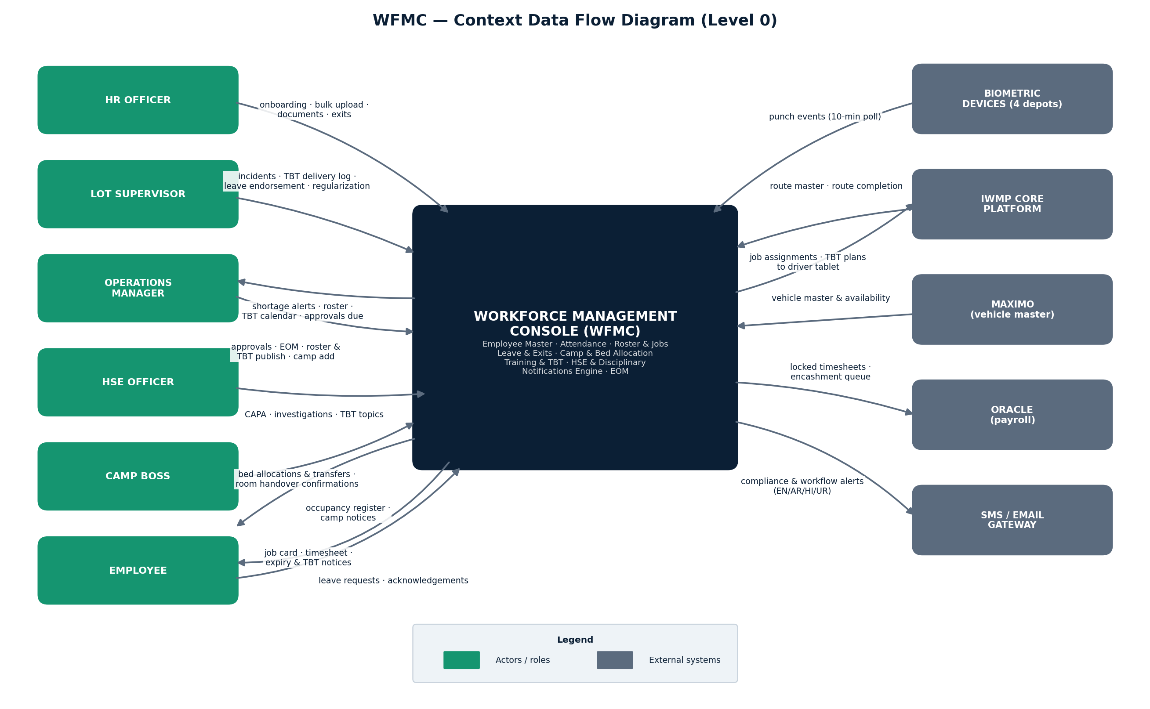
Figure 1 — WFMC context data flow diagram (Level 0)

9.1 DF-01 — Employee onboarding and bulk migration
Step | Actor / source | Action and data | Destination / outcome
1 | HR Officer | Downloads controlled Excel template (29 columns, validation lists) | WFMC template store
2 | HR Officer | Uploads completed workbook | Bulk upload wizard
3 | WFMC | Validates fields; duplicate check on Employee ID / passport / EID | Validation report
4 | HR Officer | Reviews preview; rejected rows exported | Error report
5 | WFMC | Imports clean rows under batch reference; camp-housed joiners enter the Pending-allocation queue | Employee master; camp queue; audit
6 | WFMC | New records enter the nightly compliance scan | Notifications; roster

9.2 DF-02 — Biometric attendance
Step | Actor / source | Action and data | Destination / outcome
1 | Depot devices | Punch events | WFMC (10-min poll)
2 | WFMC | Classifies punches against shift window and grace rules | Daily register
3 | WFMC | Compares actuals vs published roster; shortage by LOT / shift | Dashboard; attendance module
4 | WFMC | Shortage above threshold escalates | Supervisor; manpower coordinator
5 | Employee / Supervisor | Regularization requests | Approval workflow
6 | WFMC | Locked monthly timesheets exported | Oracle payroll

9.3 DF-03 — Roster planning and job assignment
Step | Actor / source | Action and data | Destination / outcome
1 | Scheduler | Builds weekly roster; drag-and-drop adjustments | Roster board (draft)
2 | WFMC | Rule enforcement: double-assignment, weekly-off OT, rest hours | Conflict report
3 | Scheduler | Publishes roster | Supervisors; notice output; driver tablets
4 | Scheduler | Daily job card | Driver tablet
5 | IWMP core | Route completion returns | Performance views

9.4 DF-04 — Leave approval
Step | Actor / source | Action and data | Destination / outcome
1 | Employee / Supervisor | Submits request with balance check | Leave register (Pending)
2 | WFMC | Flags roster impact | Request record
3 | LOT Supervisor | Endorses | Workflow step 2
4 | Ops Manager (+HR long leave) | Approves / rejects; SLA tracked | Notifications
5 | WFMC | Updates status, balance, attendance codes | Attendance; roster; dashboard

9.5 DF-05 — Compliance expiry alerts
Step | Actor / source | Action and data | Destination / outcome
1 | WFMC scheduler | Nightly scan vs thresholds | Alert queue
2 | WFMC | Routes alerts per rules | Bell, email, SMS, push
3 | PRO / HR / Fleet | Initiates renewals | Renewal processes
4 | HR Officer | Updates record | Alert clears
5 | WFMC | Expired safety-critical items block roster eligibility | Roster; supervisor notice

9.6 DF-06 — Incident to CAPA
Step | Actor / source | Action and data | Destination / outcome
1 | Supervisor (mobile) | Reports incident with evidence | Incident register (Open)
2 | HSE Officer | Triage and classification | Case record
3 | HSE Officer | Root cause; CAPA with due date | CAPA tracker
4 | Ops / HR | Linked disciplinary notice if warranted | Disciplinary register
5 | HSE Officer | Verifies, acknowledgement, closes | HSE KPIs

9.7 DF-07 — Employee of the Month
Step | Actor / source | Action and data | Destination / outcome
1 | Manager / Supervisor | Nominates; auto evidence card | Nomination queue
2 | WFMC | Eligibility flags | Nomination record
3 | Operations Manager | Announces or declines | Decision
4 | WFMC | Widget update, all-staff notice, certificate filed | Dashboard; documents

9.8 DF-08 — TBT calendar (create → publish → deliver)
Step | Actor / source | Action and data | Destination / outcome
1 | HSE Officer / Ops Manager | Creates monthly plan with weekly subjects | TBT calendar (Draft)
2 | Ops Manager | Publishes with confirmation | Supervisors; notice output; driver app
3 | LOT Supervisor | Delivers talks; logs delivery + attendance % | TBT items (Delivered)
4 | WFMC | Updates yearly view and dashboard counters | Dashboard; training module
5 | Any authorised user | Exports yearly / monthly plan; prints | Excel / print output

9.9 DF-09 — Camp bed allocation and transfer
Step | Actor / source | Action and data | Destination / outcome
1 | HR Officer / bulk import | New joiner enters Pending-allocation queue | Camp register; KPI
2 | HR Officer / Ops | Opens allocation form: camp (live vacancy), room, bed — vacant beds only | Allocation form
3 | WFMC | Validates at save: bed vacant, one bed per employee; previous bed auto-released on transfer | Bed registry (bound)
4 | WFMC | Notifies camp boss and security; updates occupancy dashboards and employee profile | Camp module; profile
5 | Camp Boss | Confirms room handover; reports transfer needs (welfare, maintenance, shift change) | Transfer requests
6 | WFMC | Exit clearance (DF-04 / LVE-05) releases the bed at last working day | Bed registry (freed); capacity planner

The capacity planner (Fig. 13) projects intake vs exits vs available beds per month and flags shortfalls before they land.

10. Integrations
System | Direction | Data | Mode
Biometric controllers (4 depots) | Inbound | Punch events | API / device poll, 10-minute cycle
IWMP core platform | Bi-directional | Route master in; job assignments and TBT plans out; route completion in | API
Maximo | Inbound | Vehicle master and availability | Scheduled sync
Oracle (payroll) | Outbound | Locked monthly timesheets; encashment queue | Monthly file / API
SMS gateway | Outbound | Employee alerts, multi-language | API
Email (corporate) | Outbound | Workflow and compliance notifications | SMTP / API
SSO / identity provider | Inbound | Authentication and provisioning | SAML / OIDC

11. Non-functional requirements
Ref | Requirement | Target
NFR-01 | Performance at full volume (2,000+ employees, 1,400+ beds, 35+ days attendance) | Standard views under 3 s; exports under 30 s
NFR-02 | Availability | 99.5% during 04:00–24:00 GST, seven days
NFR-03 | Security | Action-level RBAC with LOT and camp scoping; encrypted at rest and in transit; document access logged
NFR-04 | Data residency | UAE data protection requirements and Tadweer Group IT policy
NFR-05 | Auditability | All change / approval / export / allocation events captured; 5-year retention
NFR-06 | Usability | Responsive; dark mode; minimal training for field supervisors and camp bosses
NFR-07 | Localisation readiness | English at launch; Arabic (RTL) capable; SMS in EN / AR / HI / UR
NFR-08 | Browser support | Current Chrome and Edge; no client install
NFR-09 | Scalability | New LOTs, camps and Emirates by configuration; 5,000 employees / 3,500 beds without redesign
NFR-10 | Backup and recovery | Daily backup; RPO 24 h; RTO 8 h

12. Assumptions, dependencies and constraints
- The supplied HTML prototype is the authoritative UX reference; the vendor matches layouts, workflows, validations and popup behaviours unless a change is agreed in writing.
- Historic data migrates through the bulk upload wizard; cleansing before migration is Tajmee'e's responsibility. Initial bed allocations will be loaded from the current camp registers as part of migration.
- Biometric device APIs and depot connectivity are available before UAT.
- Vehicle and route masters remain authoritative in Maximo and IWMP; WFMC consumes them.
- Payroll computation stays in Oracle; WFMC delivers approved timesheets only.
- User, role and master-data administration is performed through the IWMP platform's existing capability; the access model in section 5 (including camp-level scoping) must still be fully enforced.
- Camp facilities operations (mess, maintenance, transport) are excluded from this phase; the camp module is the accommodation register and capacity layer only.
- All demonstration data in the prototype is synthetic; no live personal data is included in this pack.

13. Acceptance and delivery approach
Acceptance is against the Must-priority items in section 7 and the flows in section 9, verified in UAT with migrated LOT 4 data and one camp's live register as the pilot set. The vendor is asked to complete the Appendix A checklist — one response per function using: Available / Partially Available / Requires Development / Clarification Required — and return it with a solution design and effort estimate. Anything the IWMP platform cannot meet must be flagged with the proposed alternative.
Phase | Content | Rationale
1 | Employee Management, master data, bulk migration, access model enforcement, audit capture | Source of truth first
2 | Attendance, roster and job assignment, notifications engine | Daily operational core and compliance protection
3 | Leave and exits, Camp Management, training and TBT calendar, disciplinary & HSE | Workflow modules on stable master data; camp register loaded before LOT 5 peak intake
4 | Dashboard drill-downs, EOM workflow, capacity planner scenarios, integrations hardening | Management layer

14. Glossary
Term | Meaning
LOT | A concession collection area / contract package (LOT 3, 4, 5)
TBT | Tool Box Talk — short on-site safety briefing delivered at shift start
Camp Boss | On-site camp administrator responsible for rooms, handovers and welfare
CAPA | Corrective and Preventive Action
LTI / LTIFR | Lost Time Injury / LTI Frequency Rate
EOM | Employee of the Month
PRO | Public Relations Officer — government document processing
SLA | Service Level Agreement — response time per approval step
MoSCoW | Priority scheme: Must / Should / Could / Won’t (this phase)

Appendix A — Function checklist (vendor response sheet)
One row per function. For each, enter exactly one response: Available (A) / Partially Available (PA) / Requires Development (RD) / Clarification Required (CR), plus remarks and effort where relevant. This completed sheet forms part of the vendor's proposal.
Dashboard
Ref | Function | Pri. | Response (A/PA/RD/CR) | Remarks
DSH-01 | Eight live KPI cards | M
DSH-02 | KPI popup drill-down lists (filter, export, no redirect) | M
DSH-03 | Training-compliance action list sorted by expired certs | M
DSH-04 | Attendance vs roster trend + core charts | M
DSH-05 | Per-LOT dashboard cards with drill-down | M
DSH-06 | 35-day attendance heatmap | S
DSH-07 | EOM widget with winner history | M
DSH-08 | EOM nomination with auto evidence card | M
DSH-09 | EOM eligibility flags and override | M
DSH-10 | EOM review & announce workflow | M
DSH-11 | Vacancy drill-down with requisition action | S

Employee Management
Ref | Function | Pri. | Response (A/PA/RD/CR) | Remarks
EMP-01 | Employee master table (filters, exports, frozen column) | M
EMP-02 | 29-column master export (exact layout) | M
EMP-03 | Employee profile, five tabs incl. accommodation | M
EMP-04 | Document repository, ten types | M
EMP-05 | Onboarding form with validation | M
EMP-06 | Five-step bulk upload with duplicate checks | M
EMP-07 | Status lifecycle incl. auto bed release on exit | M
EMP-08 | Org chart; employee pinning | C

Attendance & Timesheet
Ref | Function | Pri. | Response (A/PA/RD/CR) | Remarks
ATT-01 | Biometric ingestion, 10-min poll | M
ATT-02 | Daily register with punches and exports | M
ATT-03 | Punch detail; timesheet; regularization | M
ATT-04 | Shortage vs roster with auto-escalation | M
ATT-05 | Monthly workbook and summaries | M
ATT-06 | Configurable grace / OT / night rules | S

Roster & Job Assignment
Ref | Function | Pri. | Response (A/PA/RD/CR) | Remarks
ROS-01 | Weekly roster board | M
ROS-02 | Drag-and-drop with rule enforcement | M
ROS-03 | Conflict check (double / rest-hour) | M
ROS-04 | Daily job card to driver tablet | M
ROS-05 | Publish and republish sync | M
ROS-06 | Headcount planner; coverage heat map | S

Leave Management
Ref | Function | Pri. | Response (A/PA/RD/CR) | Remarks
LVE-01 | Request capture with balance and roster impact | M
LVE-02 | Multi-step approval with SLA escalation | M
LVE-03 | Register with workflow trail and actions | M
LVE-04 | Leave planner calendar with holidays | S
LVE-05 | Exit tracker incl. camp checkout gate | M
LVE-06 | Encashment queue to payroll | S

Camp Management
Ref | Function | Pri. | Response (A/PA/RD/CR) | Remarks
CMP-01 | Camp master with auto-generated bed registry | M
CMP-02 | Employee-to-camp/room/bed mapping on profile | M
CMP-03 | Capacity vs occupancy dashboard and charts | M
CMP-04 | Camp cards with colour-graded occupancy % | M
CMP-05 | Block-wise room & bed map with export | M
CMP-06 | Room popup: occupants, assign, transfer | M
CMP-07 | Allocation/transfer: vacant-only, no double occupancy, auto release | M
CMP-08 | Bed allocation register with filters and export | M
CMP-09 | Capacity planner: intake vs exits vs beds, scenarios | M
CMP-10 | Pending-allocation queue for new joiners | M

Training & TBT
Ref | Function | Pri. | Response (A/PA/RD/CR) | Remarks
TRN-01 | Training catalogue with validity | M
TRN-02 | Session scheduling and nominations | M
TRN-03 | Session register; attendance; certificates | M
TRN-04 | Competency matrix with export | M
TRN-05 | Expiry feeds alerts; roster flag | M
TRN-06 | Compliance and effectiveness analytics | S
TRN-07 | Materials library | C
TRN-08 | TBT topic master (16 subjects) | M
TRN-09 | Create monthly TBT calendar (weekly subjects) | M
TRN-10 | Publish workflow with lock and notifications | M
TRN-11 | Yearly TBT calendar view with statuses | M
TRN-12 | TBT delivery and attendance logging | M
TRN-13 | TBT exports (yearly / monthly) and print | M
TRN-14 | Seasonal heat-stress guidance rule | S

Disciplinary & HSE
Ref | Function | Pri. | Response (A/PA/RD/CR) | Remarks
HSE-01 | Incident reporting with evidence | M
HSE-02 | Register with filters and KPI cards | M
HSE-03 | Case workflow: RCA, CAPA, closure | M
HSE-04 | Progressive discipline with escalation | M
HSE-05 | Acknowledgement tracking; warnings register | M
HSE-06 | Incident and root-cause analytics | S

Notifications
Ref | Function | Pri. | Response (A/PA/RD/CR) | Remarks
NTF-01 | Nightly scan, eight triggers | M
NTF-02 | Configurable lead times | M
NTF-03 | Bell drawer with bucket lists | M
NTF-04 | Notification Center and alert rules | M
NTF-05 | Email / SMS / push, multi-language SMS | S
NTF-06 | Auto-clear on renewal; roster block | M

Cross-cutting
Ref | Function | Pri. | Response (A/PA/RD/CR) | Remarks
GEN-01 | Global search (Ctrl+K) | M
GEN-02 | Table framework with four-format export | M
GEN-03 | Themes, shortcuts, confirmations | S
GEN-04 | Mobile-responsive layout | M
GEN-05 | Audit capture of all events | M

Appendix B — Prototype snapshots
Captured from Tajmee_Workforce_Console.html with synthetic data. Charts render from CDN when opened with internet access.
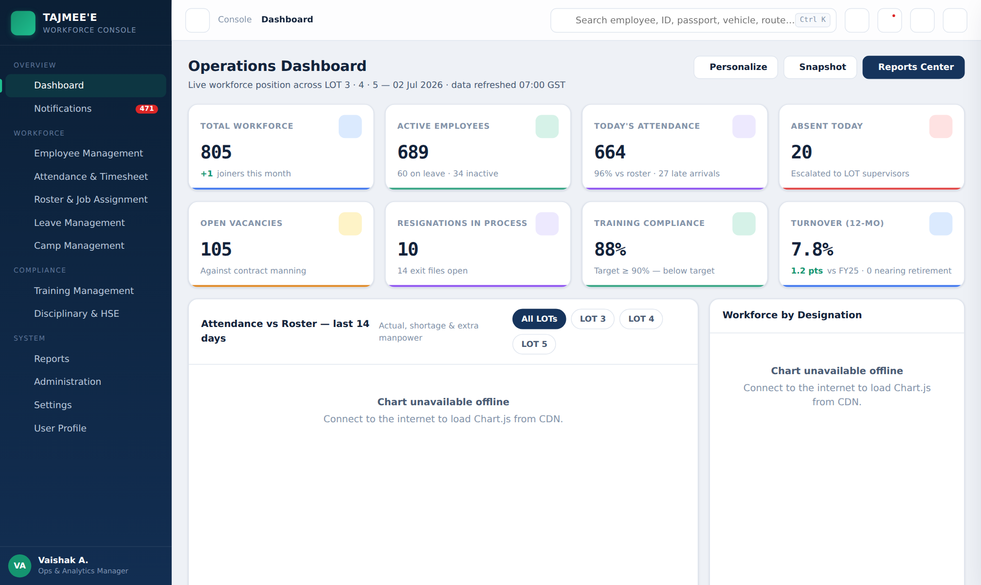
Figure 2 — Operations Dashboard — KPI cards, LOT filter chips and widgets
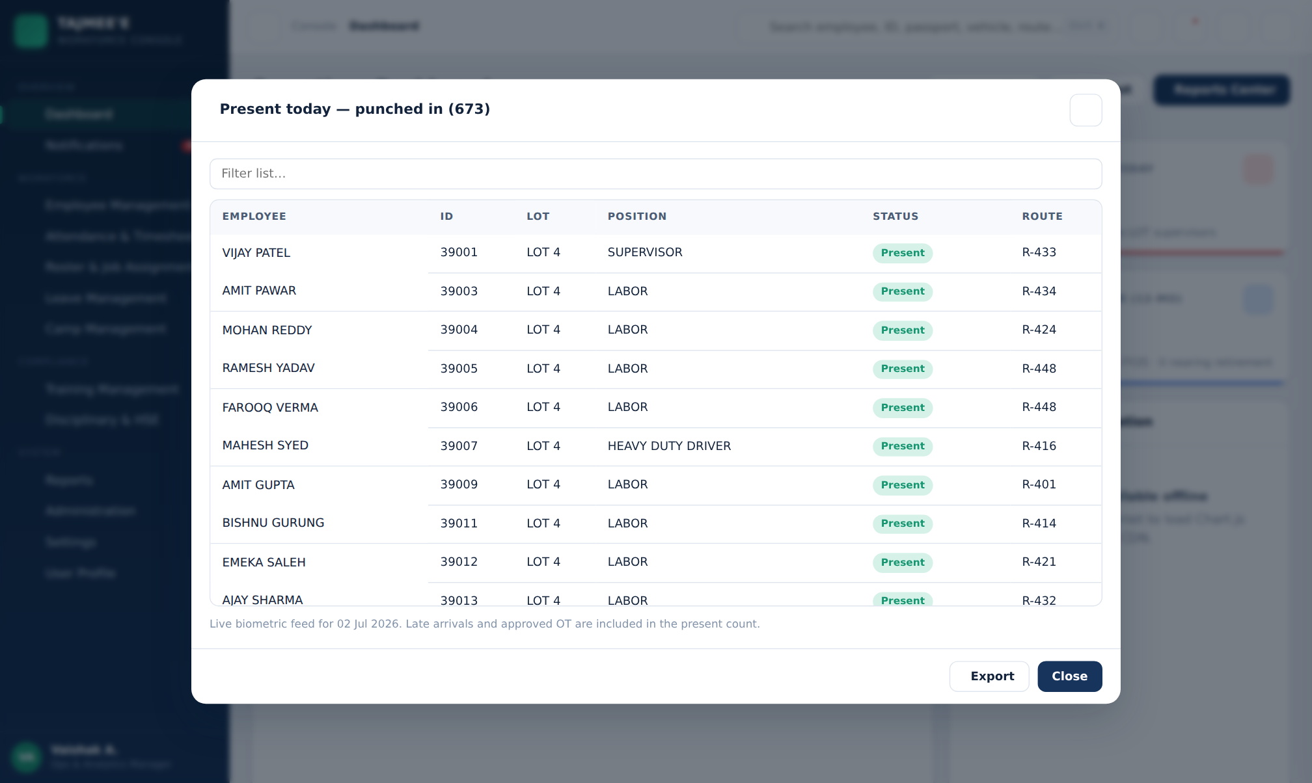
Figure 3 — KPI drill-down popup (Today’s Attendance) — in-place list with filter and export
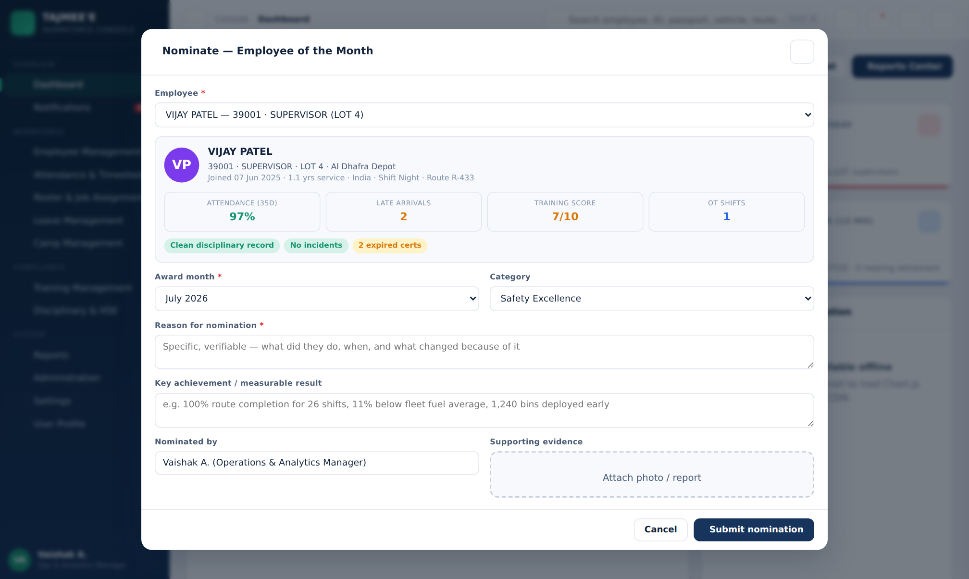
Figure 4 — Employee of the Month nomination — auto-compiled evidence card and record checks
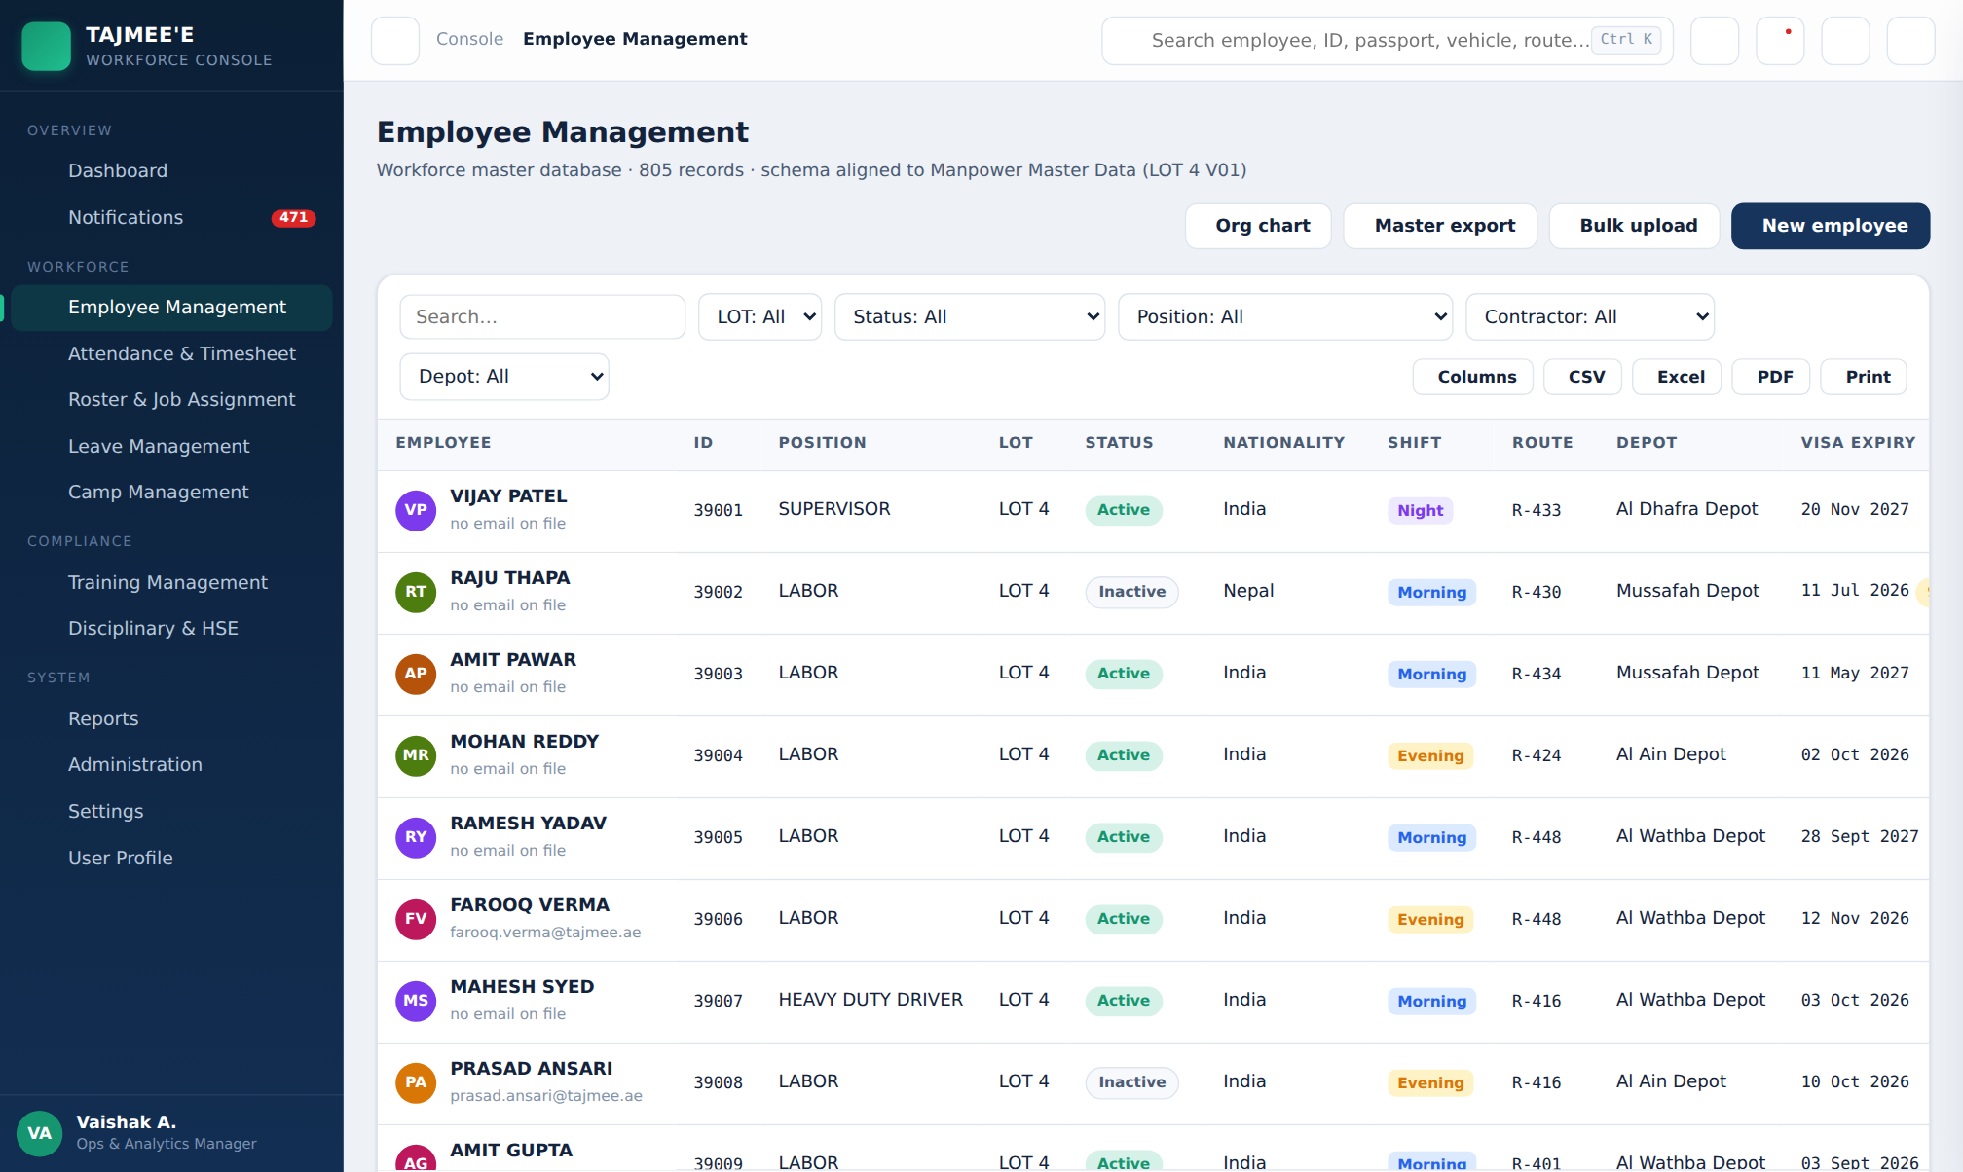
Figure 5 — Employee Management — master table with filters, badges and export set
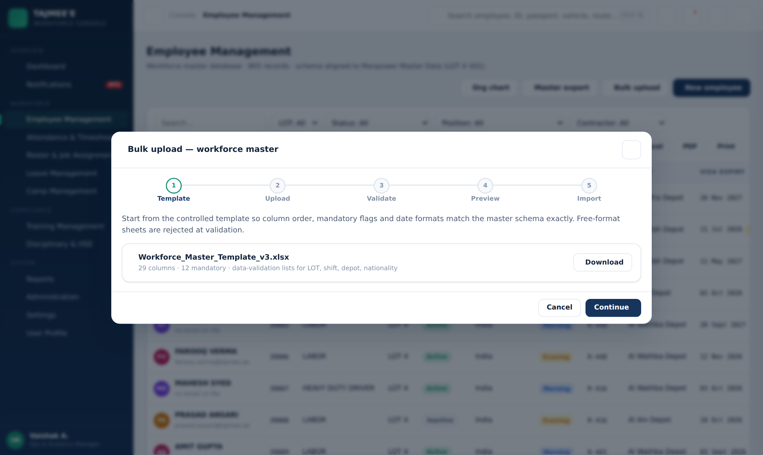
Figure 6 — Bulk upload wizard — five steps with duplicate detection and error report
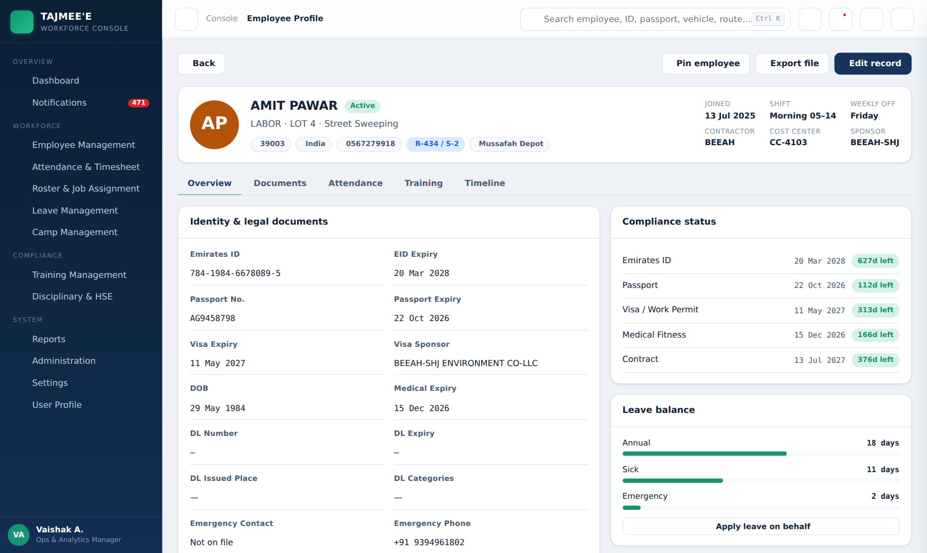
Figure 7 — Employee profile — compliance status, leave balances and camp / room / bed
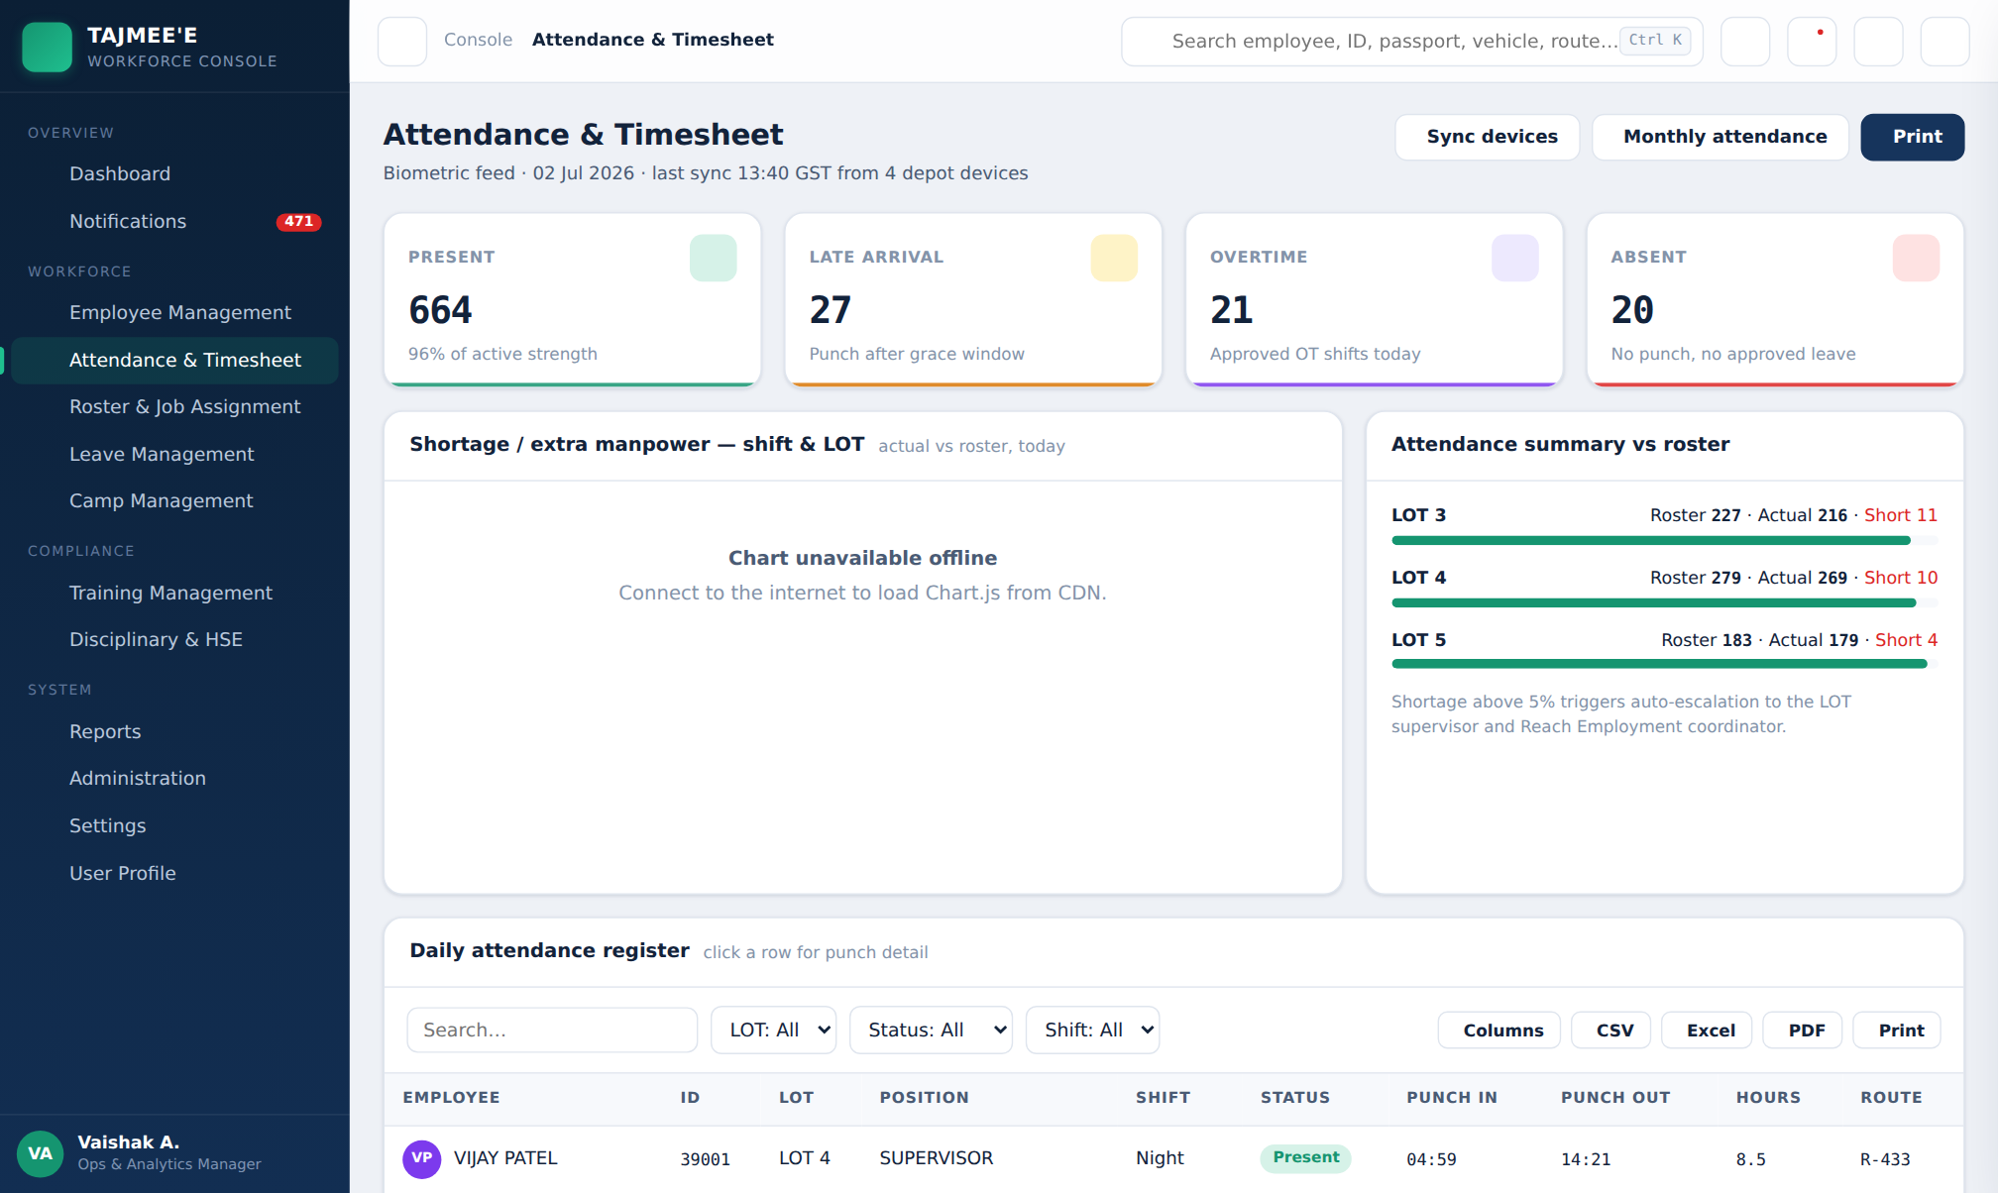
Figure 8 — Attendance & Timesheet — daily register and shortage analysis
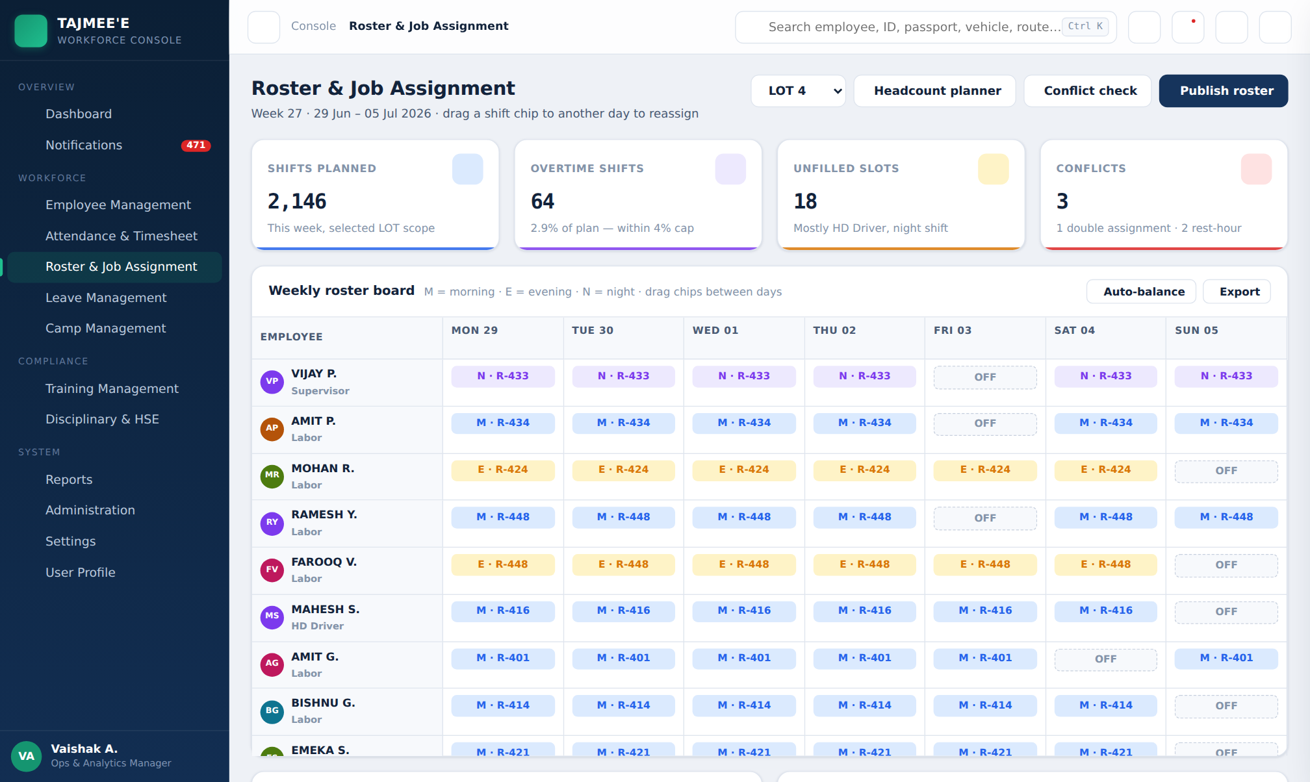
Figure 9 — Roster & Job Assignment — weekly board with drag-and-drop shift chips
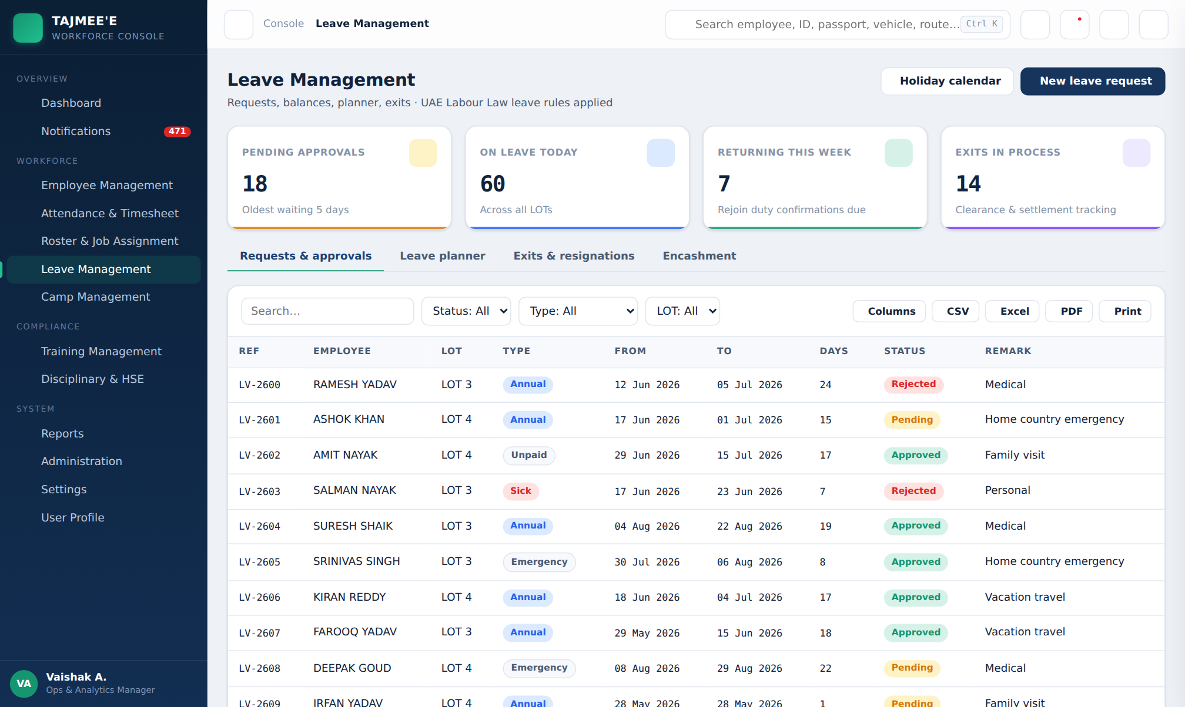
Figure 10 — Leave Management — requests, approvals and exit tracking
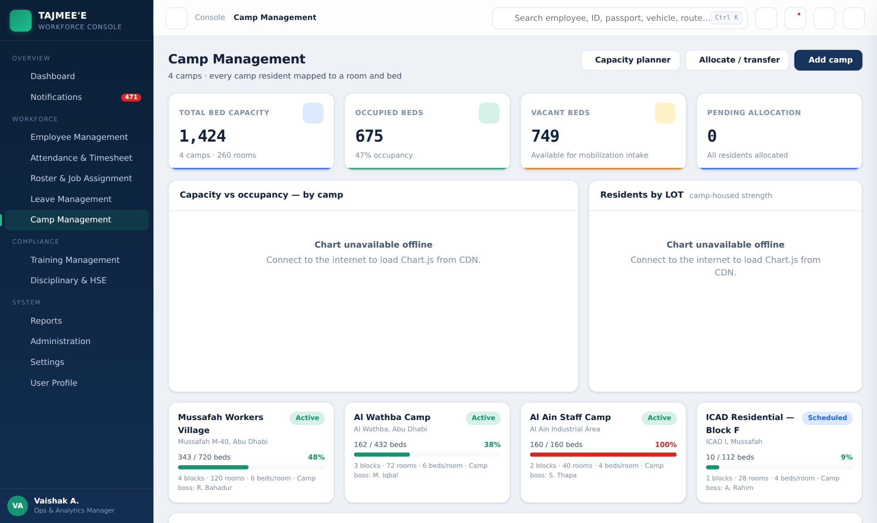
Figure 11 — Camp Management — capacity vs occupancy, camp cards and bed allocation register
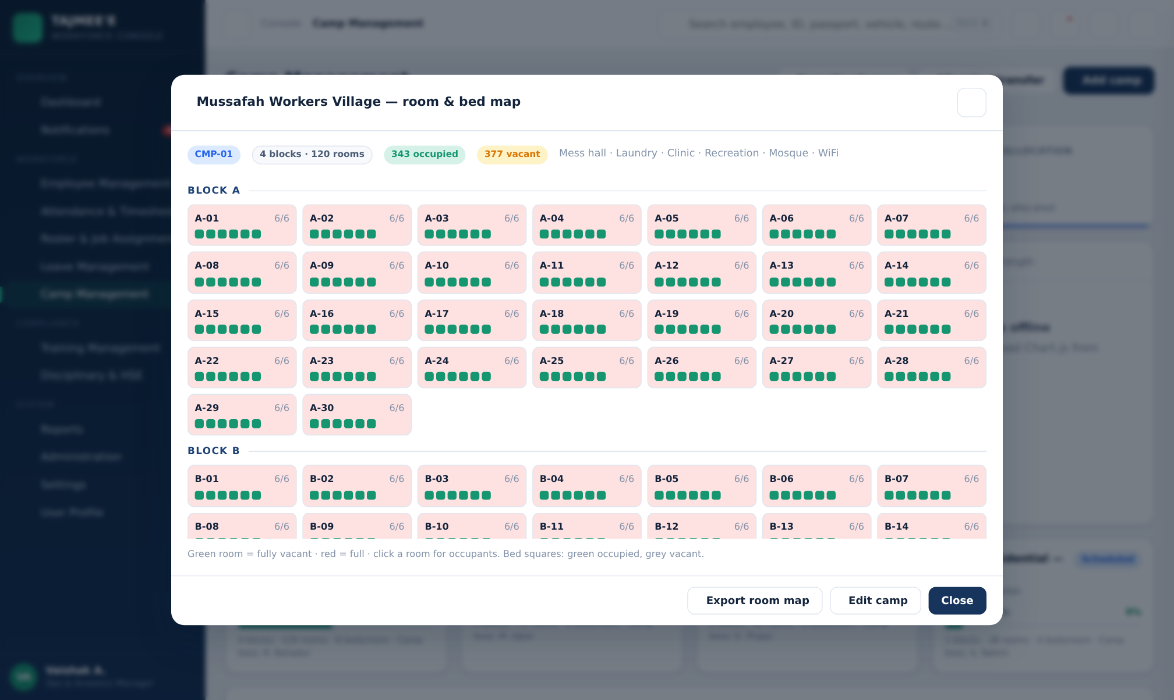
Figure 12 — Camp room & bed map — block-wise grid with per-bed occupancy
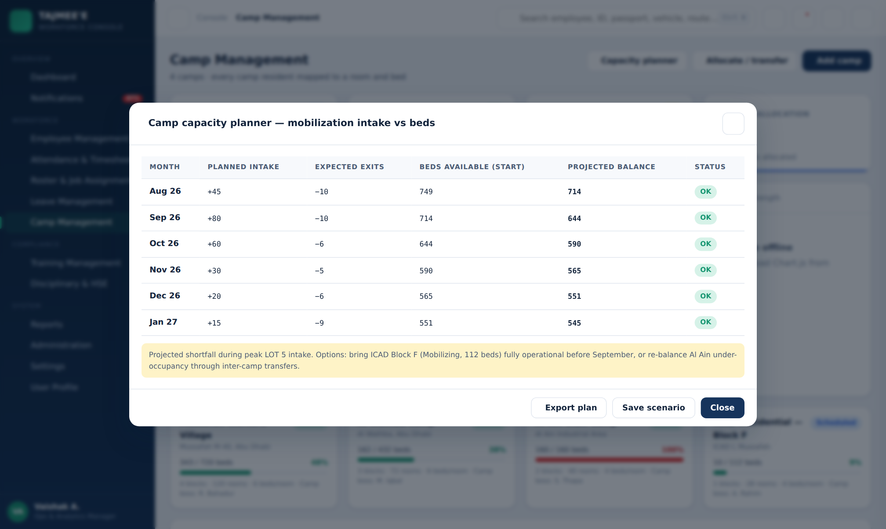
Figure 13 — Camp capacity planner — mobilization intake vs available beds with shortfall flags
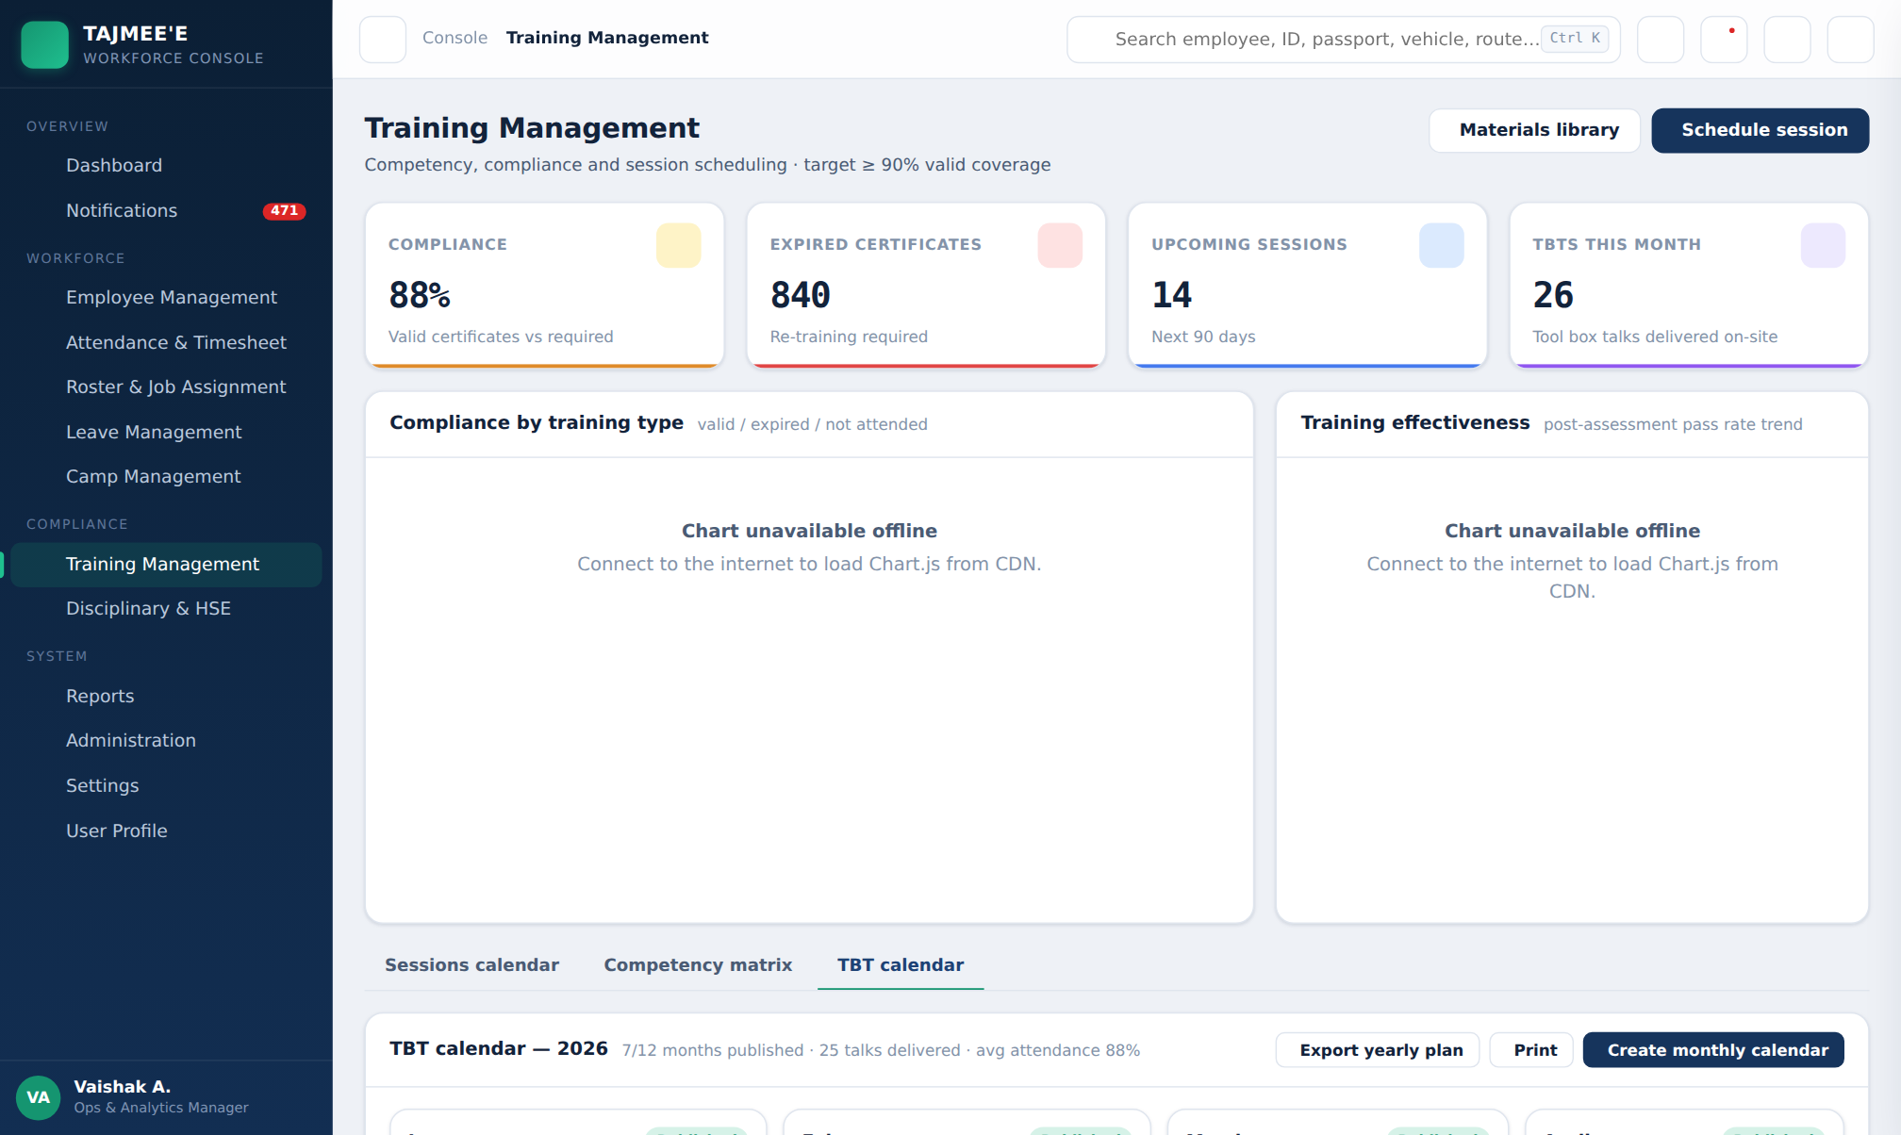
Figure 14 — TBT calendar — yearly view with monthly subjects, statuses and delivery ticks
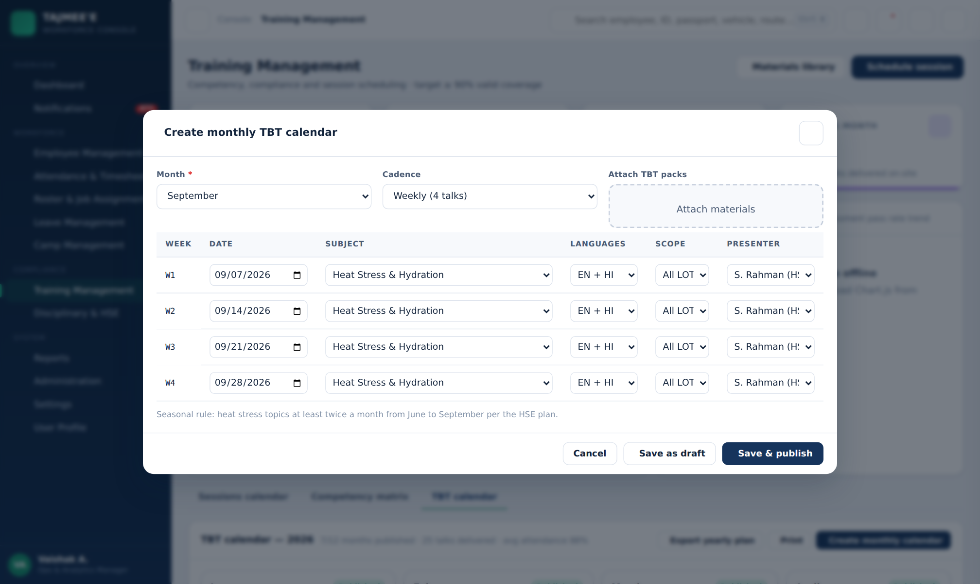
Figure 15 — Create monthly TBT calendar — weekly subjects, languages, scope and presenter
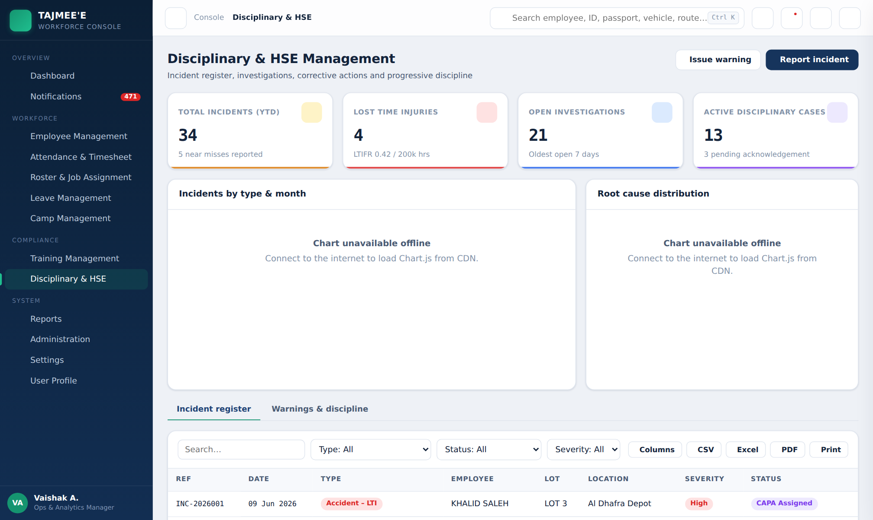
Figure 16 — Disciplinary & HSE — incident register and KPI cards
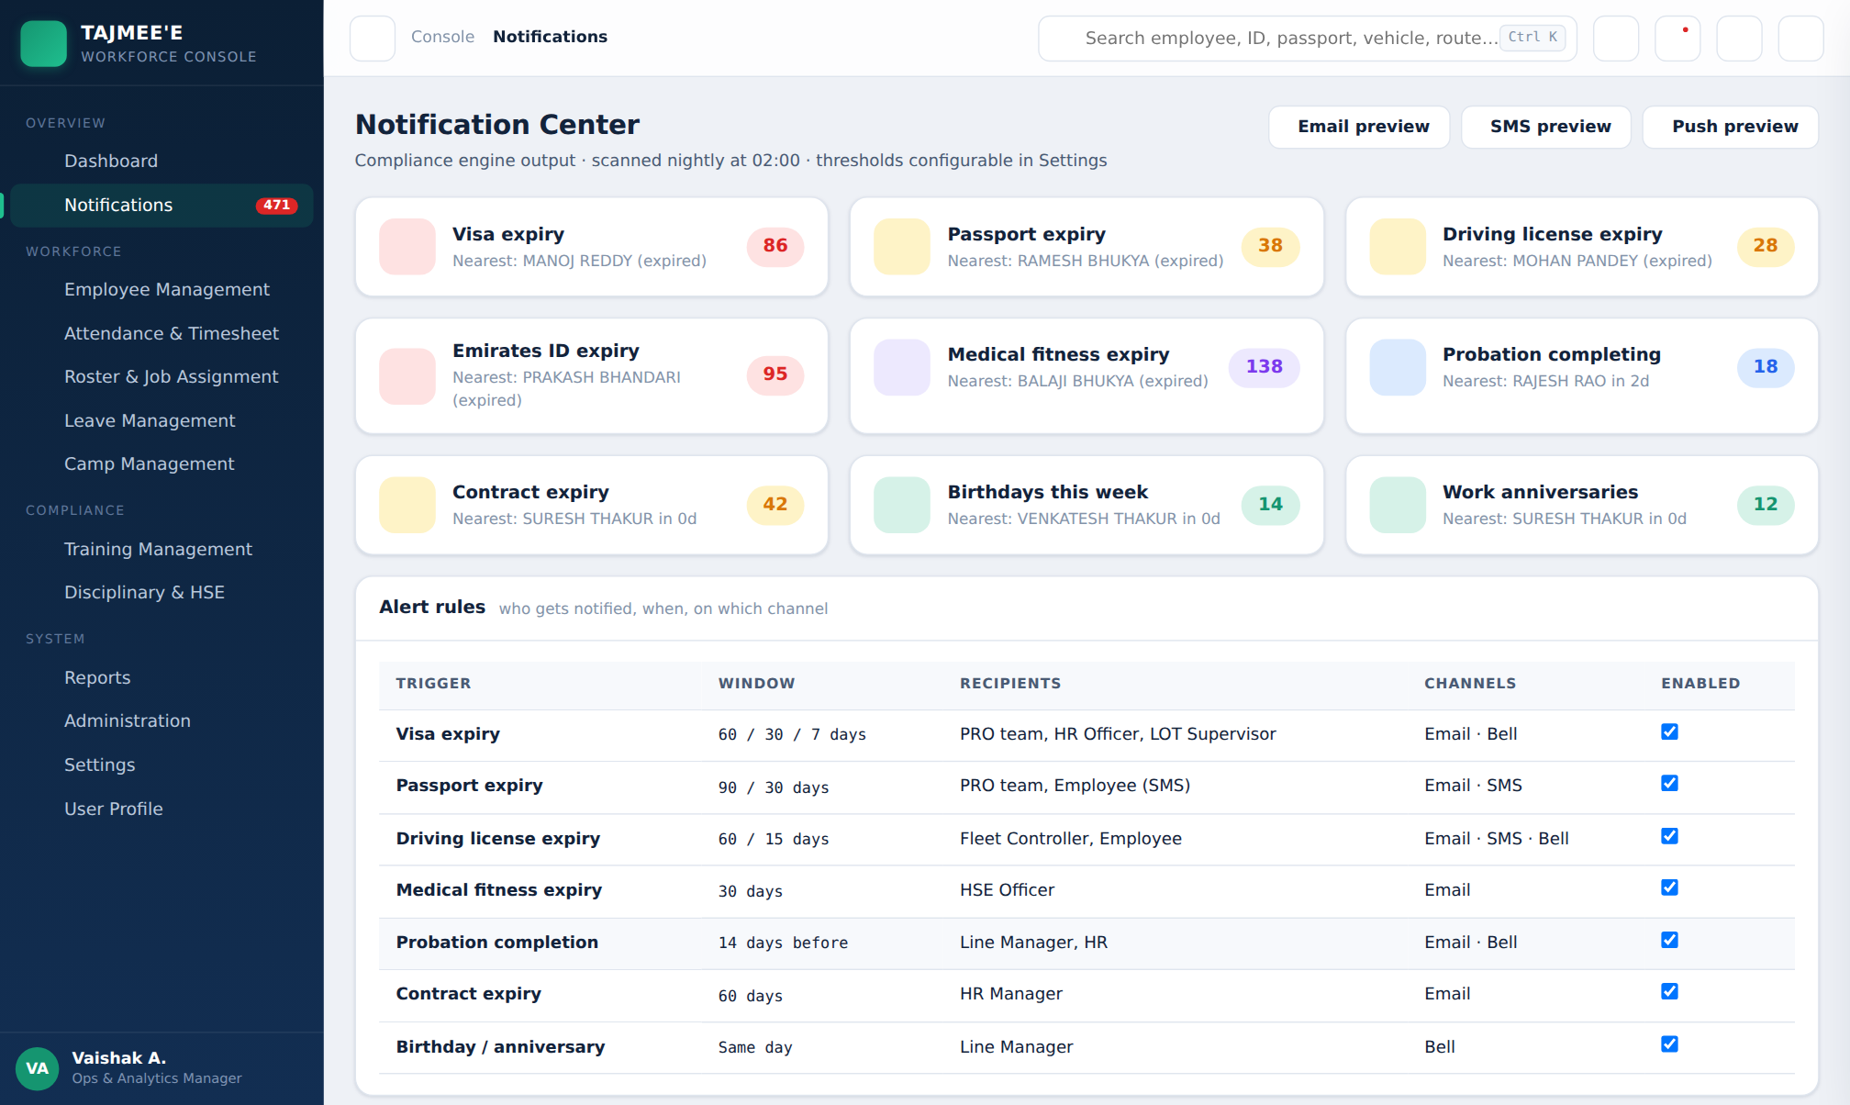
Figure 17 — Notification Center — compliance buckets and alert rules
— End of document —

