# Steps to run On Demand Parallel Sanity run on Hudson

1. Navigate to the Hudson urls in different tabs in browser. You will see the all plans created on hudson.

<http://10.96.51.89:8080/>

<http://10.96.51.88:8080/>

<http://10.96.51.90:8080/>

<http://10.96.51.45:8080/>

<http://10.96.51.122:8080/>

1. Identify the plans (which you want to run)

(Plans are created with the Parallel keyword in plans name.)

(Observe that the plans is not already running, someone has not triggered it before you)

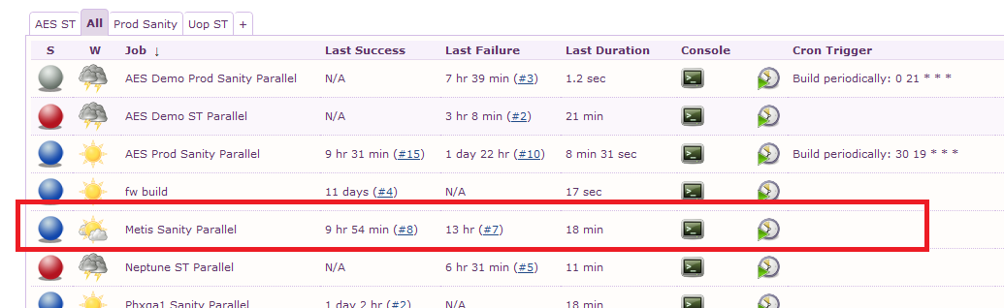

1. Observe that no other plans are running on the same Hudson instance

(If running plz wait for the completion of the running plan)

Only production sanity plans will be in running on 6:00, 8:00 and 9:30 AM IST

If still see any plans is running but sanity is completed then terminate it by pressing the red cross button

1. Select the plan which you want to build and click on the build now link on left side menu.

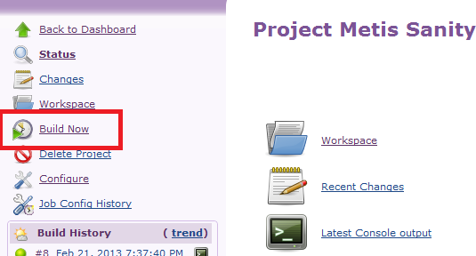

1. Or you can select the Build now from the Dashboard also.

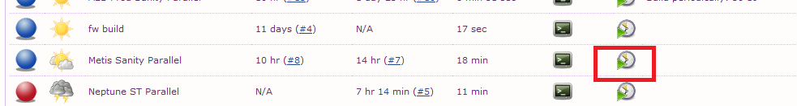

1. On completion of the sanity execution report mail sending will get trigger automatically.

(Run the plan on all 5 machines other wise email will not get triggered.)

1. You can see the console log on clicking on the console button.
2. You can observe the email able report generated under workspace folder.

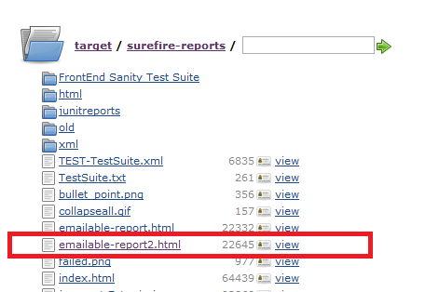

**Note: If any sanity run get stuck due to some reason in between running the build plans it will get terminate automatically in 40 minutes.**