DAY 16 AI/ML IMPLEMENTATION
PROOF & EVIDENCE
HisabDo AI Service — Prototype / POC Validation

1. Automated Test Validation
The supplied evidence records the automated test result as “18 passed,” providing direct validation that the available test suite completed successfully. 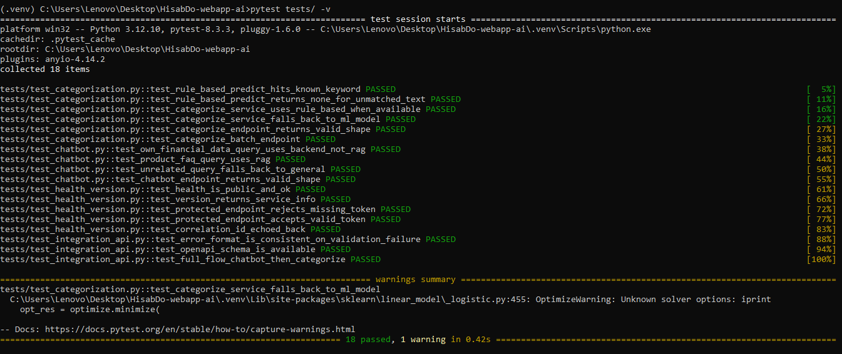
2. FastAPI Service
The evidence includes a dedicated step for starting the FastAPI server, demonstrating an executable API/service layer. 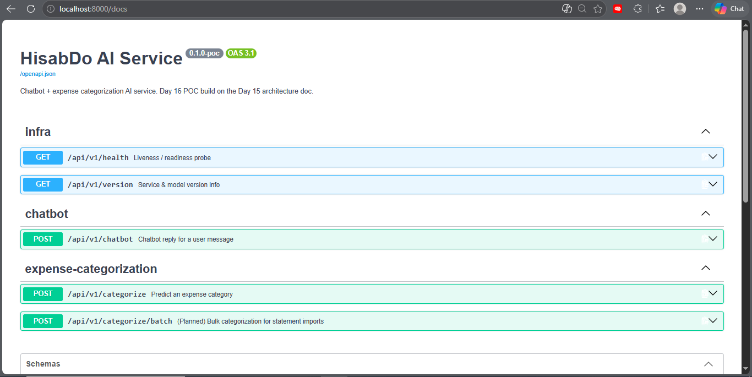
3. Authentication Validation
The evidence includes separate stages labelled “Unauthorize” and “After Authorization,” documenting authentication validation before and after authorization.
Unauthorize
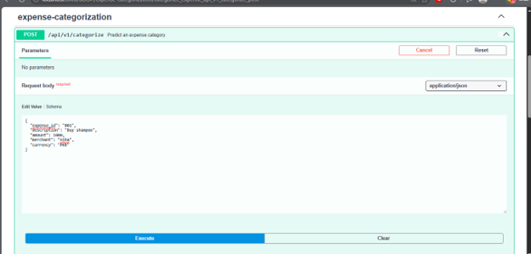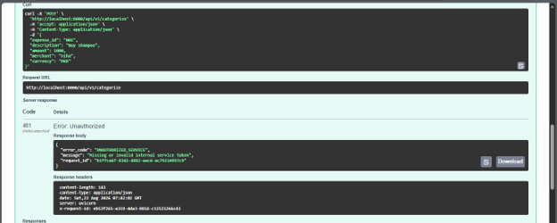
4. Chatbot Evidence
The supplied document includes a dedicated “Chat Bot” evidence section, demonstrating that chatbot functionality is included in the Day 16 POC.
