DAY 15
AI Service & FastAPI Architecture
Service structure, endpoint planning, and integration boundaries for HisabDo-webapp-ai
Project | HisabDo Web App — AI Service
Repository | usmankhalid172/HisabDo-webapp-ai
Day / Sprint | Day 15
Responsibility | Define the overall AI service / FastAPI architecture and integration boundaries
Document status | Architecture & planning complete
Date | August 21, 2026
Prepared by | Niha Batool

1. Purpose & Scope
This document defines the target architecture for the AI service that powers HisabDo's chatbot and automatic expense-categorization features. It sets out where FastAPI endpoints live, the boundary between the AI service and the main application backend, how the two chatbot and categorization capabilities are mapped to that structure, and the shared contracts both sides need to respect before implementation begins.
Scope for Day 15 is planning and structure only: no service code is implemented yet. This document is the reference other implementation days (Day 16+) will build against.

2. Assumptions
- HisabDo-webapp-ai is treated as an independent microservice repository, separate from the main HisabDo application backend repository.
- The AI service talks to the application backend only over an internal REST API (JSON over HTTPS) — no shared database access, and no direct calls from the frontend/client.
- our current Team Lead workflow is feature branch → PR to main (internal workflow, not management policy).
- The model/provider choice for the chatbot (self-hosted vs. external LLM API) is not yet finalized; both paths are accounted for in the dependency and blocker lists below.

3. Overall AI Service Structure

3.1 High-level architecture
The AI service sits behind the application backend, not in front of it. The client never calls the AI service directly — all traffic is Client → Backend → AI Service → Model/data layer. This keeps authentication, business rules, and persistence entirely inside the backend, and keeps the AI service stateless, independently deployable, and easy to scale or replace.

3.2 Proposed repository / folder structure
HisabDo-webapp-ai/
├── data
|
│── research
|
│── docs
|
│── tests
|
│── src
|──integration
│
│
│──expense_categorization
│
│
│──financial_assistant
│

4. FastAPI Service & Endpoint Planning
All endpoints are versioned under /api/v1 so the contract with the backend can evolve without breaking existing integrations.
Method | Endpoint | Purpose | Consumer
GET | /api/v1/health | Liveness / readiness probe | Backend, infra/monitoring
GET | /api/v1/version | Returns service & model version info | Backend, ops
POST | /api/v1/chatbot | Accepts a user message + conversation context, returns a generated reply | Application backend (on behalf of client)
POST | /api/v1/categorize | Accepts an expense description/amount, returns predicted category + confidence | Application backend (on behalf of client)
POST | /api/v1/categorize/batch | (Planned) Bulk categorization for statement imports | Application backend / import jobs

5. Boundaries — Application Backend vs. AI Service
Concern | Application Backend | AI Service (FastAPI)
End-user authentication | Owns login, sessions, JWT issuance | Trusts only a backend-issued service token
User & expense data storage | Source of truth database | No persistent storage (stateless; optional short-lived cache)
Business rules (budgets, limits, alerts) | Owns and enforces | Does not own or enforce business rules; can consume backend-provided context/results where needed.
Natural-language understanding / reply generation | Not implemented here | Owns entirely
Expense category prediction | Stores / applies the result | Predicts, returns label + confidence
Offline model training / retraining | Not applicable | Owned by the AI/ML component as a separate offline process, run outside the request/response cycle (data prep, training, evaluation).
FastAPI inference / service runtime | Not applicable | Serves predictions from already-trained model artifacts; does not perform training within the request path.
Rate limiting to end users | Owns | Internal safeguard only
Service-to-service auth | Issues internal token | Verifies internal token

6. Chatbot & Expense Categorization — Service Mapping

6.1 Chatbot service
Input: { user_id, message, conversation_id, history[] }
Processing: FastAPI validates the payload with Pydantic → chatbot_service builds the prompt/context → calls the configured LLM (internal or external provider) → post-processes the reply.
Output: { reply, conversation_id, intent (optional), tokens_used (optional) }
Data boundary (RAG vs. authoritative data):
- The RAG / knowledge-base (vector search) layer is scoped to HisabDo product docs, FAQs, and general financial knowledge/education content — it is not a source for live user data.
- Exact user financial values (balance, expenses, revenue, customer outstanding, etc.) must always come from authenticated backend/API data and deterministic calculation — never from RAG retrieval.
- RAG / vector search is not treated as the source of truth for live financial numbers; when a user asks about their own figures, the chatbot service calls the backend’s financial data API instead of retrieving from the knowledge base.

6.2 Expense categorization service
Input: { expense_id (optional), description, amount, merchant (optional), currency }
Processing: FastAPI validates the payload → categorization_service normalizes the text → classifier (rule-based fallback + ML/LLM model) predicts a category → low-confidence predictions are flagged for user confirmation instead of being auto-applied.
Output: { category, confidence, alternative_categories[] (optional) }

7. Integration-Flow Diagram
The diagram below shows the request path from client to model/data layer and the boundary the AI service sits behind.
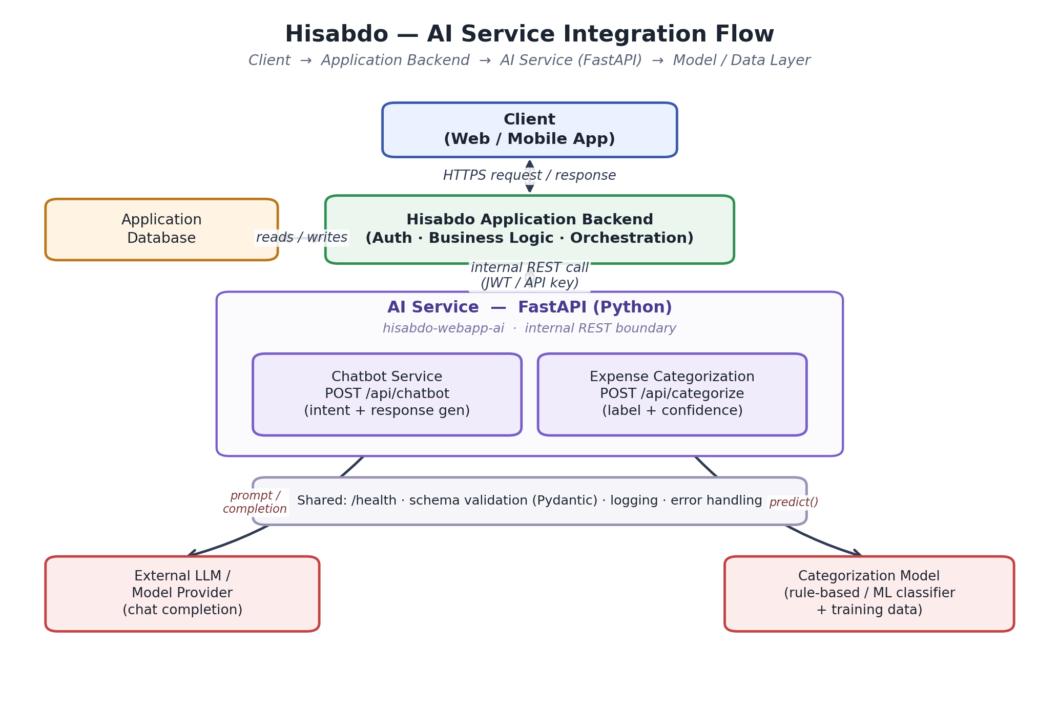

8. Shared Integration Requirements
- Common request/response contract defined via Pydantic schemas on the AI side, mirrored by matching types/interfaces in the backend's API client.
- Service-to-service authentication: a shared secret or short-lived JWT issued by the backend; the AI service never trusts client-supplied identity directly.
- Consistent error format on both services: { error_code, message, request_id }.
- A correlation / request ID propagated from the backend into the AI service for tracing across both codebases.
- Centralized, structured (JSON) logging so both services can be aggregated the same way.
- The AI service is not exposed directly to the browser — only the backend calls it, enforced at the network level (internal network / same container network).
- Environment-based configuration (.env) for both services; no secrets committed to either repository.

9. Dependencies
- Python — proposed baseline 3.11+; exact version pending Team Lead decision.
- Package manager — proposed (pip + requirements.txt, or Poetry); not yet finalized, pending Team Lead decision.
- FastAPI, Uvicorn (ASGI server), and Pydantic v2 as the core web/service framework — proposed dependencies.
- An HTTP client on the backend side to call the AI service (e.g. the backend framework's own fetch/HTTP client).
- Model dependencies: scikit-learn / transformers if self-hosted, or an LLM provider SDK if using an external API — final choice pending (see Section 10).
- Docker, for containerized deployment — proposed approach; final deployment/hosting strategy pending Team Lead decision.
- pytest for AI-service unit and integration tests.
- FastAPI's auto-generated OpenAPI schema (/docs, /openapi.json) as the single source of truth for the backend integration contract.

10. Dependency / Blocker List
Blocker / open question | Impact
Chatbot LLM provider not selected (self-hosted vs external API) | Affects dependency list, latency, cost, and the external-provider box in the integration diagram
Final production categorization approach not yet decided (POC/baseline exists) | POC/baseline results inform direction, but the production approach (rule-based vs ML vs hybrid) still needs sign-off before Section 6.2 moves beyond the baseline
No approved/production-grade labeled dataset yet for expense categorization | Only ad hoc/POC data available so far; blocks training and validating the final production categorization model
Service-to-service auth mechanism (API key vs JWT) not decided | Needs sign-off from whoever owns the backend repo; AI repo alone can't finalize it
Deployment target (same network as backend vs separate service) unconfirmed | Affects the network-boundary assumption used in Section 8
Final backend data contract for exact user financial queries not yet defined | Blocks locking the API contract the AI service will call for authoritative values (balance, expenses, revenue, outstanding, etc. — see Section 6.1 data boundary)

